Tiny15/25 Design Idea

Hi Freaks ……………………. Here comes the Sun ?

This WebSite says it all.

Using a Tiny15/ Tiny25 we can record the data, filter , further process and store it.

We chose to used the onboard Analog Vref of 2.56 Volts as the A2D reference voltage

And using the general formula for the Tiny Differential Amplifier configuration

Digital value = Vin * 1024 *20 / 2560 (MilliVolts).

We get a reading of $0008 (8) for an input of 1mV so a reading of $0320 (1000)

corresponds to an FSD of 100 mV. In the interests of readability and intuition we

multiply this sum by 1.25 to give us the results $000a to $03e8 respectively.
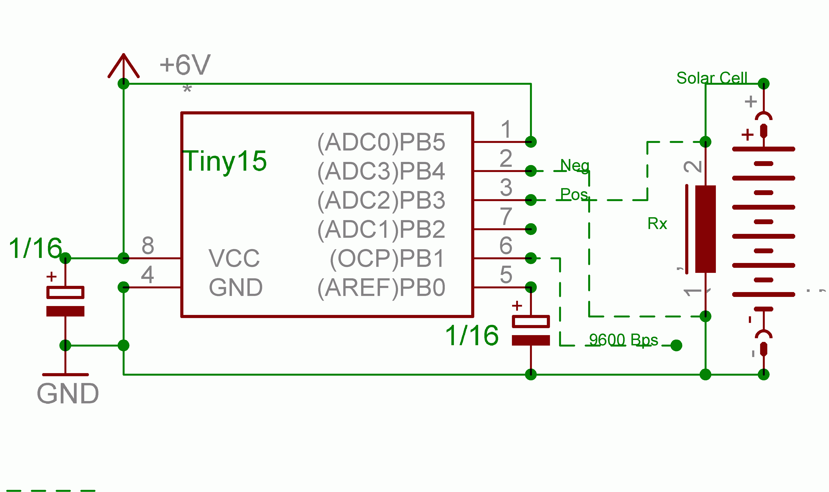

Don’t forget the Sunscreen ?

John-Alfred Ullasmann

