UC3B1256-based MP3-player

Description
This document is a report on the UC3B-based MP3-player board. The board is 14.6 by 60.5 mm and features a mini-jack for headphones, joystick for navigation, a single LED, battery clamps for a single AAA-battery, USB-connector and uSD-connector.

The software is designed to read MP3-files from a FAT file system on the uSD-card, decode and play them in real-time. The user can skip files and regulate the volume using the joystick. The player only supports the MP3-format.

Files are read from the uSD-card using SPI, which is the common way to interface SD-card with microcontrollers. There is a driver for this in the framework.

In addition to the UC3, the board features a tiny25-based buck-boost converter that creates 3.3V for the UC3 from the 1.5V AAA-battery or the 5V USB VBUS. The player can run on both.

The player uses two PWM channels for each audio channel to output the audio. The headphones are driven directly by the UC3-pins. A filter on each audio channel is supposed to combine two PWM channels to achieve 16-bit resolution.

The Helix-decoder
The player uses the Helix fixed-point MP3 decoder. It is released under the RealNetworks Public Source License.

To minimize memory usage, several modifications were made to the decoder:
- In buffers.c, the buffer allocations were changed from dynamic to static allocations.
- In subband.c, code was added to synchronize the decoder with the DAC. In this way there is no need for a double dedicated frame-sized output buffer.
- In mp3dec.c, MP3ClearBadFrame() was removed as it is no longer needed.

Programming
Both the UC3 and the tiny25 can be programmed with the edge connector on the board (CON4), a JTAGICE mkII and the “board adapter”.

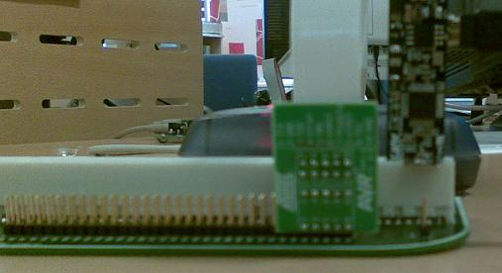

The picture shows the arrangement for programming the UC3. For programming the tiny25, rotate the player 180 degrees around so that the board is in the same position but has the battery contacts facing the other way. Make sure all the jumpers on the board adapter are removed when programming.

The tiny25 can only be programmed when powered by the USB, do not program with the battery in. Note that there is a problem addressed in the unresolved issues section that says that the tiny25 cannot be programmed when the boost transistor (Q1) is mounted. Also, due to a design mistake on the board layout, the center button on the joystick must be held down during programming of the tiny25.

Unresolved issues
- Some (most, it seems) uSD-cards draw a current spike every time the software starts to read from the uSD-card. The spike is almost twice the normal current and causes a voltage fall that leads to low-pitched noise in the audio-output. This problem is really an issue with the buck-boost-converter. If for instance the converter was replaced by a 3.3V battery, it would be fine.
- The boost-converter isn’t initializing very well, especially with 1.2V-batteries. The problem is that the voltage drop over D1 is too large, so that the tiny25 and/or the transistor (Q1) will fail to work properly. As soon as the converter starts up, it will continue working even if the battery voltage drops to below 1V.
This problem could probably be solved by replacing the diode with a PMOS-transistor connected to OC1A, but most discrete transistors feature an internal diode between D and S that will cause problems.
- The boost-converter uses too much power, almost as much as the UC3. It would help to replace the diode with a transistor as described above, as the voltage drop over the diode causes a significant proportion of the total power consumption.
- Not all uSD-cards have SPI-interface, as it’s only an optional feature in the specification. uSD-cards without SPI will not work at all. On both SD and miniSD-cards SPI is a required feature, so using one of those instead should be safe.
- The audio-quality of the player isn’t especially good. This is probably due to the excessively simple nature of the filter that is supposed to combine the most and least significant bits. Also the PWM-module probably isn’t very good suited for high-quality audio conversion, as the oversampling factor is just around 2x depending on the PBA-clock.
- The tiny25 cannot be programmed with the Q1-transistor mounted. The nature of this problem is unknown.
- A loud click is heard when the headphones are inserted with the battery in. This is because the socket is used for disconnecting the battery from the circuit, and the way this is designed causes DC from the battery to be applied to the earphones during insertion. This should be avoided by shorting the battery-pins on the connector at the footprint.

