RoCK Specifications: The Goal of a New Machine
By Joseph L. Jones and Ben Wirz

Have you ever thought of converting an RC car into a robot? Dusting off an old toy from the back of your closet and adding a microprocessor and some sensors is an appealing and inexpensive route to building a robot. But the task may be daunting if your experience is limited. Robots are notorious for requiring expertise in diverse disciplines. Electrical engineering, mechanical engineering, and programming are just some of the relevant fields.

Still, maybe you’d take the plunge and actually build that robot if it were just a bit easier to get started—if you could discover the right electrical and software modules to simplify the job. Believing that many people find themselves in just this situation we set out to create our entry in Circuit Cellar’s Design Logic 2001 contest. We devised an electronics package called RoCK, the Robot Conversion Kit, that transforms an RC car into an autonomous robot.

In this and the next few issues of Circuit Cellar we will describe how to convert a toy into an autonomous robot. Because our aim is to pass on a deeper appreciation of RoCK than a simple recitation of its features, schematics, and code we describe in this article the goals we pursued, the principles that guided us, and the specifications we developed. In subsequent articles we will describe how we realized our aims by probing more deeply into RoCK’s hardware and software. Using RoCK as our example we will illustrate how modern methods of robot programming can extract great power from modest hardware.

Design Goals
Our desire as authors and robotics professionals is to promote wider understanding of robotics. As practitioners of the field we know that understanding robotics requires building robots, writing programs, and observing robotic behavior. Unfortunately, few newcomers will take the initiative to study robotics if the available learning tools are overly expensive, needlessly complicated, or insufficiently powerful to teach sophisticated lessons. To address these concerns we require that our scheme exhibit the following features:
- Inexpensive
- Easy to use
- Sophisticated

Let’s RoCK
We’ll proceed with a more systematic exposition of our design below but to better understand the development of our story, let’s first jump ahead and describe a bit of what a RoCK-powered robot can do.
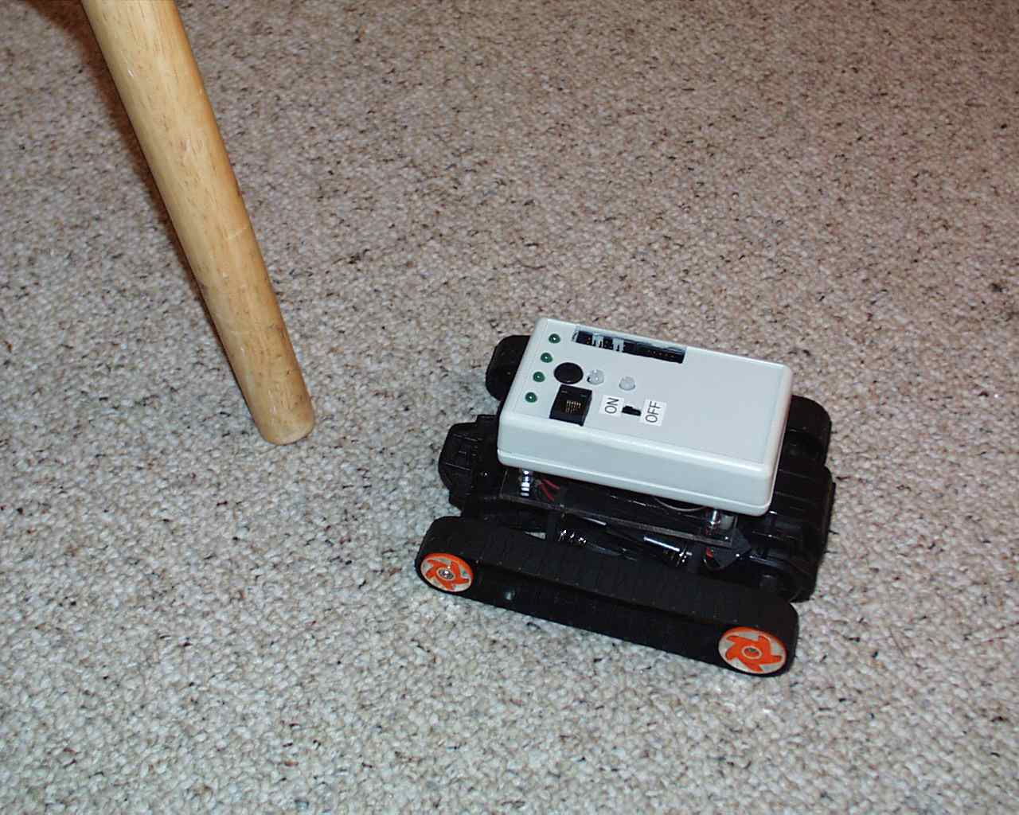
Figure 1: A robot built on a differential drive tracked base approaches a chair leg.
Let’s suppose that you have already chosen a mobile base, removed the factory-installed receiver circuit, and attached a RoCK module. On power-up your RoCK-enabled robot, call it RoCKbot, plays a wake-up tune. At the same time RoCKbot displays a pattern on its LEDs that indicates which of the sixteen possible tasks the robot will execute. You select the Chicken task. Before putting RoCKbot on the floor, command maximum speed by twisting the dial all the way to the left. Once set free, RoCKbot races across the floor toward the wall. At the last second the robot beeps and swerves away. RoCKbot then slams squarely into a narrow chair leg that the infrared (IR) obstacle sensors failed to detect. After about a second of futilely pushing against the chair the robot backs up, spins in place, and then moves forward in a new direction.

Although it tries to avoid you, grab RoCKbot as it speeds by. Press the user button and twist the dial until the LEDs display the pattern for the Roach behavior. In a darkened room place RoCKbot in the middle of the floor. RoCKbot waits patiently. When the room light is switched on, RoCKbot races about the floor, homing on the darkest spot. Safely concealed in the shadows, RoCKbot comes to a halt.

By connecting a serial cable between RoCKbot and your computer, you can display readings from RoCK’s sensors and issue commands to RoCKbot’s motors. By selecting new values for RoCK’s internal parameters and stringing together RoCK’s built-in behaviors you create a new task. Once stored in RoCK’s EEPROM your task can be selected by the dial just like the built-in example tasks.

Comfortable with your understanding of the behavior-based programming scheme RoCK employs, you can dispense with the built-in code. An external programmer and compiler let you replace the code in RoCK’s flash memory with custom code of your own. A built-in connector makes it possible to add new sensors and actuators and control them with the new code. RoCK’s abilities grow as your understanding deepens.

Design Principles
How do we achieve our goals of low cost, ease of use, and sophistication of control in a practical device? We start with a careful definition of a robot and the elements essential to all autonomous robots.

Canonical Robot
A computer program inhabits a virtual world where the rules are certain and unchanging. Not so for a robot. A robot operates in the physical world where noise is present in every measurement, where intended actions have uncertain results, and where the robot must compute a safe response even in situations not anticipated by the programmer. These cruel facts frame the fundamental realities of robot design.

Thus, to function in the real world a robot, like animals and people, must perceive key aspects of its environment. The robot then must move or otherwise act. The robot must connect its perceptions to its actions intelligently. Hence, one attractive definition of a robot is that: A robot is a device that operates in the real world and connects sensing to actuation in an intelligent way.

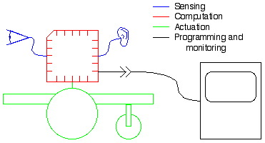
Figure: 2. A robot is a device that connects sensing to action in an intelligent way. Robot builders must be able to program the robot. Builders benefit greatly from access to the robot’s internal state.

This basic definition suggests some components that all robots share. First, a robot must incorporate one or more sensors through which it can perceive the world outside itself. Second, a robot must have a means of locomotion or actuation so that it can interact with the world. And third, a robot must have a computing element to enable complex (and hopefully intelligent) connections between the robot’s sensors and actuators. The more sensors and actuators a robot has the richer its potential interactions with the world.

A useful robotic system must address two practical matters. One, the system has to provide some method to program the robot. And two, the builder needs a way to monitor the robot’s internal state. Viewing the robot’s state, including sensor readings, can help to explain what’s going wrong when the robot behaves in strange and unexpected ways.

Implementation Choices

Behavior-based Programming
In recent years a method know as behavior-based programming has become dominant in mobile robotics. This dominance has come about because behavior-based programs have demonstrated an ability to produce robust responses even when the robot encounters unanticipated situations. Further, behavior-based programs tend to be miserly in their consumption of computational resources.

Utilizing a behavior-based scheme can help RoCK achieve both sophisticated control and low cost as well. Because behavior-based schemes require little processing power, RoCK can function well with only a modest 8-bit microcontroller, thus minimizing the cost of the computation system.

RC Base
Another key means to keeping the cost of our robotic system low is to incorporate the ubiquitous RC car. RC cars, manufactured by the millions, are a great bargain. They provide a mobility base that is rugged, low in cost, and available in a wide variety of types.

Simplify Base Interface
To keep costs low and to make a RoCKbot easy to build we sought ways to simplify the interface between RoCK and its mobile base. In our design a total of only six wires are necessary to connect RoCK to its base. Two wires link RoCK to the RC base’s motor battery and two wires go to each of the base’s two motors. All connections between base and RoCK are implemented using screw terminals, eliminating the need for soldering.

Simplify Electronics
Wherever possible we attempted to reduce the complexity of the electronics package. We chose Atmel’s AVR AT90S8535 microcontroller to support this effort. Built into the 8535 are analog to digital converters (ADCs), a comparitor, and three timer/counters. These systems allowed us to employ on-chip hardware and a bit of programming to implement features that would otherwise require costly external components.

Simplify Host Interface
To monitor the robot’s state and to program the robot, a connection to a host computer is required. In implementing this connection we chose to move the bulk of the interface code to the host computer. After simplifying as much as possible we arrived at a host-initiated serial protocol plus a low-overhead scheme for writing data to EEPROM.

Specifications
RoCK has 12 preprogrammed tasks. Users can program and store up to four additional tasks of their own. RoCK’s piezoelectric beeper can play user-programmed tunes of over 100 notes. Robot trajectories composed of more than 100 path steps can be stored and executed. RoCK has sensors to detect light, obstacles, collisions, and battery voltage. Pressing one button and adjusting a single dial lets you easily configure and control RoCK; connecting RoCK to a host computer lets you monitor and program RoCK. Despite its high level of functionality RoCK remains an inexpensive device.

Base Specifications
Our goal was to ensure that RoCK could work with as many different types of RC bases as possible. However, some bases make better robots than others.

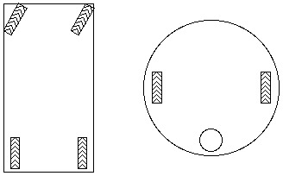
Figure 3. This bottom view shows the two major drive configurations. A typical drive/steer base (left) has two driven wheels pointing in a fixed direction and two passive wheels that can be steered. Differential drive bases (right) have two wheels whose velocities can be independently controlled. Differential drive robots often use a caster wheel for balance.
One common type of RC base uses a drive/steer configuration. Such a base has one motor to move the robot forward or back and a separate motor to point two passive wheels in the desired direction of motion. The difficulty such a base creates becomes apparent anytime the robot wanders near confining obstacles. Lacking the ability to spin in place, a base using the drive/steer configuration can easily become trapped by even sparse arrangement of obstacles.

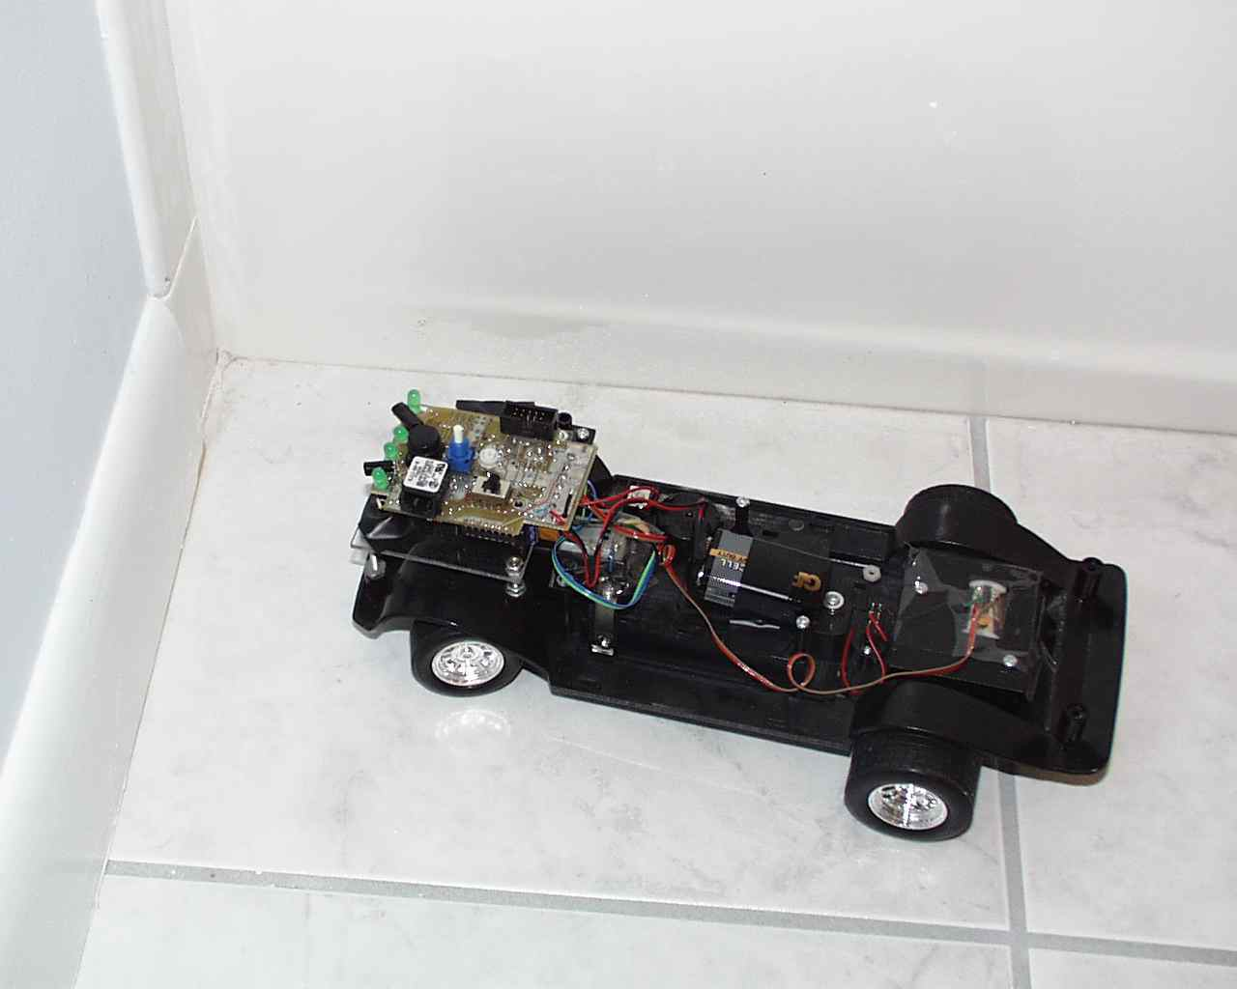
Figure 4. The non-zero turning radius of this drive/steer robot can cause trouble. If the robot comes within a turning radius of an obstacle before sensors detect the obstacle a collision and/or a complex series of back and forth escape motions may be inevitable. (The RoCK circuit board is mounted directly on the RC base in this photo.)

A second type of RC car incorporates differential drive. In this configuration motion is controlled by the differential velocity of wheels on either side of the robot. Tracked RC vehicles use the differential drive configuration almost exclusively. The capacity to spin in place gives the differential drive robot the ability to extricate itself from almost any situation. Significantly, a differential drive robot can use the same simple algorithm to escape from a trap that it used to enter the trap. By contrast the algorithms that allow a drive/steer robot to escape tend to be arbitrary and complex. The differential drive configuration thus makes a much more effective robot.

Very inexpensive RC car uses only a single motor. When this motor spins in one direction the base moves forward, and when the motor spins in the other direction the base turns and backs up at the same time. RoCK was not designed to use RC bases of this type.
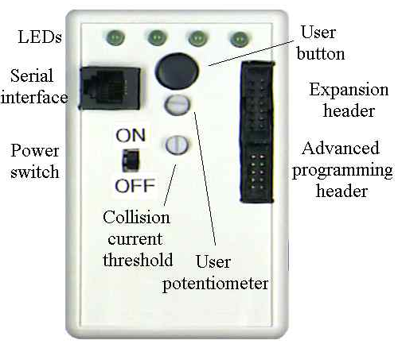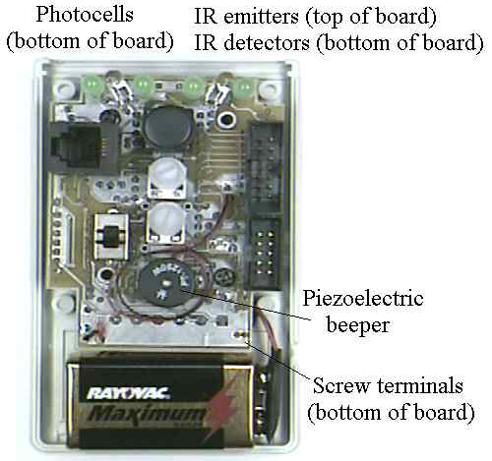
Figure 5. The RoCK circuit board and all sensors are mounted within a small plastic enclosure. The left photo shows RoCK with the enclosure top on, the right photo shows the top removed.

On-board User Interface Specifications
The on-board user interface enables RoCK to operate without being connected to a host computer. A DPDT switch controls both the nine-volt logic supply incorporated into the RoCK module and the motor battery supply attached to the mobility base.

The illumination pattern on RoCK’s four LEDs indicates robot status. During task execution LEDs generally display the state of the left and right obstacle detectors and the status of the collision detector. During task selection, the LED pattern indicates which of the built-in tasks the user has chosen.

The piezoelectric beeper can produce tones of arbitrary frequency, enabling RoCK to play a built-in or user-programmed tune. Additionally, the state of certain sensors can be mapped into the frequency played by the beeper.

The user potentiometer enables the user to experiment with the parameters that control the robot’s behaviors. For example, in a user task the gain parameter in the control loop that enables the robot to follow a bright light can be mapped to the user potentiometer. The user can then adjust the robot’s light-following behavior from sluggish to neurotic.

The user button works in conjunction with the user potentiometer to select the built-in tasks the user wishes to run.

Mechanical Specifications
The RoCK circuit board is mounted in a small plastic enclosure. The enclosure includes a compartment for the 9-volt battery that provides power to the logic. Mounting all sensors directly on the circuit board enhances reliability. The enclosure is open on one end so that the light sensors and IR obstacle detectors have a clear view. On the top surface of the enclosure are four LEDs. Also on this surface are the power switch, the user select button, and the user pot.

The RoCK module includes an RJ12 connector for the serial interface. Multi-pin headers give access to unused microcontroller ports and allow connection of a programmer for the on-chip flash memory.

Sensing and Electrical Specifications
RoCK needs enough sensory inputs to enable a variety of interesting behaviors. We chose the following set.

Figure 6. The block diagram illustrates RoCK’s major subsystems. RoCK’s sensors include light sensors, infrared (IR) obstacle sensors, voltage sensors for the logic and motor batteries, and a motor current-based collision sensor.

Obstacle Detection
RoCK incorporates a dual channel IR obstacle detection system. This system is composed of two series-connected emitters and two independently wired IR receivers. The receivers are sensitive to a 38 kHz modulation frequency. The emitter/detector pairs point diagonally outward from RoCK in such a way as to cover the area in front of the robot. Each receiver detects IR radiation reflected from nearby objects in the direction the detector is pointed, informing the robot of imminent collisions.

Light Sensors
Dual diagonally mounted photocells measure the light level in front of RoCK. The difference between the light measured by the left and right photocells enables RoCK to home on a bright light source or speed to a dark corner.

Battery Monitors
As the robot operates, the logic and motor batteries discharge, this decreases the voltage of each battery. RoCK monitors the voltage of these two batteries allowing the robot to take action if the voltage falls too low.

CPU
RoCKs Atmel AVR AT90S8535 processor contains 8kB of FLASH program storage, 512B of SRAM and 512B of software-programmable EEPROM. The chip uses the “Harvard” architecture with separate memory spaces for data and program storage.

Motor Driver and Collision Detection
RoCK implements a pair of full H-Bridge motor drivers made from discrete NPN and PNP transistors. The H-Bridge provides bidirectional control for the two permanent magnet DC drive motors in the mobility base. Motor drivers are protected from short conditions by a PTC resettable fuse. The fuse also serves as a low-side current sense resistor. Voltage drop across the fuse corresponds to motor current consumption. During a collision with an obstacle, motor torque increases substantially, thus increasing current draw, with a resultant increase in the voltage drop across the fuse. The AVR’s built-in comparitor is used to detect when the motor current draw exceeds the current reference, indicating a collision.

The user may choose to connect RoCK to any of a variety of different sized motors with differing current requirements. To ensure reliable collision detection, RoCK provides the user with the ability to adjust the current trip point. This is accomplished by using a potentiometer to form a user-settable current reference voltage.

Without the over current-based collision detector, the user would be left the complex task of constructing an instrumented bumper for RoCK, a process known to confound even experienced robot builders.

Serial Interface
RoCK uses a novel discrete component half duplex RS-232 level converter to enable serial communication while reducing cost and board space. Given RoCK’s modest communication needs the limitations imposed by half rather than full duplex are inconsequential.

Programming Specifications

Figure 7. This simplified diagram shows the structure of RoCK’s software. The primitive behaviors run constantly. Each uses the present sensor values and a set of parameters to compute an output for the robot’s motors. The Arbiter decides which behavior is permitted to control the motors. The Arbiter does this using a priority list supplied by one of the tasks via the task selector. The task selector also decides how the beeper is controlled. The User Tasks (the tasks programmed by the user) operate in a way identical to the other tasks except that their specifications are stored in EEPROM rather than flash memory. The scheduler runs one behavior after another and keeps the sensor values updated.

In the behavior-based programming scheme used by RoCK all primitive behaviors are considered to be operating in parallel. Each can compute an output for the motors, typically the outputs conflict. An arbitration behavior decides which of the competing behavior wins control. See Figure 7.

LED | Task | Description
0 | Theremin | Differential light striking photocells determines beeper frequency
1 | Dance | The robot moves in a programmed pattern while playing a tune
2 | Wimp | The robot beeps and retreats from anything that comes near
3 | Schizoid | The robot drives around erratically but tries to avoid collisions
4 | Pounce | The robot sits quietly until an object comes near—then crashes into it
5 | Moth | The robot homes in on the brightest light
6 | Mouse | The robot follows the nearest wall
7 | Chicken | The robot moves in a straight line but attempts to avoid collisions
8 | Roach | In a lighted room the robot finds a dark area then stops
9 | Joystick | The user directly control the robot’s motors via the serial interface
10 | User 1 | User programmable task number 1
11 | User 2 | User programmable task number 2
12 | User 3 | User programmable task number 3
13 | User 4 | User programmable task number 4
14 | DiffSel | Helps the user correctly connect a differential drive base
15 | SteerSel | Helps the user correctly connect a drive/steer base
Table 1. These 16 named tasks can be selected using RoCK’s on-board user interface. The left-most column indicates the number displayed in binary by RoCK’s LEDs during task selection.
Choosing a list of behaviors, ordering their priorities, and setting behavior-related parameters specifies a particular robot control program or task. The reusability of these components enables us to store many tasks in the robot. This perhaps unfamiliar control scheme will be further explained in a future article.

Host Computer Interface Specifications
The host interface operates through the serial interface. This gives the user access to the AVR’s static RAM (which includes the processor’s control registers) and read access to EEPROM. EEPROM write access is provided by a small amount of included code.

Next Issue
Now that we’ve seen the big picture of RoCK, we will take a closer look at some of RoCKs internal details in the next article.

The authors plan to offer RoCK for sale. As of this writing, January 2002, development of the commercial version of RoCK is being completed. Please check our website www.wirz.com/rock/ for availability and additional information.

