Hard RoCK: Robot Conversion Kit Circuitry
By Joseph L. Jones and Ben Wirz

RoCK, the Robot Conversion Kit, is a low-cost module that can help you transform an RC car into an autonomous robot. In the previous issue we described RoCK, speaking in general terms about the functions RoCK performs and the top-level choices we made to implement those functions. In this article we focus on RoCK’s electronic hardware, explaining in more detail how we achieve the desired functionality.

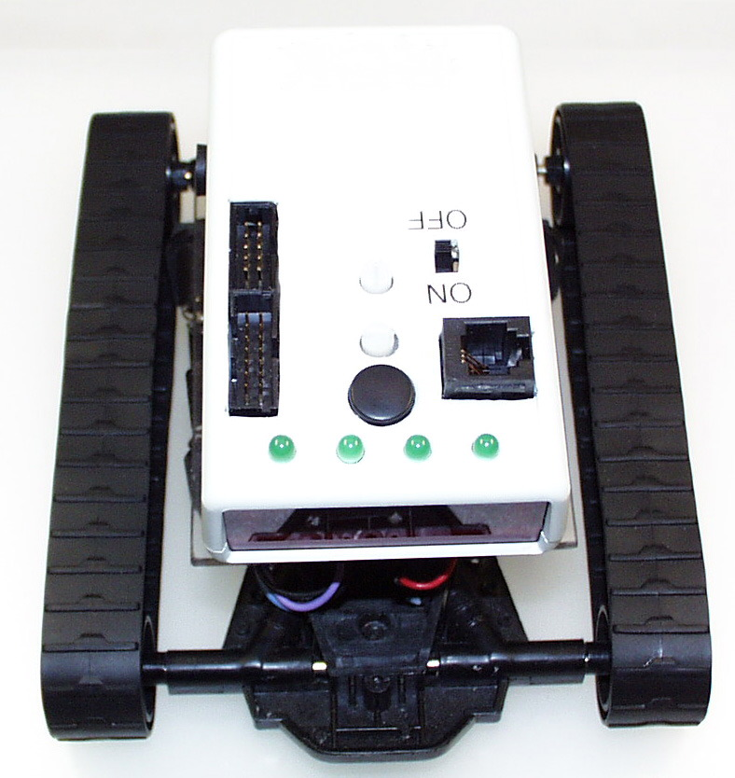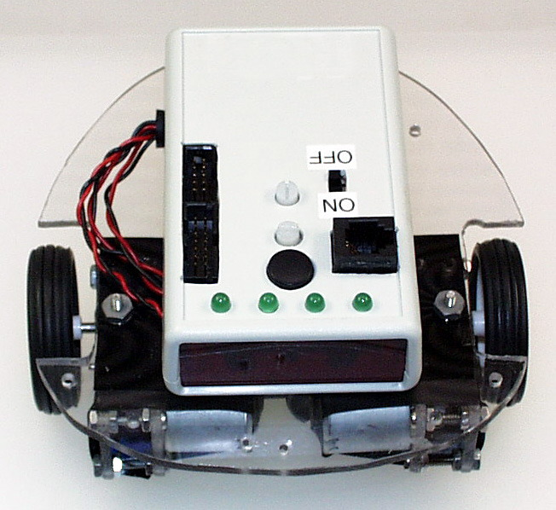
Figure 1. RoCK enables a builder to convert an RC car or other mobility base into an autonomous robot. On the left RoCK implements a robot built on a base borrowed from a tracked RC car. On the right RoCK controls a scratch-built robot. The wheels, gears, and motors were salvaged from an old toy and attached to a simple polycarbonate chassis.

Design Goals and History
We kept the following three goals in mind while designing RoCK’s electrical circuitry.

- Minimize cost and production delays by careful selection of components.
- Maximize “buildability” by simplifying connections between RoCK and the mobility base and by making RoCK tolerant of common wiring mistakes.
- Maximize battery life through careful attention to the power implications of design choices.

During its development RoCK has existed in three major versions. The first version was a proof of concept prototype. We developed this version to gain familiarity with the Atmel AVR processor and to experiment with possible user interfaces.

The second version became our entry into the Circuit Cellar Design Logic 2001 contest. Our entry, shown in Figure 1, was implemented using pin through-hole (PTH) design with components mounted on both sides of the PCB. With an eye toward commercialization we evaluated this design but decided that version two was too complex to be assembled by typical users and too expensive to be assembled professionally.

Electrically similar to the second version, we optimized the third (current) version of RoCK for machine assembly. Version three makes extensive use of surface mount technology (SMT). Only a few PTH components are used and all but two of these components are mounted on the topside of the board. The PTH components can be wave soldered following the SMT step thus eliminating hand soldering and reducing assembly cost.

RoCK Systems Overview
RoCK’s circuitry is designed to support its mission—the creation of a low-cost, high-function, autonomous mobile robot. The diagram in Figure 2 gives a top-level overview of the systems that comprise RoCK.

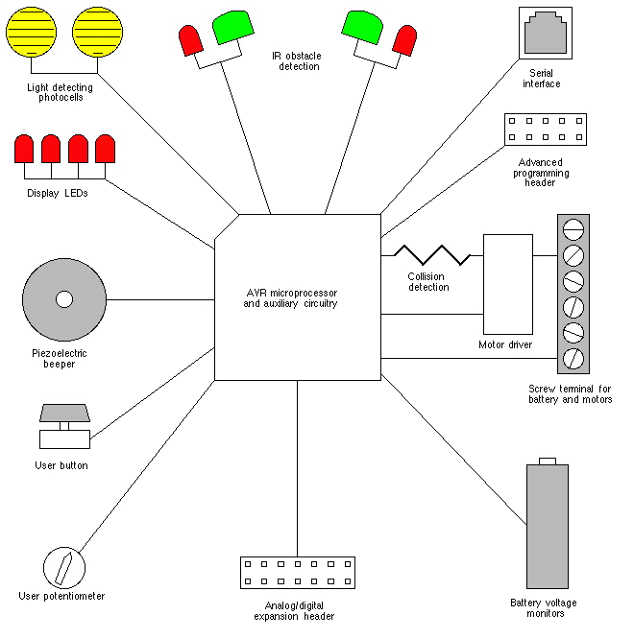
Figure 2. The block diagram illustrates RoCK’s major systems. RoCK’s sensors include light sensors, infrared (IR) obstacle sensors, voltage sensors for the logic and motor batteries, and a motor current-based collision sensor.
Light sensors enable a RoCK-powered robot to follow a light source or to avoid light and seek darkness. The obstacle detector, consisting of two infrared (IR) emitters and two IR detectors makes it possible for RoCK to sense obstacles in order to avoid collision. If a collision does occur, the motor current-based collision detector alerts RoCK so that corrective action can be taken. The motor driver provides sufficient power to operate the sorts of motors commonly found in RC cars. The user button and user potentiometer allow the user to configure RoCK and adjust certain parameters. The battery voltage monitor lets RoCK alert the user when batteries are nearly exhausted. Four LEDs and a piezoelectric beeper give RoCK the ability to inform the user of certain conditions. The serial interface provides a high-level programming channel for RoCK. The advanced programming header implements programming access to the microprocessor’s Flash memory. The expansion header gives the user a way to connect additional sensors and actuators to RoCK.

System |  | Ports/Signals | Description
On-board user interface
 | Power switch | Vcc/Batt+ | DPDT switch enables logic and motor power
 | Display | PC0-3 | Four LEDs display robot status
 | Beeper | PD6 | Interrupt-driven piezoelectric beeper produces tones of arbitrary frequency
 | User potentiometer | PA5 (ADC5) | Parameter adjustment knob
 | User button | PA4 | Momentary contact select switch
 | Serial interface | PD0,1 (RXD,TXD) | RS-232 interactive connection to host computer and high-level user programming facility
Obstacle detection
 | Left IR detector | PD2 | 38 kHz IR receiver
 | Right IR detector | PD3 | 38 kHz IR receiver
 | IR emitters | PD7 (OC2) | Chip automatically generates 38 kHz modulation for two series-connected IR emitters
Light sensors
 | Left photo cell | PA0 (ADC0) | Analog inputs enable detection of light
 | Right photo cell | PA1 (ADC1) | Analog inputs enable detection of light

Collision detection
 | Motor current | PB2 (AIN0) | Analog comparator compares set point with motor current to detect collision
 | Current set | PB3 (AIN1)

Battery monitors
 | Motor power | PA2 (ADC2) | Monitor for motor supply battery voltage
 | Logic power | PA3 (ACD3) | Monitor for logic supply battery voltage

Motor output
 | Motor PWM | PD4,5 (OC1B,A) | Chip automatically generates PWM for dual channel motor driver
 | Motor direction | PB0,1
Auxiliary IO
 | User digital | PC0-7 | Eight digital IO lines available to user
 | User analog | PA6,7 (ADC6,7) | Two analog channels available to user
Advanced programming
 | Programming header | PB5-7 (MOSI, MISO, SCK) | Enables user to program Flash memory
Table 1. RoCK’s major systems are implemented using on-chip hardware as summarized in the table. Labels in the Ports/Signals column follow Atmel’s convention.

Details of our implementation are given in Table 1. Every IO pin available on the microprocessor is assigned to a built-in sensor or is brought out to a header for user access.
Figure 3. CPU circuit

CPU
Key to RoCK’s high functionality is its CPU—an Atmel AVR AT90S8535 microcontroller. The AVR integrates many useful functions into one low power, low pin-count chip. RoCK takes advantage of almost all the features that the AVR provides.

Several channels of the AVR’s analog to digital converter (ADC) are used to monitor the light sensors, user input, and battery voltage. The AVR’s comparitor detects drive motor over-current. Timers built into the chip control the pulse width modulation (PWM) of the motors, generate the tones sent to the beeper, and produce the 38 kHz carrier signal needed by the IR obstacle detection system. Serial IO built into the AVR is used to connect RoCK to a host computer for high-level programming and monitoring. Digital IO lines drive the LEDs and detect presses of the user button. The AVR is a busy chip.

The AT90S8535 has 8kB of Flash program storage, 512B of SRAM, and 512B of software programmable EEPROM. The built-in tasks supplied with RoCK are stored in Flash memory; high-level programs created by users are saved in EEPROM. The AVR provides internally all the circuitry needed to store data to the on-chip EEPROM. To enable users to delete the built-in tasks and reprogram the Flash memory, an industry standard 2×5 IDC in-circuit programming header is provided.

The CPU obtains its clock signal from an external 8.00 MHz ceramic resonator. The resonator, chosen for its mechanical ruggedness and compact size, requires no external capacitors or resistors.

Figure 4. On board user interface circuit

On-Board Use Interface
A DPDT switch controls power to RoCK. The switch enables both the 9V logic supply battery inside RoCK’s case and the motor battery associated with the user-supplied mobility base.

Four IO lines configured as outputs connect to RoCK’s LED display. The LEDs are used to indicate robot status. The LED enable line () makes it possible to multiplex the lines that drive the LEDs.

The beeper connects to the AVR’s PD6 line. An interrupt service routine (ISR) associated with Timer/Counter 0 is used to toggle PD6 to produce a square wave for the beeper. The time between interrupts corresponds to the half-period, , of the desired beeper frequency. RoCK configures Timer/Counter 0 for 8 microsecond ticks. Thus, is related to frequency, , by , or .

Timer/Counter 0’s 8-bit register can store a number in the range of 0 to 255. Therefore, the lowest frequency the beeper can produce is = 62,500/255 = 245 Hz and the highest frequency (where equals 1) is 62.5 kHz.

RoCK restricts the set of tones that it actually produces to those approximating the “well-tempered” scale. That is, for a tone of a given base frequency, , the nth tone of a scale, , is given by . RoCK uses 532 Hz for . Given that only integer values of half-periods can be stored, the chosen base frequency produces a scale whose tones closely match a well-tempered scale.

Externally driven piezoelectric beepers are typically rated for a drive voltage of greater than +/- 10V. The sound volume of such a beeper driven directly from a 5V TTL output is substantially less than the volume produced when the full driving voltage is applied. Gear noise from a mobile robot base can easily make the sound from a piezoelectric beeper driven by this method inaudible. To combat this problem, RoCK uses a pseudo H-Bridge driver to create a 14Vpp swing. This is accomplished by adding a single external transistor and two resistors.

The microcontroller's output stage can be driven to ground or +5V, see figure 4. In order to create a negative voltage swing, an H-Bridge driver is required which is capable of reversing the beeper’s terminal voltage. With microcontroller output driven low, Q5 is off and current flows through R12 into the microcontroller's pin. Thus, the beeper’s lower terminal is at a voltage of 0V and the upper terminal is at approximately +9V. With the output driven high, Q5 is turned on. Current flows out of the microcontroller pin through Q5 to ground. The beeper now sees +5V at its lower pin and close to 0V at its upper terminal. This creates a beeper excitation voltage of approximately +9V to -5V representing an increase in magnitude of nearly a 300% over direct TTL drive.

To select a built-in or user-programmed task, the user presses the user button and adjusts the user pot. The user pot is connected to ADC channel five, and the user button to digital IO pin PA4. Both lines are part of the AVR’s port A. Port A lines can be individually configured for either digital or analog operation.

Figure 5. Discrete RS-232 transceiver circuit and signal diagram

RoCK implements a novel half-duplex RS-232 level converter to enable serial communication while reducing cost and board space. Given RoCK’s modest communication needs, the limitations imposed by half rather than full duplex are inconsequential.

It is a challenge to generate the negative TX voltage required by the RS232C specification without an expensive charge pump IC such as the venerable Maxim MAX232. RoCK solves the problem by looping back the TX voltage from the host computer’s serial line. The host’s TX voltage is negative in its marking (inactive) state. In order for this method to work, the host must not transmit at the same time as RoCK transmits and the host must ignore the commands it sends which are echoed back to it by the resistor R2. This scheme produces the half duplex requirement. See the signal diagram in Figure 5 for more detail.

A serial speed of 9,600 bps was chosen for RoCK's serial link. The baud rate (BAUD in units of bits per second) is set by the UBRR register. The serial speed is given by the formula:
, where is the clock frequency.
The ceramic resonator is specified at 8.00 MHz +/- 0.5% at 25 degrees C. The resonator has a temperature stability of +/- 0.3% over its range of operation and a 10-year aging spec of +/- 0.3%. In the worst case with parameters at their least favorable extremes, the resonator frequency is 8.00 MHz +/- 1.1%, or 7.912 to 8.088 MHz.

Using a UBR register setting of 51 the maximum and minimum baud are given respectively by:

This is equivalent to a speed of 9,600 bps +1.3/-0.9 %, absolute worst case. These error rates are acceptable for reliable asynchronous serial operation.

Figure 6. Power supply and reset circuits

Power Supply and Reset
The original PTH version of RoCK utilized the common and inexpensive 7805 linear 5V regulator in a TO-92 package. A 9V battery was chosen to power the logic supply. The conversion to surface mount components in latest version of RoCK prompted us to survey modern SMT linear regulators. Modern linear regulators are available with dropout voltages lower than that of the 7805. Low dropout voltages are important because they translate directly into increased 9V battery life. Most low dropout regulators are more expensive than the 7805; often they require costly and sometimes scarce low ESR tantalum output capacitors. During our search we discovered the National Semiconductor LM2931AM-5.0. The LM2931 is a low dropout regulator that requires only a standard electrolytic capacitor for output filtering. In addition, the LM2931 offers a quiescent current lower than the 7805, is available in SO8 SMT package, and costs only about $0.35 in quantity.

RoCK provides a 5V power supply monitor that puts the microcontroller into reset when the 5V supply dips below an acceptable level. The reset circuit helps prevent erroneous operation of the microcontroller during low battery conditions.

Figure 7. IR detector, IR Emitter, and light sensing circuits

Light Sensors
RoCK uses cadmium sulfide (CdS) photo-resistive elements, photocells, to detect light. Among opto-electronic devices, photocells are relatively slow to respond to changes in illumination. Rise times for CdS cells can exceed 35 mS. However, the fact that photocells are slow to respond electrically to changes in illumination is of no consequence given that the robot is even slower to respond physically to changes in commanded velocity. The robot responds slowly because of physical limitations imposed by mass, motor torque, and so on.

Photocells are two terminal devices that change their resistance in response to light—more light means lower resistance. Each of RoCK’s two photocells is connected in a resistive voltage divider such that increasing illumination causes increasing voltage on the signal line. The photocells are mounted at the front of RoCK’s circuit board; one is angled to the left and the other to the right. Thus, the differential signal between the left and right photocells can be used to guide RoCK toward or away from light.

Obstacle Detection
RoCK’s obstacle detection system is composed of two IR emitters connected in series and two IR receiver units connected independently. Because current requirements are low, the emitters are driven directly by AVR line PD7 (OC2). The active low signals from the left and right IR receivers are connected to lines PD2 and PD3 respectively.

The emitters shine IR radiation diagonally outward from the robot toward the left and right. If an obstacle is present, some of the radiation is reflected back into one or both receivers. An active signal from a receiver indicates that an obstacle is present on the same side of the robot as the receiver. Active signals from both detectors suggest that an obstacle lies directly ahead.

The IR receivers are the same as those used for detecting remote control signals for TVs and other consumer electronics devices. The detectors have a built-in lens, photo diode, automatic gain control amplifier, band-pass filter, and demodulator. To function properly, the IR receivers must see an infrared signal with a 38 kHz carrier modulated at around 1 kHz. AVR Timer/Counter 2 is used to generate the 38 kHz carrier signal automatically. Timer/Counter 2 is configured to count up to a number corresponding to a half period of the desired 38 kHz frequency. When the counter matches this number line PD7 toggles and the counter resets. Code in RoCK’s main software loop superimposes the 1 kHz modulation on the 38 kHz carrier signal by alternately activating and deactivating the connection between Timer/Counter 2 and line PD7. The connection is switched approximately every 500 microseconds.

Figure 8. Collision detection and over-current protection circuits

Motor Driver and Collision Detection
RoCK’s motor driver has been one of the more difficult design challenges presented by the project. After some experimentation, we settled on the following specifications.

- Dual channel with a maximum continuous current of 500 mA per channel
- Input voltage range of 3–15 VDC
- Minimal quiescent current consumption
- Total cost less than $1.50 in thousand quantity
- Capable of being interfaced to the AVR’s internal PWM generation hardware
- Provide bump sensing and over current protection

A motor-driver IC favored by hobby robot experimenters is the Unitrode/STMicroelectronics L293D. The L293D is appealing because it can be configured as a dual H-Bridge driver, comes in a DIP16 package, and is available for less than $1.50. Also, the L293D requires minimal external parts. The first two versions of RoCK utilized this chip. The main shortcoming of the L293D is quiescent current. In the worst case quiescent current draw is 60 mA for the logic supply and 24 mA for the motor battery supply. The L293D alone would discharge a standard 9V alkaline battery in few hours; we deemed this unacceptable. The L293D also failed to meet our minimum motor battery voltage requirement. With the L293D ruled out, we searched for other IC’s that might better fit the requirements for the commercial version of RoCK. The Vishay Siliconix Si9986 came closest, matching all of our requirements except cost—over $4.00 for a pair.

Frustrated by the lack of an appropriate chip we decided to design a motor driver made of discrete transistors. We determined that a bipolar transistor design would be adequate for our low current requirements. A bipolar-based design would also be less expensive and avoid other complications of a MOSFET design. Details of the discrete bipolar motor driver we settled on and the process we followed to design it will be presented in a future article.

The motor driver in all versions of RoCK is protected from excessive current draw by a 1.25A positive temperature coefficient (PTC) resettlable fuse. The fuse is over-sized to prevent nuisance trips. The fuse protects the motor driver from two of three possible fault conditions. A fault condition opens the fuse only if the fault current flows through the fuse. This condition occurs when the motor leads are shorted together or when one of the leads is shorted to the battery positive rail while that lead is being driven low. The fuse will not open if one of the motor leads is shorted to the battery ground while it is driven high, because, in this case the fault current does not flow through the fuse. A shorted motor lead is the most common fault condition. The chosen design provides a reasonable level of protection against user faults without excessive complexity.

Total motor current is monitored in order to detect collisions. When the robot collides with an obstacle, the motors produce increased torque. This results in increased current draw in response to the additional load created by the robot pushing against the obstacle. By monitoring the total motor current draw RoCK is able to detect collisions with obstacles. Current draw is determined by measuring the voltage drop across the resettable PTC fuse—the larger the current drawn by the motor, the higher the voltage drop across the PTC. The initial resistance of the PTC is specified to be 0.07 to 0.25 Ohms depending on whether the fuse has been previously tripped or not.

The user can connect RoCK to a variety of different sized motors with varying current requirements. Thus, to ensure reliable collision detection, RoCK must provide the user with the ability to adjust the current trip point. This is accomplished by using a potentiometer voltage divider to form a user-settable current trip point reference voltage. The reference voltage is connected to the negative AVR comparator input, and the voltage drop across the PTC is connected to the positive comparator input. When the current exceeds the user set point, the processor detects a collision. (Software filters out momentary over-current conditions.) Diode D11 limits the voltage present at the AVR’s input to a value no greater than a pair of diode forward voltage drops. This design protects the AVR from the higher-than-logic-level motor voltage that could damage the AVR. Resistor R42 and capacitor C12 help filter out spurious current spikes.

Battery Monitors
Each of the logic and motor batteries are connected in a voltage divider network. The center tap of the voltage dividers connects to lines PA2 (ACD2) and PA3 (ACD3). Code in RoCK’s main loop polls the ADC and stores the battery voltages for other code to examine.

Auxiliary IO
Expansion ability is provided to the user via the Auxiliary IO header. Eight digital IO lines (PC0 through PC7) and two lines that can be configured as digital IO or analog inputs (PA6 and PA7) are present on this header. Lines PC0 through PC3 are shared with the LEDs.

Advanced Programming Header
The Advanced Programming Header enables the experienced user to program RoCK’s Flash memory. Lines PB5, PB6, and PB6 plus are provided on the header for this purpose.

Next Issue
We’ve now seen many of the gritty details of the RoCK’s electronics. In the next issue we will delve into what is perhaps RoCK’s most distinguishing feature—its behavior-based programming scheme.

The authors plan to offer RoCK for sale. As of this writing, January 2002, development of the commercial version of RoCK is being completed. Please check our website www.wirz.com/rock/ for availability and additional information.

