VGA Interface Module

Specifications:

Monitor Mode | Standard VGA
Frequency | 25.175 MHz
Frame rate | 60 Hz
Resolution | 640 x 480
Color depth | 256 color
Interface | 8 Bits data, RS, Enable, Busy\

Module Pinout

Pin no. | Function
1 | GND
2 | VCC (+5V)
3 | E
4 | RS
5 | Busy\
6 | D0
7 | D1
8 | D2
9 | D3
10 | D4
11 | D5
12 | D6
13 | D7
14 | GND

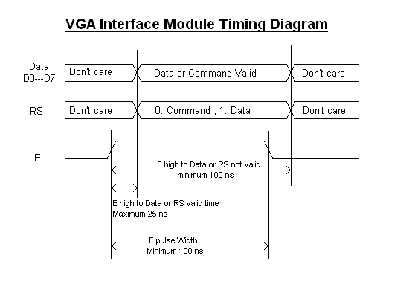

Data, RS and E inputs:
These pins are used for the communication between the module and the host system. They are all compatible to TTL and CMOS signals (5V and 3.3V).
Eight data pins are used to load a single byte to the module controller at a time.
A register select input (RS) is used to differentiate between command and data, when RS is 0 a command is expected, and when RS is 1 a data byte is expected.
An Enable pulse (E) moves data from input buffer to the module controller.

Busy output:
The busy output from the module is an indication for the host system that the module is ready to accept a new command or data.
The busy output is an open drain signal (0: busy, open: ready).
This output should be tied to a pull up resistor of 3.3 Kohm or more to 5V or 3.3V.
No data or command should be transferred when Busy is zero.

Command | Command code | data
CLS | 00H | No data
Fill screen | 01H | Color code
Put Pixel | 10H | XL, XH, YL, YH, Color code
Draw line | 11H | X1L,X1H,Y1L,Y1H, X2L,X2H,Y2L,Y2H,Color code
Draw rectangle | 12H | XL, XH, YL, YH, LenL, LenH ,HeightL ,HeightH ,Color code
Draw filled rectangle | 13H | XL ,XH ,YL ,YH ,LL ,LH ,HL ,HH ,Edge color, fill color
Draw segment(data) | 14H | XL ,XH ,YL ,YH ,Height
Load data | 15H | 0,0,0,0,0,Dat1,Dat2,Dat3,………..,Dat250
Copy and Paste | 16H | SXL, SXH, SYL, SYH, length, height, DXL, DXH, DYL, DYH
Put Character | 20H | Character ASCII code
Character Cursor Position | 21H | XL,XH,YL,YH
Character Mode | 22H | Character Mode code
Set Forecolor | 23H | Color code
Set Backcolor | 24H | Color code
Set text area | 25H | XL,XH,YL,YH, LenL, LenH ,HeightL ,HeightH
Mouse Cursor Position | 30H | XL,XH,YL,YH
Show Mouse | 31H | No data
Hide Mouse | 32H | No data

Character Mode codes:

Small font, opaque | 00H
Medium font, opaque | 01H
Large font, opaque | 02H
Very large font, opaque | 03H
Small font, transparent | 04H
Medium font, transparent | 05H
Large font, transparent | 06H
Very large font, transparent | 07H

