ABSTRACT:

The “Tesla coil” has been around since the late 1800’s, and has been the subject of thousands of student science projects and can be considered one of the standards for entrance into the world of high voltage systems for the electrical hobbyist. They’ve been built as small as a quarter, and taller than a house. In just the last few years, the focus for Tesla “coilers” has changed from the old standard spark-gap and mechanical rotary-gap driven coils to new solid-state designs that allow microprocessor control over spark frequencies and duty cycle. This project is an Atmel Atmega16 based controller that will drive a solid-state Tesla coil power supply at frequencies defined by the MIDI standard for digital musical devices.

This project was originally conceived from a brain-storming session on an internet forum late last year, and the first version was completed in April 2006 using a Motorola MC68HC11E2 as the main processor. Version 2 (this project) is a re-design using an Atmel Atmega16 as the main processor, and a few user interface enhancements such as a PC keyboard for input, and an Optrex 20x4 LCD display.

The Atmel processor and its programming tools and interfaces were new to me, and I’m sure I could not have completed this project in time to enter this contest if it were not for the help I received from others on the Internet forums and sample code and sample parts provided by Atmel and others to learn from.

BLOCK DIAGRAM:

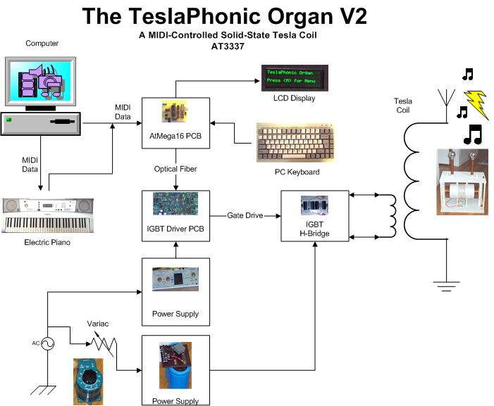
PROJECT PHOTOS:

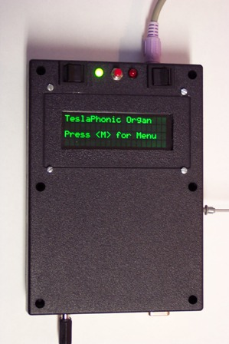 | Shown on the left is the top view of the controller. Switches for power, RS232/MIDI, and RESET along with indicator LEDs are located at the top of the box. The keyboard connector is on top, the Optical fiber output is on the right side, and the connectors for power in, MIDI in and RS232 in/out are located at the bottom of the box.  Shown below is the internal layout of the PCB, LCD, and switches, connectors, etc. The main PCB was constructed using wire-wrap sockets and also uses wire-wrap headers for resistors, diodes, and capacitors.  It was not easy fitting all those parts inside that small box!

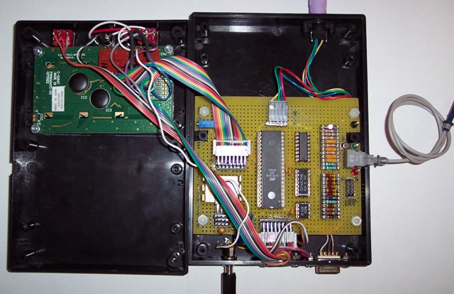
SCHEMATIC DIAGRAM:

Shown below is the controler schematic. The ribbon cable connectors used on the PCB are not shown.

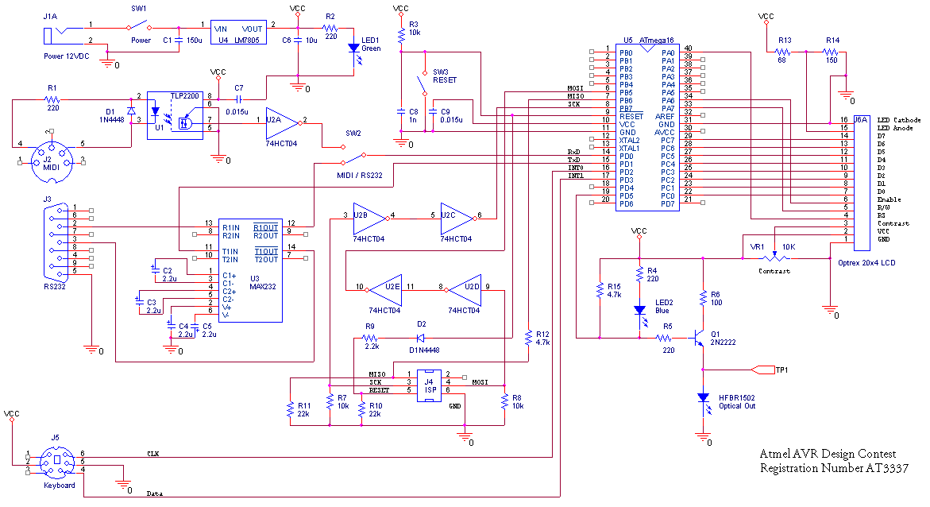

The 74HCT04 is used on the ISP lines so that an Atmel Butterfly board operating from a battery at 3 VDC can be used to program the ATmega16 powered at 5 VDC using a program known as “ButtLoad” available from links on the project pages at http://www.avrfreaks.net/.

CODE SAMPLE:

The source code for this project is a combination of standard library routines available with Atmel’s AVR Studio 4, some code ported from Atmel white papers and application notes (i.e. AVR313 Interfacing PC AT Keyboard), and translation of my Motorola MC68HC11 assembly code (from the earlier version of this project) to AVR code. Shown below is a function that determines how to decode the MIDI data stream.

void MIDIStartFast()
{
unsigned char MIDIData;
char MIDI_out[3];
int MIDINoteNumber;
int MIDINoteVelocity;
int MIDIState;
setbaud(BAUD31250);
pwmInit();
InitDisplay();
DisplayChar_P(MT_OFF_MENU_P);
DisplayChar_P(MT_COUNT2_P);
DisplayChar_P(MT_COUNT_P);
PWM1change();
TCCR1A = 0;
MIDI_out[2] = 0;
InitDisplay();
DisplayChar_P(PSTR("Ready for MIDI Data "));
DisplayChar_P(MT_BLANK_LINE_P);
DisplayChar_P(MT_MIDI_NOTE_P);
DisplayChar_P(MT_MIDI_EXIT_P);
LCDInstruction(LCD_CURSOR_OFF);
MIDIState = 0;
while(1)
{
if (UCSRA & (1<<RXC))
{
MIDIData = UDR;
switch (MIDIData)
{
case 0xfe :
break;
case 0xf8 :
break;
case 0x90 :
{MIDIState = 1;
break;}
case 0x80 :
{MIDIState = 3;
break;
default :
{switch (MIDIState)
{
case 1 :
{MIDINoteNumber = MIDIData;
MIDIState = 2;
break;}
case 2 :
{if (MIDIData == 0)
TCCR1A = 0;
else
{
setICR1_P(MIDINoteNumber);
TCCR1A = (1<<COM1A1)|(1<<WGM11);
LCDInstruction(LCD_CURSOR_SHIFT_L);
LCDInstruction(LCD_CURSOR_SHIFT_L);
itoa(MIDINoteNumber,MIDI_out,16);
DisplayChar(MIDI_out[0]);
DisplayChar(MIDI_out[1]);
}
MIDINoteVelocity = MIDIData;
MIDIState = 1;
break; }
case 3 :
{TCCR1A = 0;
break;}
}
}
}
}
}
}
}

