PROJECT DESCRIPTION:

The “Tesla coil” has been around since the late 1800’s, and has been the subject of thousands of student science projects and can be considered one of the standards for entrance into the world of high voltage systems for the electrical hobbyist. They’ve been built as small as a quarter, and taller than a house. In just the last few years, the focus for Tesla “coilers” has changed from the old standard spark-gap and mechanical rotary-gap driven coils to new solid-state designs that allow microprocessor control over spark frequencies and duty cycle. This project is an Atmel Atmega16 based controller that will drive a solid-state Tesla coil power supply at frequencies defined by the MIDI standard for digital musical devices.

This project was originally conceived from a brain-storming session on an internet forum http://thegeekgroup.org late last year, and the first version was completed in April 2006 using a Motorola MC68HC11E2 as the main processor. Version 2 (this project) is a re-design using an Atmel Atmega16 as the main processor, and a few user interface enhancements such as a PC keyboard for input, and an Optrex 20x4 LCD display.

The Atmel processor and its programming tools and interfaces were new to me, and I’m sure I could not have completed this project in time to enter this contest if it were not for the help I received from others on the Internet forums and sample code and sample parts provided by Atmel and others to learn from.

SYSTEM BLOCK DIAGRAM:

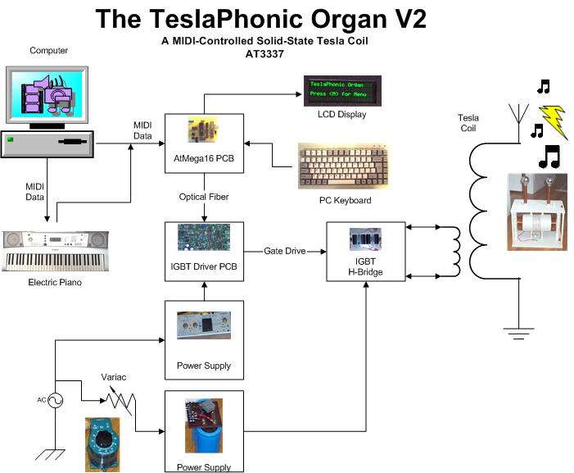
SYSTEM REQUIREMENTS:

The TeslaPhonic Organ requirements were as follows:

- Input from digital piano or PC via {song}.mid file
- Translation of MIDI data into square wave frequency pulses
- User configurable frequency pulse width and/or duty cycle
- LCD user display of configuration and menu items
- RS232 input/output for bootloading and/or control
- Optical fiber output to existing IGBT driver PCB
- Keyboard / keypad user input for configuration
- Complete by August 16, 2006 !

Additional useful features (not yet implemented in version 2):

- Polyphonics
  - Multi-note on single channel
  - Multi-channel
- MIDI music file download / storage / playback
- Tesla Coil setup and tuning pulses
- Data acquisition of coil operation parameters:
  - Coil resonant frequencies
  - Voltages / Currents / Power usage
  - IGBT and driver IC temperatures
  - Fault conditions of driver circuit
- Emergency stop (fault) control of main power

Other design objectives:

- Learn some AVR assembly code
- Learn Atmel and third-party hardware/software tools
- Make the system portable for demonstrations and/or future design courses
(I teach part-time at a local community college)
- Make the controller flexible / expandable for future projects
- Have fun doing it…..
- Sell it to a big-time rock group and make a zillion dollars…..

Now back to reality.
  - PROJECT PHOTOS:

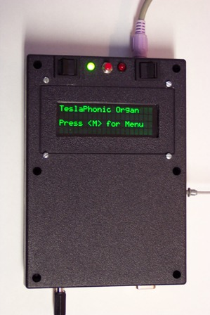 | Shown on the left is the top view of the controller. Switches for power, RS232/MIDI, and RESET along with indicator LEDs are located at the top of the box. The keyboard connector is on top, the Optical fiber output is on the right side, and the connectors for power in, MIDI in and RS232 in/out are located at the bottom of the box.  Shown below is the internal layout of the PCB, LCD, and switches, connectors, etc. The main PCB was constructed using wire-wrap sockets and also uses wire-wrap headers for resistors, diodes, and capacitors.  It was not easy fitting all those parts inside that small box!

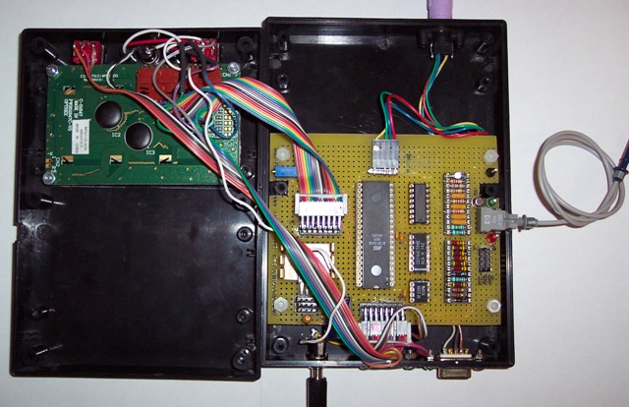

Maybe version 3 will have a professional PCB layout. Someone once said, “So many projects……So little time.” I agree completely.
SCHEMATIC DIAGRAM:

Shown below is the controller schematic. The ribbon cable connectors used on the PCB are not shown.

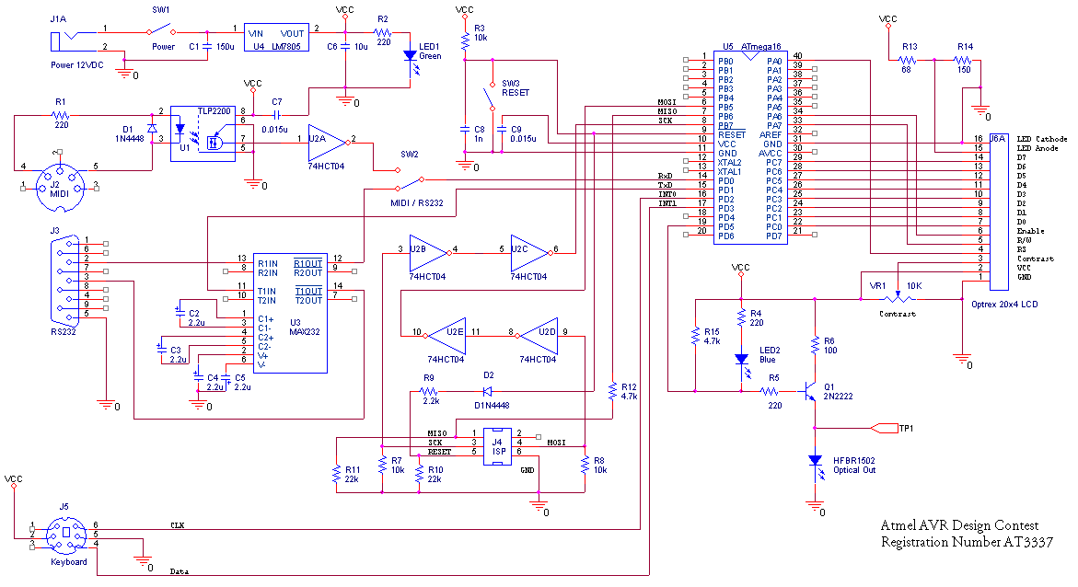

I’m not going to discuss construction of the Tesla coil, the driver PCB and IGBT circuits since most of this information is already public domain and available on the internet. For those interested, plenty of information can be found at http://www.pupman.com or from doing a quick Google search.

I didn’t need this controller to have battery power, so I opted for an external 12V AC adaptor and a simple LM7805 regulator for the controller power supply circuit. I added an LED to the box for power indication. The reset line to the micro is controlled three ways. The first is due to power-on, and the timing is controlled by a pull-up resistor and capacitor to ground. The second is a physical switch to ground located on the front of the box. The third is from a signal from the ISP interface from an external firmware programmer. I added a protection diode and resistor divider to the ISP interface to help prevent the micro from releasing its magic smoke.

The MIDI interface is also well known in the public domain. I used an optical coupler I had in my box of I-may-use-this-some-day parts, and added an inverter to correct the output polarity. An additional switch is installed on the box for user selection between MIDI and RS232 data. A MAX232 circuit was added to the board for serial input and output although the current code doesn’t use it for anything yet. In the future it may be used for control, and/or software bootloading, file transfer, etc.

The 74HCT04 is used on the ISP lines so that an Atmel Butterfly board operating from a battery at 3 VDC can be used to program the ATmega16 powered at 5 VDC using a program known as “ButtLoad” available from links on the project pages at http://www.avrfreaks.net/ (once again to avoid the magic smoke).

I looked at several keypads I already had, but determined that a PC keyboard was the easiest to connect and decode since Atmel had already published the code to do this in an application note. All I had to do was find a connector. A quick search through a stack of old computers revealed the perfect match.

The fiber optic transmitter used was chosen for its compatibility with the other various circuit boards I had already made for version 1 of the project. An NPN (the good old 2n2222 that’s been around forever) was used to drive the transmitter reliably through a 25 foot fiber optic cable.

The Optrex LCD was chosen because it had lots of characters (20 x 4 lines) for user data, and not too expensive. The PDSP2110 I had been using for all my projects up to this point is a nice display, but you can’t fit much information in 8 characters without scrolling. The LCD interface uses PORTC for data and PORTA for control signals.

SOFTWARE:

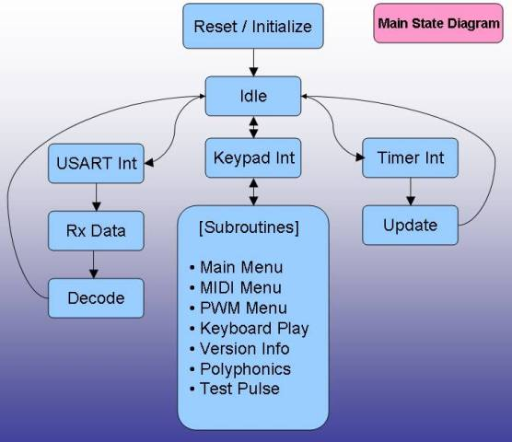

The main software states are shown in the diagram above. The first operation after power-on or reset is to initialize variables, the LCD display, the USART, and the timer interrupts. The controller then waits for user input via the keyboard to enter one of the other subroutines listed. If the timers are on and an interrupt occurs, the interrupt service routine will update the timer values and return. If MIDI input is active and new data is received, then that data is decoded and timer values updated to use for the next timer interrupt. There are some diagnostic related subroutines to manually set the timer frequency and PWM duty cycle included in the package. There is also a polyphonic subroutine that I have been experimenting with that uses time-slicing to output the 3 frequencies in a C-major chord.

MIDI DECODING:

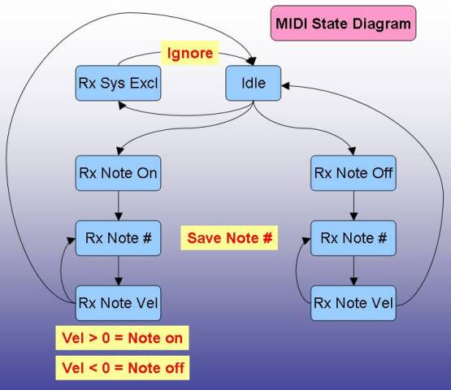

The MIDI decoding subroutine state diagram is shown above. There are big differences in how each instrument manufacturer implements the MIDI “standard”, so my code is optimized for use with the Yamaha keyboard I had on hand.

CODE SAMPLE:

The source code for this project is a combination of standard library routines available with Atmel’s AVR Studio 4, some code ported from Atmel white papers and application notes (i.e. AVR313 Interfacing PC AT Keyboard), and translation of my Motorola MC68HC11 assembly code (from the earlier version of this project) to AVR code. Shown below is a function that determines how to decode the MIDI data stream.

void MIDIStartFast()
{
unsigned char MIDIData;
char MIDI_out[3];
int MIDINoteNumber;
int MIDINoteVelocity;
int MIDIState;
setbaud(BAUD31250);
pwmInit();
InitDisplay();
DisplayChar_P(MT_OFF_MENU_P);
DisplayChar_P(MT_COUNT2_P);
DisplayChar_P(MT_COUNT_P);
PWM1change();
TCCR1A = 0;
MIDI_out[2] = 0;
InitDisplay();
DisplayChar_P(PSTR("Ready for MIDI Data "));
DisplayChar_P(MT_BLANK_LINE_P);
DisplayChar_P(MT_MIDI_NOTE_P);
DisplayChar_P(MT_MIDI_EXIT_P);
LCDInstruction(LCD_CURSOR_OFF);
MIDIState = 0;
while(1)
{
if (UCSRA & (1<<RXC))
{
MIDIData = UDR;
switch (MIDIData)
{
case 0xfe :
break;
case 0xf8 :
break;
case 0x90 :
{MIDIState = 1;
break;}
case 0x80 :
{MIDIState = 3;
break;
default :
{switch (MIDIState)
{
case 1 :
{MIDINoteNumber = MIDIData;
MIDIState = 2;
break;}
case 2 :
{if (MIDIData == 0)
TCCR1A = 0;
else
{
setICR1_P(MIDINoteNumber);
TCCR1A = (1<<COM1A1)|(1<<WGM11);
LCDInstruction(LCD_CURSOR_SHIFT_L);
LCDInstruction(LCD_CURSOR_SHIFT_L);
itoa(MIDINoteNumber,MIDI_out,16);
DisplayChar(MIDI_out[0]);
DisplayChar(MIDI_out[1]);
}
MIDINoteVelocity = MIDIData;
MIDIState = 1;
break; }
case 3 :
{TCCR1A = 0;
break;}
}
}
}
}
}
}
}

There are two MIDI subroutines in the full source code. One will update the LCD screen with MIDI note and velocity data, but is too slow to handle a fast stream of data (like running your finger up and down the keyboard). The fast routine only shows the current note played, and sometimes is too fast for the LCD to update. When the higher notes are being played, the timer is interrupting so much that any LCD updating is pointless.

FILES:

The files included in this project are listed below:

- Abstract.doc - Project Abstract
- Complete.doc - This file
- The ATmega16MIDI folder for use with Atmel AVR Studio containing:
  - ATmega16MIDI.c - Main code
  - ATmega16MIDI.h - Main header
  - kb.c - Keyboard routies
  - kb.h - Keyboard header
  - midilookuptable.h - MIDI lookup table (16-bit timer value array)
  - scancodes.h - Keyboard lookup table
  - OptrexLCD20x4.h - LCD specific data
  - pwm.c - Timer routines
  - serial.c - USART routines

SUMMARY:

The main objectives for version 2 have been successfully achieved. Now on to version 3 and pursuit of the zillion dollars. Thank you for your time in reviewing my TeslaPhonic Organ project.

