MegaLoad

History
MegaLoad is a Windows based boot loader for all Atmel ATMega microcontrollers that support the Bootloader function. MegaLoad is a solution for everybody who wants fast loading (~8k in 3 seconds) and easy software upgrade via MCU RS232 port.

Features
Now support device larger than 128k flash
Small Bootloader code. Only 256 words if only flash program is need (512 word if flash & EEPROM)
Auto baud configuration allowing any oscillator setup.
Only embedded requirement is RS232 connector like a MAX232.
Communicates at 9600,19200,38400,57600,115200bps on Com1 to 20
Simple Monitor window is available to help you to debug your code
Checksum everywhere to secure data
Automatic page retry, if error in flash programming
Automatic byte retry, if error in EEPROM programming
Manual set & clear DTR,RTS if need.
Reset button

System Requirements
Windows, .NET framework 2.0 runtime
RS232
ATMega

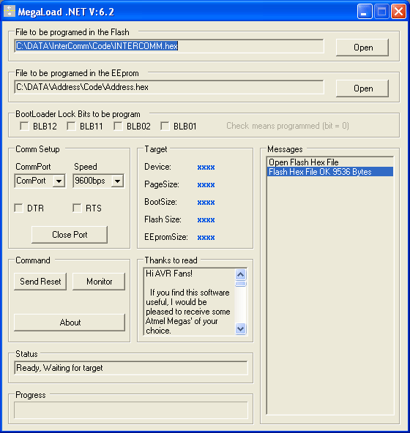

Download
MegaLoad
And
The bootloader files
------>Take the two files!!!<------

Step 1: Load bootloader code
MegaLoad requires the ATMega to be programmed with the boot loader code first. This can be done with almost any programmer, including the Atmel STK500, AVRISP and PonyProg. Instructions for PonyProg follow. All programmers must program the BOOTRST fuses, for the BOOTSZ1 & BOOTSZ0 you must check in the datasheet of your mega to have a boot size of 512byte.

- Connect your Mega as shown on PonyProg website
- Read the fuse bit of your Mega, change the value of BOOTSZ1..0 and BOOTRST.
- Program the new fuse bit setup (don't touch to RSTDISBL you will scrap your ATmega!)
- Locate the bootloader ZIP file in the MegaLoad directory.
- Extract the entire file from the ZIP file.
- Use ICCAVR from www.imagecraft.com to build your hex file
- Don't forget to make the good #define for your hardware (Check the source code the info is there)
- Program the ATMega*.HEX file
- That's it.

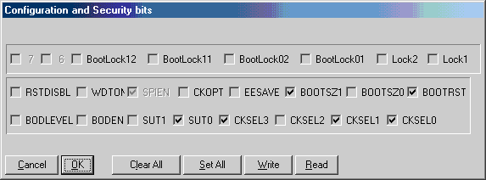

Step 2: Setup MegaLoad
- Run the MegaLoad program
- Click Open and locate the HEX file to program
- Select the COM port that the ATMega is connected to (only COM1-COM19 are supported)
- Connect the ATMega to the Windows PC
- Reset the ATMega
- MegaLoad should see the ATMega reset and will program the ATMega at the speed of light!
The MONITOR button opens up a basic terminal emulator for simple debugging.
The MegaLoad listens on the selected COM port for a handshake signal when the ATMega resets. If MegaLoad isn't working make sure that the cable is correctly connected. Use the MONITOR button to verify that communication is working between the ATMega and Windows.

