**ABSTRACT**

Measurement is the most important part of any control system. The accuracy of measurement is of paramount importance in such as asystem.

Design constraints, specially in Embedded System, dictates the implementation and always pose a challenge for the engineers.

In this project, measurement of temperature and humidity was implemented using Embedded System. These measurements formed a part of another system which was being designed by another team.

Project was implemented using ATMega16 microcontroller for ATMEL and SHT11 temperature cum humidity sensor from Sensirion.

The major design parameters to be adhered to, was limited number of available I/O interface lines and limited flash memory available for the software (as same microcontroller was being used by another purpose).

Along with above constraints, the design had to ensure that the measured quantity was accurate and for the purpose CRC8 check was also implemented.

**HARDWARE**

The measuring circuit was based around 8-bit microcontroller ATMega16[1] from ATMEL and sensor SHT11[2] from Sensirion. The readings were to be displayed on LCD ( based around Hitachi HD44780)[3].

As per requirement, selected I/O interface lines were made available for the implementation of the design; as other I/O interface lines were already being used in the existing design for some other purpose.

The constraints of the available I/O lines challenged the design and same had to be implemented using the available resources only. Available I/O lines were – PB0, PB3, PD0, PA0, PA6, PA7, PC0-PC7.

Since, both temperature and humidity had to measured and constraint of available I/O interface lines, it was decided that a sensor namely SHT11 available from Sensirion to be used in the design, which is easily available in the market and combines temperature and humidity sensor in the same package.

For accuracy in measurement, it was desired that some sort of error checking mechanism is to be implemented which will overcome erroneous measurement, and SHT11 filled this gap very well as it generates CRC8 data for each and every measurement by on chip CRC8 generator. This CRC8 data is transferred from the sensor to the microcontroller for error checking of the measured data. Same was implemented, successfully in the project.

The block diagram, with I/O interface lines used for the purpose is as given below in Figure-1.

PSU

+ 5V

LCD

PA6, PA7, PC0-PC7

PB0, PD0

Sensor

SHT11

**Micro Controller**

**ATMega16**

PB0, PD0

Activity LED

PA0

Diagnostic Switch

**Figure – 1**

As per design requirement, a diagnostic switch SW1 was provided, which when pressed, displayed CRC8 being generated by the sensor and CRC8 data as calculated for the received data from the sensor, this was helpful as the CRC8 accuracy could be checked at any time of the operation. The switch was interface to microcontroller through PA0 I/O line.

For visual indication of the working of the circuit, a LED D1 was provided, which blinked with every measurement of temperature as well as humidity quantity. The LED was interface to the PB3 interface line of the microcontroller.

For the display of measured data, a LCD U7 was used in the circuit. This LCD is ogf16 characters and data was displayed on two lines. The data lines of the LCD was tied down to ATMeag16’s port PORTC ( PC0-PC7) and it’s control interface lines tied to PA6-PA7 lines of the microcontroller. For controlling the contrast a variable resistor pot VR1 has been provided, and Read/Write pin of the LCD pin has been grounded and hence it works in write mode only i.e. data can be send in command mode to LCD and no data can be read back from LCD.

The port declaration of the microcontroller used in the circuit are as given below in Table-1

|  |  |  |  |
| --- | --- | --- | --- |
| **S.No** | **PORT USED** | **I/O Lines Used** | **Interfaced to** |
| 1. | PORTA | PA0  PA6  PA7 | Diagnostic Switch- SW1  LCD – Enable Pin  LCD – Read Strobe |
| 2. | PORTB | PB0  PB3 | SHT11 – System Clock  Activity LED |
| 3. | PORTC | PC0-7 | LCD – Data Pin |
| 4. | PORTD | PD0 | SHT- Data |

**Table-1**

Constraint placed on the design was that; only 5KB of the ATmega16, flash memory was available for the implementation of the software.

SHT11 sensor was used for measuring temperature and humidity. SHT1x (including SHT10, SHT11 and SHT15) is The sensors integrate sensor elements plus signal processing on a tiny foot print and provide a fully calibrated digital output. A unique capacitive sensor element is used for measuring relative humidity while temperature is measured by a band-gap sensor. The applied CMOSens® technology guarantees excellent reliability and long term stability. Both sensors

are seamlessly coupled to a 14bit analog to digital converter and a serial interface circuit. This results in superior signal quality, a fast response time and insensitivity to external disturbances (EMC)[2]. Each SHT1x is individually calibrated in a precision humidity chamber. The calibration coefficients are programmed into an OTP memory on the chip. These coefficients are used to internally calibrate the signals from the sensors. The 2-wire serial interface and internal voltage regulation allows for easy and fast system integration. [2].

The supply voltage of SHT1x must be in the range of 2.4 – 5.5V, recommended supply voltage is 3.3V. Power supply pins Supply Voltage (VDD) and Ground (GND) must be decoupled with a 100 nF capacitor . The serial interface of the SHT1x is optimized for sensor readout and effective power consumption. The sensor cannot be addressed by I2C protocol; however, the sensor can be connected to an I2C bus without interference with other devices connected to the bus. The controller must switch between the protocols.

The power supply, was based onboard LM7805, 5 volts regulator. The circuit diagram of the circuit is as given below in Figure-2.



**Figure-2**

**Sensor**

Pin diagram of SHT11 is as given blow in Table-2

|  |  |  |
| --- | --- | --- |
| **S.No** | **Pin No.** | **Function** |
| 1. | 1 | Ground |
| 2. | 2 | DATA Serial Data, bidirectional |
| 3. | 3 | SCK Serial Clock, input only |
| 4. | 4 | VDD Source Voltage |
| 5. | NC | NC Must be left unconnected |

**Table-2**

The hardware interface of SHT11 and microcontroller is as given below in Figure-3

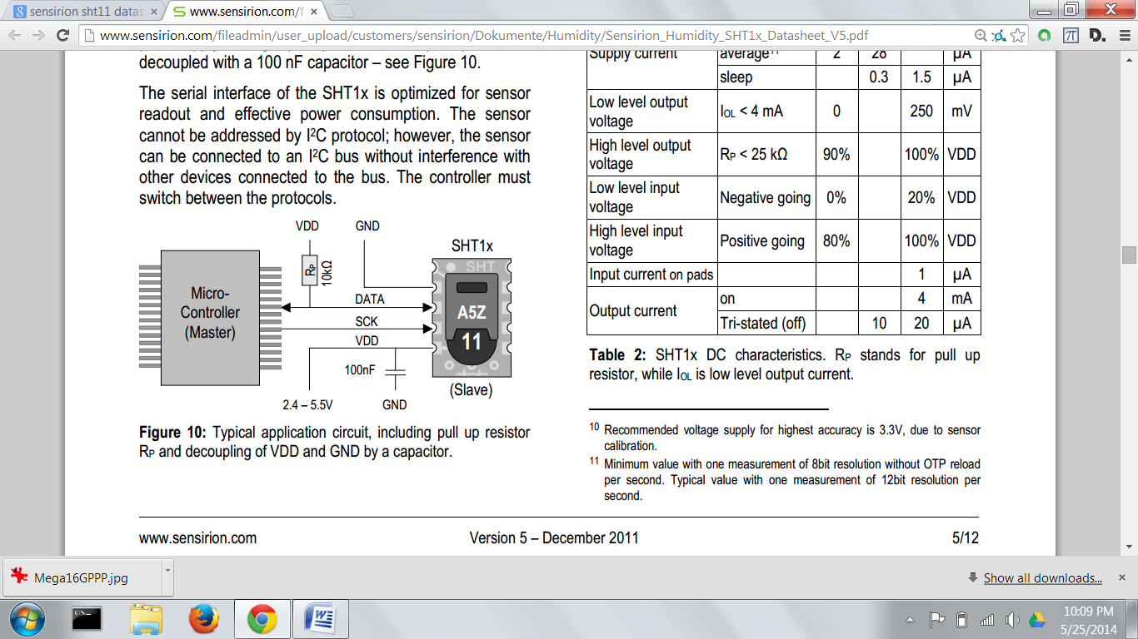

**Figure -3 ( Interfacing)**

Serial clock input (SCK), is used to synchronize the communication between microcontroller and SHT1x. Since the interface consists of fully static logic there is no minimum SCK frequency. Serial data (DATA). The DATA tri-state pin is used to transfer data in and out of the sensor. For sending a command to the sensor, DATA is valid on the rising edge of the serial clock (SCK) and must remain stable while SCK is high.

After the falling edge of SCK the DATA value may be changed. For safe communication DATA valid shall be extended TSU and THO before the rising and after the falling edge of SCK, sensor, DATA is valid TV after SCK has gone low and remains valid until the next falling edge of SCK. To avoid signal contention the microcontroller must only drive DATA low. An external pull-up resistor (e.g. 10kΩ) is required to pull the signal high – it should be noted that pull-up resistors may be included in I/O circuits of microcontrollers.

The timing diagram of SHT11 operations under microcontroller control is as given in Figure-4, and same has to be taken care in the software, while reading/writing data to the sensor.

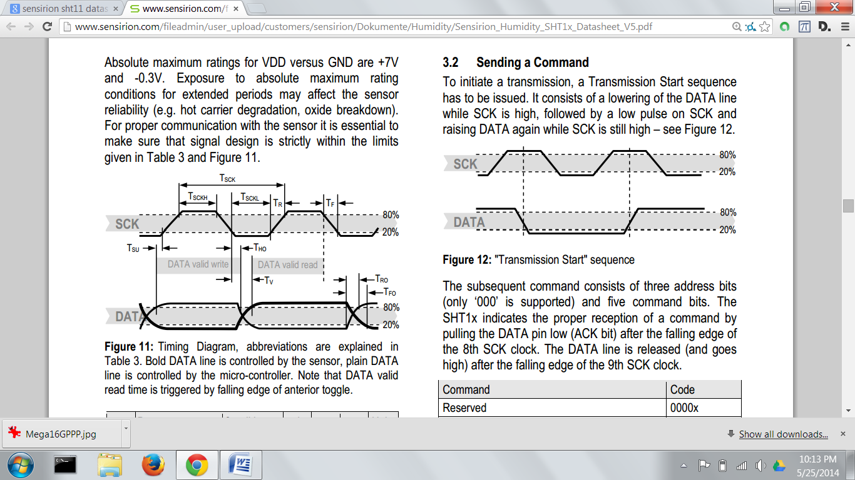

**Figure- 4 (Timing)**

successfully.

**REFERENCES**

1. Atmel ATMage16

<http://www.atmel.in/Images/doc2466.pdf>

1. Sensiron SHT11 <http://www.sensirion.com/fileadmin/user_upload/customers/sensirion/Dokumente/Humidity/Sensirion_Humidity_SHT1x_Datasheet_V5.pdf>
2. LCD – HD44780 Based Starter Guide. <http://www.stanford.edu/class/ee281/handouts/lcd_tutorial.pdf>

<https://en.wikipedia.org/wiki/Hitachi_HD44780_LCD_controller>