­­­

|  |  |
| --- | --- |
| CEC173x OTP reader | |
| User manual | |
| Rev 0.4 | May 5th 2022 |

|  |
| --- |
| Copyright © 2022 Microchip or its subsidiaries. All rights reserved.  The information contained herein is confidential and proprietary to Microchip, shall be used solely in accordance with the agreement pursuant to which it is provided, and shall not be reproduced or disclosed to others without the prior written consent of Microchip. Although the information is believed to be accurate, no responsibility is assumed for inaccuracies. Microchip reserves the right to make changes to this document and to specifications and product descriptions at any time without notice. Neither the provision of this information nor the sale of the described semiconductor devices conveys any licenses under any patent rights or other intellectual property rights of Microchip or others. The product may contain design defects or errors known as anomalies, including but not necessarily limited to any which may be identified in this document, which may cause the product to deviate from published specifications. Microchip products are not designed, intended, authorized or warranted for use in any life support or other application where product failure could cause or contribute to personal injury or severe property damage. Any and all such uses without prior written approval of an officer of Microchip will be fully at the risk of the customer.    MICROCHIP DISCLAIMS AND EXCLUDES ANY AND ALL WARRANTIES, INCLUDING WITHOUT LIMITATION ANY AND ALL IMPLIED WARRANTIES OF MERCHANTABILITY, FITNESS FOR A PARTICULAR PURPOSE, TITLE, AND AGAINST INFRINGEMENT AND THE LIKE, AND ANY AND ALL WARRANTIES ARISING FROM ANY COURSE OF DEALING OR USAGE OF TRADE. IN NO EVENT SHALL MICROCHIP BE LIABLE FOR ANY DIRECT, INCIDENTAL, INDIRECT, SPECIAL, PUNITIVE, OR CONSEQUENTIAL DAMAGES; OR FOR LOST DATA, PROFITS, SAVINGS OR REVENUES OF ANY KIND; REGARDLESS OF THE FORM OF ACTION, WHETHER BASED ON CONTRACT; TORT; NEGLIGENCE OF MICROCHIP OR OTHERS; STRICT LIABILITY; BREACH OF WARRANTY; OR OTHERWISE; WHETHER OR NOT ANY REMEDY OF BUYER IS HELD TO HAVE FAILED OF ITS ESSENTIAL PURPOSE, AND WHETHER OR NOT MICROCHIP HAS BEEN ADVISED OF THE POSSIBILITY OF SUCH DAMAGES. |

Table of Contents

1 Introduction 3

1.1 Purpose 3

1.2 Scope 3

1.3 References 3

1.4 Glossary of Terms and Acronyms 3

1.5 Assumptions 3

2 Tools & HW 4

3 CEC173x EVB setup 8

4 Read back the OTP using mdb script with the help of icd4 or pickit4 9

5 Revision History 10

# Introduction

## Purpose

This document provides steps to read OTP data for your CEC173x device using ICD4 debugger.

## Scope

This document explains the procedure using CEC173x Development board as a reference.

## References

## Glossary of Terms and Acronyms

MDB – Microchip Debugger

## Assumptions

None.

# Tools & HW

Following tools and utilities should be installed and available for accomplishing OTP programming

* CEC173x OTPGEN utility
* MPLabX IDE Version 5.50 or later versions
* ICD4/ PICKIT4 debugger with JTAG cable
* CEC173x Development Board.

6 Pin JTAG header to RJ-45

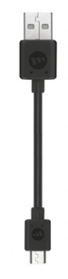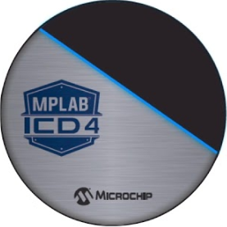

P J

O T

W A

E G

R

**CEC173x Development Board**

**Power**



*System connection*

*Simple connection using mplabx icd4*



CEC173x EVB

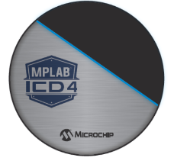

*Simple connection using mplabx pickit4*



CEC173x EVB

**Connect the ICSP 6 pin header to J29 in the CEC173x EVB board**

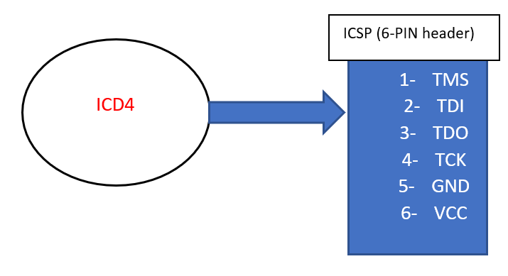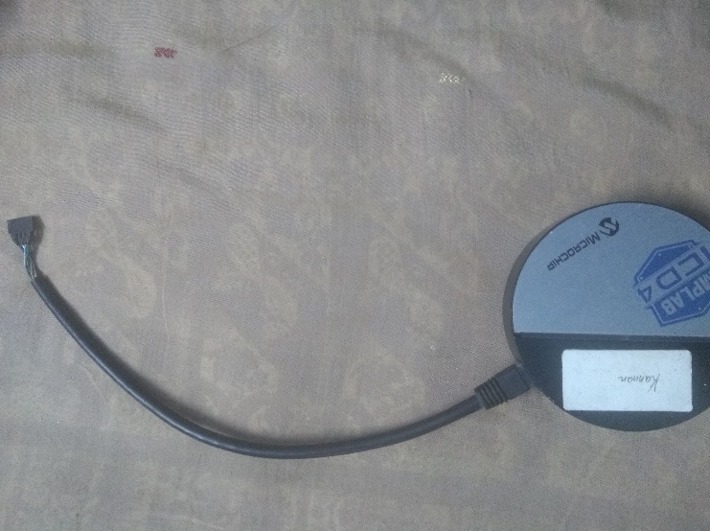

**

Connection Type 2 – 2wire Connection

|  |  |
| --- | --- |
| PICKIT4 | CEC173x EVB board of J30 |
| 2 - VDD | 1 - VTref |
| 3 – GND | 4 – GND |
| 5 – PGC | 9 - TCK |
| 8 - TMS | 7 - TMS |

*System connection*

# CEC173x EVB setup

Power + JTAG connection

# Read back the OTP using mdb script with the help of icd4 or pickit4

1. Use the otp_reader.exe

Under the below directory:

1. Connect the CEC173x device with the hardware ICD4 or pickit4 and UART
2. Run the otp_reader.exe, it will detect the MPLABX of higher version and connect to any hardware device icd4 or pickit4

1. It will read the OTP value

# Revision History

|  |  |  |  |  |
| --- | --- | --- | --- | --- |
| Name | Revision Level | Date | Section | Remarks |
| Prabhakar V | 0.1 | 7th Jan 2021 | All section | Initial draft |
| Prabhakar V | 0.2 | 23rd Feb 2022 | All Section |  |
| Saravanan V | 0.3 | 28rd April 2022 | All Section | Revised few words for market launch |
| Prabhakar V | 0.4 | May 5th 2022 |  | Updated the exe |