**Microcut Ltd**

**Lengnau**

V4620304

**UniBore821-X-C**

**Software Update V4620304**

**Palumbo Marco**

**07.07.2015**

# Table of contents

Content

1 Table of contents 1

2 General 2

3 Description 3

3.1 Configuration of the Process analyse file (result file) 3

3.2 Input of Talon Information 10

3.3 Writing of process parameter in Process analyse file (result file) 12

3.4 Add work information in Process analyse file (result file) 13

3.5 Example of Process analyse file (result file) 14

# General

For this Software Update it will gives the follow features:

* In the result file we add the follow parameter:
  + "ToolTorque StartPos"
  + "ToolTorque EndPos"
  + "ToolDeflection Offset"
  + "ToolDeflection Force"
  + "Z1 Work forward v"
  + "Z1 Work backward v"
  + "Z1 Work stroke backward"
  + "S Work n", "Z1 Infeed v"
  + "S Infeed n"
  + "Number try repeat Infeed"
  + "Z1 Infeed back stroke"
  + "Infeed DeflectionForce"
  + "Z1 Spark-out stroke"
  + "Z1 Spark-out Number"
  + "Z1 Spark-out v"
  + "Spark-out DeflectionForce"
  + "Spark-out ToolTorque"
  + "CheckHC Window"
  + "CheckHC Number"
  + "CheckHC coeff. Backward"
  + "Minimal Process Time"
  + "Maximal Process Time"
  + "Z1 Outfeed v"
  + "S Outfeed v"
  + "Overload Torque"
  + "Number try Infeed adjust X Axis"
  + "Infeed adjust X Axis Offset"

Note: The parameter will save only when you start to work a new Talon. If while working of a Talon you change the Parameter, you do not see this change in the file!

* In the result file we add how many time the machine tried to infeed the tool and also how many time it tried to infeed with the assistance of the table.
* In the Setup Mode you can configurate max. 12 field name (max. 20 character per field name). When you start a new Process, than you can put the value (max. 20 character per value) to the defined field name (1-12, only such where are activated)

# Description

## Configuration of the Process analyse file (result file)

It gives a new Page on the Setup Mode C on the Task « Config. » and the fifth Page « 5.Configuration Process Analyse File ». This Page look as follows :

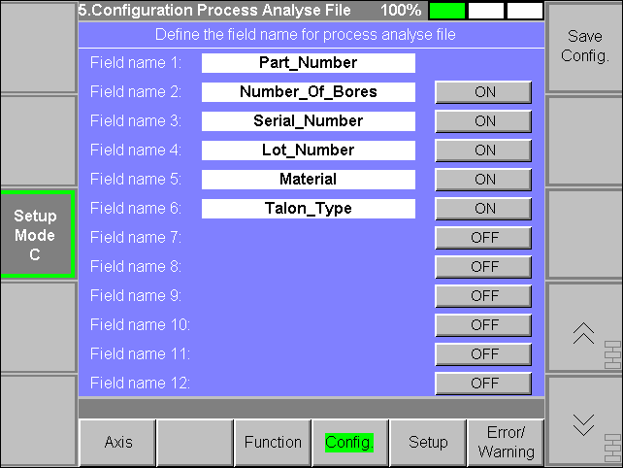

You can define from 1 to 12 field name for describe a Talon (Version before you could only define the Talon Number). On the upper picture you see selected only for example field name 1 until 6. With the Button on the right side you can activate or deactivate a field name. The field name 1 you could not deactivate (therefore the Button is missing for activation or deactivation).

Note : For example you have the upper adjustment, when you start a new Process on the Automat, than it will show only this 6 field name, which you must input the associated value. It show also only the activated field name and also in the result file it write only the activated field name.

Note: When a field name is activated, you see on the Button « ON » else it is deactivated you see « OFF »

If you change something than you must save this with the right Button « Save Config » and after press EnterButton :

1. Press the right Button «  Save Config »  
    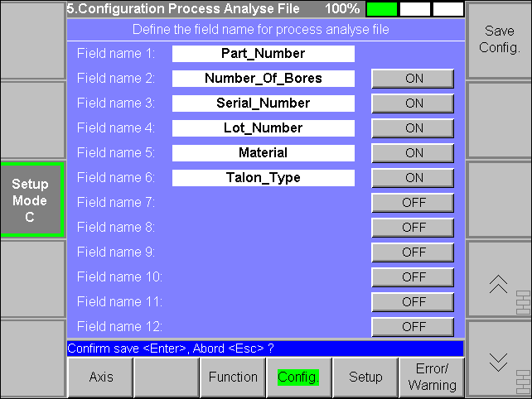
2. Press « EnterButton »  
    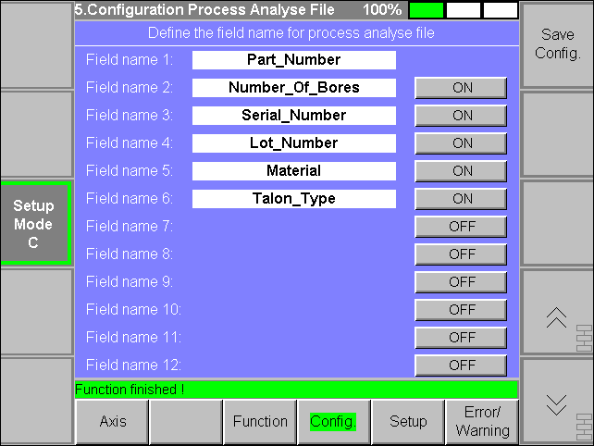  
   The value are now saved !

Example for a changement without saving :

1. Before changing :  
    
2. Changing :  
    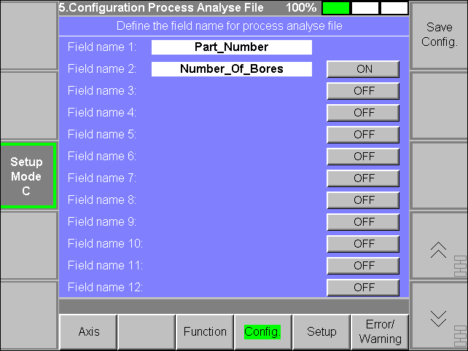
3. Leaving this page without saving and turn back to this Page i twill show as follow  
      
   You have again the old value !

The field name could only define consecutively. You can also not define for example field name 1, 3, 10. If you would define 3 field names, than define field name 1, 2 and 3.

For example if you have define as follow:



Now you press the Button of the second field it will show as follow :

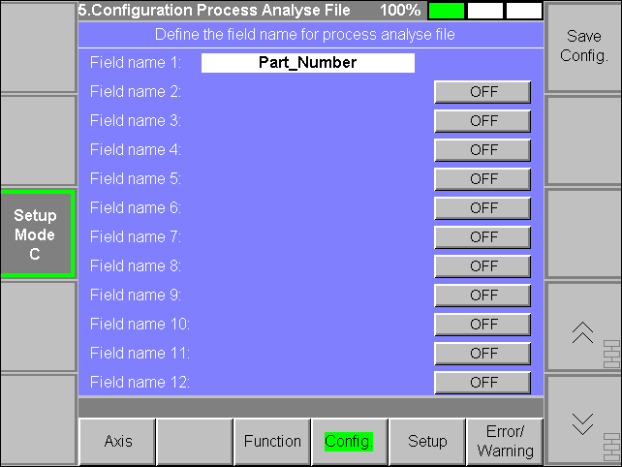

It haves automatically deactivate field name 3 until 6. If you now press again the Button of the field name 2, than it shows as follow :

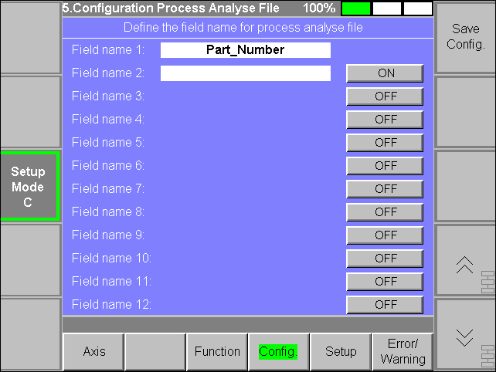

If in this case you press the Button of field name 4 or greather than it will nothing happen, because of missing of the consecutively field name.

The field name 1 is mandatory and if you do nothing writing on this field, than automatically it write „Talon Number“ for example:

1. You have the follow initial position  
    
2. Press now on the white field and it shows as follow  
    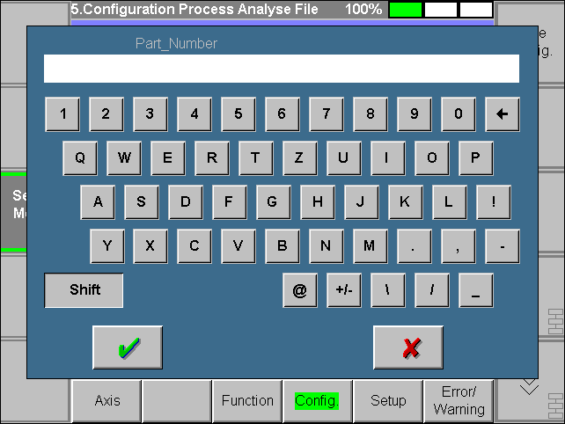
3. Without to input something press the Input Button an it shows as follow  
    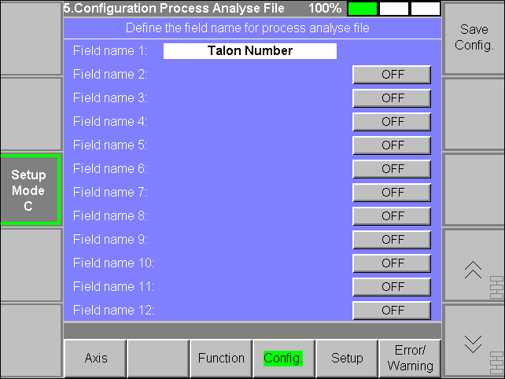  
   Only for field name 1 in this case the name is no more « Part_Number » but « Talon Number ». This is now automatically saved, but only the field name 1 and not the rest. (see next Page)

For example:

1. You have the follow initial position  
    
2. Press now on the white field and it shows as follow  
    
3. Without to input something press the Input Button an it shows as follow  
    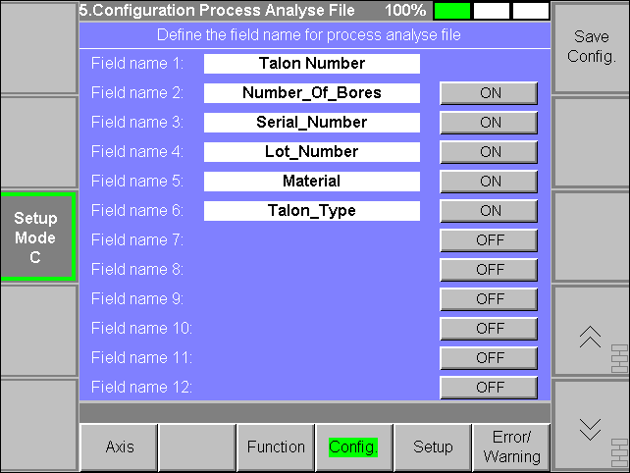  
   The name of the field name 1 has automatically changed !
4. Change the Page and turn again on this Page and it shows as follow  
      
   You have still the same configuration but only the name of the field name 1 has changed !

It is mandatory that activated field name must not be empty otherwise when you press the Save button, a message appear like this example :

1. You have the follow initial position  
    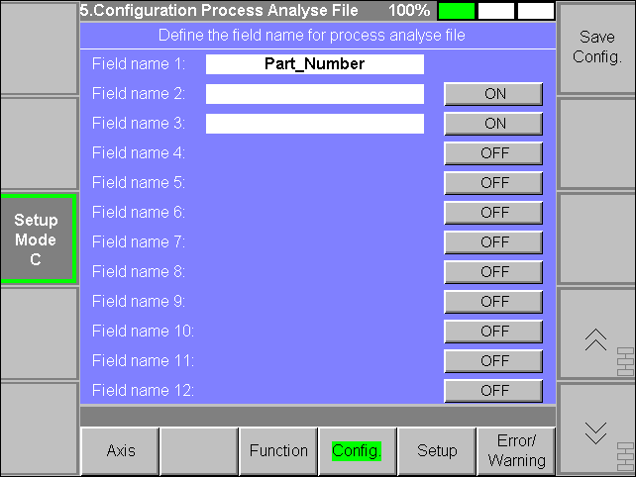
2. Press now the right Button « Save Config » and it shows as follow  
    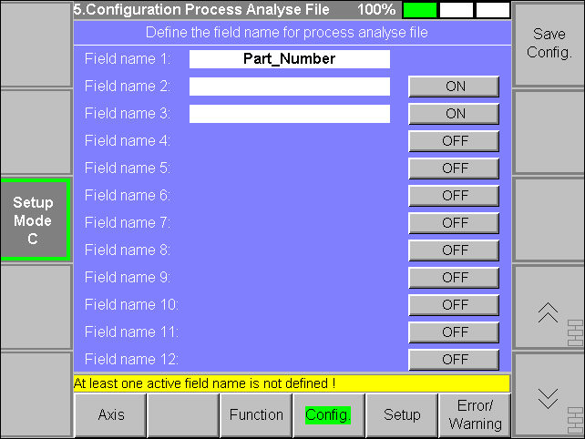

## Input of Talon Information

When you start a new process in the Automat then the follow Overlay will be open:

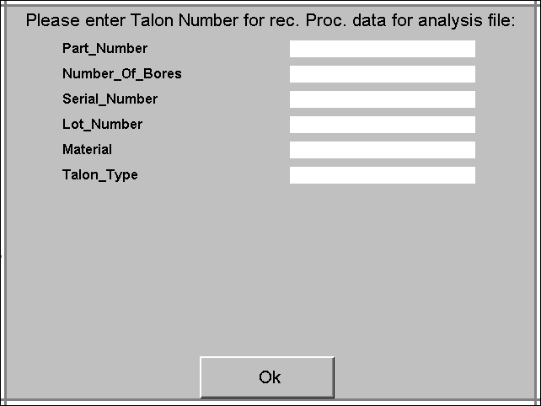

Here you see the field names of the configurated Process analyse file. You see only fields which in the configuration are activated (maximal 12 field). You must entering in each field a value else if you press the OK Button the follow message will appear:

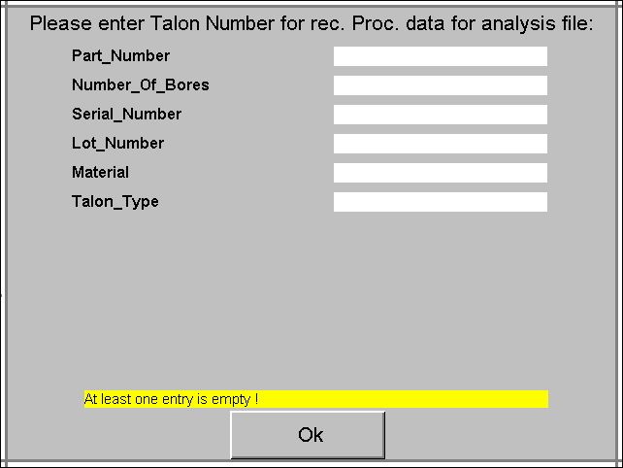

If you have insert as example all value as follow…

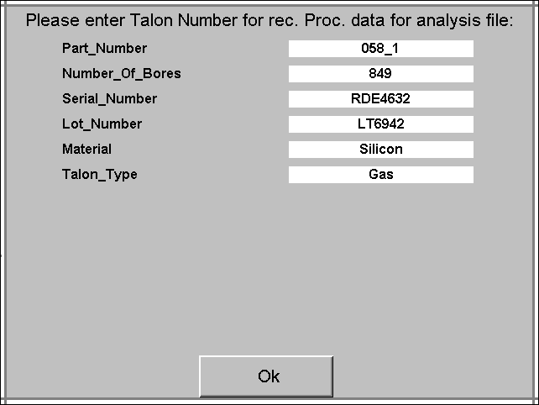

…and you press the OK Button, the overlay will close and it look as follow:

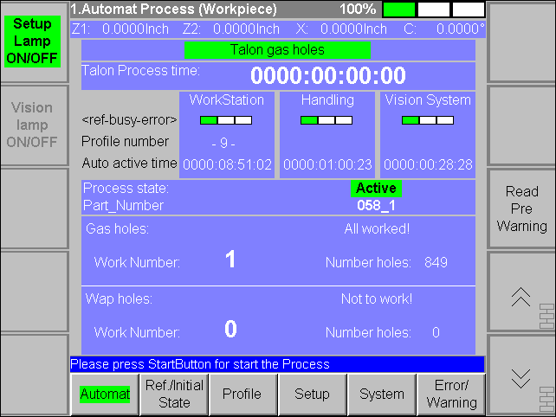

On this page you see only the first field name wiht the inserted value (Part_Number 058_1). The other value you do not see on the MMI. You see this then in the result file. It is also not possible to change the value while the process state is active.

## Writing of process parameter in Process analyse file (result file)

In the result file it write 28 process parameter as follow:

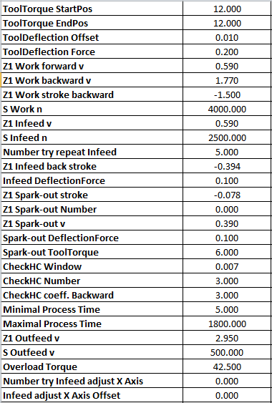

It is not possible to write this in a separate tab. It write on the same sheet where the other Data are. (see on chapter „Example of Process analyse file (result file)“ the structure of this file)

Note: When you start a new Process in the Automat, than it read the actual process parameter. This parameter will be write then into the result file. If you change the process parameter after he has already read, then these changes will be not written in the result file.

## Add work information in Process analyse file (result file)

On the WP Analysis Page it gives new two more work information for each worked bore:

* Z1 Infeed counter
  + How many time the machine tried to infeed the tool with the Z1 Axis. If the Tool infeed without a HC, than the counter is on „1“. If for example while infeed it gives 3 times a HC an the fourth times it can infeed, than the counter is on 4.  
    Note : If you abort the working of a bore, than the counter will not reset. On the next start of this bore it will continue with the existing value.
* X Infeed counter
  + How many time it tried to infeed with the assistance oft he X Axis.  
    Note : If you abort the working of a bore, than the counter will not reset. On the next start of this bore it will continue with the existing value.

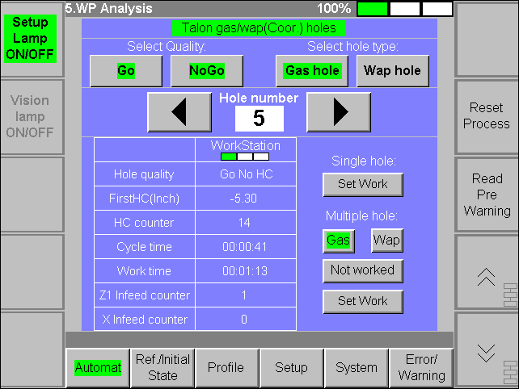

This two new work information it will be written also into the result file !

## Example of Process analyse file (result file)

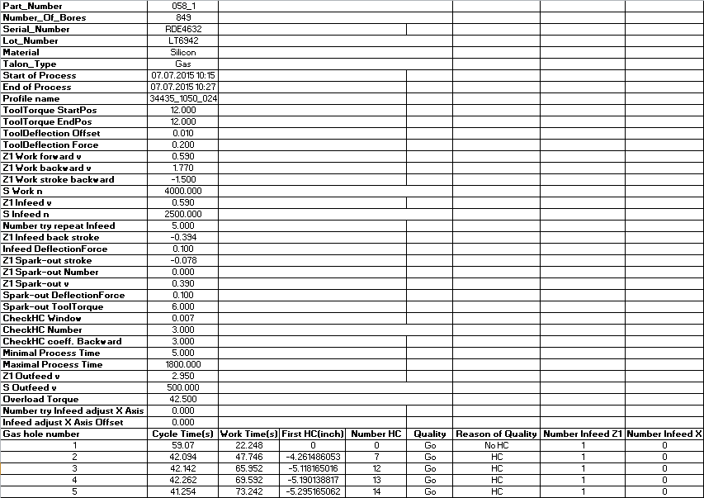

* Green border
  + This are information about the defined Talon. In depending of the configurated process analyse file it can have from 1 to 12 lines. Here in this example are six field name activated and for this reason it haves 6 lines
* Orange border
  + 28 process parameter
* Yellow border
  + Two new work information for too know how many times it has infeeded for each bore.