**Microcut Ltd**

**Lengnau**

V4620305

**UniBore821-X-C**

**Software Update V4620305**

**Palumbo Marco**

**11.08.2015**

# Table of contents

Content

1 Table of contents 1

2 General 2

3 Description 3

3.1 Ending of the Automat with the MessageBox 3

# General

For this Software Update it will gives the follow features:

* When the Automat ended at least one hole as NoGo, then the MessageBox is yellow and no longer green

# Description

## Ending of the Automat with the MessageBox

When the Automat end with all holes as Go, than the follow MessageBox appear like this (still the same as the previous Version):

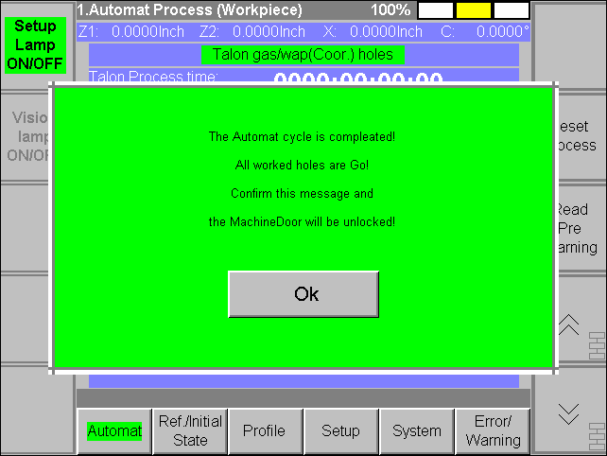

New when the Automat end at least with one hole as NoGo, then the follow MessageBox appear:

