**Microcut Ltd**

**Lengnau**

V4620307

**UniBore821-X-C**

**Software Update V4620307**

**Palumbo Marco**

**13.07.2016**

# Table of contents

Content

1 Table of contents 1

2 General 2

3 Description 3

3.1 Pre-Measuring of all selected holes 3

3.2 Select or deselect range of holes 8

3.3 End of cycle estimation 10

3.4 Sending of E-Mail 11

3.5 Stop Machine after Hole Quality “NoGo maxTime” 17

3.6 Handscanner 18

# General

For this Software Update it has the follow features:

* Pre-Measuring of all selected holes
* Select or deselect range of bores
* End of cycle estimation
* Sending of E-Mail
* Stop Machine after Hole Quality “NoGo maxTime”
* Handscanner

# Description

## Pre-Measuring of all selected holes

For improve the cycle time of working of a Talon, it has the possibility that a Talon will first measure all selected Holes and save this Measure value in a Register. After Measuring it will bring the hole direct to the Workposition and work it. You need no more Machine cleaning of all Holes.

With the new Parameter “Pre-Measuring all Holes ON/OFF” you can as follow define:

* Set value “0” 🡪 The Machine is set conventional
* Set value “1” 🡪 The Machine is measuring first all selected holes

This Parameter you will find in the NormalMode on the Parameter list 1, as follow:

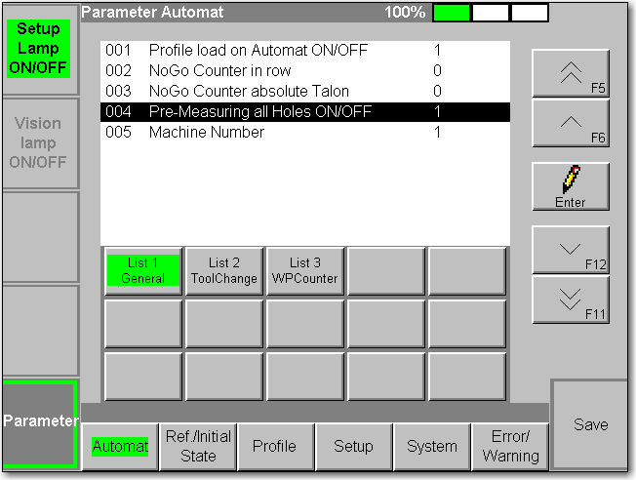

The Pre-Measuring of all selected holes is only valid for the Automat for the follow Process:

* Automat (Workpiece)
* Automat (Single hole)
* Automat (Multiple hole)

When the Register of all the selected holes are empty and you start the process, than it will not appear a Request for the Operator. The Machine start direct with the Process and measure all selected holes.

If the Register of all the selected holes are not empty and you start the process, than it will appear the follow Request (Note: if the Process state is Inactive and you start the Process, than you must put first the Talon Information, press OK Butten and press StartButton and after comes the request)

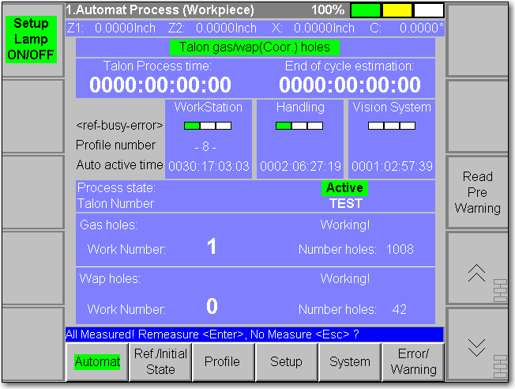

The Request is called as follow:

* All Measured! Remeasure <Enter>, No Measure <Esc> ?

If you press EnterButton, than it will measure again all selected holes. If you press the EscButton, than it do no Measuring and works with the Measure value in the Register for bring the holes to the WorkPosition.  
Independent whitch Button you have selected, after pressing of one of both Button the follow Request appear:

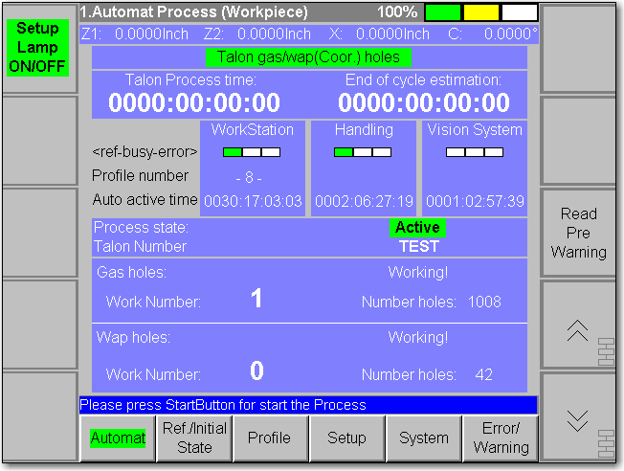

When you Press here now the StopButton, than it will aboard the Process and nothing will happen. If you press the StartButton than it will happen follow:

* Before pressing of the StartButton you have press the EscButton
  + No measuring of the selected Holes
  + No changing of the Register
* Before pressing of the StartButton you have press the EnterButton
  + The Register of the selected holes will be deleted. The Register of the selected holes is then empty
  + Measuring first of all selected holes

If the Register of all the selected holes are only a part empty and you start the process, than it will appear the follow Request (Note: if the Process state is Inactive and you start the Process, than you must put first the Talon Information, press OK Butten and press StartButton and after comes the request)

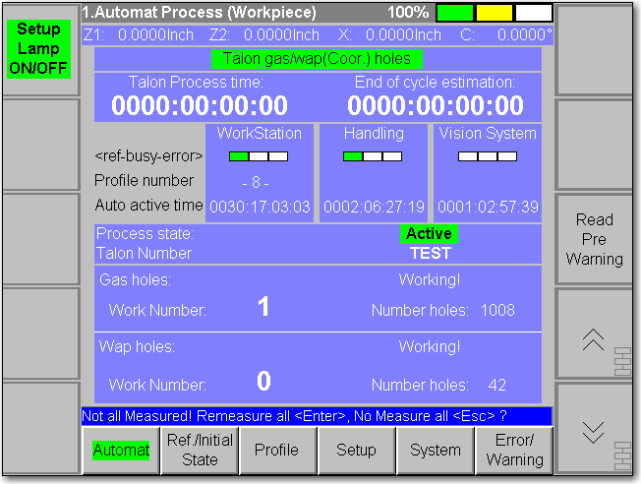

The Request is called as follow:

* Not all Measured! Remeasure all <Enter>, No Measure all <Esc> ?

If you press EnterButton, than it will measure again all selected holes. If you press the EscButton, than it Measure only the holes that the Register are empty.

Independent whitch Button you have selected, after pressing of one of both Button the follow Request appear:



When you Press here now the StopButton, than it will aboard the Process and nothing will happen. If you press the StartButton than it will happen follow:

* Before pressing of the StartButton you have press the EscButton
  + Measuring only of the selected Holes which the Register is empty
  + After Measuring, the Register is no more empty of the selected holes (but only if the Vision System can see all the selected holes)
* Before pressing of the StartButton you have press the EnterButton
  + The Register of the selected holes will be deleted. The Register of the selected holes is then empty
  + Measuring first of all selected holes

Note 1: The Register is not dependent of the Process state. When the Process State will be deleted (manually or from starting of the process), the Register will not deleted. As example, when you put a new Talon and the above described Request appears, then you must press the EnterButton for measuring all selected holes, elsewise you work with Measure value of an other Talon. The same problem is when you unfix and fix again the same Talon, you must measure again all selected holes.  
The reason, why it is not dependent with the Process State is, because you have more flexibility with working of a Talon especially when you have NoGo.

Note 2: Independent if you have set the Parameter for cleaning the hole before or after Work, with acitve Pre-Measuring of all selected holes, it will never clean the holes. For this reason, when you work with active Pre-Measuring, than you must clean manually the Talon.

Note 3: Each hole which can not see the Vision System will be classificate with the Quality   
“< NoGo NoHole >”. This Register of the NoGo Holes will be empty. At the End of the Measuring it will work only with holes that the Vision System has detected. The Automat will not stop.

Note 4: It gives no manually Function that you can only Measuring all selected holes. The Measuring is combined only with the Automat Process.

Note 5: When you have activate the Paramter “Auto Talon Gas check ON/OFF”, than it will check first the Orientation of the Talon and if the Orientation is OK then it will after measuring all selected holes. If the Parameter “Auto Talon Gas check clean ON/OFF” is activated, then it will anyway clean the Holes only for the check procedure.

Note 6: If while measuring of all selected holes the Automat will be stop (Error or Stop from Operator), then the register of the already measured holes will be not deleted. When after you start again the Automat, you will be request if you will Measuring again all or if you will measure only the holes which the Register is empty.

Note 7: The Register is saved permanent, that mean when you switch Off/On the machine, you do not lose the Register value.

Note 8: When the Talon is defined with Gas and Wap holes, than it measure both holes type. As well when the Parameter “Transition Gas to Wap Auto stop ON/OFF” is activated.

Note 9: If while measuring off all selected holes you press the Stop cycle Button, than the Machine will after measuring of all selected holes work the first holes and after it will stop.

Note10:If in the Parameter List 1 of the NormalMode you set on the Parameter “Pre-Measuring all Holes ON/OFF” the value “0” and save it, then the Register will be deleted. After the hole Register is empty. You can so delete the hole Register manually by set first the value “0”, save it and then set again the value “1” and again save it.

## Select or deselect range of holes

For the Automat (Multiple hole) Process it gives a new functionality for select oder deselect holes. The third Page auf the Automat see as follows (first selection):

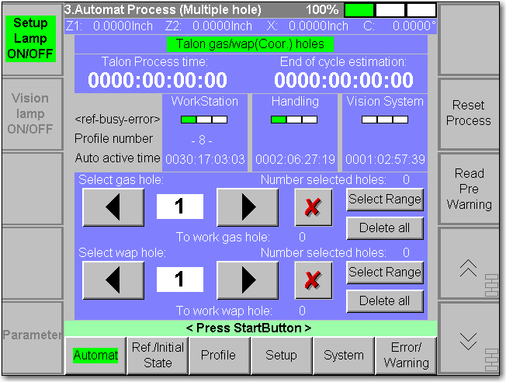

For Gas or Wap holes it gives a new Button “Select Range”. When you press for example the Button “Select Range” on Gas hole, then it will appear as follow(second selection):

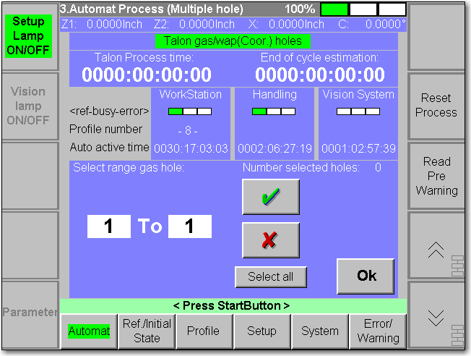

Here you have the follow possibility:

* Define a range for select or deselect holes
  + Select with the Button green sign
  + Deselect with the Button red sign
  + You can define more than only one Range for example 1 - 50, 55 - 105, 120 – 130 etc.
* Select all holes with the Button “Select all”
* Finally when you have define one or more range, then you can press the Button “Ok” and you are again on the first Selection. You can after again press the Button “Select Range” for select or deselect more Range of holes.
* When you are on the second Selection and you start the Automat or you leave this Page and comes back to this Page, than the first Selection is show again.

Note 1: In the second selection when you define a Range for example 10 To 20, you can also define 20 To 10. The result is the same.

Note 2: It gives one second Selection for Gas Holes and one for Wap holes.

Note 3: If for example the Talon is configured only for Gas holes, than the Button “Select Range” for Wap holes is disabled. The same is when the Talon is configured only for Wap holes, than the Button “Select Range” for Gas holes is disabled.

Note 4: If the Automat Process is active, than the Button “Select Range” are disabled.

## End of cycle estimation

For the follow Automat Process…

* Automat (Workpiece)
* Automat (Multiple hole)

…it gives a New functionality as follow:

* After working of the first hole, it will calculate how long it will work until the Automat will stop.

This Time you will find on the follow Pages:

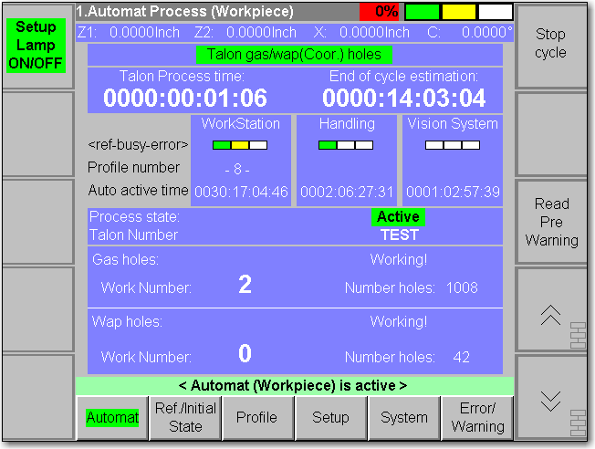 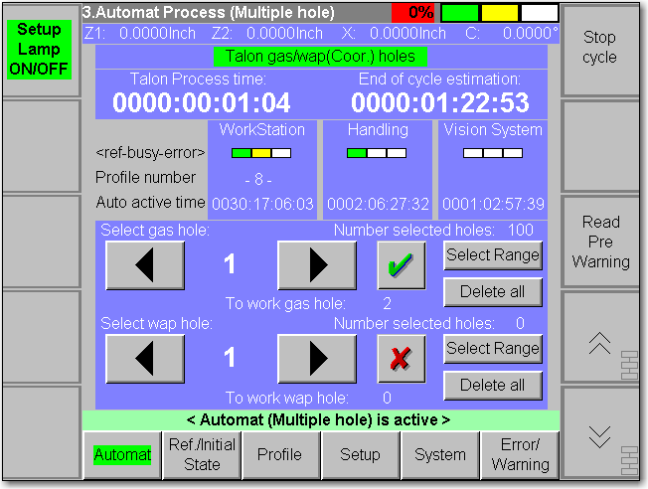

You see this Time under “End of cycle estimation”.

Note 1: Every Time you start the Automat, the Time will be calculate New

Note 2: After each Hole cycle it will calculate the average and with this average it calculate the End of cycle estimation. The average will be lose when the Automat stop. When you after start again, than it will calculate with the too work holes.

Note 3: If the Pre-Measuring is activated, then while the Measuring of all selected holes you see the Time “0000:00:00:00” and after worked of the first hole, it will calculate the End of cycle estimation Time.

Note 4:If the Pre-Measuring is activated, and while the Measuring of all selected holes it see not all holes, than it will calculate only the End of cycle estimation of holes that the Vision System has see.

Note 5: When you stop the Automat, the End of cycle estimation Time will be not deleted. If you start again the Automat, than it will be deleted, because it will calculate new. As well when you reset the Process state, than it will delete this Time.

Note 6: No Time calculate for the Single hole Process!

Note 7: The calculate Time is only a roughly value. As less the variance between the single hole work Time is, as correcter is the calculated Time.

## Sending of E-Mail

For the follow Automat Process…

* Automat (Workpiece)
* Automat (Multiple hole)

…it gives a New functionality as follow:

* For the follow event you can send an E-Mail to a selected recipient
  + Stop of the Automat (abording of the Automat🡪press two times the StopButton)
    - When the E-Mail function is activated, then you can not switch Off this functionallity
  + A selected first Time for recall the Operator that the Process is near to End
    - When the E-Mail functions is activated, then you have the possibility to define if you will send or not
  + A selected second Time for recall the Operator that the Process is near to End
    - When the E-Mail functions is activated, then you have the possibility to define if you will send or not

If you will use the E-Mail functionallity, then you must first configure the SMTP Server. It gives a new Page in the Setup Mode A under the Task Setup and the third Page…

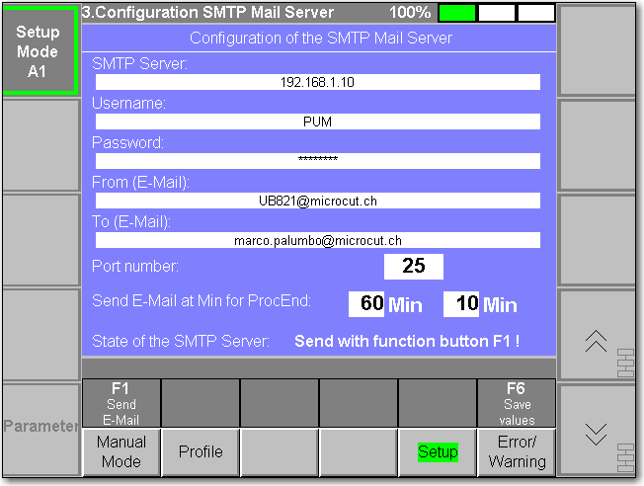

You must define as follow:

* SMTP Server: Name or IP Address of your own Mail Server or a Mail Server which you have an E-Mail Account (not allowed empty field)
* Username: Username that has access to the Mail Server (not allowed empty field)
* Password: Password that has access to the Mail Server (not allowed empty field)
* From (E-Mail): E-Mail Address from the sender (Machine). You can define also a not exist E-Mail Address (not allowed empty field)🡪It is depentend from the Mail Server what is allowed and what not!
* To (E-Mail): E-Mail Address of the recipient, where the E-Mail must be transmitted. Here it is allowed an empty field. In case that the E-Mail functionallity is activated, if it is empty, then you can define it when you start the Automat with an Inactive Process state. If it is not empty, then you can not define an other E-Mail Address in the Automat.
* Port number: To define the communication Port of the Mail Server.
* Send E-Mail at Min for ProcEnd: Here you can define two different Time for send E-Mails when the calculated End of cycle estimation is at this Time before it endet. It is not Important on which side which value you define. If you set the value “0” then it is deactivated of one of the Time. If on both side you set the value “0” then this functionallity is deactivated.
* State of the SMTP Server: This state is depending only for send Test E-Mail with the function Button F1. It gives the follow State
  + Send with function button F1 !
    - Sending of Test E-Mail is not activated
  + Test E-Mail is sending…
    - The Machine is sending a Test E-Mail
  + Test E-Mail is sendet !
    - The Machine has sendet a Test E-Mail successful
  + SMTP connection failure !
    - The SMTP Server occurs an Error. Check the configuration of the SMTP Server.
  + ADS service error !
    - The DLL of the SMTP Server has failed. Please switch OFF/ON the Machine, check the SMTP configuration and try again to send a Test E-Mail
  + Wrong username/password !
    - You have configured a bad username or password to have access to your SMTP Server. Check the SMTP configuration
  + Sending was abordet !
    - SMTP Server is not ready. Try again to send a Test E-Mail
* With the F6 Button you can save the configuration

If a mandatory Field (SMTP Server, Username, Password and FROM) is empty and you press the F1 or F6 Button, then an accordet message appear, that is not allowed empty!

If you will use the E-Mail functionallity in the Automat, then make sure that when you press the F1 Button, that the E-Mail will send to the recipient. (State: Test E-Mail is sendet).

Sending of E-Mail from the Automat, when it has a problem then the SMTP will occur an error, but it will not abord the Automat. The Errors appear then when the Automat is stopped.

When the SMTP is configured and the Test E-Mail is sendet, then the E-Mail functionallity is not just yet activated. (see further down for activate)

For activate the E-Mail functionallity you must go to the Setup Mode C and select the Task Config and select the fifth Page as follow:

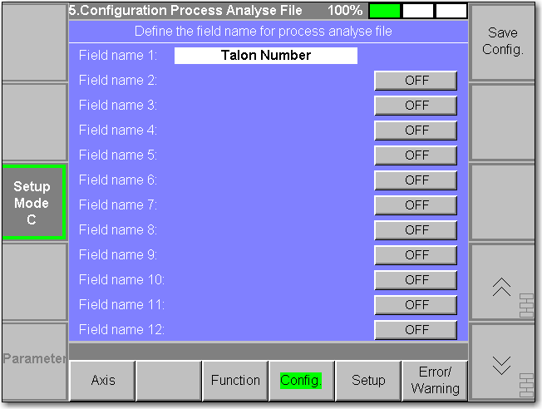

For activate now the E-Mail functionallity you must define one of the selected Field name as “E-Mail”. It is Important that you define this Field as follow:

* EMail
* E-Mail
* E_Mail

Only this three words are accepted. It is not Case-sensitive. You can also write “EMAIL”. If you write for example “E.Mail” then it will not recognize and you have no E-Mail functionallity.

For activation do also for example as follow:

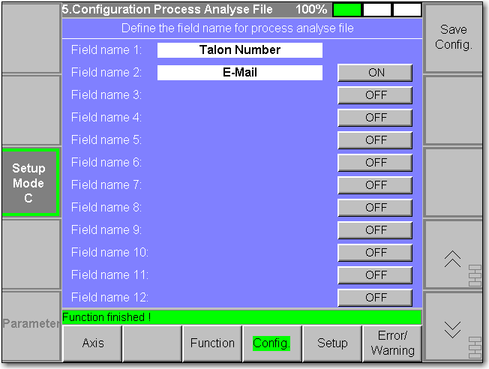

…and save then with “Save Config.” Button.

When you start the Automat with an Inactive Process state, then it gives now with activated E-Mail functionallity two possibility:

* The Field “To (E-Mail)” is not empty. You have in the Automat no possibility to define an E-Mail Address like this:

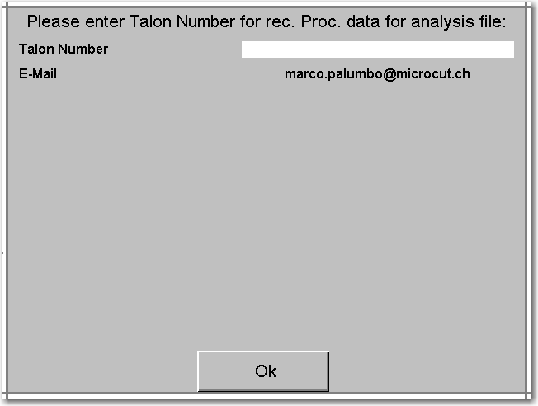

* The Field “To (E-Mail)” is empty. Each time it appears the Talon Input Data Window you must define an E-Mail Address like this

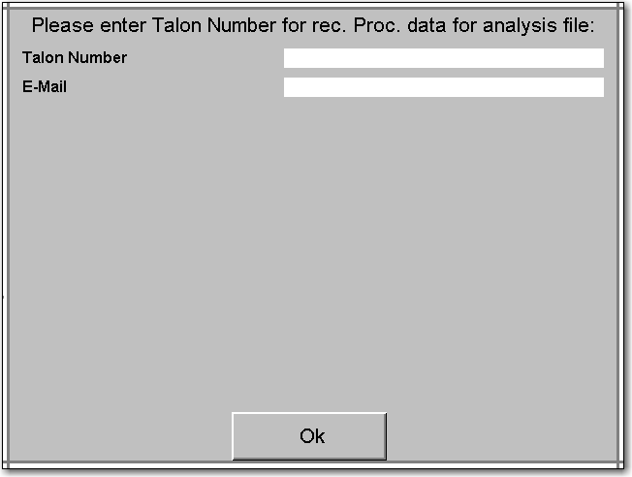

The E-Mail Address will be set to the Process state. If the Process state is active, and you will change the E-Mail Address, then you must Reset the Pocess state.

The Subject and the Message of the E-Mail is defined and you can not change it.

For the Subject and Message is apply as follow:

* Subject: UniBore821-X-C (M1): Manually sendet E-Mail by Operator !
  + Message: Manually sendet E-Mail by Operator !
    - This is when over the SMTP Configuration you send a Test E-Mail by press the F1 Button
* Subject: UniBore821-X-C (M1): Process near to End !
  + Message: Process ends in 10 Minutes
    - Here shows the Minutes how long it takes until the Automat ends
* Subject: UniBore821-X-C (M1): Process Ended !
  + Message: Reason: Energy Supply switched OFF !
    - The Automat has stopped, because the Energy Supply has switched OFF for example because the Operator has switch On the Operate Mode
  + Message: Reason: Automat cycle compleated. All worked holes are Go !
    - The Automat has stopped, because all holes are worked and all holes are GO
  + Message: Automat cycle compleated. At least one worked hole are NoGo !
    - The Automat has stopped, because all holes are worked and at least one hole are NoGo
  + Message: Reason: All Gas Hole worked!Change of Tool for work Wap Holes !
    - The configured Talon has Gas and Wap holes and the Parameter for stop the Automat for the Transfer from Gas to Wap is activated. All Gas holes are worked (Go or NoGo). For Wap holes you must restart the Process
  + Message: Process Abordet !
    - After Press of the StopButton in the Automat the Operator have press again the StopButton for abord the Process
    - After Press of the Stop Cycle Button the Operator press the StopButton for abord the Process
  + Message: Error has occured !
    - The Automat has stopped because an Error has occured
  + Message: Reason: Warning has occured !
    - The Automat has stopped because a Warning has occurred

Example of an E-Mail:

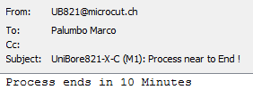

In the Subject you see always the Machine Number like “(M1)”. In the Normal Mode on the Parameter list 1 you can New define with the Parameter “Machine Number” the Number of the Machine like this…

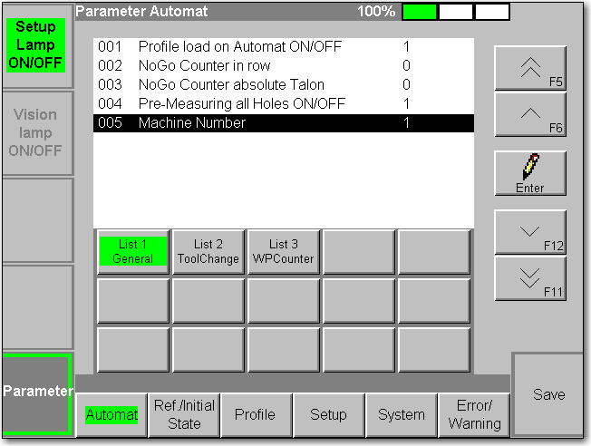

If you put for example the Value “2” then on the Subject appear “(M2)”. So you can identify from which Machine you received an E-Mail.

Note 1: When in the Automat an E-Mail will be send and an Error will be occure from the SMTP, then the Automat will be not stop. It works Normal along. At the End of the Automat when no MessageBox more appear, only then comes the Error like for example this:



Note 2: If you have Problem with the SMTP Server and you becomes each Time Error, then deactivate the E-Mail functionality by delete the Field with E-Mail:



Press Button ON, so that E-Mail do not more appear and Save it, then the E-Mail functionality is deactivated and no more Error from SMTP can appear.

Note 3: If the E-Mail functionality is activated and you start the Automat and after calculation of the End of cycle estimation Time is already less than one of the settled Time, then an E-Mail will send with the calculate Time that appears in the E-Mail how long it takes until the End of the Automat.

## Stop Machine after Hole Quality “NoGo maxTime”

If while work of a hole, the Process Time exceed the MaxTime, then this hole becomes the Quality “NoGo maxTime” (still equal like the previous Version) and new the Error   
“St1: Process time exceeded” will be set. The X/C Axis do not moves.

This error could appear for example when the Operator do not firm fix the Tool on the Spindle and while working the Tool is release from the Spindle. The hole will no more work and stop with the MaxTime. In this case it is possible that the Tool is in the hole, and it is fatal for the Tool if the X/C Axis moves. As this reason we define an error, so that the Machine stops without movement of the X/C Axis. Important is after that the Operator fix by Hand this Problem.

## Handscanner

With the Handscanner you have the possibility to Input Data automatically instead of a keyboard. For this it needs no Software Update. It works yet with previous Software version. The Machine M1 is yet ready. Important for the Handscanner is that it assist the keyboard emulation and have a USB Interface.

The Beckhoff Embedded-PC CX2020 has the Windows Embedded Standard 7P installed. It need no manually driver to install. You can connect the Handscanner to a USB-Port on the CX2020 and the Embedded-PC will automatically install the driver. As soon as the Handscanner cheep and lights red, then the Handscanner is Ready.

Important is that the Embedded-PC is configured with the English Keyboard, otherwise it will set not the right symbol.

For example we have here a QR-Code Barcode like this…



Start now the Automat with inactive State of the Process and it shows for example as follow:



Select the white field of the Talon Number and the Keyboard will be opening like as follow:

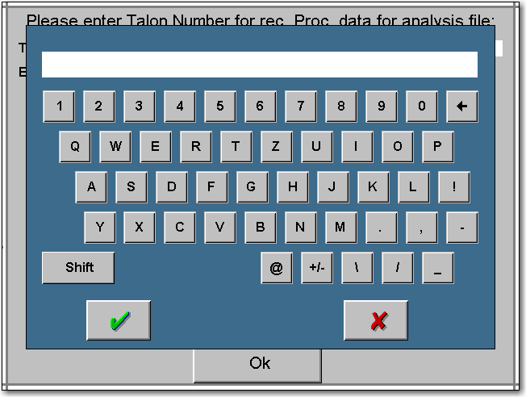

Be shure that you have not pressed the Shift Button, otherwise you will have lowercase letter.  
Shift Button not pressed:  Shift Button pressed: 

Now do the scan of the Barcode. The Keyboard will close automatically (in case that the Handscanner is configured with Return Key) and it shows as follow:

