  - 1.Hardware setup first ESP 32 have to configure with existing wifi system for that need to configure by using this screen our ESP32 wifi username password will be
  - Username: mgennpowerconfig
  - Password: password (it is default hard coded by the board provider)
  - Once I connect this ESP32 network then I will get this screen 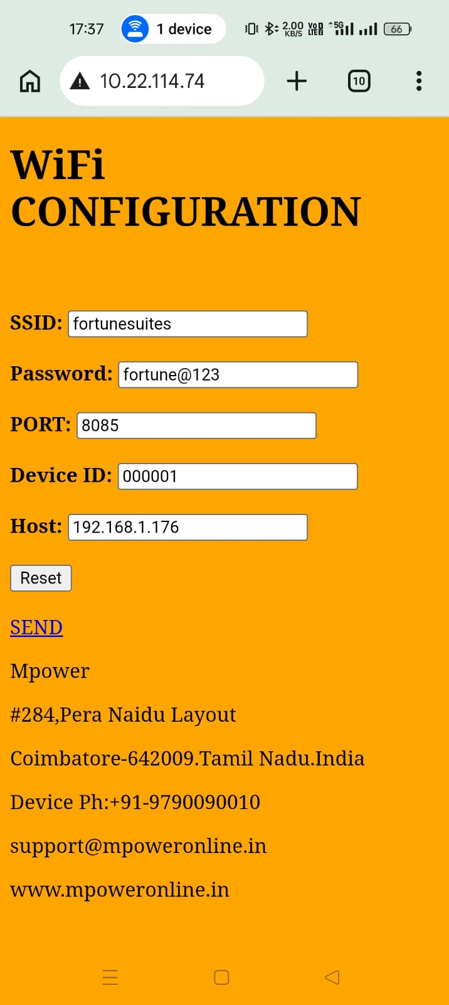
  - IN this screen I will provide Hotel SSID Details with portnumber . This Host IP is the server IP where my Powerhub application Running where my database is located. Once I click send then this information has send to the power box mother board. Now the system will be ready after 10 – 20 seconds for the front office automation with \MHMS (you can check this process in the very first I have provide you the PHP source file from that you can read the process.
  - Simply once the MHMS insert records into PowerLog (case sensitive hardcoded this table) table with flag=0 once this flag changes to 1 then the power automation box has taken the record and hit in the power box and it was success so this flag changes to 1 we can understand this way like this all the process will continue for this while insert into powerlog table currently microgenn using this api to insert record in the powerlog table by using the following api thisis for your reference
  - Power log table structure

  - 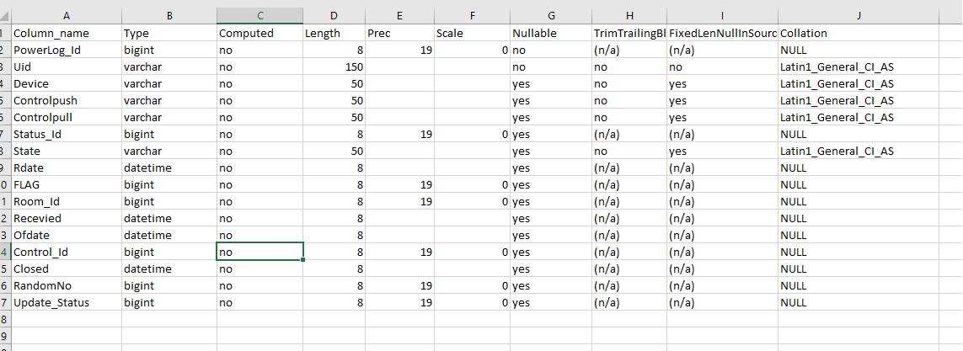
  - This is the API in this deviceno length should be 5 digits it is mandatory

  - 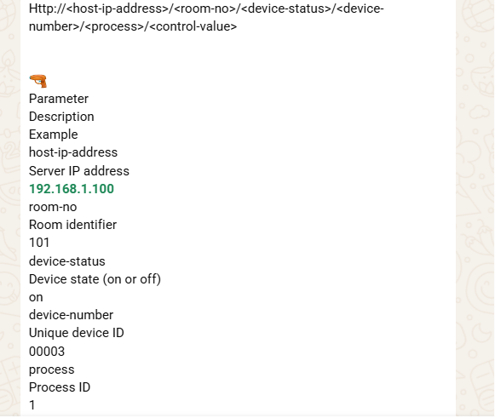
  - The mother board takes this information in the following api format
  - 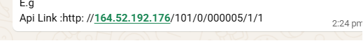
  - This api will work on http only it is hardcoded I trust .
  - If any records inserted into powerlog table with flag = 0 value then the motherboard will pick the record and hit into microprocessor by using this above api will run and after successful hit it will change the flag to 1 so that the system will understand and based on this it will change the icon / color change on the display screen on the power hub each and every control in a room controls can be single or multiple since a room have multiple controls like light,ac,geezer like based on the checkin if the room checkin as AC room then it should open light control and ac control simultaneously likewise in checkout it should cut off after the checkouttime(Bill prepared time)+grace hours time it should cut off. Likewise Cleaning after the auto cutoff time it should cut off the power like wise visiting and other process like maintanence or md checkin based on the auto cut off time it should cut off. For this operation we want a crystal clear report that each roomwise breakup when the room was open with checkin(GRcno),checkoutno(billno),roomno total used hourswith consumption details and hours details with date range filters with roomno,guestname,billno and username based export option to excel,pdf,mail and whatsapp.

