Luminis

installation manual

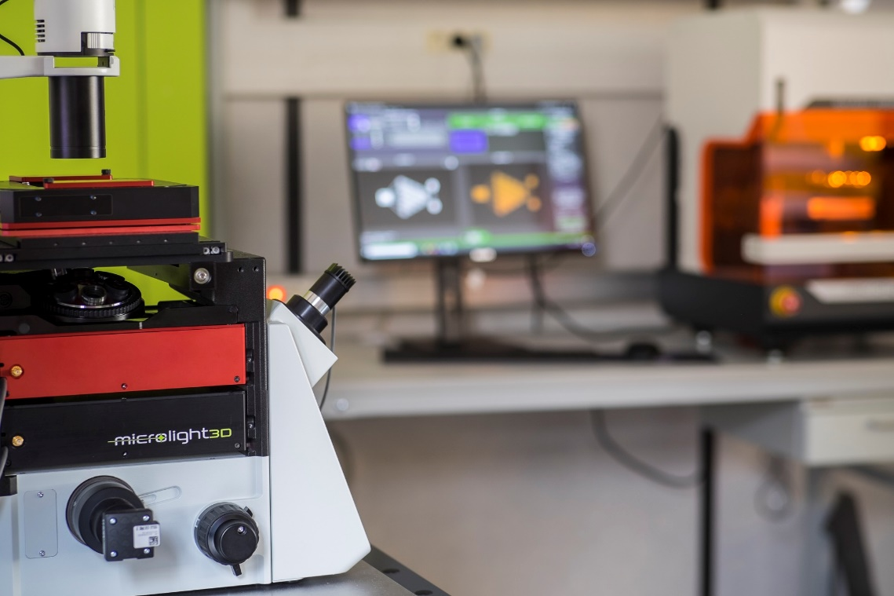

Table of content
1 Luminis Design 3
1.1 Dependencies 3
1.2 Installation 3
1.3 License 3
2 Luminis Print 4
2.1 Cameras 4
2.1.1 IDS UI and Thorlabs DCC Cameras 4
2.1.2 IDS U3 Cameras 4
2.2 Fabrication stage 5
2.2.1 Analog voltage control via NI-DAQ board 5
2.3 Lasers 5
2.3.1 Analog voltage control via NI-DAQ board 5
2.4 Large stages 5
2.4.1 MS2000 and Tiger ASI XY large stage controllers 5
2.4.2 MCS2 SmarAct large stage controllers 6
2.5 Auto-focus 6
2.5.1 Software auto-focus 6
2.6 Miscellaneous 6
2.6.1 Microlight light logo 6
2.6.2 Enabling dedicated GPUs 6
NVIDIA 6
3 Calibration 7

Luminis Design

Dependencies
Pior to installing Luminis, install all it’s dependencies. Luminis’ dependencies are all located in “Fichiers Installations\MicroFAB\Logiciels_MicroFAB\Luminis\Dependencies”. Dependencies are:
- .NET runtime 3.1 installed using “dotnet-runtime-3.1.32-win-x64.exe”;
- .NET Framework 4.8 installed using “ndp48-x86-x64-allos-enu.exe”.
Simply copy on the target machine’s file system and run all these installers sequentially and follow the standard installation procedure.

Installation
To install Luminis on a machine, copy the “\Fichiers Installations\MicroFAB\Logiciels_MicroFAB\Luminis\<VERSION>\<TARGET>\Luminis” folder in the machine’s file system, preferably somewhere not protected by administrator privileges. Here <VERSION> should be replaced the desired version of Luminis, generally the latest and <TARGET> by either “x86” or “x64” for 32bits and 64bits systems respectively.

License
To activate Luminis on a machine, run “Luminis.exe”, located in the Luminis folder. Running Luminis for the first time should start the license registration panel. Follow the instructions displayed on the panel:
- Generate a computer ID file (.cid);
- Create a license (.lic) using the CID file;
- Load the license using the registration panel.
To create a license, copy on the target machine’s file system and run the license generator located at “Fichiers Installations\Commun\Licence generator\LicenseGenerator.exe”. Enter the master password “sagittariusastar” and choose “Luminis” in the “Application” field. Enter a maximum version greater of equal than the installed Luminis version of the target machine and check desired optional modules for activation. Optional modules are:
- LargeXY, to add support for large stage on the XY plane;
- LargeZ, to add support for large stage on the Z axis;
- MachineControl, to add support for machine control (Luminis Print).
If “MachineControl” is added to the license, be sure to follow section 2 of this manual to install machine drivers. Load the previously generated computer ID using the “Load .cid file…” button and generate the license using the “Generate license file…” button. Load the generated license back in the Luminis registration panel.

Luminis Print
To install Luminis Print for machine control, first follow all installation steps of section 1 to install Luminis Design. Be sure to check the “MachineControl” license option in section 1.3.

Cameras
If the target machine has one or more cameras, follow the installation steps of the sub-sections bellow corresponding to the installed camera models. Luminis currently only supports one concurrent camera.

IDS UI and Thorlabs DCC Cameras
To add camera support for IDS UI or Thorlabs DCC models to Luminis first install the IDS uEye driver located at “Fichiers Installations\Commun\Drivers\Camera_IDS_UI_THORLABS_DCC\Dependencies\uEye64_49230_WHQL.exe”. Copy on the target machine’s file system and run the EXE file and follow the standard installation protocol. Then, copy the content the from “Fichiers Installations\Commun\Drivers\Camera_IDS_UI_THORLABS_DCC\<VERSION>” into the target Luminis installation folder. <VERSION> should be replaced by the desired driver version, generally the latest.
Some older Thorlabs cameras such as the C1285R12M will need the ThorCam software to be installed in addition to IDS uEye “Fichiers Installations\Commun\Drivers\Camera_IDS_UI_THORLABS_DCC\Dependencies\thorcam_x64.exe”.

IDS U3 Cameras
To add camera support for IDS U3 models, install the IDS peak driver located at “Fichiers Installations\Commun\Drivers\Camera_IDS_Genicam\Dependencies\0f_ids_peak_2.1.0.0.exe”. Copy the installer on the target machine’s file system and run the EXE file and follow the standard installation protocol. Then, copy the content the from “Fichiers Installations\Commun\Drivers\Camera_IDS_Genicam\<VERSION>” into the target Luminis installation folder. <VERSION> should be replaced by the desired driver version, generally the latest.
Note that the IDS peak driver can be used to drive IDS UI or Thorlabs DCC camera models. To enable this option, first install the IDS uEye driver following the instructions In section 2.1.1. Then, install the IDS peak driver as described previously but choose the “Custom installation” option and check the “uEeye Transport Layer” option in the feature selection panel.

Fabrication stage

Analog voltage control via NI-DAQ board
If a NI-DAQ board for analog stage control is installed in the target machine, the NI-DAQ driver is required. To install the NI-DAQ driver first install the NI-DAQ MX driver at “Fichiers Installations\Commun\Drivers\NIDaqMX\Dependencies\ni-daqmx_22.8_online.exe”. Copy the installer on the target machine’s file system and run the EXE file. During module selection in the driver installer be sure .NET Framework 4.0 and 4.5 are checked as chown in Figure 1. Once the driver installation done, simply copy the content the from “Fichiers Installations\Commun\Drivers\NIDaqMX\<VERSION>” into the target Luminis installation folder. <VERSION> should be replaced by the desired driver version, generally the latest.
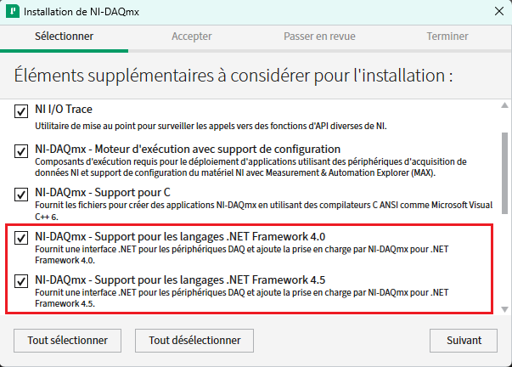Figure 1: NI-DAQ MX .NET Framework option selection during driver installation

Lasers

Analog voltage control via NI-DAQ board
If a NI-DAQ board for analog laser control is installed in the target machine, the NI-DAQ driver is required. It is the same driver used for analog fabrication stage control and light logo control. To install it, follow instructions in section 2.2.1.

Large stages

MS2000 and Tiger ASI XY large stage controllers
In order to add ASI XY large stage using MS2000 or Tiger controllers support to Luminis, the ASI driver must be installed and the LargeXY License module must be activated in the target machine’s luminis license. To install the driver, install the CP210x USB to UART Bridge VCP Drivers located at “Fichiers Installations\Commun\Drivers\Stage_ASI_MS2000_TIGER\Dependencies\CP210x_VCP_Windows” using “CP210xVCPInstaller_x86.exe” on a 32bit machine and “CP210xVCPInstaller_x64.exe” on a 64bit machine. Copy the installer on the target machine’s file system and run the EXE file. Then, copy the content the from “Fichiers Installations\Commun\Drivers\Stage_ASI_MS2000_TIGER\<VERSION>” into the target Luminis installation folder. <VERSION> should be replaced by the desired driver version, generally the latest.

MCS2 SmarAct large stage controllers
If the option LargeZ is activated in the target machine’s Luminis license, the SmarAct driver must be installed. To install the driver first install its dependencies at “Fichiers Installations\Commun\Drivers\Stage_SmarAct_MCS2\Dependencies”. Dependencies for SmarAct control are:
- FTDI CDM drivers installed using “CDM21228_Setup.exe”;
- MCS2 SmarAct driver installed using “MCS2_Installer_2.1.12.exe”.
Copy on the target machine’s file system and run all these installers sequentially and follow the standard installation procedure. Then, copy the content the from “Fichiers Installations\Commun\Drivers\Stage_SmarAct_MCS2\<VERSION>” into the target Luminis installation folder. <VERSION> should be replaced by the desired driver version, generally the latest.

Auto-focus

Software auto-focus
To add software auto-focus support to Luminis, copy the content the from “Fichiers Installations\Commun\Drivers\AutoFocus_Software\<VERSION>” into the target Luminis installation folder. <VERSION> should be replaced by the desired driver version, generally the latest.

Miscellaneous

Microlight light logo
If a NI-DAQ board for light logo control is installed in the target machine, the NI-DAQ driver is required. It is the same driver used for analog fabrication stage control and light logo control. To install it, follow instructions in section 2.2.1.

Enabling dedicated GPUs
If the PC on which Luminis is installed has a dedicated GPU one might want to configure it to be used when using Luminis to boost 3D performances. To to so, the GPU driver must be configured to use the dedicated GPU for OpenGL rendering. The process will change depending on the GPU manufacturer:

NVIDIA
Open NVIDIA control panel. In “Manage 3D settings” change the base profile parameter “OpenGL Rendering GPU” to the dedicated GPU (see Figure 2).
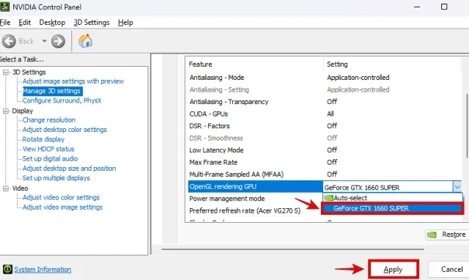Figure 2: OpenGL rendering GPU option change in NVIDIA control panel

Calibration
Once the Luminis installation complete, refer to the calibration manual at “Fichiers Installations\MicroFAB\Logiciels_MicroFAB\Luminis\configuration_manual_luminis.pdf” to configure the software.

