Luminis design

user manual

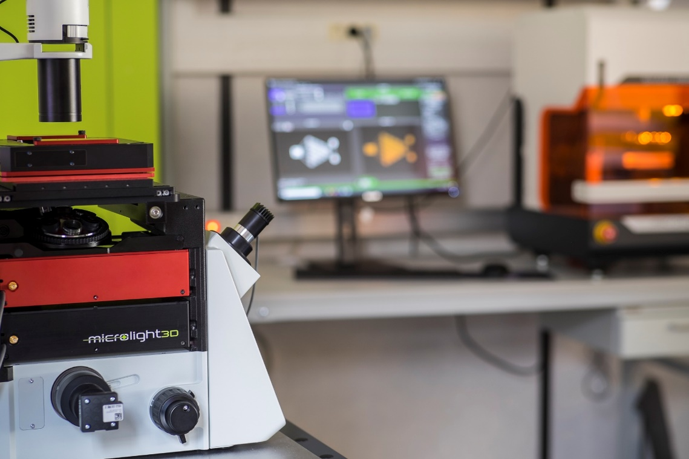

Table of content
1 About Luminis 3
2 Quick start 3
2.1 Overview 3
2.2 Basic use 4
3 Basic features 4
3.1 Entity manipulation 4
3.2 3D view navigation 6
3.3 Fabrication task parameters 8
3.4 Assemblies and Blueprint 9
4 Advanced features 10
4.1 Advanced slicing options 10
4.2 Transform pivot points 12
4.3 Object grid cut (Large stage only) 12
4.4 Fabrication task replications 13
4.5 Fabrication simulation 14
4.6 OBJ as Tasks 15
4.7 Resist profiles 17
5 Scripting 17
6 Keyboard shortcuts 17

About Luminis
Luminis is a slicing software for Microlight3D’s two photon polymerization 3D printer line. It is packed with easy to use and powerful features to prepare 3D objects for micro-meter scale printing. Luminis does not provide any tools to create or edit 3d objects, it is not a CAD software. However, it includes features to prepare large scale fabrications and large replications easily.

Quick start

Overview
The main user interface is designed to be read from left to right. It is split into three main panels shown in Figure 1:
- the object panel (A) on the left side, used for 3D object manipulation;
- the 3d view (B) in the center, where all 3D objects and fabrication tasks will be visible;
- the fabrication task panel (C) on the right side, used for fabrication task manipulation;
A button bar for easy access to the main features of the software is located above the three main panels. Additional features specific panels might appear during use.
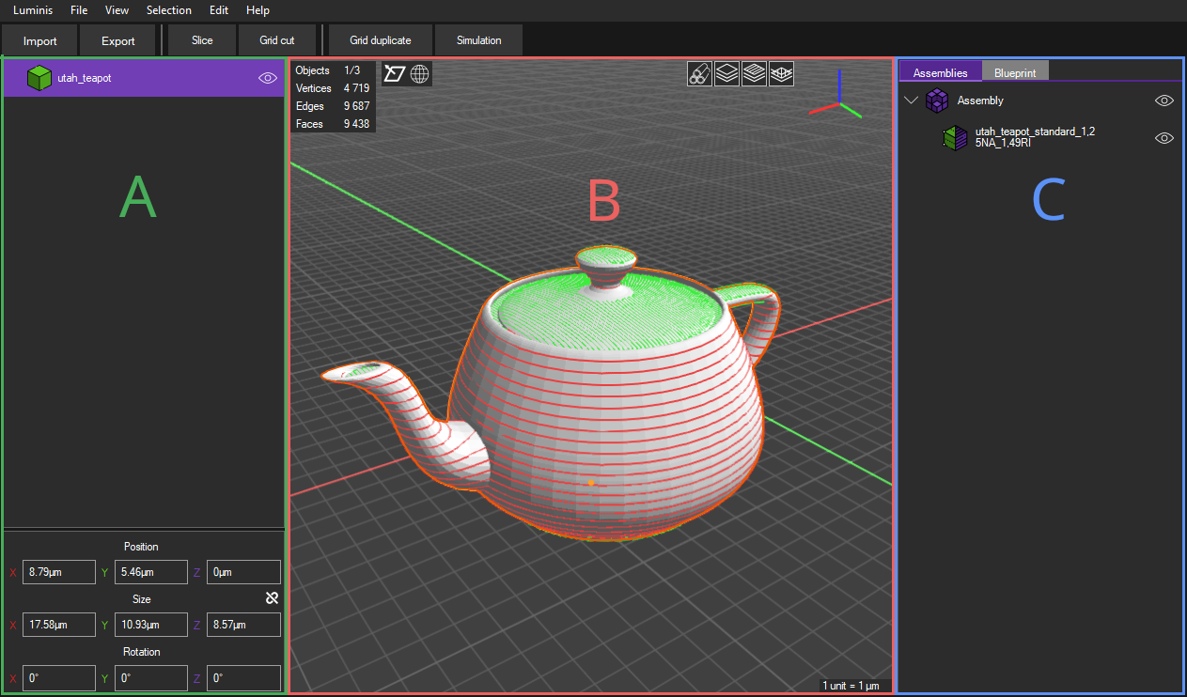Figure 1: Luminis' main user interface

Basic use
To prepare your first object for fabrication follow the steps below:
- Start Luminis ;
- Click on the “import” button on the left side of the top button bar (Ctrl+i);
- Select one or several 3D object file from your system in one of the following formats : STL, OBJ ;
A pop-up window appears, shown in Figure 2.
- If you have already positioned your object(s) in your CAD or modeling software and wish to keep that position in Luminis, select “Yes”. Select “No” otherwise;
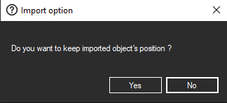Figure 2: Object reset dialog on import
Your object(s) appears in the left panel and in the 3D view in the center.
- Click on the “slice” button on the top button bar;
The slice menu appears next to the left panel.
- Select the numerical aperture of the objective you will use for the fabrication;
- Input the refractive index of the resist you will use during the fabrication;
- Click on the “slice” button at the bottom of the slice menu;
The fabrication task(s) for your object appears on the right panel and overlays your object(s) in the 3D view.
- On the bottom of the right panel, under the “General” section, choose an appropriate laser power and a speed value;
- Your fabrication is ready, you can export it by clicking on the “export” button on the top button bar (Ctrl+e);

Basic features

Entity manipulation
Luminis provides all the manipulation features you could expect for objects and tasks such as 3D transformation, addition/deletion and duplication. All manipulations can be performed on a single entity or on a selection of entities. The features can generally be accessed via multiple ways: through custom panels for easy access, the top menu bar or the context menus when right clicking on the desired entity. Entity manipulation features include:
- Transform
  - 3D object
3D object transformation include position, size, scale and rotation. It can be accessed via the transform panel as shown in Figure 3. The transform panel will appear on the bottom left of the interface, below the object list when at least one object is selected. Regarding scale, either each axis values can be modified individually or can be linked to keep scale ratio. To switch between these two modes, click on the link button next to “size” in the transform panel in Figure 3. If the link is crossed axis values will be individually modified, otherwise scale ratio will be kept.
  - Fabrication task
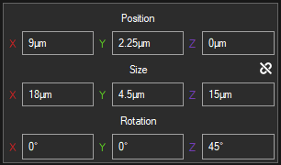Figure 3: Object transform panel
For fabrication tasks, only position is editable as one can see in Figure 4. However, fabrication tasks have two different positions: one for small stage and one for large stage (if your machine supports it). In similar fashion to 3D object transform, position editing is available from a panel that appears on task selection, at the bottom right of the interface.
- Show/Hide in 3D view (Ctrl+h);
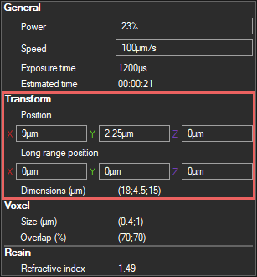Figure 4: Fabrication task parameters panel exposing task transform options (highlighted red)
- Remove (Ctrl+Del);
- Duplicate (Ctrl+d);
- Rename (Ctrl+Tab);
Except for transforms, all manipulations can be accessed either by right clicking on a selection of entities, under the “selection” menu in the top menu bar or using their given keyboard shortcut.

3D view navigation
The 3D view can be navigated into using your mouse. A left click drag will orbit the camera around a center point. A right click drag will move that center point in a panning motion. A mouse wheel roll will move in on or out of the center point (dolly motion).
The center point is set to the world origin on startup and on 3D objects or fabrication tasks centers when added. It can be reset to these default values by selecting View>Fit to selection (Ctrl+0) or View>Fit to origin (Alt+0). Moreover, the camera can be aligned to a specific world axis using:
- “Front” (-X) (Ctrl+1),
- “Back” (+X) (Alt+1),
- “Left” (-Y) (Ctrl+3),
- “Right” (+Y) (Alt+3),
- “Top” (-Z) (Ctrl+7),
- “Bottom” (+Z) (Alt+7)
under the “View” menu in the top menu bar.
Several overlay options are available for both 3D objects and fabrication tasks within the 3D view. For 3D objects, two options exist:
Display face orientation (Ctrl+n) | Displays 3D objects facet orientations. Facets pointing outward are displayed in blue and facets pointing inward in red. If this overlay is disabled, facets facing inward will not be displayed, resulting in weird looking objects. Facet orientation should not impact slicing quality but are generally an indicator for bad object quality.
Display edges (Ctrl+w) | Displays edges of 3d objects, useful for checking model topology.

Four more overlay options are available, this time for fabrication tasks:
Real voxel size display | Displays task trajectories using real voxel shape display rather than simple lines (only on selected task for performance reasons).
Display layering
Display hatching
Display infill | See section for details on what are layering, hatching and infill.

Finally, useful information is displayed on the 3D view as shown in Figure 5 corners such as selected entities statistics (A) (entity, vertex, edge and face counts), a view orientation helper (B) and the current grid scale (C).
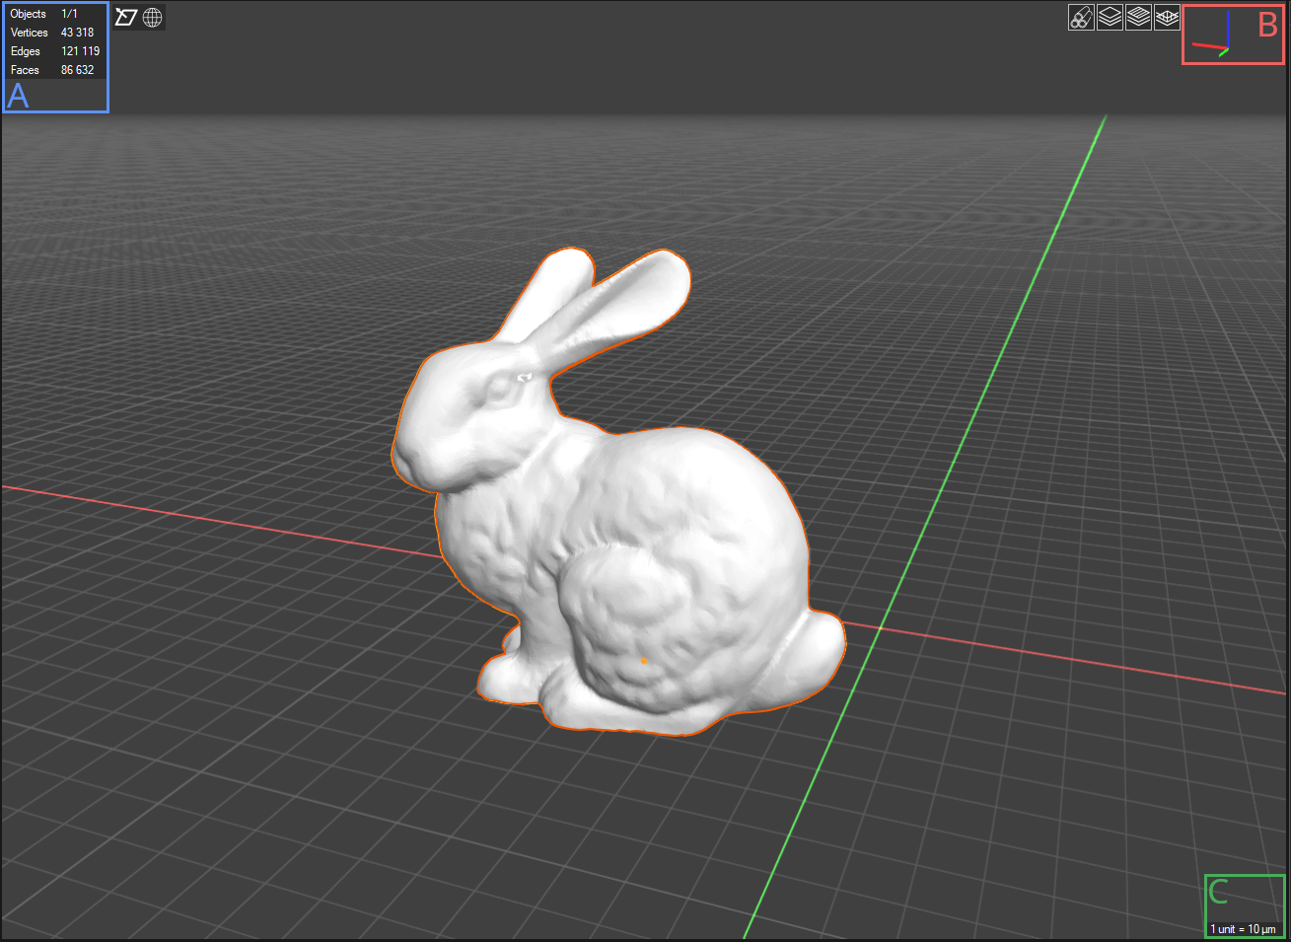Figure 5: Luminis' 3D view

Fabrication task parameters
When one or several fabrication tasks are selected, a panel appears below the task list in the interface’s bottom-right (Figure 6). This panel displays all the important information about the focused task including: the estimated printing duration, the total dimensions of the task, the expected voxel size used by the slicer and the resist refractive index also used by the slicer. All non-editable fields would require re-slicing the source object to be modified.
Under the “General” section are two editable fields: power and speed. Power relates to the laser gain in percent of the maximum laser power. The speed directly translates to the exposure time spent on each voxel. At this stage of the process an accurate estimation of the printing time cannot be computed. Therefor the estimated printing time resulting from the speed input is a rough estimate and should be trusted accordingly. The exposure time is indicated below the speed for convenience and is given by the expression below.
Given V_{x} the horizontal voxel size in µm, VO_{x} the horizontal voxel overlap in µm and S the speed in µm/sec, the exposure time S in sec is given by
The laser power needed to polymerize a resist depends on several factors such as the resist itself, the laser max power (which varies between lasers), the proximity to already polymerized resist and the speed. One is advised to perform dose tests on power and speed for new resists and complex fabrications in order to optimize results. The “Transform” section is detailed in section 3.1.
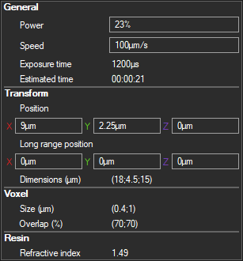Figure 6: Fabrication task parameters panel

Assemblies and Blueprint
On the right panel are two tabs: “Assembly” and “Blueprint”. Both of these tabs contain the same list of fabrication task but are organized differently. The “Assemblies” tab list contains two types of objects: assemblies and fabrication tasks. Assemblies are just containers for tasks and only one assembly is really needed to store all the tasks. The “Blueprint” list, as shown in Figure 7, only contains tasks. Blueprint tasks are ordered from top to bottom in print order. This order can be modified using the arrows next to a task or by using shortcuts Ctrl+Up and Ctrl+Down to respectively move up or down a selection of tasks.
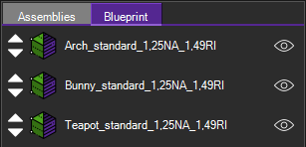Figure 7: Fabrication taks blueprint list

Advanced features

Advanced slicing options
Luminis offers a wide range of options to slice your objects. These options are split in four tabs: General, Advanced, Envelop and Infill. The general tab in Figure 8 contains simplified options to configure a slicing in a few clicks. It includes:
- The objective used for the fabrication;
- The resist used for the fabrication;
- The general quality of the finished object, the better the quality the longer the print time;
The advanced slicing tab in Figure 9 contains more precise parameters to control the print quality:
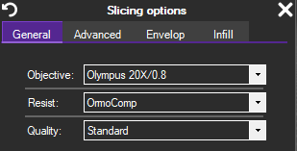Figure 8: General tab of the object slicing menu
- The slicing direction, which is used to optimize the surface quality on desired parts of objects (e.g. a horizontal slicing (+X) for micro-lens gives better surface quality than the default vertical one (+Z));
- The custom cut size, used to control the automatic cuts performed when the sliced object is larger than the fabrication stage area.
- The fabrication start order, either from beginning or end. Useful for rare special cases (e.g. start fabrication from the top of the object if it is hanging on a structure);
- The custom voxel dimensions and overlap, which influence the gaps between layers. A smaller voxel size or a bigger voxel overlap will typically give better surface quality at the cost of over-polymerizing the resist, making it more prone to damage.
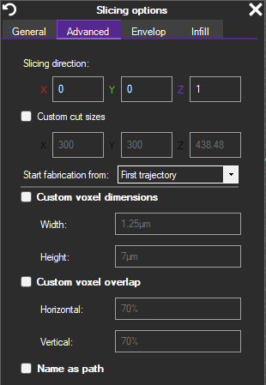Figure 9: Advanced tab of the object slicing menu
The envelop slicing in Figure 10 gives control over the outer shell thickness of the slicing result. The “inner layers” field controls how many layers are added inside the model. The spacing between layers is set to the horizontal voxel size by default but can be modified by enabling the “custom spacing” field.
Finally, the infill tab controls the filling of the inside of the model. Be wary that infill lengthen the print time quite a lot and object filling can generally be performed after the fabrication by post baking the resist after development. From this tab can also be controlled the fill percentage.
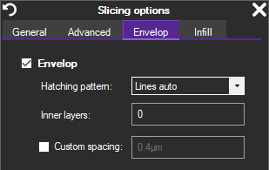Figure 10: Envelop tab of the object slicing menu

Transform pivot points
All entity transformations are performed on the focused object’s center point by default. The center point of an entity is on the center of its axis aligned bounding box (AABB) on X and Y and on the minimum of the AABB on Z. The pivot point used for transforming entities can be changed from “Selection>Transform pivot” to one of the following options:
- Focused object: described above;
- Median point: the median point of all selected entities centers;
- Individual origin: entities are transformed around their respective center;
- Bounding box min: minimum of the AABB of the entities on X, Y and Z.
Note that for fabrication task transformations, only the “Focused object” and “Bounding box min” pivots are available. Moreover, rotation is not permitted when the “Bounding box min” pivot point mode is selected for performance reasons.

Object grid cut (Large stage only)
When an object is too large to be printed in the printing area alone, it can be cut into smaller parts, each fitting in the small stage ranges. This is done automatically when slicing a large object though the user will be warned by a pop-up (Figure 11) before the slicing starts.
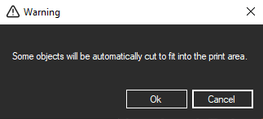Figure 11: Automatic grid cut warning on slicing pop-up
If the automatic cut result is not satisfying (e.g. a cut is performed on a structurally important part which might result in a collapse of the structure), one can perform a custom grid cut on one or several objects prior to slicing them. This feature is accessible via “Selection > Grid cut” or from the top button bar. On the grid cut panel shown in Figure 12 are three parameters:
- The cell size, to set the size of the cells of the cut grid;
- The grid offset, to adjust the position of the cut grid;
- The fill holes option, if enabled, cut parts will be closed.
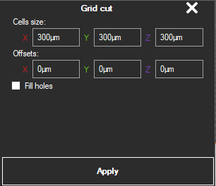Figure 12: Object grid cut panel

Fabrication task replications
The fabrication task replication feature enables the user to prepare dose tests, tasks arrays and scaffolds in just a few clicks. To access it, select at least one fabrication task and either click on the “grid duplicate” button in the top button bar or go to “Selection > Grid duplicate”. A panel will appear next to the fabrication task list panel shown in Figure 13. The grid duplication can be performed from here using the following parameters:
- Count;
The number of duplicates on world X, Y and Z axis.
- Position offsets;
The small stage position offset, relative to the previous duplicate, to be added to a given duplicate;
- Long range position offsets;
Same as above but for large stage (only for large stage option);
- Power offset;
The laser power offset, relative to the previous duplicate, to be added to a given duplicate. The X, Y and Z values are combined in function of the duplicate position in the duplication grid.
- Speed offset;
Same as above but for print speed;
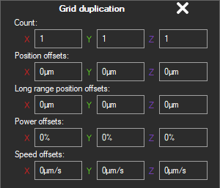Figure 13: Fabrication task grid duplication panel

Fabrication simulation
In order to control the slicing quality of one or several fabrication tasks, one can use the fabrication simulation feature. It can be used to to navigate through the fabrication trajectories in print order. This is useful to detect detached parts during fabrication that might sink mid print, over-polymerized zones or un-optimized trajectories. The simulation panel as shown in Figure 14 can be accessed through “Selection > Fabrication simulation” (Ctrl+P) or via the “Simulation” button in the top button bar.
The simulation can be navigated through a vertical track bar. By default it increments path by path. For a more fine control, hold Ctrl to switch to segment by segment increments. The track bar is controlled by sliding the cursor or using the mouse wheel while over it.
At the bottom of the simulation panel is a play button which start/stop the real time simulation. The track bar will not be modifiable while the real time simulation is playing. Speed modifier settings for the real time simulation are located above the play button. The left speed modifier will play the fabrication using the speed set in the task parameters. Note that if the speed for a task isn’t set or is set to zero, the real time fabrication simulation will not start.
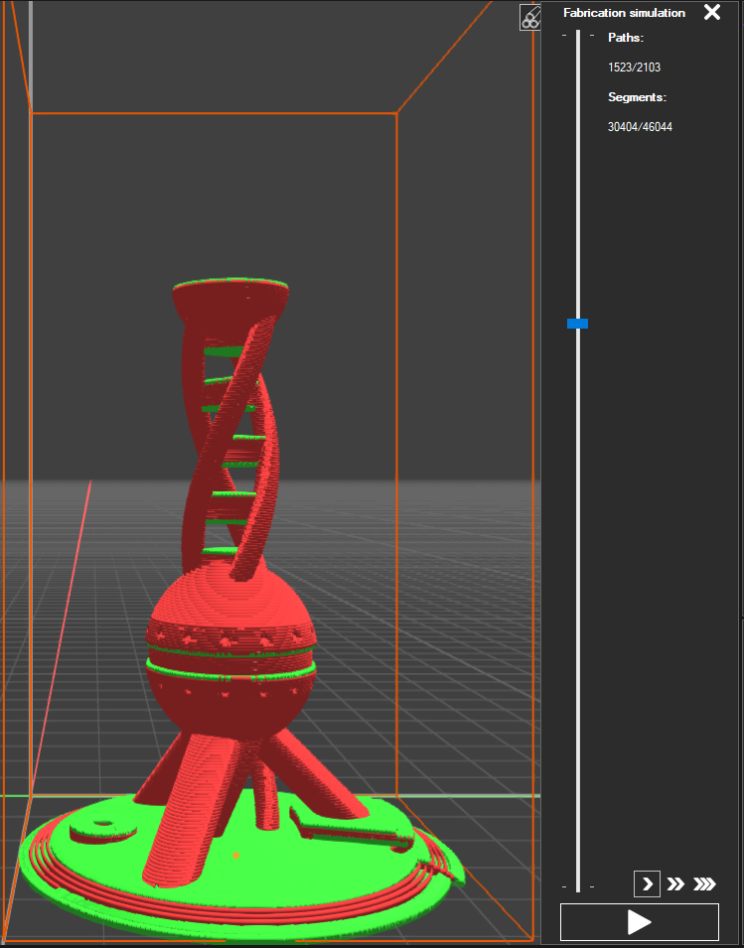Figure 14: Fabrication task simulation panel

OBJ as Tasks
Some users might need to print objects made of custom trajectories such as scaffolds, lines or individual voxel arrays. For this need, Luminis implements the feature “import OBJ as task” (Alt+i). It is an alternative import mode for importing objects in wavefront format (OBJ) directly as tasks by transforming edges into print trajectories. Bear in mind that the modeling of the desired object will be exclusively made in a modeling or CAD software as Luminis does not support geometry creation and modification. Below are a few example applications of this feature.

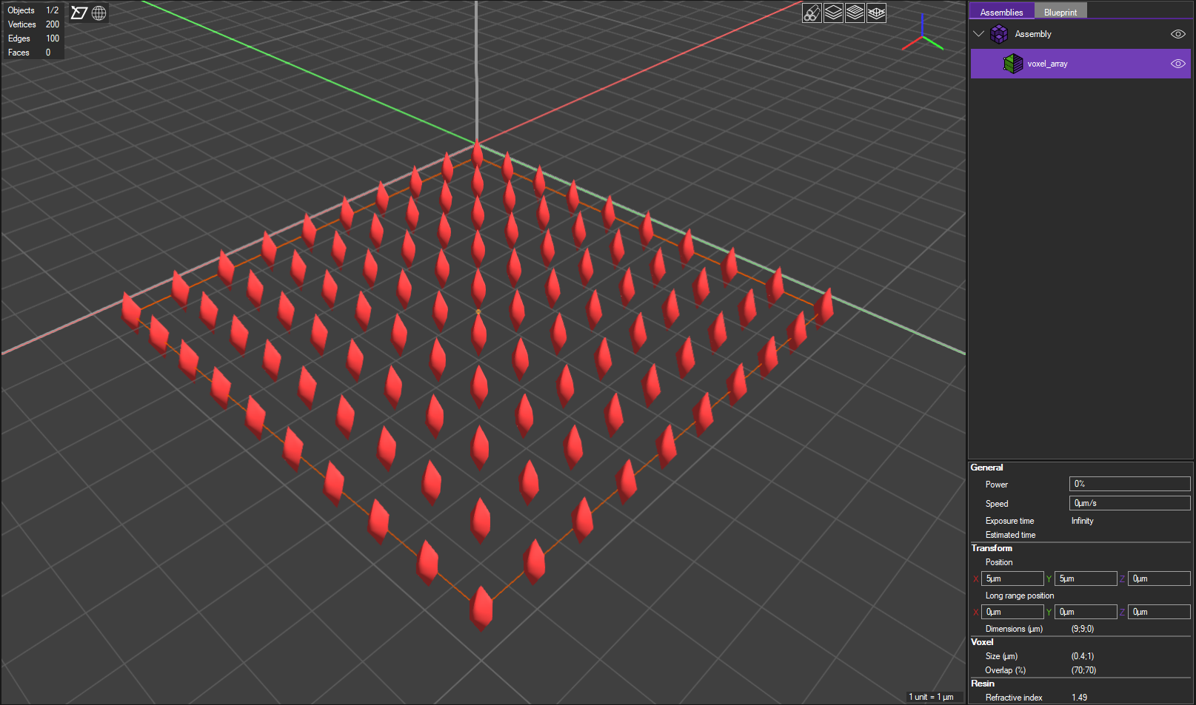Figure 15: Single voxels array imported using the import as task feature
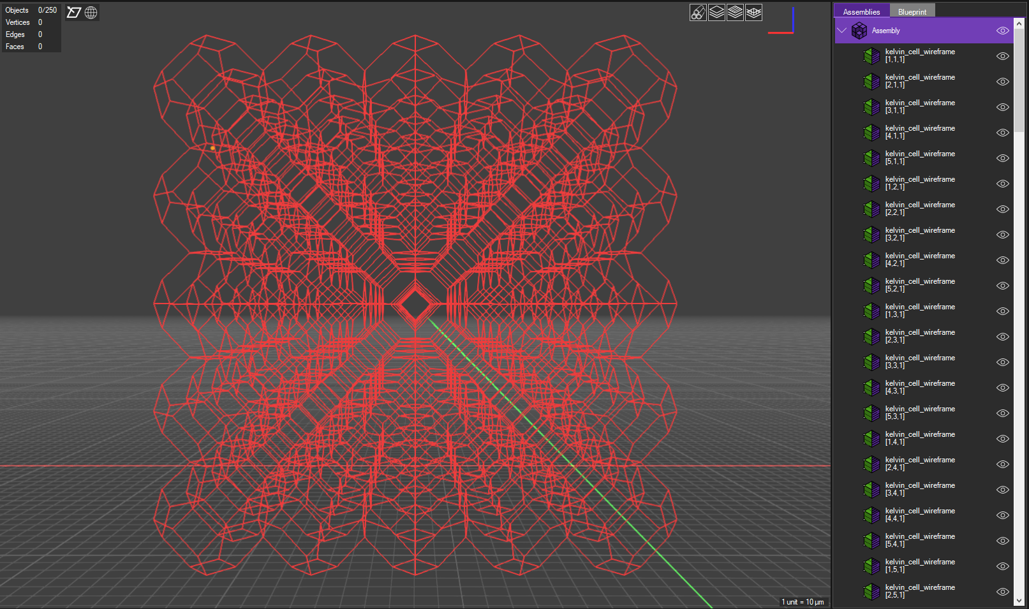Figure 16: Optimized Kelvin cell scaffold imported using import as task feature

Resist profiles
Resists are defined in Luminis’ configuration file “SLICING_PRESET.xml”. They can be added and modified by the user through this file. A resist profile is defined as shown in Snippet 1. I contains:
- The resist name in the “Model” attribute of the “Resist” element;
- its refractive index under the “RefractiveIndex” element;
- and its laser curve defined by several “LaserCurveElement” elements;
The laser curve maps a resist thickness to a laser power offset. The laser offset is meant to be added to the laser power set for the fabrication. Each laser curve element sets a point in the laser curve. A point in the curve is defined by a two dimensional vector. The X component of the vector is the traversed resist thickness (in µm) and the Y component the associated laser offset (in percent). In Snippet 1 for example, the laser curve is a line defined by two points. The first one, line 3, sets the laser offset to 0% at thickness 0µm. The second, line 4, sets the laser offset to 1,2345% at thickness 450µm.
Snippet 1: Resist profile definition exemple
1 <Resist Model="MyResist">
2 <RefractiveIndex Unit="none" Type="Single"> 1.33 </RefractiveIndex>
3 <LaserCurveElement Unit="none" Type="Vector2"> (0;0) </LaserCurveElement>
4 <LaserCurveElement Unit="none" Type="Vector2"> (450;1.2345) </LaserCurveElement>
5 </Resist>
The default resist set on application start can be changed in the <General> element using a <DefaultResistIndex> element, defining the default resist’s index. Indices are defined by the order of definition of the resists and start from zero. In example Snippet 2, the first resist defined is set as the default startup resist.
Snippet 2: Example of resist profil definition
1 <General>
2 <DefaultResistIndex Unit="none" Type="Int32"> 0 </DefaultResistIndex>
3 </General>

Scripting
Luminis supports Python scripting enabling Luminis advanced user to automate, optimize and customize their 3D micro-printing process. To execute a script, simply import a python script through the standard import process. For everything else related to Python scripting, refer to the Luminis scripting documentation.

Keyboard shortcuts
Function | Shortcut
Undo | Ctrl+z
Redo | Ctrl+Maj+z
Import | Ctrl+i
Import as task | Alt+i
Export | Ctrl+s
Show/Hide | Ctrl+h
Delete | Ctrl+Del
Duplicate | Ctrl+d
Rename | Ctrl+Tab
Fit 3d camera to selection | Ctrl+0
Fit 3d camera to world origin | Alt+0
Align 3d camera with world -X axis (front) | Ctrl+1
Align 3d camera with world +X axis (back) | Alt+1
Align 3d camera with world -Y axis (left) | Ctrl+3
Align 3d camera with world +Y axis (right) | Alt+3
Align 3d camera with world -Z axis (top) | Ctrl+7
Align 3d camera with world +Z axis (bottom) | Alt+7
Display face orientations | Ctrl+n
Display edges | Ctrl+w
Move up in Blueprint list | Ctrl+o
Move down in Blueprint list | Ctrl+l
Select next entity below | Down
Select next entity above | Up
Focused object pivot mode | Maj+F1
Median point pivot mode | Maj+F2
Individual origins pivot mode | Maj+F3
Bounding box min pivot mode | Maj+F4
Fabrication simulation | Ctrl+p
Grid cut | Ctrl+Alt+x
Grid duplication | Ctrl+Alt+d

