Luminis print

user manual

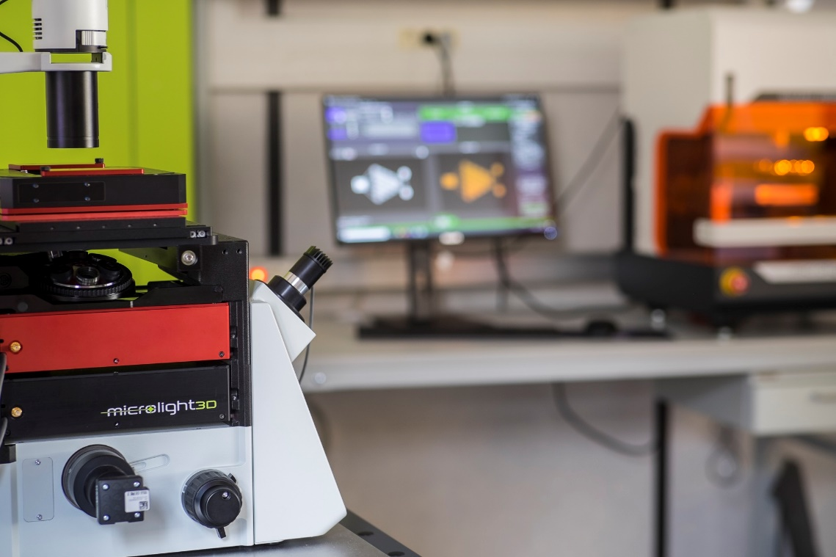

Table of content
1 About Luminis printing tab 3
2 Quick start 3
2.1 Overview 3
2.2 Basic use 4
3 Features 5
3.1 Camera 5
3.2 Upside-Down mode 8
3.3 Objective selection 8
3.4 Large stages homing 10
3.5 Hardware control 10
3.6 Auto-focus 12
3.7 Optimized laser gain 12

About Luminis printing tab
Luminis is a FAO software for Microlight3D’s two photon polymerization 3D printer line. It is packed with easy to use and powerful features to prepare 3D objects for micro-meter scale printing as well as printing them. The printing tab groups all the tools needed to print any objects with ease.

Quick start

Overview
Similarly to Luminis’ design tab, the print tab is split into three panels designed to be read from left to right. As shown in Figure 1, these panels are:
- the fabrication task panel (A) on the right side, used for fabrication task manipulation. Carried on from the design tab, it has exactly the same features;
- the camera view (B) in the center. Used for focus, alignment and fabrication monitoring;
- the hardware controllers (C) on the left side, used to monitor and control machine components.
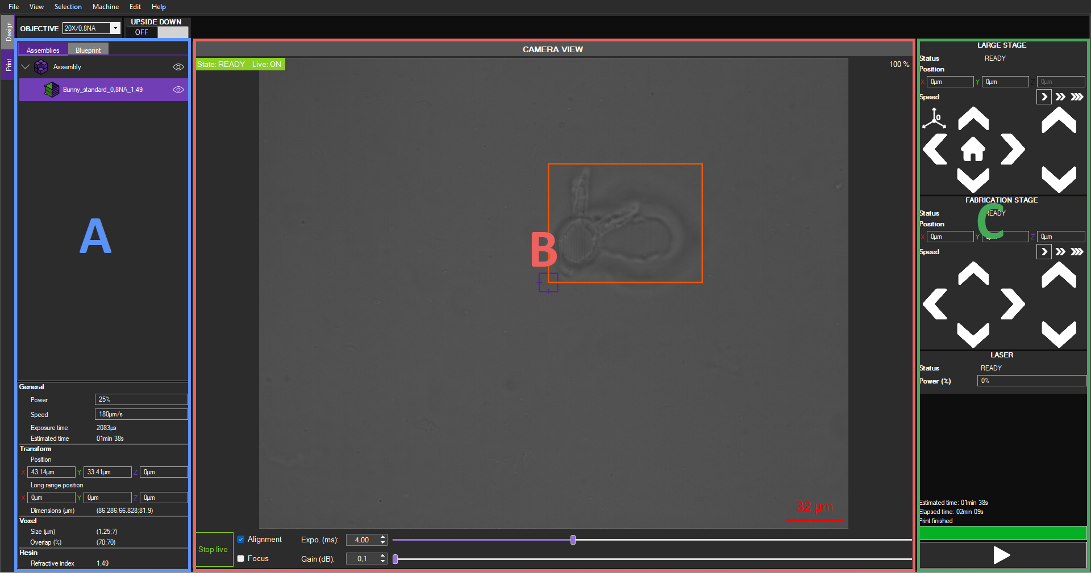Figure 1: Luminis’ print tab main view

Basic use
To print your first object follow the steps bellow:
- For importing and slicing objects refer to the design tab documentation;
- Switch to the print tab;
- Make sure all component status are in the “READY” state (right panel for stages and laser, center panel for camera). As reference, the large stage controller is ready in Figure 2;
- Start camera view by clicking the  button in the bottom left corner of the center panel;
- Switch camera view to alignment mode using the checkbox next to the start live button;
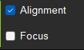
- Move to the desired printing location using the directional arrows or the numeric box of the stage controller;
- Set the origin as the chosen position using the  button. Stage position will be set to zero;
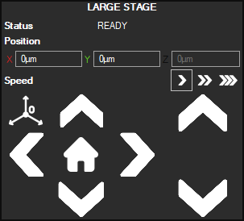Figure 2: Large stages control panel
- Switch camera view to focus mode;
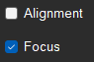
- Perform manual focus;
- Switch camera view back to alignment mode;
- Start fabrication using the start button on the bottom right;


Features

Camera
The camera view can be used in two distinct modes: focus mode, shown in Figure 3, and alignment mode, shown in Figure 4. In both these modes, a purple target shows where the laser focus should be. The focus target can be:
- Moved using ctrl + left click and drag;
- Resized horizontally using ctrl + scroll wheel;
- Resized vertically using ctrl + scroll wheel;
- Hidden using the context menu (right click) shown in Figure 5.
A scale bar is always present on the bottom right of the camera view (see Figure 3). The correct objective must be selected for the scale bar to display correctly. For more information on objective selection see section 3.3.
When in focus mode, the camera view is zoomed and centered around the focus target to ease focus search. The exposure time and gain are maxed out to be able to see the laser spot clearly.
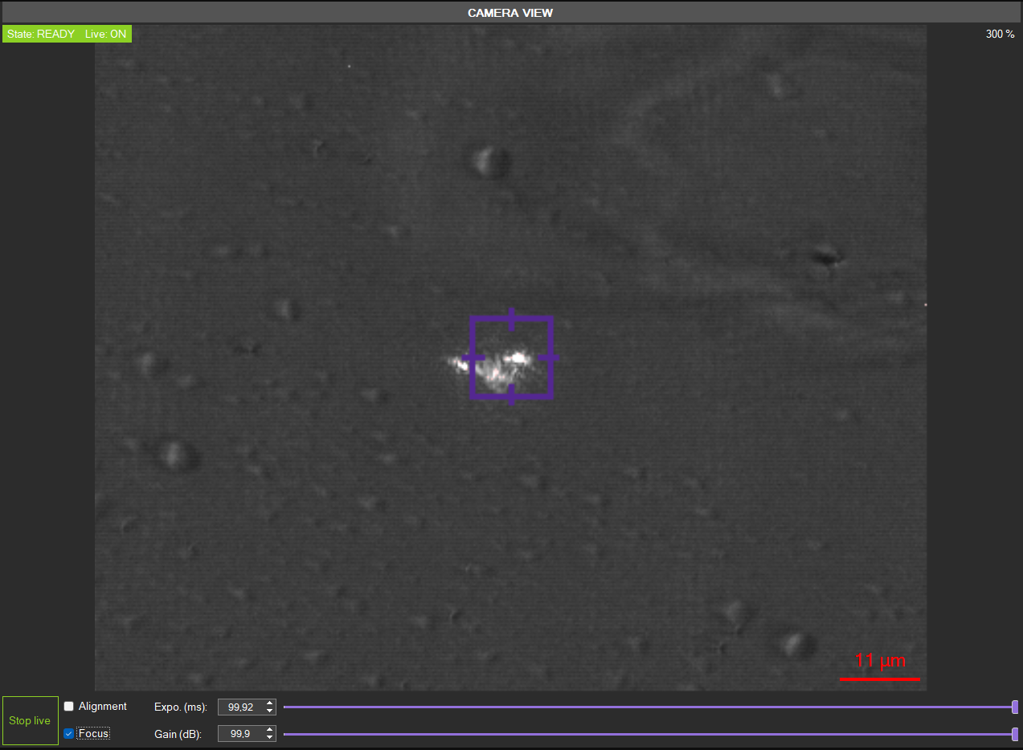Figure 3: Camera view in focus mode
As shown in Figure 4, rectangles delimiting fabrication tasks are overlayed onto the camera view. These rectangles allow for precise alignment between fabrication tasks as well as with existing features on the substrate. In this mode, exposure time and gain are adjusted to be able to see fabricated objects.
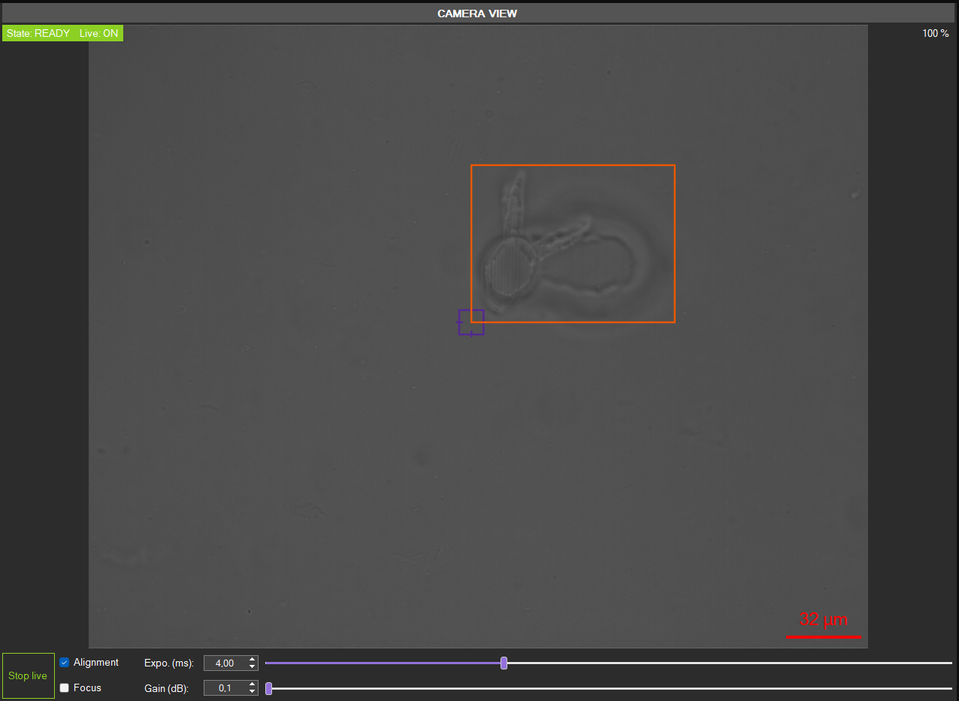Figure 4: Camera view in alignment mode
The context menu in Figure 5 is displayed by right clicking anywhere on the camera view. It allows to change the visibility of the center target and the scale bar. It also allows to save high quality images of the camera view. Saved images contain the scale bar if it is visible when saving.
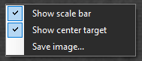Figure 5: Camera view context menu

Upside-Down mode
For fabrication using large Z stage or upside-down substrate, the machine must be in “upside-down” mode. To transition to upside-down mode, click on the toggle button shown in Figure 6. The toggle is located on the top left, next to the objective selection panel (3.3). When switching to upside-down mode, the fabrication stage will move through all its range on the Z axis. Make sure nothing is in the way of the stage before performing this operation. A warning dialog box (Figure 7) will appear to remind to exercise caution.
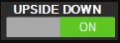Figure 6: Upside-down toggle

Objective selection
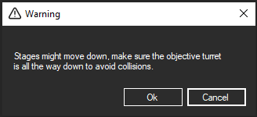Figure 7: Upside-down collision warning message
For the scale bar to properly display pixel to micro-meter equivalence on screen, the current objective must be selected in the objective selection panel in the top left corner as shown in Figure 8.
Objectives can be defined in the “SLICING_PRESET.xml” file located in the installation folder. Objectives are defined as shown in Snippet 1 they contain:
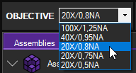Figure 8: Objective selection drop down menu
- a model name under the “Model” attribute of the “Objective” tag;
- a numerical aperture under the “Aperture” tag;
- whether or not the objective is immersive;
- and its working distance.
Snippet 1: Objective definition example
1 <Objective Model="Olympus 20X/0.8">
2 <Aperture Unit="none" Type="Single"> 0.8 </Aperture>
3 <IsImmersion Unit="none" Type="Boolean"> False </IsImmersion>
4 <WorkingDistance Unit="µm" Type="Single"> 600 </WorkingDistance>
5 </Objective>
In addition to the objective definition in “SLICING_PRESET.xml” the micron per pixel ratio must be added to the camera hardware configuration in “HARDWARE_CONFIGURATION.xml” for each objectives. They are presented like so:
Each objectives is indexed by its position in the “SLICING_PRESET.xml”. The first objective will be assigned the <MicronsPerPixelObj1> ratio the second the <MicronsPerPixelObj2> one and so on. In order to find the micron to pixel ratio:
Snippet 2:Micron per pixel ratio definition examples
1 <MicronsPerPixelObj1 Unit="µm" Type="Single"> 0.0727527793 </MicronsPerPixelObj1>
2 <MicronsPerPixelObj2 Unit="µm" Type="Single"> 0.7275420287 </MicronsPerPixelObj2>
3 <MicronsPerPixelObj3 Unit="µm" Type="Single"> 0.786565 </MicronsPerPixelObj3>
4 <MicronsPerPixelObj4 Unit="µm" Type="Single"> 0.4453278768965 </MicronsPerPixelObj4>
5 <MicronsPerPixelObj5 Unit="µm" Type="Single"> 0.387787265 </MicronsPerPixelObj5>
- print two points separated by a given distant (ex: 10µm);
- save a camera frame (left click on camera view > Save image…);
- measure the distance, in pixels, between the two points;
- divide the distance in µm by the distance in pixels.
The default objective set on application start can be changed in the <General> element using a <DefaultObjectiveIndex> element, defining the default objective’s index. Indices are defined by the order of definition of the objectives and start from zero. In example Snippet 3, the first objective defined is set as the default startup objective.
Snippet 3: Example of default objective definition
1 <General>
2 <DefaultObjectiveIndex Unit="none" Type="Int32"> 0 </DefaultObjectiveIndex>
3 </General>

Large stages homing
Some stages need to be calibrated using a homing procedure to find ranges and ensure position accuracy. Homing only needs to be done:
- on first startup;
- on stage or stage controller replacement;
- on stage controller reset.
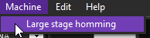Figure 9: large stage homing menu option
When performing homing, all large stages will move through all their ranges. Make sure they are free to do so in order avoid collisions. The stage homing option can be found in the top menu bar under “Machine/Large stage homing” (Figure 9).

Hardware control
All hardware control panels are located on the right panel (see Figure 1 of section 2.1). Controllable hardware include:
- fabrication stage (see Figure 10);
- laser (see Figure 11).
- Large stage if present (see Figure 2);
Both large stage and fabrication stage control panels are similar. They include editable numerical boxes for each axis to set precise positions as well as directional arrows for easy approximate translations. The translation speed when using directional arrows can be chosen from three profiles using the buttons on the right of the “Speed” label (see Figure 10). Some stages, such as large stages (see Figure 2), have the option to redefine their origin. Doing so defines the current position as the origin, meaning X, Y and Z coordinates are set to zero. This can be done using the button.
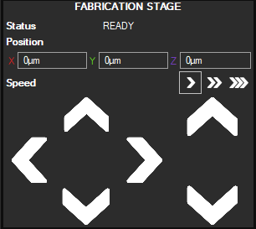Figure 10: Fabrication stage control panel
The laser control panel as shown in Figure 11 is very simple and straightforward. It allow to set a constant laser power in percent (%).
Hardware panels display the current state of the hardware. Hardware state are:
- UNKNOWN: the connection has not or could not be established;
- INIT: the connection is in progress;
- READY: the device is ready to use;
- BUSY: the device is performing a command and will not accept any other command during that time;
- EXIT: disconnection in progress;
- ERROR: an error occurred, the device is not available in this state similarly to the BUSY state;
- WARNING: something requires user’s vigilance on that device.

Auto-focus
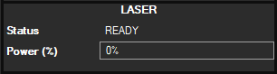Figure 11: Laser control panel
The auto-focus toggle button shown in Figure 12 is located on the top left of the application, next to the “upside-down” toggle button (see 3.2). The auto-focus procedure is designed to find the laser focus in a selected range. It operates using the fabrication stage Z axis. The fabrication range on the Z axis is therefore limited when auto-focus is enabled.
When auto-focus is toggled on, the fabrication stage’s Z axis is moved to the center of the auto-focus range. As an example, if the auto-focus range is [0;20] µm, the Z axis will be moved to 10µm. The user shall proceed to a manual focus at this position. This way, the auto-focus will search for the focus around the user defined focus. In the preceding example, it will search at ±10µm around the focus as the focus is at height 10µm and the range is [0;20] µm.
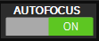Figure 12: Auto-focus toggle button

Auto-focus parameters can be edited in the “HARDWARE_CONFIG.xml” under the <AutoFocus> element, as shown in Snippet 4.
- The <Range> element allows to control the start and end Z elevation of the auto-focus search;
- The <Step> element controls the interval between focus tests. The smaller the value the more precise the auto-focus will be. On the other hand a large value will accelerate the auto-focus process;
- Finally the <DriftThreshold> element determinate the distance on the XY plane between two auto-focuses. Objects closer together than the drift threshold will be printed using the same focus Z value.
Snippet 4: Software auto-focus definition
1 <AutoFocus Model="Software">
2 <Range Unit="µm" Type="Vector2"> (0;20) </Range>
3 <Step Unit="µm" Type="Single"> 0.5 </Step>
4 <DriftThreshold Unit="µm" Type="Single"> 100 </DriftThreshold>
5 </AutoFocus>

Optimized laser gain
Depending on the resist chosen for the fabricated task, a laser curve can be applied to the laser gain during fabrication. This curve gives a laser offset for a traversed resist thickness. It is used to compensate laser power loss when traversing resists. Optimized laser gain curves are defined for each resist in its profile define in configuration files. For more information about resist profiles and their definition see the corresponding session in the Luminis design documentation.

