<for each="o in get_objects(data)">
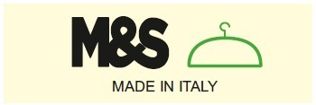 | SCHEDA RISCONTRO |  | Stagione <o.season_id> |  |  | <o.model><'\nCodice cliente (%s)' % (o.customer_code) if o.customer_code else ''>
 | Data <formatLang(o.write_date, date=True) if o.date else ""> |  | Tg. <o.size_base>
Tessuti
Tessuto |  | Composizione |  |  | Simb. Lavaggio | Descriz. Agg.
<for each="l in o.partner_rel_ids">
<if test="data.get('partner_fabric_id', False) == False or data.get('partner_fabric_id', False) == l.id">
<l.fabric_id.code if l.fabric_id else l.note_fabric> |  | <l.perc_fabric> |  |  | <l.symbol_fabric> | <l.corr_fabric>
</if>
</for>
<if test="data.get('image',True)">
</if>
Utente di rif.: <o.user_id> |  |  |  | <' Lavaggio: %s' % (o.washing) if o.washing else ''>
Misura (in cm) | Taglia <o.size_base> | Ns. Riscontro
<for each="l in o.measure_rel_ids">
<if test="l.visible">
<l.measure_id> | <l.__getattr__('size_%s' % (o.col_ref))> | <l.real>
</if>
</for>

</for>

