<for each="record in get_report_label(data)">
<for each="counter in range(0, 1 if data.get('demo_mode', False) else (load(record, 'counter') or 1))">
<load(record, 'description_partner')>  <load(record, 'code_partner')> | <load(record, 'text1')>  <load(record, 'text3')>  <load(record, 'fabric')> |  | <load(record, 'text2')>  <load(record, 'order_ref', mode='string', position=1)><load(record, 'order_ref')>  <load(record, 'q_x_pack', mode='string', position=1)><load(record, 'q_x_pack')>    Fabriqué en Italie
 | 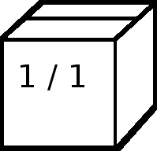 | Article en 1 colis
</for>
</for>

<if test="get_placeholder(data)">
Codice: <get_placeholder(data, 'code')>
Quantità: <get_placeholder(data, 'quantity')>
Linea: <get_placeholder(data, 'line')> periodo <get_placeholder(data, 'period')>
<get_placeholder(data, 'partner')>
<get_placeholder(data, 'address')>
</if>

