The below screenshot is from the Gantt Custom Visual

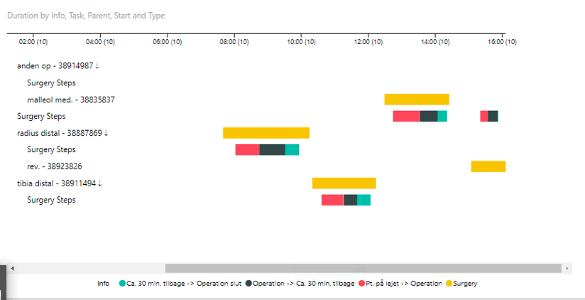

The underlying data has the following shape:

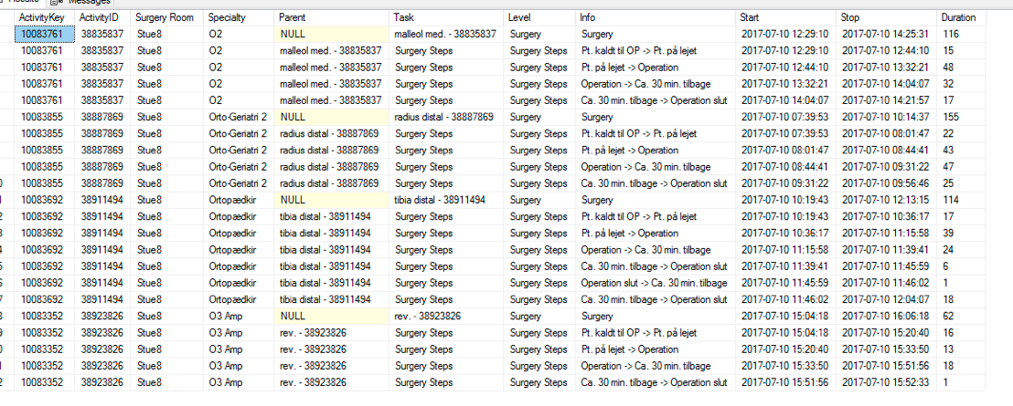

You would therefore expect the following Surgeries (yellow bars)

malleol med. - 38835837
radius distal - 38887869
tibia distal - 38911494
rev. - 38923826

However they are mixed up - it seems to be the problem when the children (Tasks) have the same name

