

GameTrial Sample

*\* This sample is compatible with the [August 2016 Xbox One XDK]*

# Description

This sample demonstrates how to implement game trials with Xbox One. It provides guidance on how a title can check if it is running under a trial license or full license as well as who that license is registered to. Some best practices such as event handling and limiting the active user to only the licensed XUID are also shown. For a more comprehensive explanation of how Game Trials work on Xbox One, please see the [Xbox One Game Trials - Best Practices](https://developer.xboxlive.com/en-us/platform/development/education/Pages/WhitePapers.aspx) whitepaper.

# Using the sample

Currently the only way to test with a real trial license is to prop your game to your Sandbox’s marketplace and download it with a trial license. For this reason the Game Trials sample has been propped to the XDKS.1 sandbox for you to download and verify proper flow of users and functionality that is available when doing the trial

To download the Game Trials sample and run with a real trial license, just go to the Search option on your Xbox Home screen and search for ‘Trials’.

And this screen for the fully licensed game.

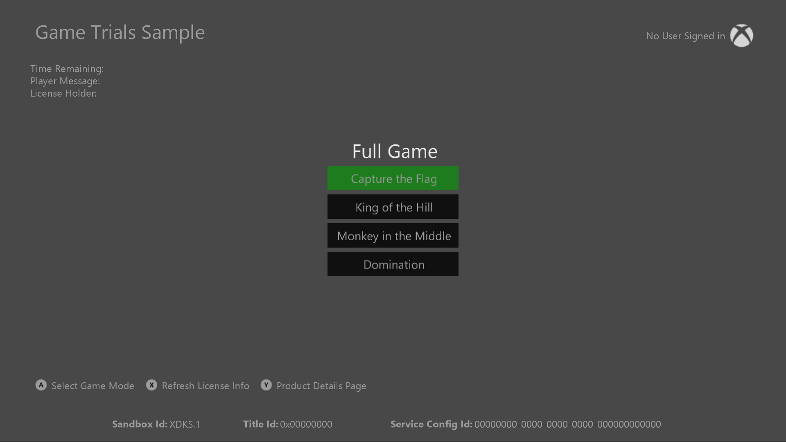

|  |  |
| --- | --- |
| Action | Gamepad |
| Select the menu option (simulates gating access and features and modes in the game under a trial license) | A button |
| Refresh License info manually | X button |
| Open up the Marketplace Details page to for purchase/upgrade to full license | Y button |

# Implementation notes

All packages signed with /LT or when launching through Visual Studio will have a full license automatically deployed with the package. Due to this, the only way to fully test this is to prop a Trial product to your sandbox.

To get the current license state and information, check the LicenseInformation class:

Windows::ApplicationModel::Store::CurrentApp::LicenseInformation

This class will provide the following information on if the license is trial or full, who the license is registered to / who the active user in the game should be, an event handler for tracking license changed notifications, and an estimate on when the license will expire.

The ExpirationDate member is only an estimate as to when the current license will expire and should not be used as an absolute time. The ExpirationDate is most accurate right after the title has launched and should be checked then or right after resuming from a suspend event and cached. The actual expire time vs the reported time in ExpirationDate may fluctuate between 5-10 minutes, so this is best used by titles to get an estimate on how much time is remaining. If the time is short (less than 30-20 minutes) the title could do its own notification to the user that their trial is almost over and upsell them to the full retail game.

Because a license will enable any user to launch the title on the console, it is critical that for time-limited trials the title strictly enforce that the active user playing the game (save progress, etc.) matches the XUID in the license information. Otherwise users would be able to create free Xbox Live accounts just to obtain more trial licenses and continue to play with their real account for an unlimited amount of time. Strictly locking game functionality to only the user whose license is being currently consumed will block this ‘ride-along’ scenario. The sample demonstrates this by locking all main menu items if the active user (selected in the account picker) does not match the user who the current license is registered to.

If two users are signed in and both have a trial license, the older (obtained first) license is consumed. So if you have one user playing the trial and another user signs-in who has a valid trial license that is older, the system will switch to start consuming the older license and a LicenseChanged event will be fired to notify your title.