

InGameChat Sample

*\* This sample is compatible with the November 2017 Xbox One XDK.*

# Description

The InGameChat sample provides a working example of integrating the GameChat2 library into an Xbox ERA title. It brings together the pieces needed to demonstrate in-title VOIP communications: GameChat, Multiplayer Sessions, and Peer Networking.

# Using the sample

You will need at least two Xbox One kits each with a microphone and speaker. These can be Kinect, mono and stereo headsets, TV speakers, etc. You will need a valid Xbox Live user for each kit and it helps if they are friends. The Xboxes and user accounts should be configured for the XDKS.1 sandbox.

## Local Lobby

|  |  |
| --- | --- |
| Action | Gamepad |
| Start your own chat session where you can invite users or they can join you | A button |
| Search for open chat sessions in your social graph | X button |
| Select a user for your controller | Y button |
| Close the sample | B button |

## Select A Session

|  |  |
| --- | --- |
| Action | Gamepad |
| Select between list items | D-Pad Up/Down |
| Refresh the list | X button |
| Go back | B button |

## Chat Session

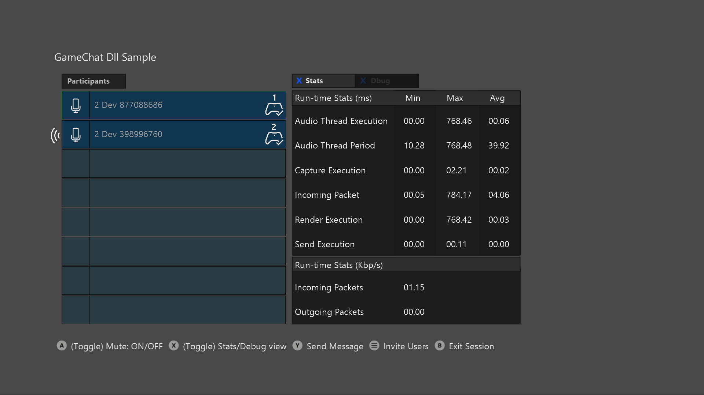

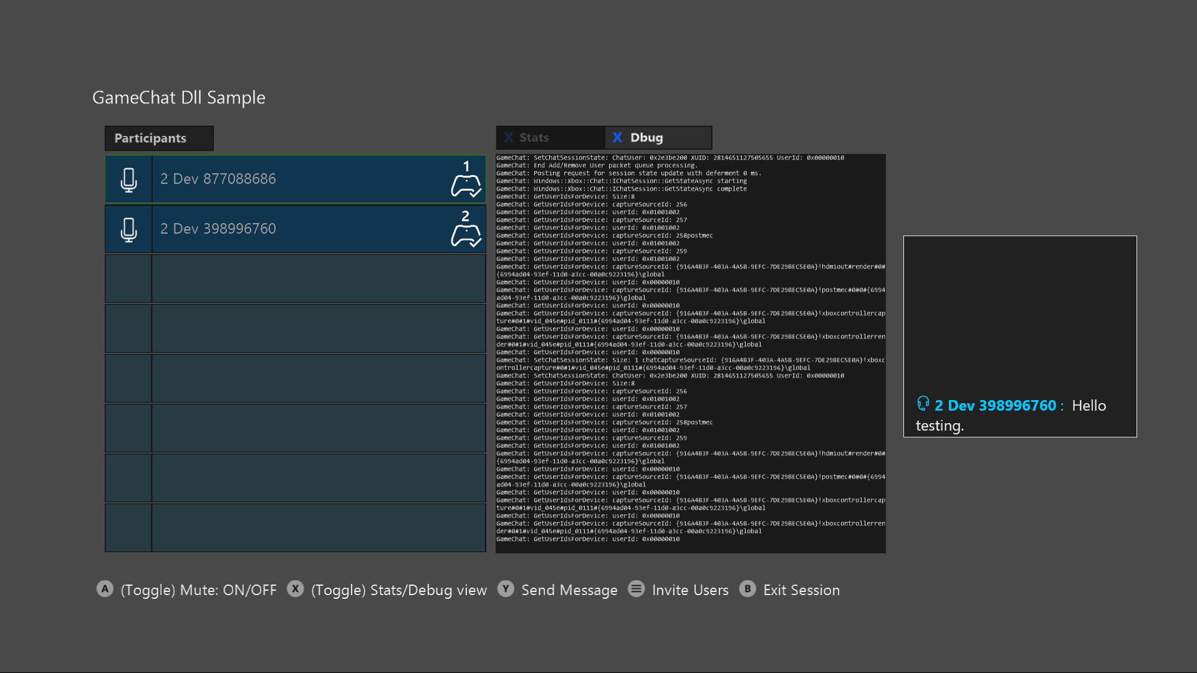

|  |  |
| --- | --- |
| Action | Gamepad |
| Select a user in the list | D-Pad Up/Down |
| Toggle mute for selected user | A button |
| Toggle between Stats panel and Debug panel | X button |
| Send a text message | Y button |
| Invite users | Menu button |
| Go back | B button |

# Implementation notes

The main purpose of this sample is to demonstrate integrating GameChat2 into your title. GameChat2 is controlled through the xbox::services::game_chat_2::chat_manager::singleton_instance() class. This class is wrapped up into the ChatIntegrationLayer. The integration layer is the interface between GameChat and your title. It handles interfacing with the peer network and multiplayer session members.

The ChatIntegrationLayer.cpp/.h files are called out to aid in understanding and should be the primary focus of the sample.

The remaining code is there to facilitate end-to-end VOIP. It was written to be simple and straightforward rather than performant or production ready. We do not recommend using other parts of the sample directly or to use it as a canonical example for things other than its intended purpose.

# Update history

December, 2016 – Created

February 2018, Updated to use GameChat2 and the November 2017 XDK.