

InGameChatUWP Sample

*\* This sample is compatible with the April 2018 Xbox Live SDK, the April 2018 GameChat2 library and the Windows10 October 2018 Update SDK (17763)*

# Description

The InGameChatUWP sample provides a working example of integrating the GameChat2 library into a UWP title. It brings together the pieces needed to demonstrate in-title VOIP communications: GameChat, Multiplayer Sessions, and Peer Networking.

# Known issues

* Use of the **Windows::Networking::XboxLive** namespace requires using *Windows Desktop Extensions for the UWP (17134)*

# Building the sample

**UWP Build Requirements**

* Visual Studio 2017 (15.7 update) or later
* Windows 10 April 2018 Update SDK (17134)
* Microsoft Xbox Live C++ API for Windows Apps **2017.11.20171204.1 or later** and Microsoft.Xbox.Game.Chat.2.Cpp.UWP **1802.1.0 or later**.
  + The package is available publicly on nuget.org
  + In Visual Studio, nuget.org is a default package source and the packages should automatically be restored the first time you build.

# Using the sample

You will need at least two PCs each with a microphone and speaker. These can be mono and stereo headsets, TV speakers, etc. You will need a valid Xbox Live user for each PC and it helps if they are friends. The PCs and user accounts should be configured for the XDKS.1 sandbox.

## Local Lobby

|  |  |
| --- | --- |
| Action | Gamepad |
| Start your own chat session where you can invite users or they can join you | A button |
| Search for open chat sessions in your social graph | X button |
| Select a user for your controller | Y button |
| Close the sample | B button |

## Select A Session

|  |  |
| --- | --- |
| Action | Gamepad |
| Select between list items | D-Pad Up/Down |
| Refresh the list | X button |
| Go back | B button |

## Chat Session

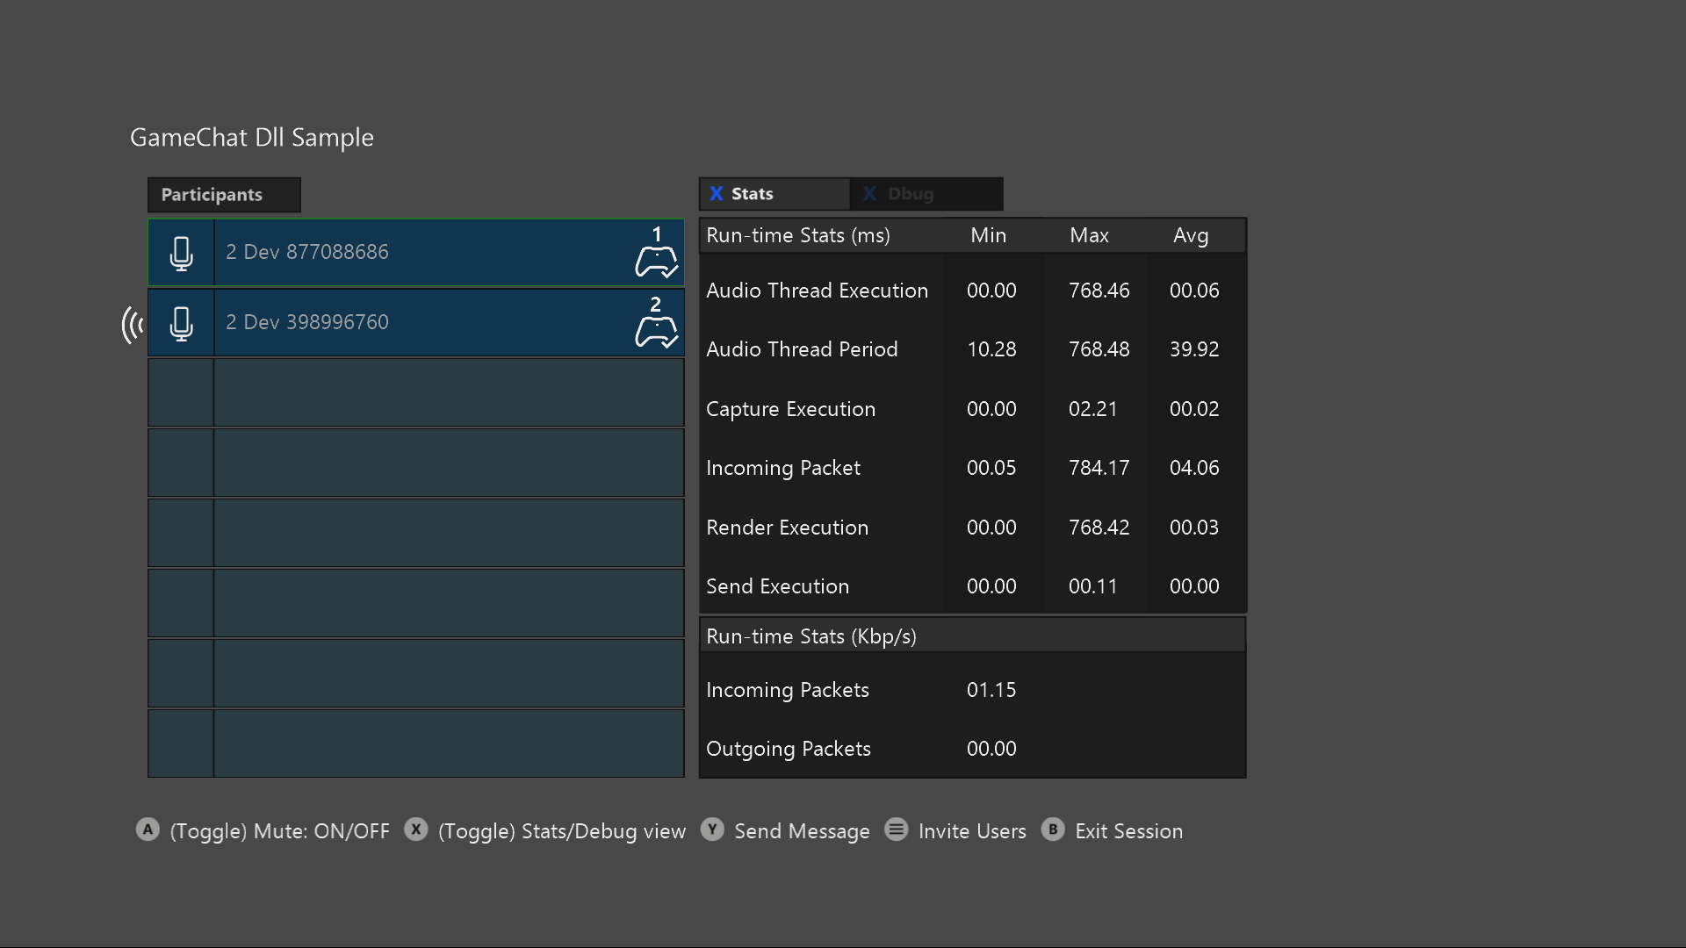

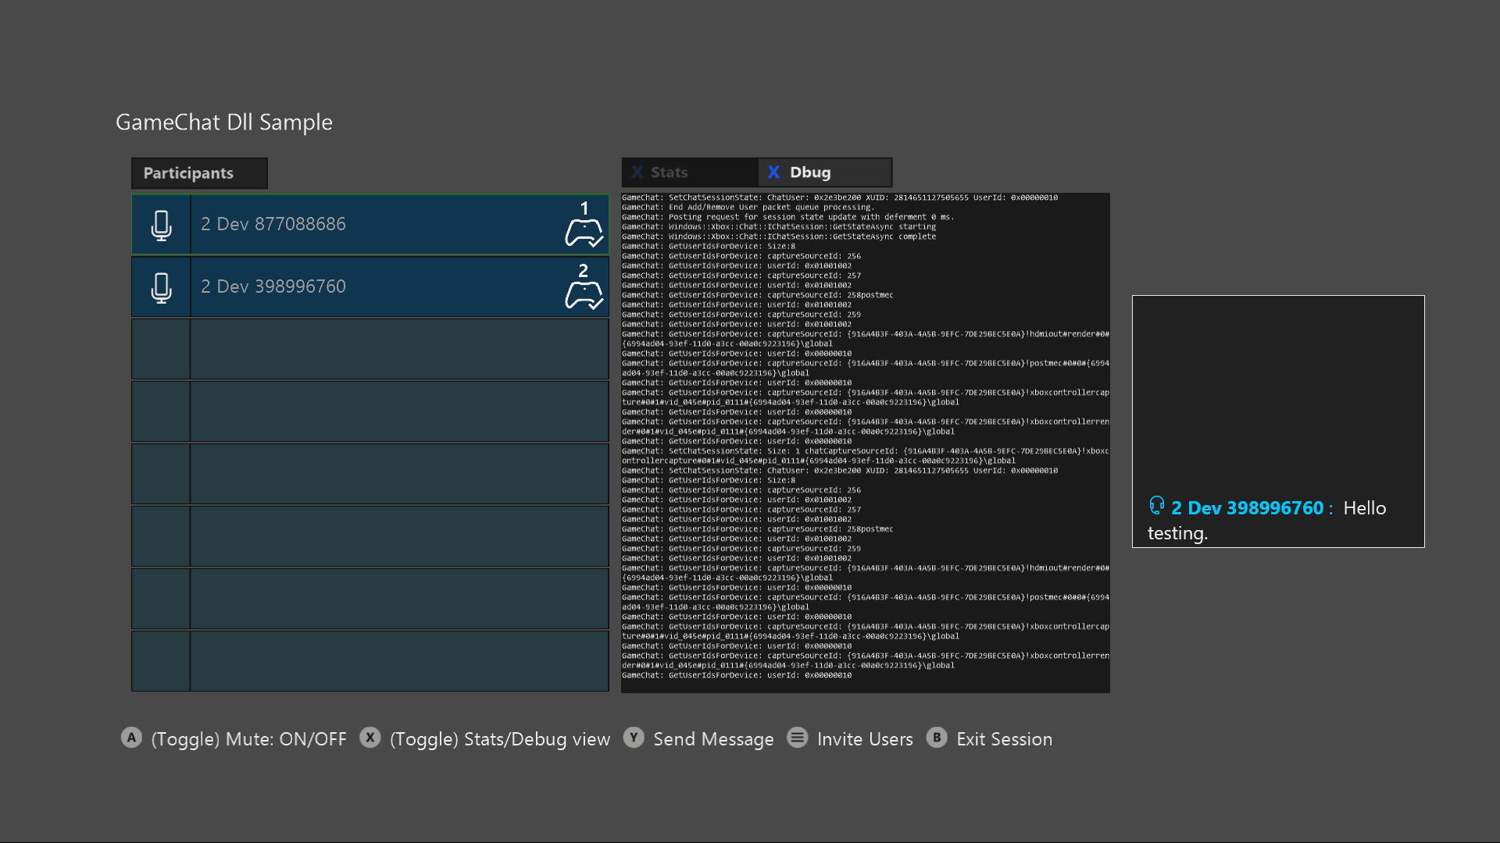

|  |  |
| --- | --- |
| Action | Gamepad |
| Select a user in the list | D-Pad Up/Down |
| Toggle mute for selected user | A button |
| Toggle between Stats panel and Debug panel | X button |
| Send a text message | Y button |
| Invite users | Menu button |
| Go back | B button |

# Implementation notes

The main purpose of this sample is to demonstrate integrating GameChat2 into your title. GameChat2 is controlled through the xbox::services::game_chat_2::chat_manager() class. This class is wrapped up into the ChatIntegrationLayer. The integration layer is the interface between GameChat and your title. It handles interfacing with the peer network and multiplayer session members.

The ChatIntegrationLayer.cpp/.h files are called out to aid in understanding and should be the primary focus of the sample.

The remaining code is there to facilitate end-to-end VOIP. It was written to be simple and straightforward rather than performant or production ready. We do not recommend using other parts of the sample directly or to use it as a canonical example for things other than its intended purpose.

# Update history

March 2017 – Created

March 2018 – Updated for game_chat_2 and bug fixes.