

Social Sample

*This sample is compatible with the October 2016 Xbox One XDK*

# Description

This sample demonstrates the social_manager from the Xbox Live SDK.

This sample includes examples of:

* Adding users and creating groups
* Retrieving social groups based on filters
* Responding to social_manager events

# Using the sample

The sample is controlled using the standard gamepad. The screen contains the controller legend with the available actions.

## Sample Screen

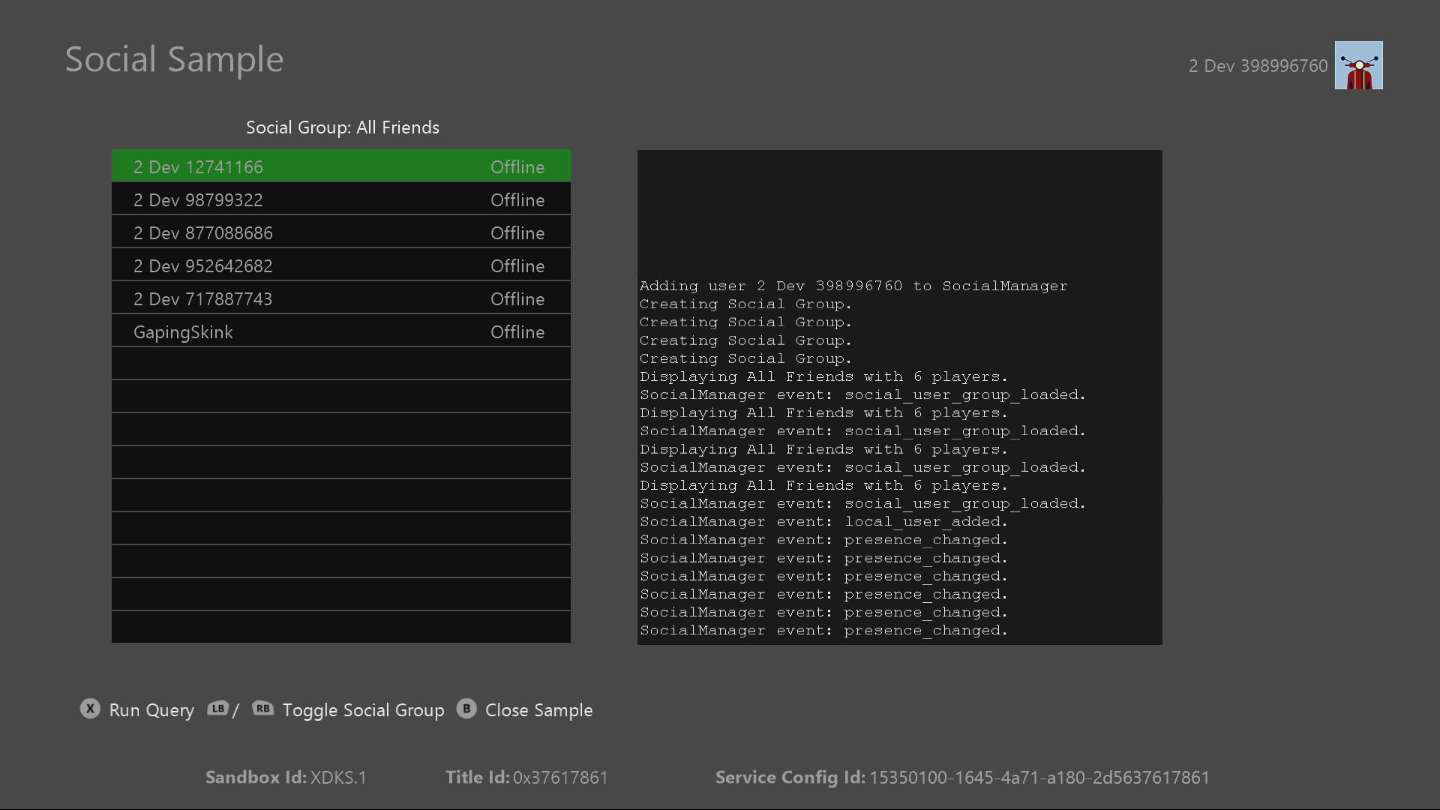

|  |  |
| --- | --- |
| Action | Gamepad |
| Refresh UI for current filter | A button to invoke |
| Toggle social group viewed | Left and Right Shoulder buttons |
| Exit | View Button / B button |

# Implementation notes

The code that directly interfaces with social_manager is encapsulated into SocialManagerIntegration.cpp/.h.

# Update history

**Initial Release:** *January 2017*

# Privacy Statement

When compiling and running a sample, the file name of the sample executable will be sent to Microsoft to help track sample usage. To opt-out of this data collection, you can remove the block of code in Main.cpp labeled “Sample Usage Telemetry”.

For more information about Microsoft’s privacy policies in general, see the [Microsoft Privacy Statement](https://privacy.microsoft.com/en-us/privacystatement/).