

Title Storage Sample

*\* This sample is compatible with the November 2015 Xbox One XDK.*

# Description

This client-side sample demonstrates the functionality of the Xbox Live Services Title Storage API. Using this sample, it is possible to query the Title Storage service for quota information and directory listings, as well as download, upload and delete files.

# Building the Sample

No custom requirements

# Using the sample

This sample does not require that a user be signed-in before running in order to make the service calls. For more information on setting up a user account, refer to the Xbox One XDK documentation topic **Xbox Live Authentication**.

## Sign-In Screen

|  |  |
| --- | --- |
| Action | Gamepad |
| Sign In | Menu Button |

## Main Screen

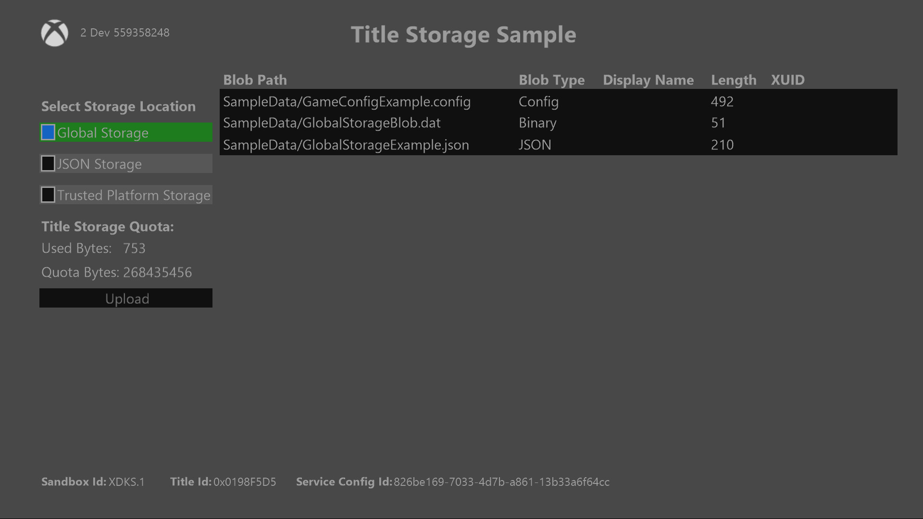

|  |  |
| --- | --- |
| Action | Description |
| Select Storage Location | Select the storage location to view and download the data blobs from |
| Upload | Upload a blob to a specified location. Disabled for global storage. |
| DPad Up/Down | Navigate the sample |
| Select Blob | Brings up menu to Download or Delete a selected blob. Delete is disabled for global storage |

# Implementation notes

This sample requires that your console be set to the XDKS.1 sandbox. The sample method ChangeStorageType retrieves the quota information for the given storage type as well as all of the blob metadata in that location.

# 

# Known issues

# Update history