Xbox Web Security Plugin for Fiddler

*By Ferdinand Schober, Xbox ATG  
Last Updated: January 31, 2017*

XWebSecPluginForFiddler is an add-on to Fiddler that enables developers to analyze the security level of their web service calls. Using this plugin, developers can get a real-time view into the calling patterns of their game titles. The tool shows HTTPS/HTTP usage and flags insecure service calls that may cause a rejection during the Xbox certification process. All Xbox One and UWP titles are supported.

# Setting up

1. Install and set up Fiddler 4 on the Xbox One consoles. Instructions for dev kit setup are available in the XDK documentation.
   1. You may also set up Fiddler on multiple consoles and have their collective traffic captured in one Fiddler instance on a given PC. You will just need to copy and export the identical Fiddler.cer and ProxyAddress.txt files to multiple kits.
   2. It is also possible to use Fiddler on retail consoles.
2. Shut down Fiddler on your PC.
3. Run XWebSecPluginForFiddler-Setup.bat. Verify that:
   1. XWebSecPluginForFiddler.dll resides in **%USERPROFILE%\Documents\Fiddler2\Scripts**
   2. excludedDomains.xml resides in **%USERPROFILE%\Documents\Fiddler2\Scripts**

*Note: Regardless of Fiddler version, the path above referencing Fiddler 2 must be used.*

1. *[optional]* Update the excludedDomains.xml file to include domains that are not relevant for testing. By default, this includes non-secure domains that are approved by default for any game title.

# Using XWebSecPluginForFiddler

1. Reload Fiddler. You should now see an **Xbox Web Security** tab:  
     
   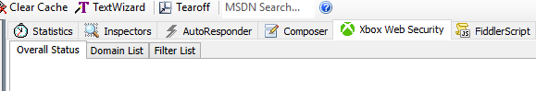
2. The functionality of the plugin is automatically active and will show information about the requests made by Fiddler in real-time:

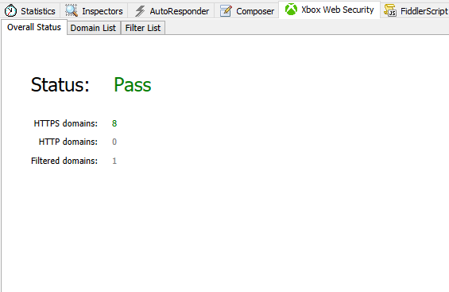

1. The additional ‘Domain List’ and ‘Filter List’ show a summary of the requests for HTTPS/HTTP and filtered domains:

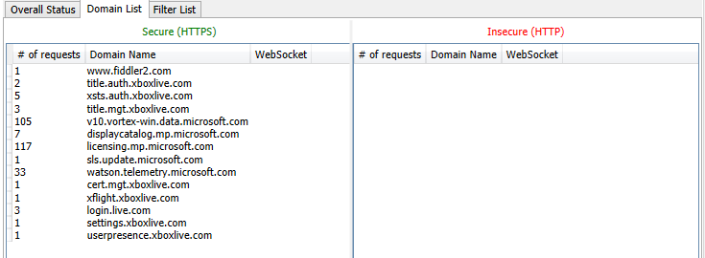

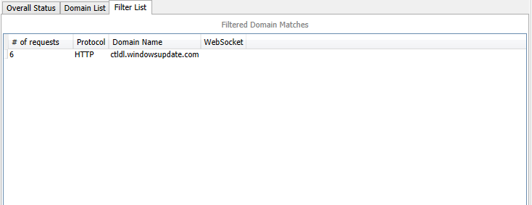

# Known Issues

* Deleting sessions from the Fiddler session list will not delete the sessions from the plugin. This will be added in a future version.
* The plugin currently does not provide an automatic version check. This will be added in a future version.