

Social Sample

*\* This sample is compatible with the August 2016 Xbox One XDK*

# Description

This sample demonstrates the social_manager from the Xbox Live SDK.

This sample includes examples of:

* Adding users and creating groups
* Retrieving social groups based on filters
* Responding to social_manager events

# Building the Sample

To build the sample you will need Visual Studio 2015 and the August 2016 or later XDK and Recovery.

# Using the sample

The sample is controlled using the standard gamepad. The screen contains the controller legend with the available actions.

## Sample Screen

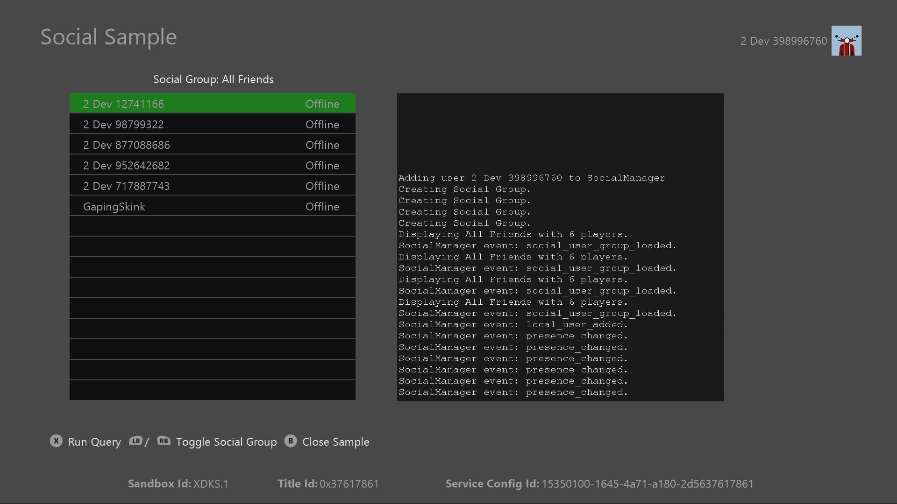

|  |  |
| --- | --- |
| Action | Gamepad |
| Refresh UI for current filter | A button to invoke |
| Toggle social group viewed | Left and Right Shoulder buttons |
| Exit | View Button / B button |

# Implementation notes

The code that directly interfaces with social_manager is encapsulated into SocialManagerIntegration.cpp/.h.

# Update history

**Initial Release:** *January 2016*