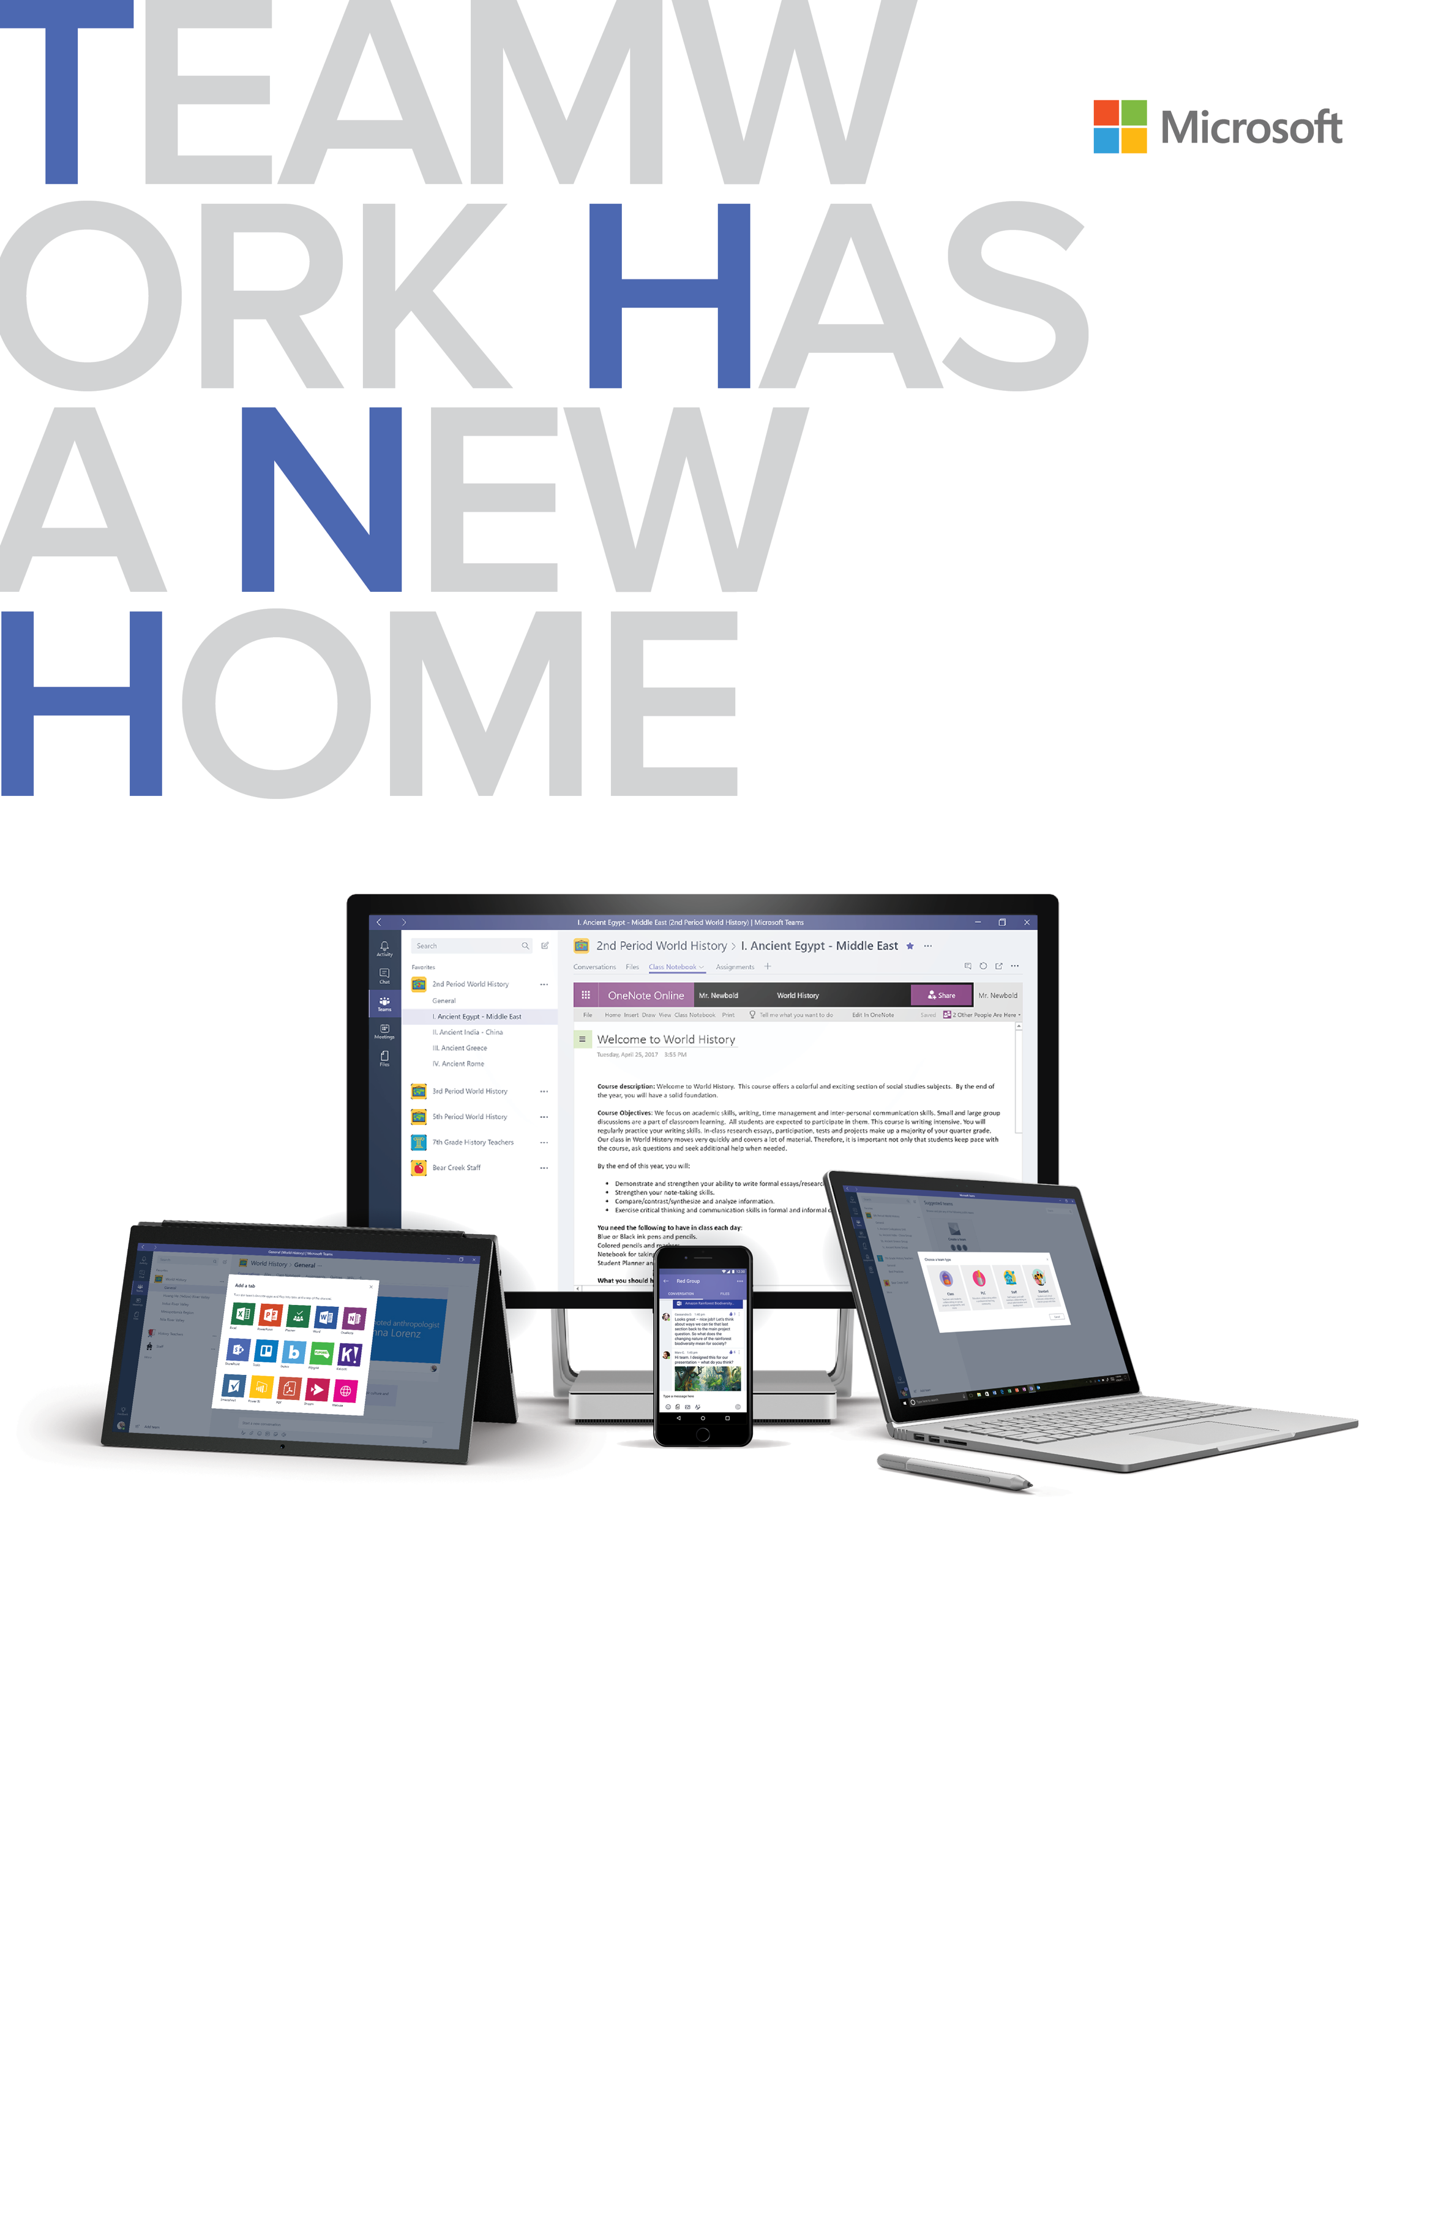

# **Microsoft Teams for Education**

One place for conversations,   
meetings, and files

Chat privately or as a group with threaded and contextual   
chat. Use your favorite gifs, stickers and emojis to add   
personality. Join meetings from anywhere with HD audio   
and video, all in one place, instead of using multiple apps.

Collaborate with integrated   
Office 365 apps

Built in Office apps like Word, Excel, PowerPoint, and OneNote give you access to files and tools in one place, so you stay in your workflow. Collaborate in real-time using Office Online.

Tailor your workspace

Use your favorite education apps, like Quizlet, Flipgrid, and   
Skooler within Teams. Get notifications and content from   
services of interest like Trello, GitHub, SurveyMonkey, and more.

Work with confidence

Teams is integrated into Office 365, which means   
you can rely on the enterprise-grade security and compliance you need.

Your new hub for conversations, files, assignments, and meetings. Designed for education – all in one place, wherever you go.

## Start using Teams Go to [**www.aka.ms/MicrosoftTeamsEdu**](http://www.aka.ms/MicrosoftTeamsEdu)

For additional guidance, tutorials and tips visit [www.support.office.com/education](http://www.support.office.com/education)

**Add your message here.** Lorem ipsum dolor sit amet, consectetur adipiscing elit. Donec mattis enim eu lorem malesuada hendrerit. Suspendisse eget quam et ipsum pretium ultrices. (200 characters)

