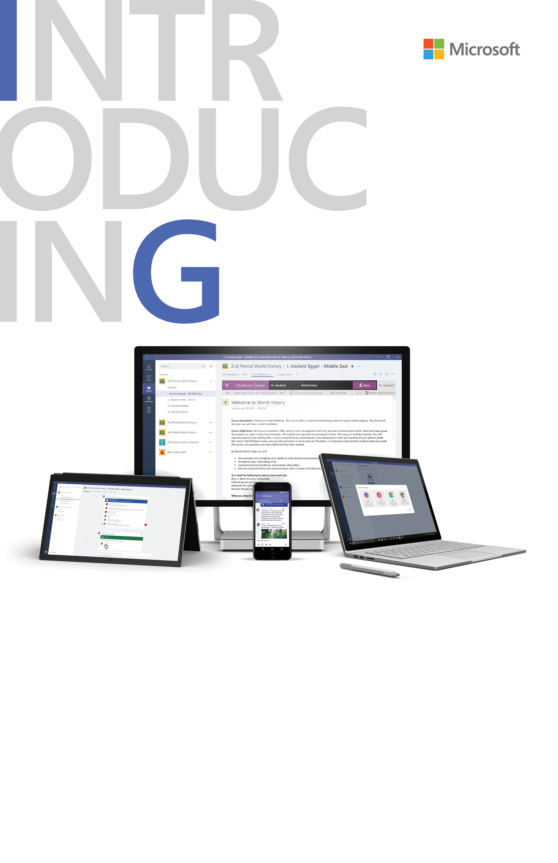**––––**

# **Microsoft Teams for Education**

## Start using Teams Go to [**www.aka.ms/MicrosoftTeamsEdu**](http://www.aka.ms/MicrosoftTeamsEdu)

For additional guidance, tutorials and tips visit [www.support.office.com/education](http://www.support.office.com/education)

Come together in any team

Work together on any team-based or project-based   
activity, from student extracurricular groups to school-wide initiatives with staff and educators. Connect with anyone at   
your school to communicate and collaborate easily.

Streamline staff communication

Seamlessly share information with staff, educators, and   
school leaders – making cross-department collaboration   
easier in staff teams. Work together on school-wide initiatives   
in online meetings with HD video, VoIP, and dial-in audio conferencing options, or connect in 1:1 private or group chat.

Always stay connected

Connect with others across your devices, including mobile and tablet. Chat one-on-one, or as a group with threaded and contextual chat. Keep up to date with your team with video meetings and chat.

Create collaborative classrooms

Engage students with rich conversations, video, and   
educational content. Deliver personalized learning with a customized assignment-management experience, built-in OneNote class notebooks, and integrated Office 365 apps.

Your new hub for conversations, files, assignments, and meetings. Designed for education – all in one place, wherever you go.

**Add your message here.** Lorem ipsum dolor sit amet, consectetur adipiscing elit. Donec mattis enim eu lorem malesuada hendrerit. Suspendisse eget quam et ipsum pretium ultrices. (200 characters)

