

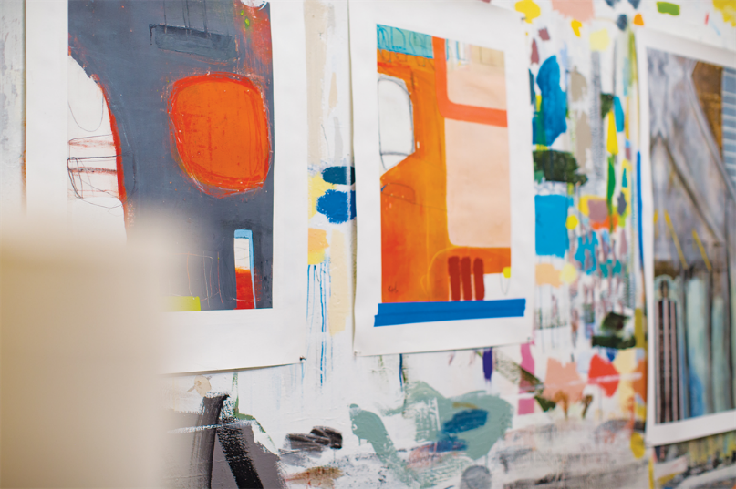

Review: I love the coffee drinks here, but my favorite part is the local art they sell. There are many kinds of paintings and watercolors they showcase each week. I love checking out the new prints that they have and buying cards for friends. Also did I mention that the wi-fi is excellent?

Date: September 3, 2018

Location: Seattle, Washington