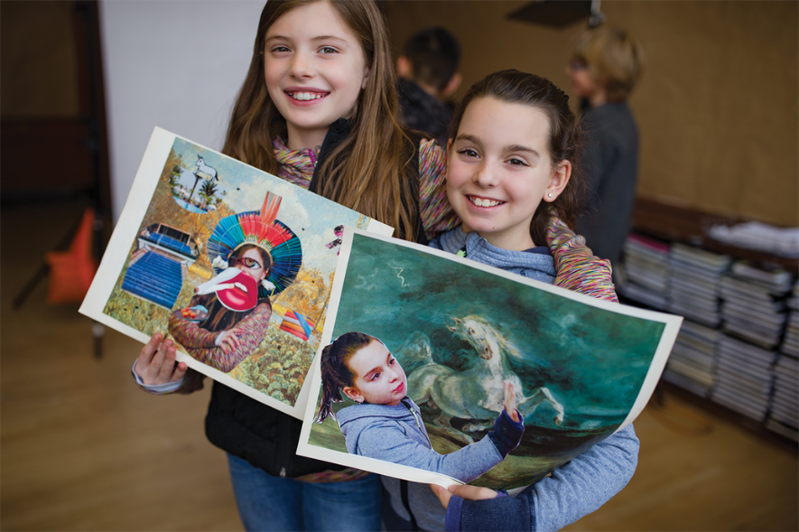

Review: What I really like about this location is that there are also art classes offered for children! My family loves to come to Fourth Coffee on weekends for the live music and paint events! Some of the best events my kids have been to are at Fourth Coffee on a rainy Saturday. Hopefully they will bring back the Melodies & Collage Memories event, that was a great time for our whole family.

Date: October 14, 2018

Location: Seattle, Washington