Caldova Customer Scenario

Hero Products
- Azure Infrastructure Resiliency Manager
- Resiliency Agent
- Azure Advisor (Reliability pillar)
- Azure Backup
- Azure Site Recovery
- Microsoft Defender for Cloud
- Secure Score, security policies, and compliance controls
- Azure Arc and Azure Policy
- Sovereign Landing Zone and Azure Local, including connected and disconnected requirements

Overview
Caldova is a pharmaceutical company racing to launch an accelerated V2, next-generation product ahead of a competitor. Success depends on supply chain, manufacturing, procurement, data, application, and compliance teams working from the same trusted context. Caldova must address a 7% production gap across three manufacturing plants and determine whether internal capacity is sufficient or whether pre-qualified contract manufacturing organizations must provide support within 3–6 months.
The current estate was not designed to support AI workloads. The supply chain planning application runs on legacy .NET, the manufacturing database runs on an on-premises SQL Server, and the broader estate runs on VMware that is past renewal. Operational and manufacturing data remains fragmented across IoT, supply chain, customer, production, supplier, and quality systems. Caldova is also acquiring Litware, whose manufacturing database runs on an on-premises PostgreSQL server.
Caldova’s early AI experiments have shown promise, but scaling across the fragmented environment has introduced agent drift, duplicated builds, disconnected tools, siloed data, security risks, and governance gaps. The immediate focus is to determine whether the platform can operate with confidence and trust as modernization proceeds, not to prescribe the final AI solution.

Main Goals
- Launch an accelerated V2, next-generation pharmaceutical product ahead of a competitor’s scheduled release.
- Close a 7% production capacity gap across three manufacturing plants, either internally or with pre-qualified contract manufacturers that can support a 3–6-month window.
- Modernize the legacy platform while protecting regulated manufacturing operations, data integrity, and business continuity.
- Establish resilient, secure, governed, and sovereignty-ready operations across Caldova’s current estate and the acquired Litware environment.
- Create an initial trust-layer architecture and a prioritized technical roadmap that can support modernization and future AI workloads.

Current-state problem statement:
Caldova’s critical manufacturing and planning workloads span aging on-premises SQL Server, VMware, legacy applications, segmented plant networks, external partner dependencies, and an acquired PostgreSQL environment. Existing recovery, security, governance, and sovereignty controls are not presented as a unified, validated operating model. Caldova must identify workload criticality and dependencies, define recovery targets, protect regulated data, improve security posture, and establish a resilient trust layer before modernization and AI adoption can scale.

Current infrastructure:
London primary datacenter:
- CALD-SQL-PROD01, SQL Server 2019 CU25, 64 cores, 512 GB RAM, 15 TB.
- CALD-SQL-REPORT01, SQL Server 2017 CU31. (Reporting)
- CALD-SQL-LEGACY01, SQL Server 2016 SP3, (Pharmacy Gateway)
Miami DR datacenter:
- ZAVA-SQL-DR01, SQL Server 2019 CU25, 32 cores, 256 GB RAM.
- Asynchronous Availability Group replication from London.
Applications:
- Broader application estate on VMware that is past renewal.
- Legacy supply chain planning application built on .NET.
- Litware acquisition environment with an on-premises PostgreSQL manufacturing database.
- Plant-floor MES and IoT historian networks segmented from IT; data crosses through approved DMZ brokers only.
- No direct internet access from datacenter servers; traffic uses a Zscaler proxy with SSL inspection.
- Limited ExpressRoute bandwidth; 2-week firewall change control; partner-side changes can take up to 4 weeks.
Database estate:
Database | Size | Purpose | Protection
BatchManufacturingCore | 8 TB | Electronic batch records, MES transactions, batch genealogy, equipment and line history across three plants | TDE
QualityLIMS | 3 TB | QC results, stability studies, deviations and CAPA, batch release records | TDE
SupplierPayments | 300 GB | Procurement and CMO payments; supplier banking details | Always Encrypted
7 smaller databases | ~1 TB | Serialization, labels, environmental monitoring, warehouse, training, planning staging, and reporting | Not specified

Availability and constraints:
Application or constraint | Requirement | Significance
Supply Chain Planning Portal | 5 minutes; 500 req/sec | Planning continuity during peak load
Batch Release & QA Console | 2 minutes; 200 req/sec | Regulated batch release
MES / Batch Execution Service | 0 minutes; 100 req/sec | 24/7 production execution
BatchManufacturingCore | Maximum 30 minutes | In-process electronic batch records cannot be lost mid-run
GxP batch and quality records | UK region | BatchManufacturingCore and QualityLIMS must remain in the UK
Migration window | 16 weeks | Cutover cannot collide with V2 process validation runs

Cross-cutting network conditions: no direct internet access from datacenter servers; Zscaler proxy with SSL inspection; limited ExpressRoute bandwidth; 2-week firewall change control; partner firewall changes may take up to 4 weeks.

Current architecture diagram:
The following chart represents the current state and intentionally does not propose a future-state solution.
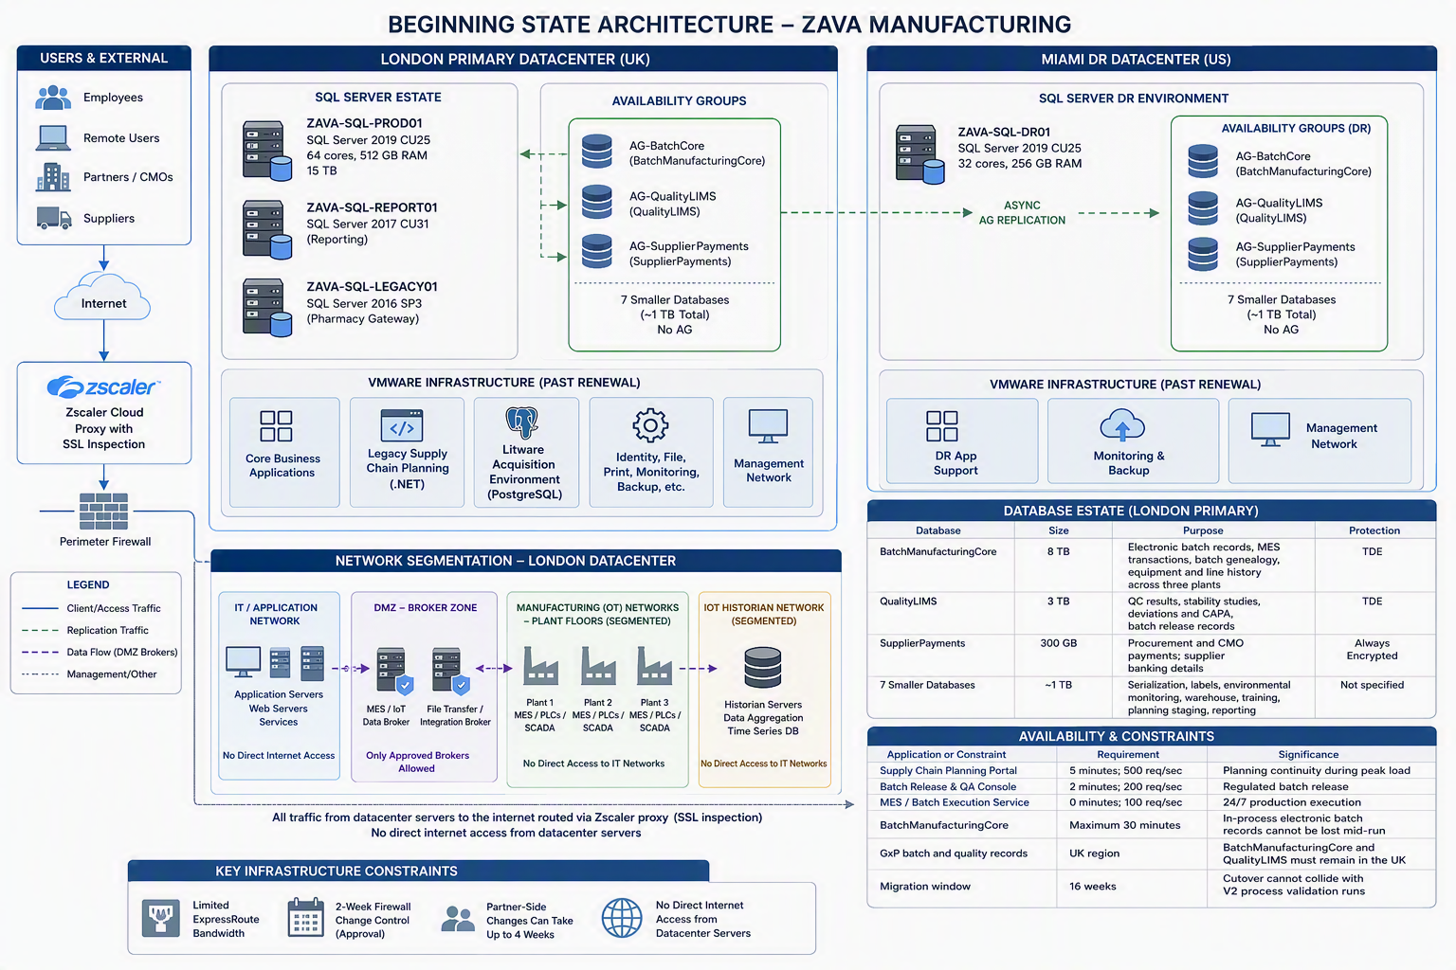

Customer needs
COO - Peter:
- Maintain continuity for manufacturing, batch execution, quality, and supply-chain operations while Caldova modernizes.
- Understand which workloads are most critical to the V2 launch and establish recovery priorities based on business impact.
- Integrate Litware’s manufacturing environment into Caldova’s operating model without weakening regulatory controls or operational oversight.
- Receive a prioritized roadmap that connects resilience, security, governance, and sovereignty improvements to business risk and launch readiness.
Cloud Architect - Marcus:
- Establish a complete view of workloads and dependencies across VMware, SQL Server, PostgreSQL, legacy .NET applications, plant networks, and external partner services.
- Translate workload criticality, recovery requirements, data classifications, and residency constraints into an initial trust-layer architecture.
- Determine appropriate availability, redundancy, backup, disaster-recovery, cyber-recovery, governance, and sovereignty patterns for the current estate.
- Define an architecture that supports modernization while accounting for Caldova’s network restrictions, hybrid environment, and acquired Litware systems.
IT Operator:
- Gain consistent visibility into resilience, security posture, compliance, and operational health across the on-premises, hybrid, and modernized estate.
- Define practical recovery objectives and operating procedures for critical workloads, including the MES / Batch Execution Service, Batch Release & QA Console, and Supply Chain Planning Portal.
- Validate that recovery plans, backups, failover processes, and cyber-recovery capabilities can meet established business requirements.
- Establish an ongoing process for identifying, prioritizing, remediating, and validating operational and security-posture gaps.
Security, governance, compliance, and risk stakeholders
- Ensure that regulated manufacturing data, GxP records, identities, access, encryption, policies, and audit trails remain protected and verifiable.
- Map data classifications, UK data-residency requirements, and regulatory obligations to enforceable security, governance, and sovereignty controls.
- Identify and prioritize security-posture and compliance gaps across servers, databases, applications, APIs, and hybrid resources.
- Confirm that the proposed architecture supports continuous compliance, workload protection, cyber recovery, and auditable operational control.
Supporting roles
- CEO - April: Protect the V2 launch and receive clear evidence that modernization reduces operational, regulatory, and business risk.
- Database Administrator - Olaf: Preserve database availability, integrity, encryption, audit continuity, and UK residency while supporting recovery and modernization requirements.
- Developer / Software Developer / Tech Lead: Modernize applications and services in alignment with the resilience, security, governance, and recovery requirements defined for the platform.

Customer objections
COO - Peter:
- Caldova cannot accept a modernization approach that introduces manufacturing disruption or places the V2 launch at risk.
- Recovery objectives and proposed resilience improvements must be tied to business impact, not established only as technical targets.
- Litware integration cannot create inconsistent controls, fragmented oversight, or additional compliance exposure.
- The roadmap must clearly distinguish urgent operational risks from improvements that can be addressed later.
Cloud Architect - Marcus:
- The current dependency picture may be incomplete, particularly across linked servers, partner APIs, plant-floor brokers, and the Litware environment.
- Regional, zonal, hybrid, connected, or disconnected patterns should not be selected without documented workload and business requirements.
- Network restrictions, limited ExpressRoute bandwidth, and long firewall lead times may constrain monitoring, protection, failover, and recovery designs.
- The architecture must balance resilience, security, sovereignty, governance, technical feasibility, and modernization priorities without assuming every workload requires the same pattern.
IT Operator - :
- Recovery plans may appear complete on paper but remain unproven until failover, restore, and recovery processes are tested.
- Monitoring, security management, backup, and recovery may be difficult across systems with no direct internet access and tightly controlled network paths.
- Responsibilities between Microsoft and Caldova must be clear so workload configuration, testing, remediation, and ongoing validation are not left unowned.
- New tools and controls could increase operational complexity unless they provide a consistent way to prioritize and manage the estate.
Security, compliance, governance, and risk stakeholders:
- Caldova must be able to demonstrate that GxP records remain in the required UK region and that access, encryption, policy, and audit controls remain continuously enforced.
- Modernization cannot weaken existing protections such as TDE, Always Encrypted, audit continuity, or regulated batch genealogy.
- Security recommendations must be prioritized according to actual exposure and regulatory impact rather than treated as an undifferentiated list of findings.
- Backup and disaster-recovery capabilities must also address ransomware, clean recovery, and protection from unauthorized alteration or deletion.
Supporting roles
- CEO - April: Concerned that modernization could delay the V2 launch or fail to provide clear evidence of reduced business and regulatory risk.
- Database Administrator: Concerned that the proposed design may not meet downtime, residency, encryption, dependency, and audit-continuity requirements.
- Developer / Software Developer / Tech Lead: Concerned that legacy dependencies and new platform controls may require significant redesign or slow application delivery.

