Show Create tables:

Insertions of sample data:

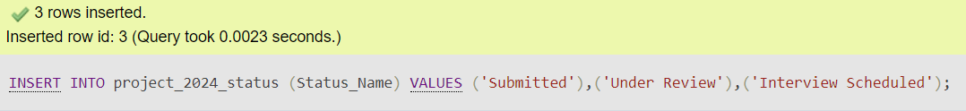



Show create views and their purposes:

The Job Applications This Month view presents a focused perspective on job applications received within the current month on the job recruitment site. It filters and displays data exclusively for applications submitted within the current calendar month, providing real-time insights into recent applicant activity. By highlighting applications submitted within the month, this view assists recruiters in staying updated on the latest candidate engagements and enables them to prioritize and manage applications effectively.

this view offers a summarized overview of job applications received by each employer registered on the recruitment site. It aggregates data to display the total number of applications and the average salary offered by each employer. This summary facilitates analysis of application trends and enables comparison between different employers based on factors such as application volume and salary offerings, assisting job seekers in making informed decisions.

The Candidate Job Details view provides detailed information about candidates and their associated job applications. It presents the candidate's first name, last name, along with the job title, description, salary, and their current activity status. By consolidating candidate and job details into a single view, it offers a comprehensive overview for recruiters, aiding in assessing candidate suitability for specific job roles and facilitating informed decision-making in the hiring process.

The Active Candidates view showcases a list of candidates actively engaged on the job recruitment site. It filters and displays candidates who are currently active, indicating their availability for potential job opportunities. This view simplifies the process for employers to identify and reach out to candidates who are actively seeking employment, streamlining the recruitment process, and enhancing efficiency for both candidates and employers.

Python snippets:

Code for connecting to database

Code to display the inputted view:

Output of said statement using option 2:

Code to insert a new application into the database:

Inputs into console for adding a record

Sample data: applicant john doe should appear in the database as applicant id 1 job software engineer should have job id 1 date should be 12/03 and status should be 1.

Proof it is added to database as intended:

