# CS 340 Dashboard README

## About the Project/Project Title

This project is to use my MongoDB and Python skills to have a functioning dashboard for Grazioso Salvare’s company. Both the creation and importing of files into a database were used along with python CRUD implementation and functioning HTML dashboard using ipynb script. This interactive Dashboard can be used by any user setup in the AAC database.

**Class Specific Questions**

1. The reason MongoDB was selected for this project is its overall functionally and its Open-Source software which is free to use. With its link to PyMongo having the DB and python code interact is simple and easy to implement. The DashFramework with Ploty make combining the code and python with an HTML interface a breeze and offer many different forms of components such as charts, graphs, color schemes, etc. It is what allowed us to display all the data from mongo and coding from python into something people can use and access.
2. To begin we started with the Database creation in mongo. Importing the csv files and making an AAC database with username and password authorization. Then we worked in Python to connect the basic CRUD functionality to that database. Once completed we moved onto the actual Interface of the webpage that brings it all together. The Html page used the CRUD and DB to display data in a way we choose to have on the dashboard.
3. The biggest challenges for me where syntax errors. I had many times when running the code would fail and not give exact details of where to find the error. This came down to double checks almost all my commas and brackets and indentation to get it up and running. In one module I forgot to change from AnimalShelter import AnimalShelter to my own Py file which caused me issues. Another was making sure Mongo was started on the machine before running the code as it wouldn’t have any access to Mongo while program wasn’t running.

## Motivation

This project was created to connect a Database to an interface for users to access. Keeping these files up to date allows any authorized users to effectively handle the job they are looking for. Other reasons for this project include improving the skills required to link a database to a python interface. It shows how free mongo software combined with python can be used on a business level database system. It also allowed me to learn the basics of how databases and coding are implemented together.

## Getting Started

I will have supplied a zip file that contains all the code and CSV file and this ReadMe that can be used to replicate this database. You must have up to date Python, MongoDB and Juypter to run this. You must also create your own MongoDB as the connection to my host IP will only work while I’m running mongo through Apporto.

## Installation

-Install MongoDB

- Install Python

- Install Jupyter this will come with many of the Plot and Dash functions

- Install the Zip file and Unzip keeping everything in the same folder

## Usage

For beginning usage, you must create your own Mongo Database and import the CSV file included with Zip, Create database as AAC to be easier to work with Py file. Once that has been done you create a user account and password for that database. In Jupyter open the animal_Shelter Py file change the username, password and host to match the machine you are setting it up on. Finally open the ProjectTwoDashboard.ipynb file in Jupyter and change username and password in there to have all the code linked together.

### Code Example

Crud File

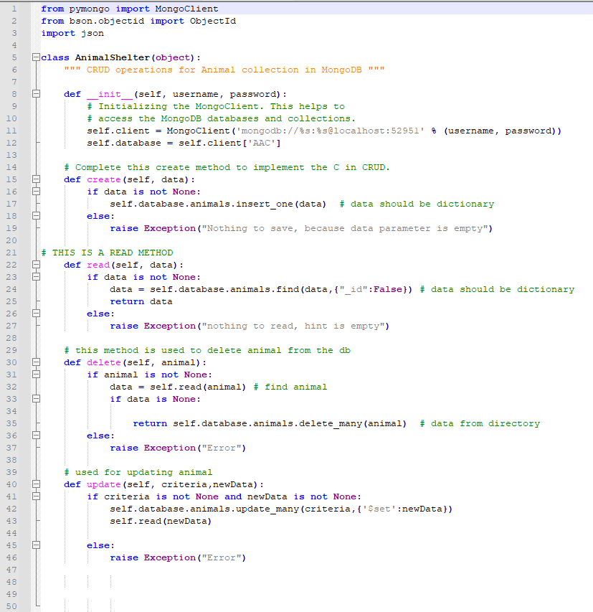

PojectTwoDashboard.ipynb

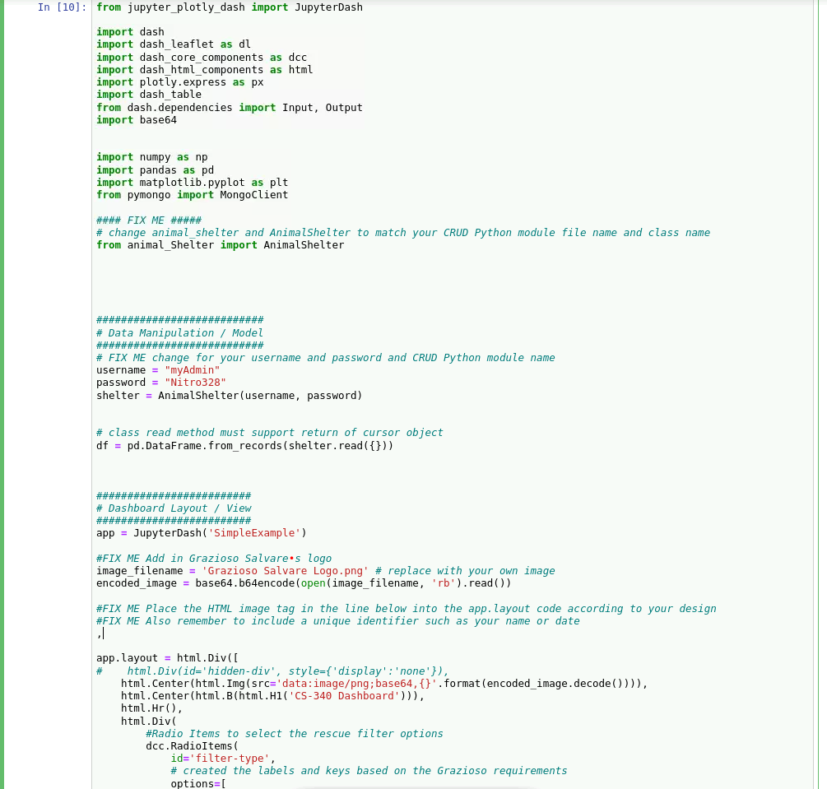

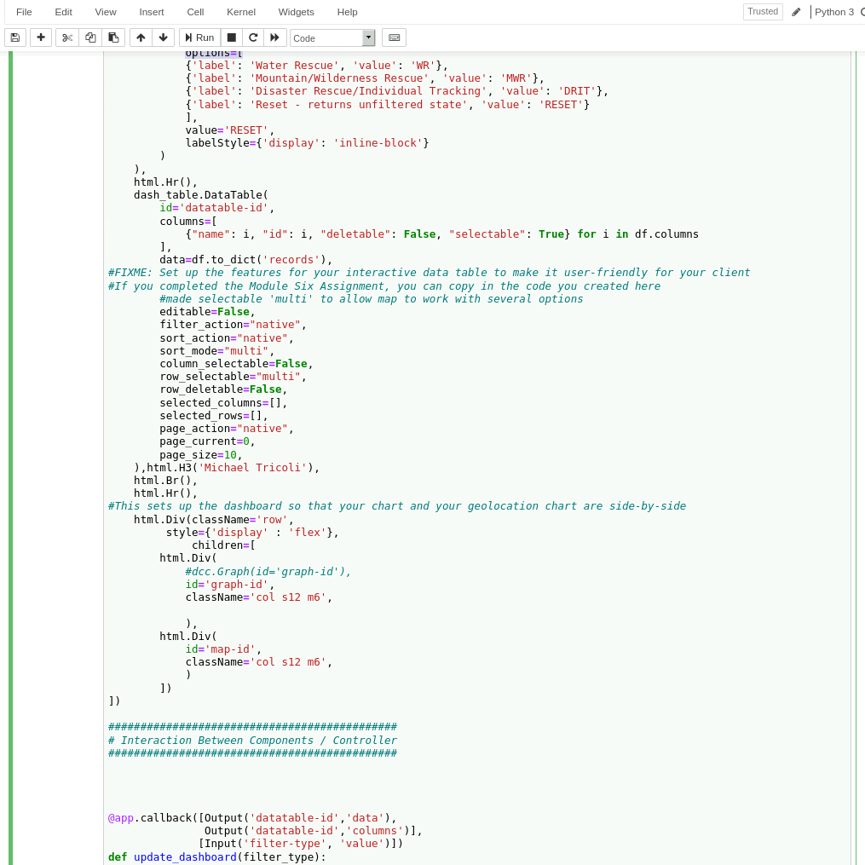

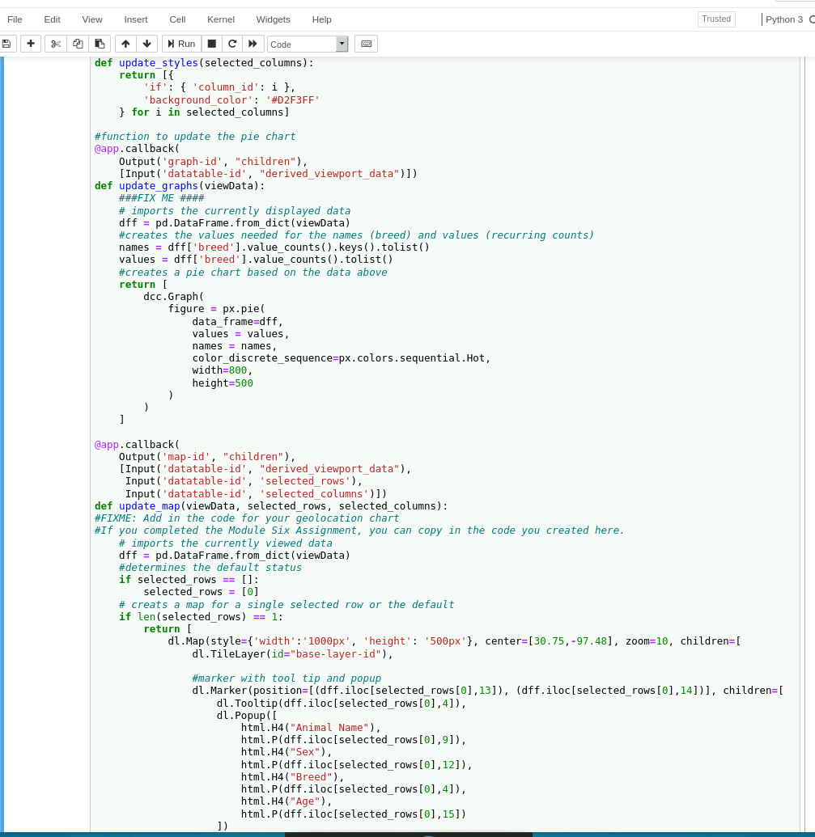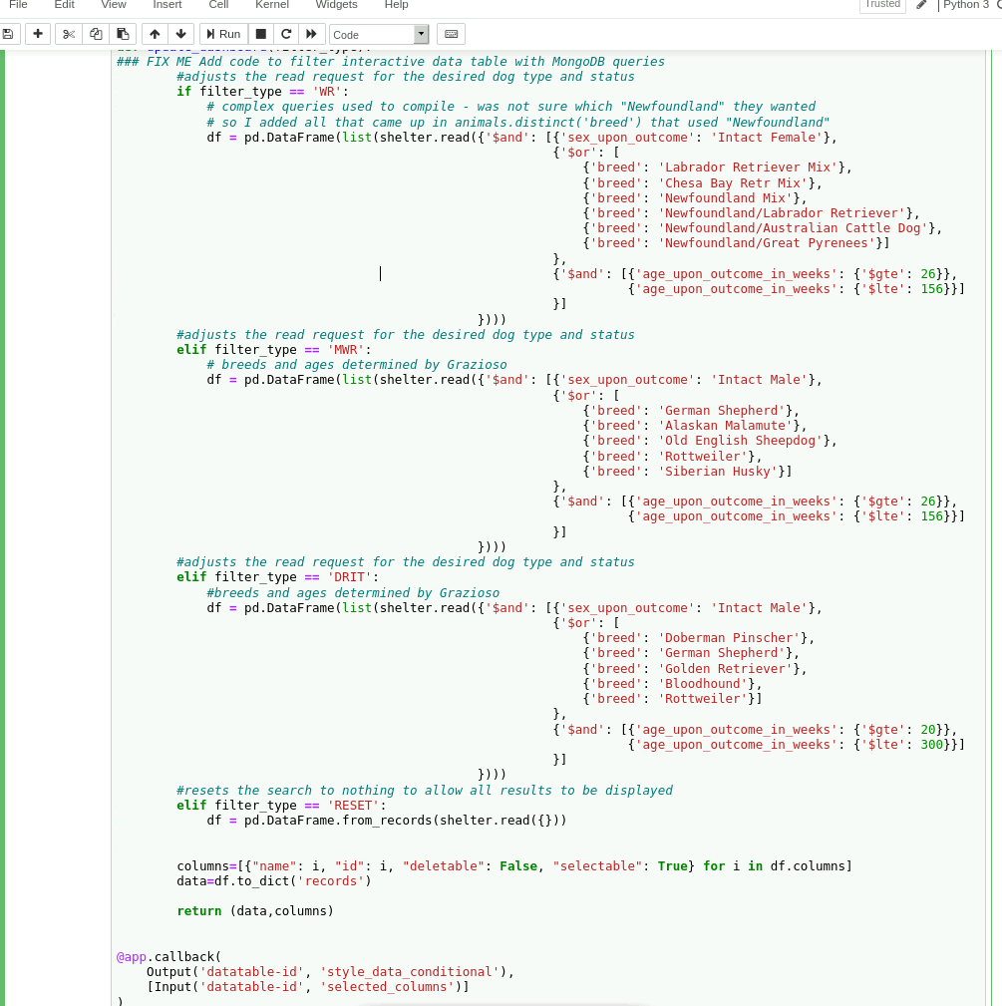

### Tests

Starting App

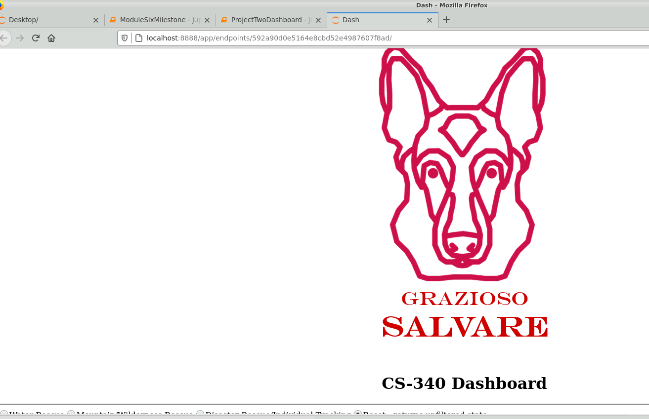

Table with Unique ID at bottom

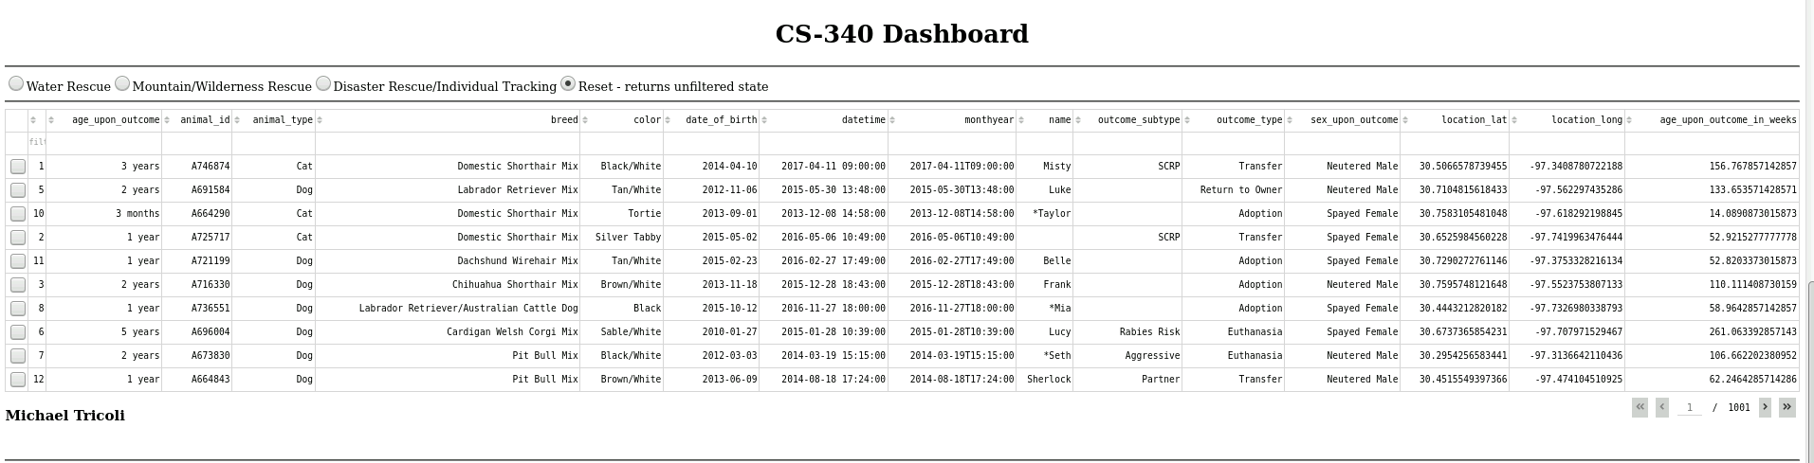

Default Pichart and Geo

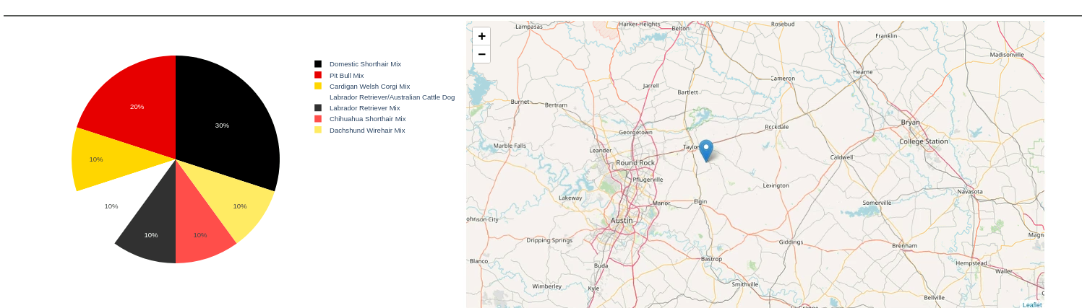

Select a filter and get filtered results and pie chart update

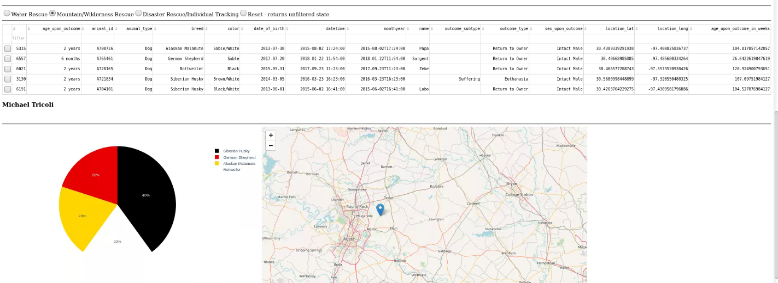

GeoUpdate select a dog to get GeoLocation

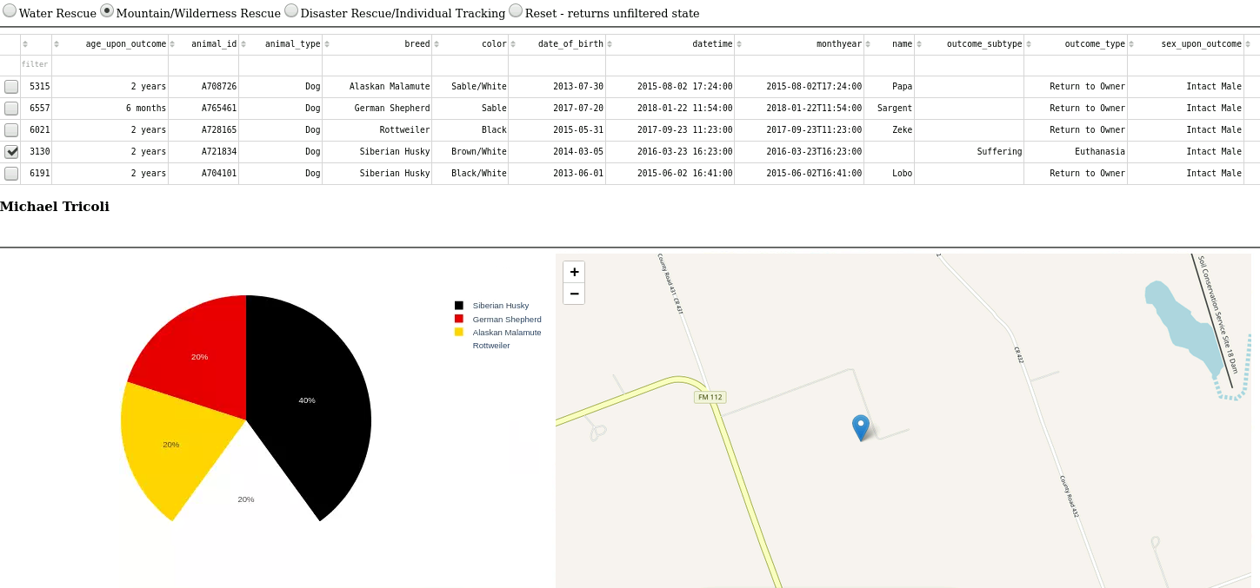

Trying Different Filter

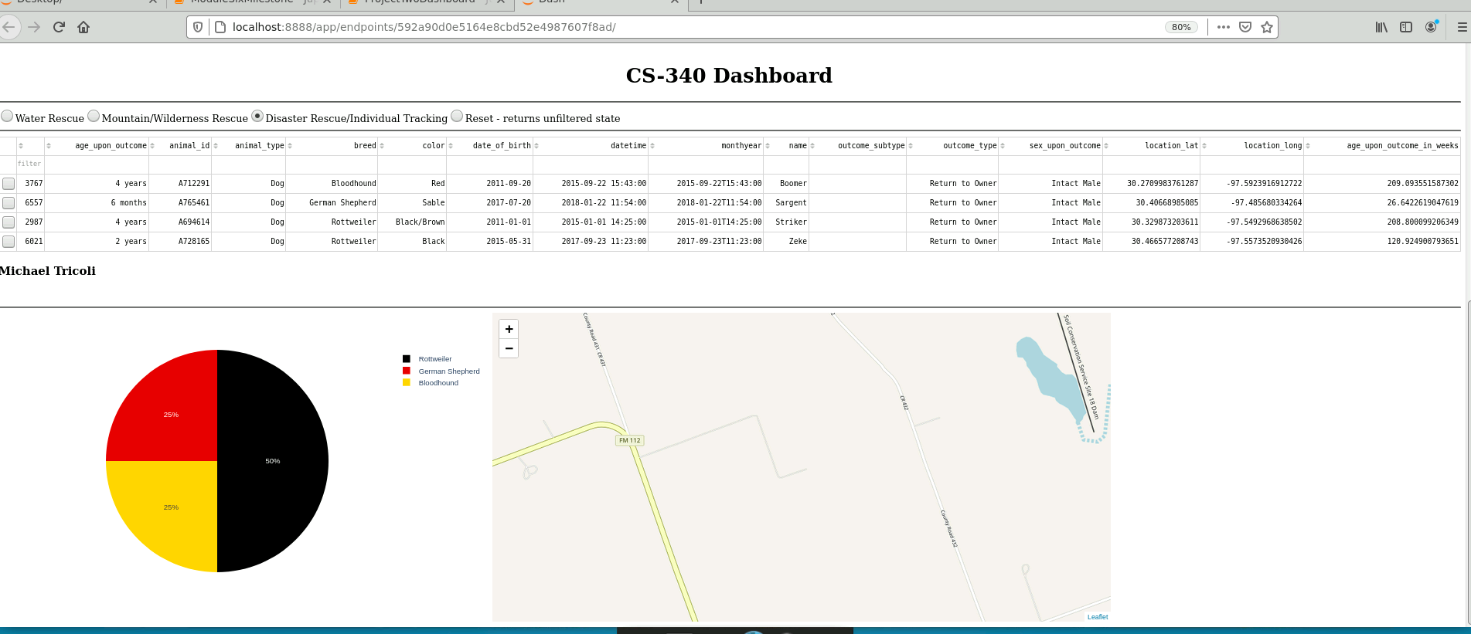

Reset Filter State

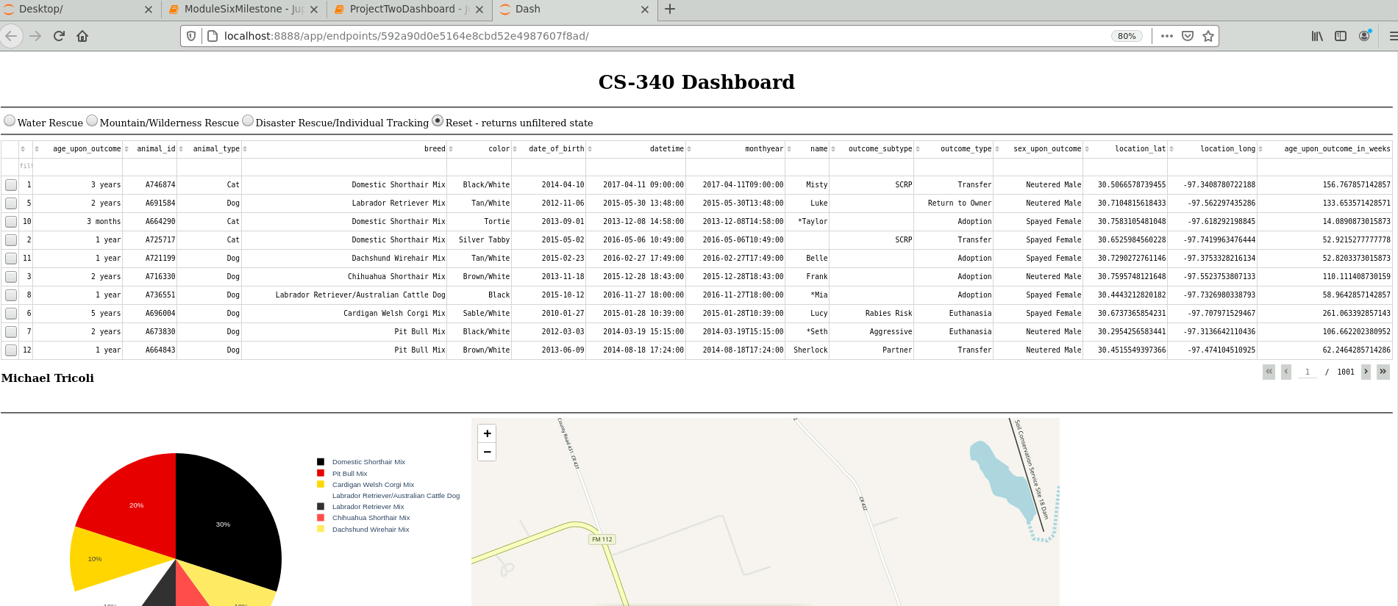

**RoadMap**

Some basic roadmap ideas are to fix Geo filter to uncheck box automatically after selecting new target dog and allow multiple selections at once which would reset after max selectable is achieved. UI color tweaks and maybe change buttons from circlebox to full block text selection.

## Contact

Your name: Michael Tricoli

Email: Michael.Tricoli@snhu.edu