

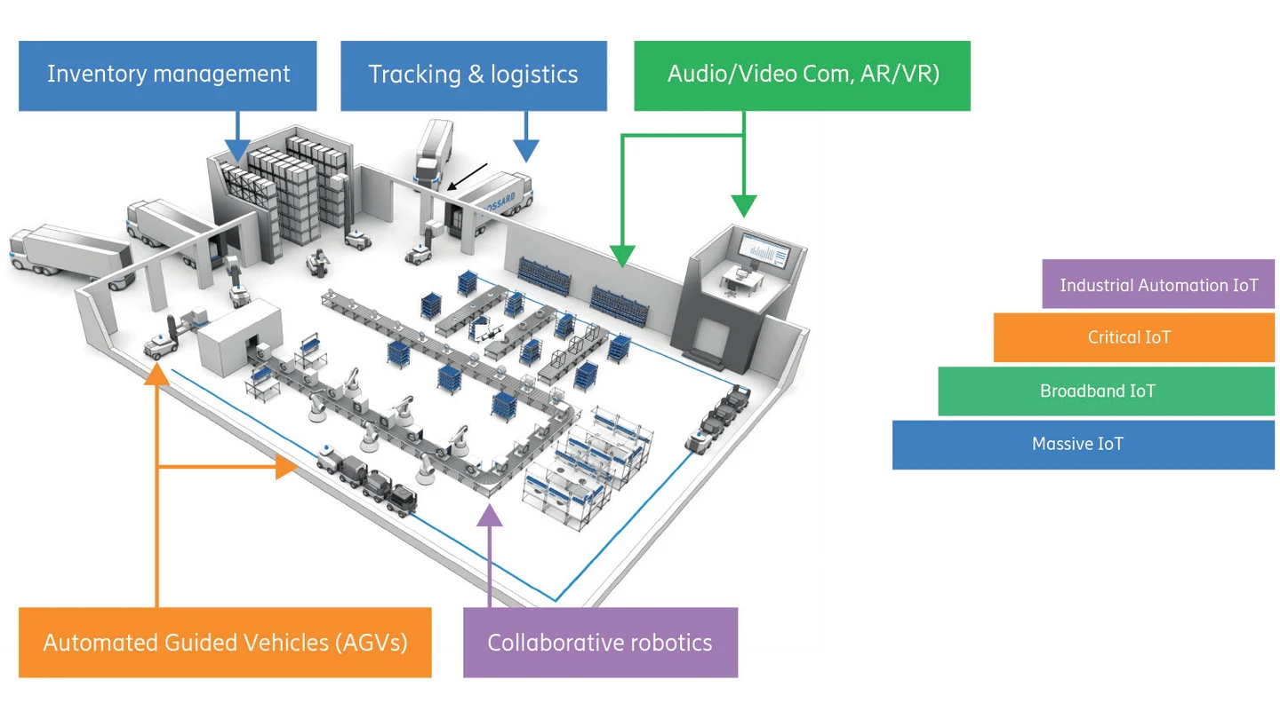

Autonomous Ground Vehicle

# System requirements:

1. Autonomous car with attached sensors
2. Router
3. MQTT dashboard App
4. Web Interface

# Diagram:

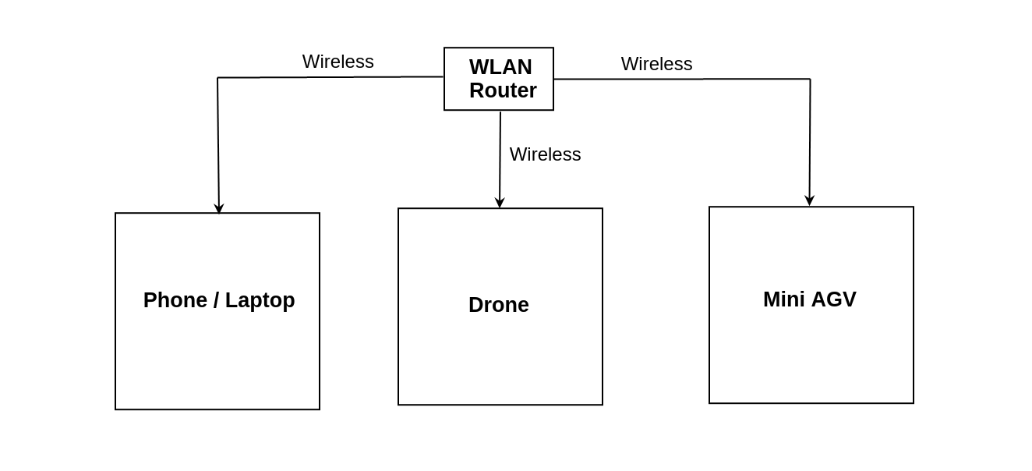

# Procedure:

## Internet

1. Switch ON the Router

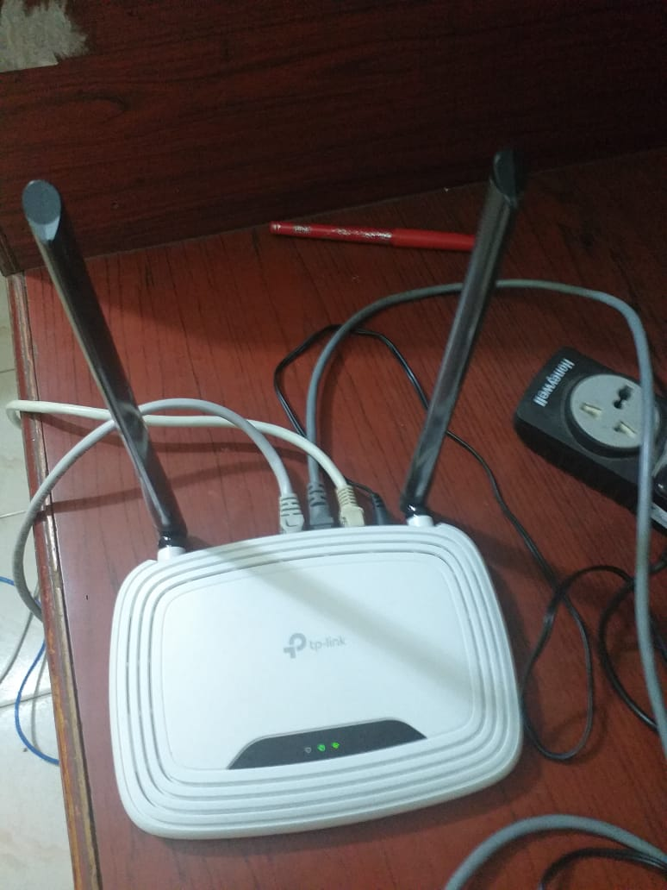

1. Connect the 4G USB dongle to the car.
2. Power On the car motors.

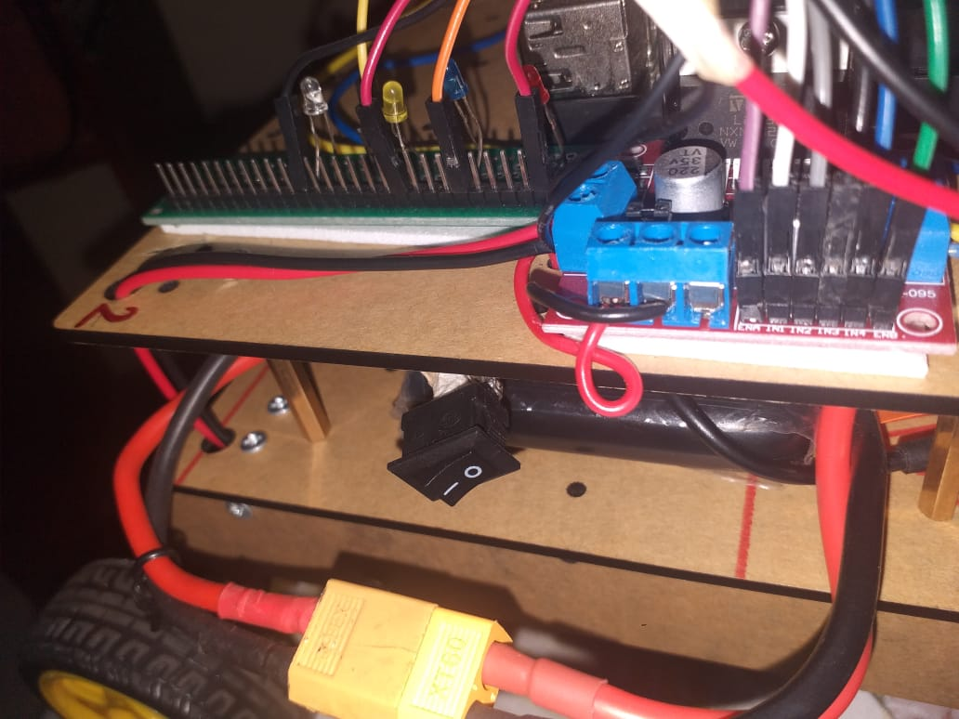

1. Connect PC/laptop with router’s Wi-Fi: CRL-GCET(password: chandharlabs)
2. Wait for a minute until white LED glows in the car.

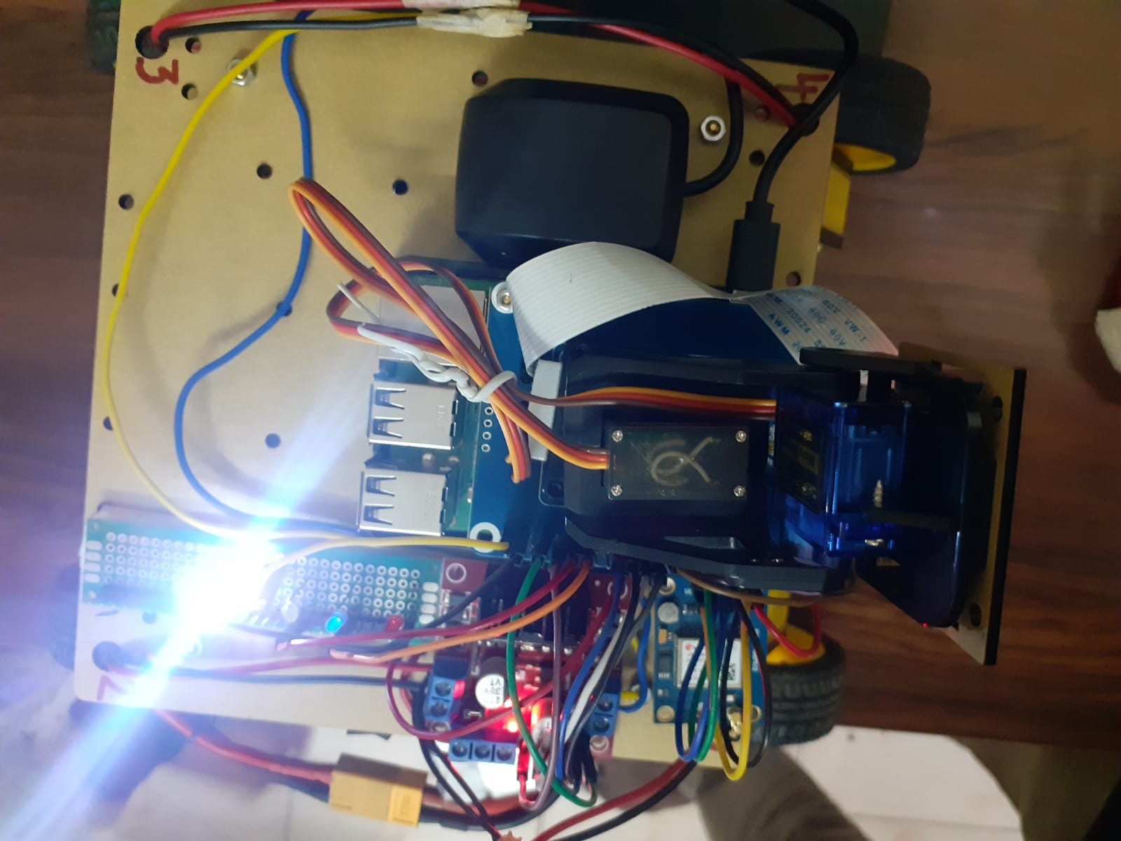

1. Using the “MQTT Dashboard” app in the mobile/PC, press any button (forward, backward, left, right, stop) to move the car manually in the different direction at different speeds.
2. Using the “MQTT Dashboard” app in the mobile/PC, press the autonomous button so that the car itself selects the direction path based on the obstacles in the route..
3. Open Main.html in the web browser and select the Internet option.
4. You can monitor the location of the car using a GPS map.
5. Control the motion of the car based on the video received using the control buttons:

forward, backward, left, right, stop.

1. You can adjust the speed of the car using horizontal and vertical bars.

## Local:

1. Switch ON the Router
2. Connect the 4G USB dongle to the car.
3. Power On the car motors.
4. Connect PC/laptop with router’s Wi-Fi: CRL-GCET(password: chandharlabs)
5. Using the “MQTT Dashboard” app in the mobile/PC, press any button (forward, backward, left, right, stop) to move the car in the different direction at different speeds.
6. Open Main.html in the web browser and select the local option.
7. You can monitor the location of the car using a GPS map.
8. Control the motion of the car based on the video received using the control buttons: forward, backward, left, right, stop.
9. You can adjust the speed of the car using horizontal and vertical bars.

# Precautions to be checked:

1. Power bank supply for RPi board. Make sure all four LEDs glow to ensure full charge in the power bank.

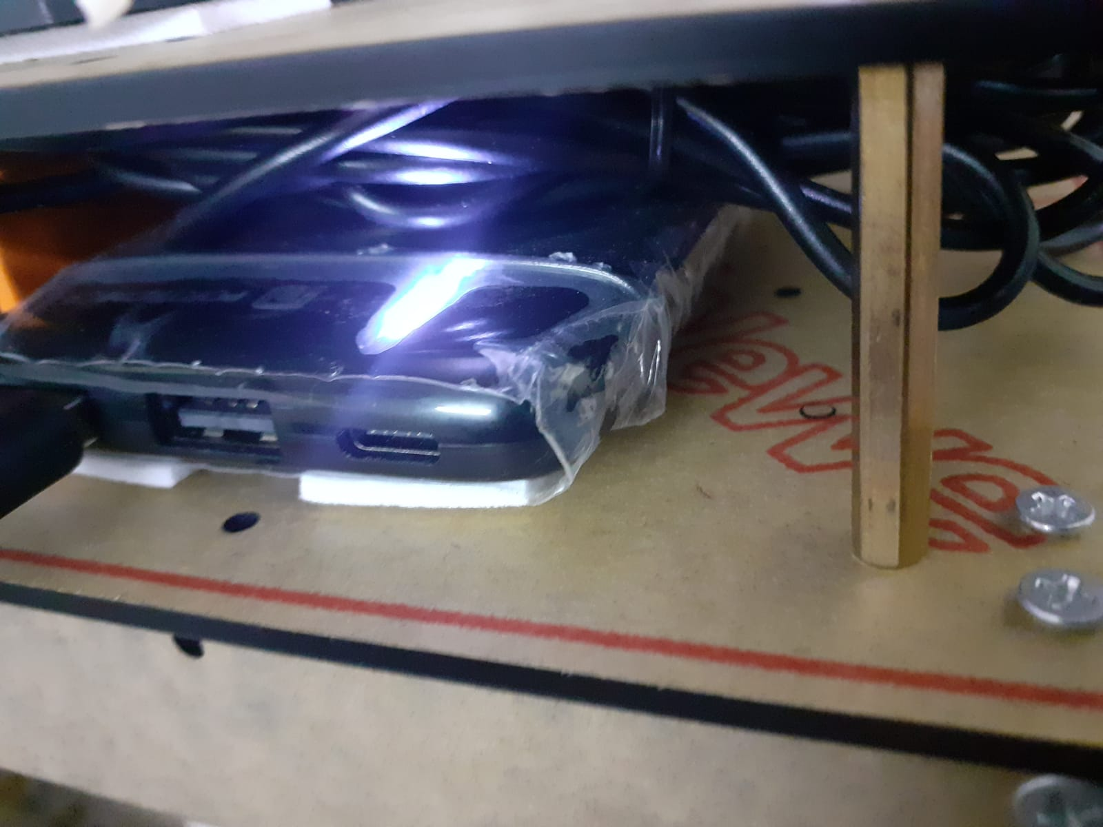

1. Battery power supply for the car driver circuit can be tested using the LIPO battery checker. If the voltage goes low(< 10 V), charge the battery using a LIPO battery charger.

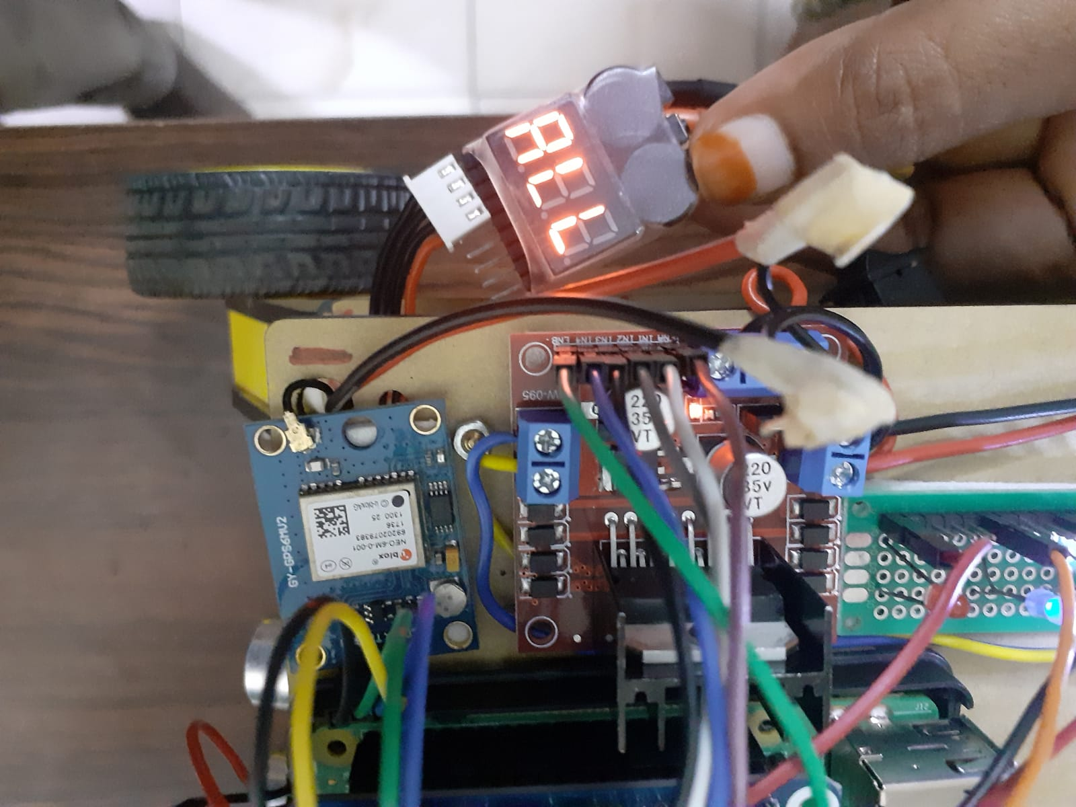 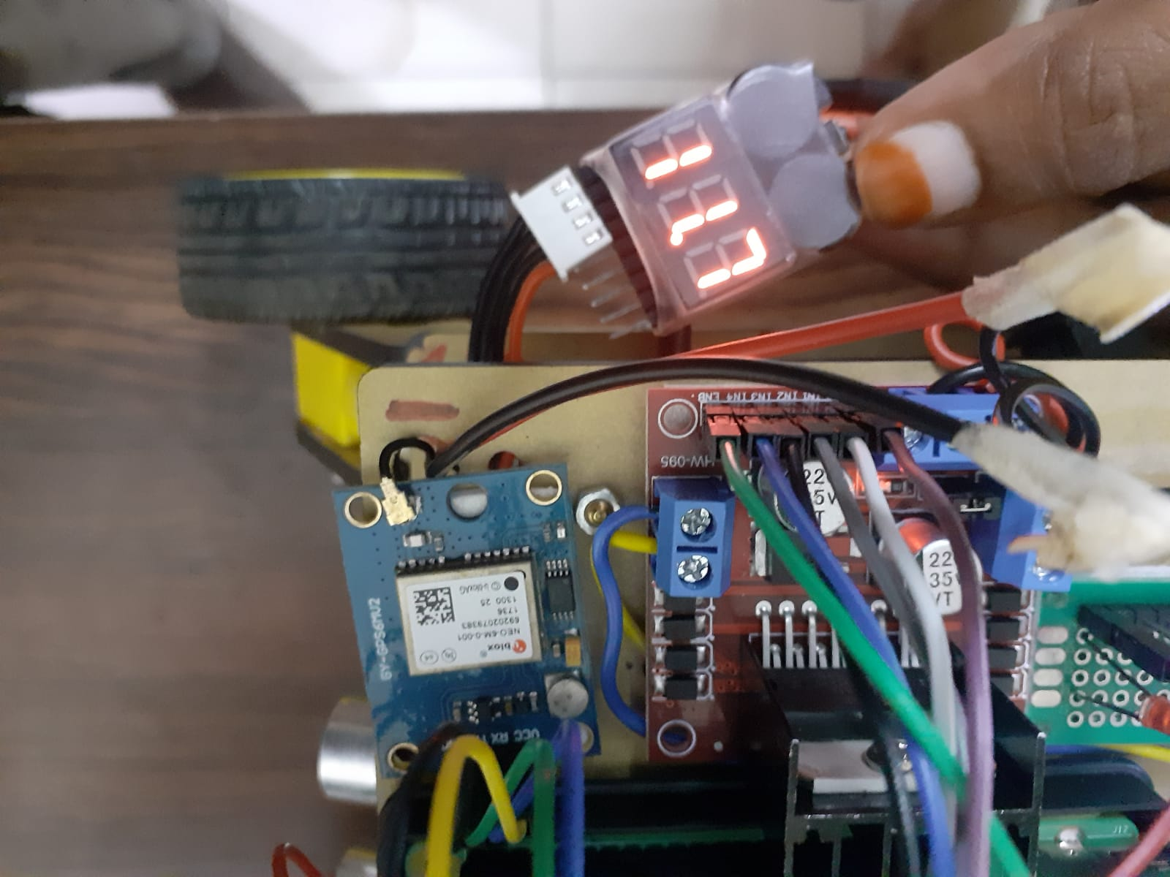

1. Introduction to and Raspberry Pi and Arduino Uno
2. Introduction to DC Motor Control using Raspberry Pi and Arduino Uno
3. Interfacing Sensors (IR, Ultrosonic)
4. Automatic line follower using RPi
5. Introduction to Messgae Queuing Transfer Protocol (MQTT)
6. Remote AGV control via MQTT
7. Remote AGV control via MQTT over WLAN (4G)
8. Remote AGV control via MQTT over Internet (4G)

Future projects:

* AI enabled AGV (using camera and image processing)
* Vehicle-to-Vehicle Communication using Zigbee

