Customer Requirements Specification

AAS Digital Nameplate Generator

Customer: Rentschler & Holder

Company address: Rotebühlplatz 41, 70178 Stuttgart

Supplier: Team 2

|  |  |  |
| --- | --- | --- |
| Role | Name | Email Address |
| Team Lead | Adrian Khairi | Inf21196@lehre.dhbw-stuttgart.de |
| Test Manager | Janin Ahlemeyer | Inf21006@lehre.dhbw-stuttgart.de |
| System Architect & Software Developer | Mika Kuge | Inf21059@lehre.dhbw-stuttgart.de |
| Technical Documentation | Maris Koch | Inf21050 @lehre.dhbw-stuttgart.de |
| Product Manager | Erika Zhang | Inf21174@lehre.dhbw-stuttgart.de |

Version Control

|  |  |  |  |
| --- | --- | --- | --- |
| Version | Date | Author | Comment |
| 1.0 | 26.09.2022 | Erika Zhang | Initialized and created the CRS with Adrian Khairi’s (BC) input |
| 1.1 | 27.09.2022 | Erika Zhang | Refined the document with Adrian Khairi’s comments |
| 1.2 | 29.10.2022 | Erika Zhang | Added BPMN diagrams |
| 1.3 | 22.10.2022 | Erika Zhang | Refined the document with Adrian Khairi’s comments |
| 1.4 | 15.10.2022 | Erika Zhang | Refined the document with the customer’s - and Mika Kuge’s input |
| 1.5 | 26.10.2022 | Erika Zhang | Refined the document with Adrian Khairi’s comments |
| 2.0 | 15.03.2023 | Erika Zhang | Final improvements based on Adrian Khairi’s comments |

Table of Contents

1 Introduction 3

2 Scope 4

3 Product Environment 5

4 Product Usage 5

4.1 Business Processes 5

4.1.1 BP01 View Asset 5

4.1.2 BP02 Nameplate generation 6

4.1.3 BP03 Nameplate download 7

4.2 Use cases 8

4.2.1 UC01 Select a Server 8

4.2.2 UC02 Browse the Server 9

4.2.3 UC03 Select and view an asset 10

4.2.4 UC04 View nameplate preview 10

4.2.5 UC05 Download in SVG format 11

4.2.6 UC06 Download in PNG format 12

4.3 Functional Requirements 12

4.3.1 REQ1 Responsive and compatible GUI 13

4.3.2 REQ2 Dark and light mode menu 13

4.3.3 REQ3 Download menu for SVG and PNG format 13

4.3.4 REQ4 Search functionality 14

4.3.5 REQ5 Navigation buttons 14

4.3.6 REQ6 QR-code generator 14

4.3.7 REQ7 Nameplate generator 15

4.3.8 REQ8 Nameplate preview 15

4.3.9 REQ9 Error handling 15

4.4 Non-functional Requirements 16

4.4.1 NREQ1 User-friendly 16

4.4.2 NREQ2 Performance 16

4.4.3 NREQ3 Reliability 16

4.4.4 NREQ4 Maintainability 17

4.4.5 NREQ5 License 17

5 UI sketches 18

6 References 18

# Introduction

The purpose of this document is to define the requirements for the digital nameplate generator. The information stated in this document will be used for other documents, for instance, the Software Requirements Specification (SRS) as well as providing a base for subsequent development activities. This includes design, implementation and testing.

# Scope

The main objective of this project is to create a nameplate generator for an Asset Administration Shell (AAS). As visible in figure 2.1 the application shall be able to create graphical illustrations based on the properties provided by the AAS as well as the ability to generate QR codes according to the DIN standard.

Furthermore, a user-friendly front-end application, set up on the host system, shall be designed and implemented utilizing React. This includes a home page where the user can enter a server address. After selecting the server, the user shall be directed to a user interface (UI) listing all the components available on the server. Additionally, the interface shall display the data regarding the asset chosen by the user in an organized and clear structure. Both search functions contain autocomplete. The interface allows the communication between any AAS server through REST-API. Additionally, there shall be an option to download the nameplate in SVG or PNG format. The application shall be tested to ensure compatibility with a diverse AAS server infrastructure. Forbye, the project shall provide a user manual documentation online.

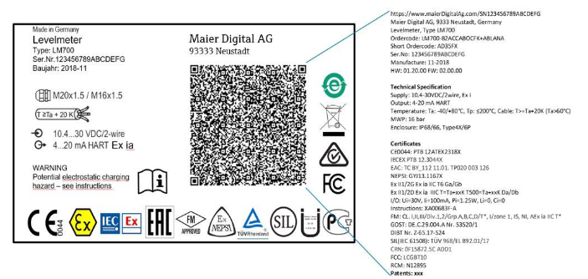

Figure 2.1: Nameplate

# Product Environment

The web application shall be developed utilizing the framework React, which is an open source front-end JavaScript library. It is used for creating user interfaces (UI) based on UI components [1] . The source code shall be converted to pure with the assistance of the JS platform *Node.js* as well as other modules. This ensures the display of the application in the browser without the use of Node.js.

Thus, the user’s web browser acts as the execution environment loading the application through Hypertext Transfer Protocol (Secure), also known as HTTP(S), as well as acquiring the data through REST-API from the AAS-Server.

Since the compiled project shall be hosted on a HTTP(S) server, it does not require an extraordinary infrastructure except providing HTML, CSS and JS to the user.

The AAS is comprised of a number of submodules containing information and functionalities of an asset. It is not only a digital representation of an asset but also acts as a link between physical objects and the intertwined, digital world [2].

# Product Usage

## Business Processes

# BP01 View Asset

Figure 4.1: BPMN diagram of view asset

|  |  |
| --- | --- |
| Business Process ID | BP01 |
| Involved Roles | User, AAS-Server |
| Result | The user is able to access a chosen server by entering the server address into a search bar. To ensure easier handling the most popular servers shall be suggested. A table filled with the components of the server is displayed. The user can select an asset and view all the sorted information provided by the AAS-Server regarding the given asset. Additionally, if the user clicks on the wrong asset, they can return to the previous page by using the back button. |
| Triggering event | The user wants to view a chosen asset on a specific server. |
| Exceptions | The server is unavailable therefore the user’s web browser cannot acquire the information for the component list and the information regarding a specific asset. |
| Control points and measurement | There shall be search functions for servers and assets.  All the components of a chosen server shall be displayed.  The user can select an asset and more information about it shall be presented in a structured order.  A navigation button shall enable to user to return to the previous page. |

# BP02 Nameplate generation

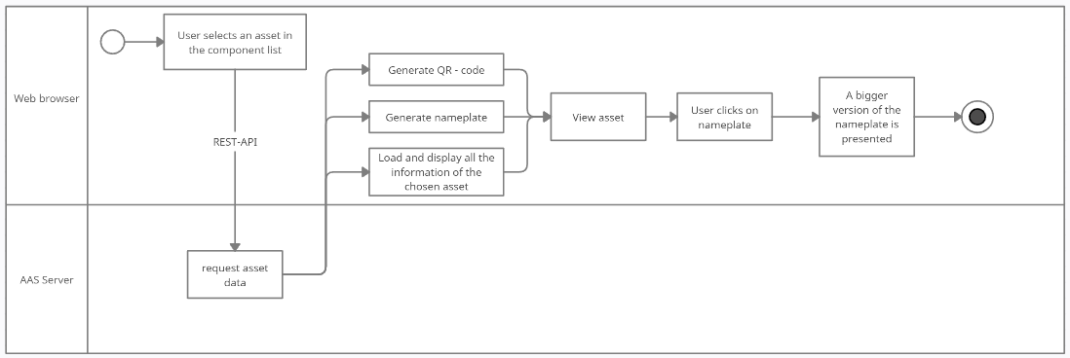

Figure 4.2: BPMN diagram of nameplate generation

|  |  |
| --- | --- |
| Business Process ID | BP02 |
| Involved Roles | User, AAS-Server |
| Result | The application generates a graphical illustration of a nameplate for a given asset with the information provided by the AAS-Server. It contains General Information, Technical Specification, Certificates and Patents. Additionally, the information is stored in a QR-code displayed on the nameplate. Furthermore, the nameplate must conform to the DIN standard. The nameplate shall be displayed on the UI as well as a larger preview version of it shall be accessible by clicking on it. |
| Triggering event | The user wants to look at the nameplate of a chosen asset. |
| Exceptions | The nameplate shall be generated regardless of missing information, however, the application shall alert the user that the nameplate is not complete. |
| Control points and measurement | * A nameplate corresponding to the DIN standard must be generated for every asset. * The information used for the generation should belong to the chosen asset. * It shall always be displayed in the same position on the web application. * If there is an error such as missing information, the user shall be notified. |

# BP03 Nameplate download

Figure 4.3: BPMN diagram of nameplate download

|  |  |
| --- | --- |
| Business Process ID | BP03 |
| Involved Roles | User, AAS-Server, User’s device |
| Result | A version of the nameplate in either SVG or PNG format is downloaded to the user’s device. |
| Triggering event | The user wants a version of the nameplate on their device. |
| Exceptions | The user’s device has no storage for the file or downloads a broken file that cannot be opened by the hardware. |
| Control points and measurement | A correct version of the nameplate is on the user’s device.  The user can open the downloaded file and examine the nameplate. |

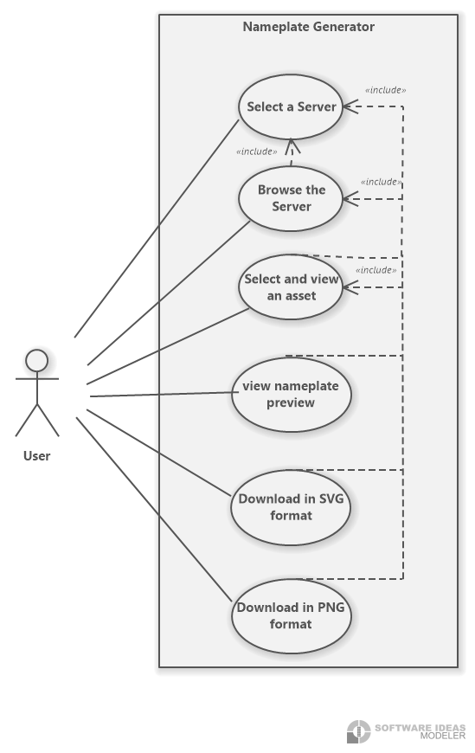

## Use cases

Figure 4.4: Use Case diagram

# UC01 Select a Server

Figure 4.5: Select a server flow chart

|  |  |
| --- | --- |
| Use Case ID | UC01 |
| Description | The user gains access to a server by entering the server address into the search bar. When clicking on the search bar a suggestion list opens and shows the most visited servers.  The search function contains autocomplete to ensure easier handling. |
| Involved roles | User, AAS-Server |
| System boundary | AAS-Server, web browser |
| Precondition | The user knows the server address and the server must exist as well as being available. |
| Postcondition on success | The interface visualizes a table filled with all the components that the server contains. |
| Triggering event | The user opens the website and wants to view the components of a specific server. |

# UC02 Browse the Server

Figure 4.6: Browse the server flow chart

|  |  |
| --- | --- |
| Use Case ID | UC02 |
| Description | Acquire the information of an asset by searching for the product name in the component table directly or with the search bar.  The search function contains autocomplete to ensure easier handling. |
| Involved roles | User, AAS-Server |
| System boundary | AAS-Server, web browser |
| Precondition | The user knows the name of the product and is on the right server containing that specific product. |
| Postcondition on success | The table displays the product names of the assets that match the search key. |
| Triggering event | The user wants to find a certain product. |

# UC03 Select and view an asset

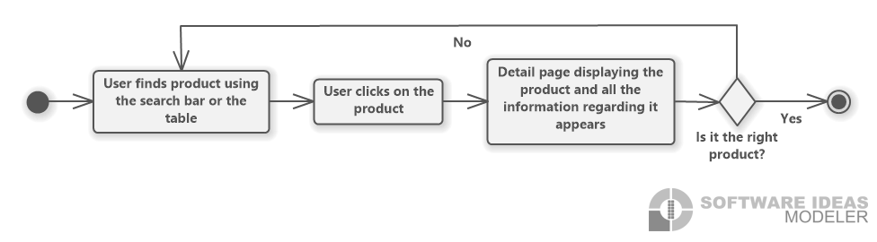

Figure 4.7: Select and view an asset flow chart

|  |  |
| --- | --- |
| Use Case ID | UC03 |
| Description | It describes the selection of an asset and displaying the data regarding it. |
| Involved roles | User, AAS-Server |
| System boundary | AAS-Server, web browser |
| Precondition | The user is on the right server containing that specific product. Additionally, if there are multiple assets with the same name, the user knows which one they are searching for. |
| Postcondition on success | The user is lead to a page displaying the data regarding the chosen asset. |
| Triggering event | The user wants to view the data of a selected product. |

# UC04 View nameplate preview

Ein Bild, das Text enthält.
Figure 4.8: Nameplate preview flow chart

|  |  |
| --- | --- |
| Use Case ID | UC04 |
| Description | A preview of the nameplate shall be shown. |
| Involved roles | User, AAS-Server |
| System boundary | AAS-Server, web browser |
| Precondition | A nameplate has been generated. |
| Postcondition on success | The preview of the nameplate filling the whole screen is displayed. |
| Triggering event | The user wants to inspect a preview of the nameplate in a bigger version. |

# UC05 Download in SVG format

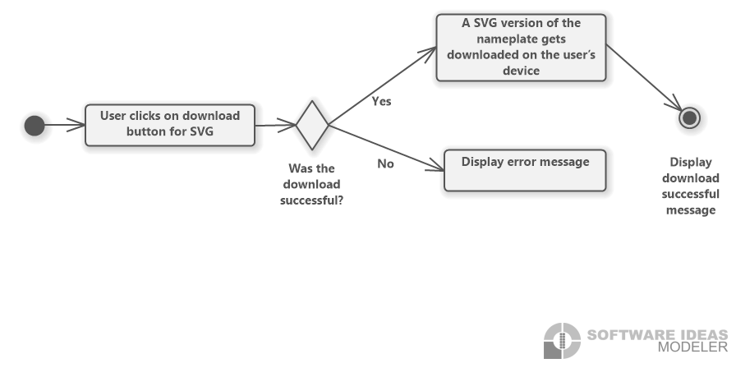

Figure 4.9: Download in SVG format flow chart

|  |  |
| --- | --- |
| Use Case ID | UC05 |
| Description | The nameplate shall be downloaded in SVG format. |
| Involved roles | User, User’s device |
| System boundary | Web browser |
| Precondition | The user’s device has enough space to store the file. |
| Postcondition on success | A SVG version of the nameplate is on the user’s device. |
| Triggering event | The user wants to download the nameplate in a SVG format. |

# UC06 Download in PNG format

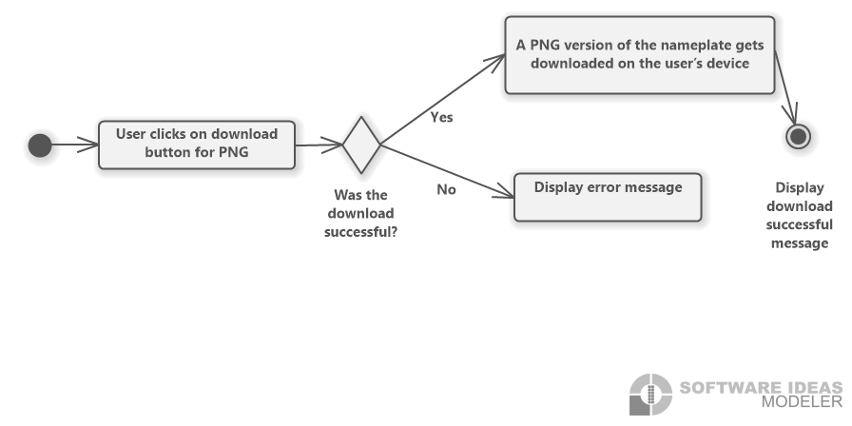

Figure 4.10: Download in PNG format flow chart

|  |  |
| --- | --- |
| Use Case ID | UC06 |
| Description | The nameplate shall be downloaded in PNG format. |
| Involved roles | User, User’s device |
| System boundary | Web browser |
| Precondition | The user’s device has enough space to store the file. |
| Postcondition on success | A PNG version of the nameplate is on the user’s device. |
| Triggering event | The user wants to download the nameplate in a PNG format. |

## Functional Requirements

**The requirements shall be described using a requirement number, an overview describing the requirement, originator, fit criterion and a priority number. The requirements shall be ranked from zero to five. Zero being the least important and five being the highest priority. This enables the developers to determine which requirements, have a higher priority and therefore need to be dealt with first or which ones are rather optional.**

# REQ1 Responsive and compatible GUI

|  |  |
| --- | --- |
| Requirement ID | REQ1 |
| Overview | The interface is built on a responsive web design thus it can be accessed on phone and laptop and the view shall adjust according to the user’s device.  It shall also be compatible with multiple browsers. |
| Priority | 2 |
| Originator | Customer |
| Fit Criterion | Testing whether there is a similar design on laptop and phone as well as on different Browsers, for instance, Chrome, Firefox and Edge. |

# REQ2 Dark and light mode menu

|  |  |
| --- | --- |
| Requirement ID | REQ2 |
| Overview | The buttons shall enable switching between light and dark mode. |
| Priority | 0 |
| Originator | Team |
| Fit Criterion | If the user is using light mode and clicks on the dark mode button the colors of the page shall change to a darker theme. If the user is using dark mode and clicks on the light mode button, the color theme shall change to a lighter one. |

# REQ3 Download menu for SVG and PNG format

|  |  |
| --- | --- |
| Requirement ID | REQ3 |
| Overview | The nameplates are downloaded onto the user’s device. |
| Priority | 4 |
| Originator | Customer |
| Fit Criterion | A SVG or PNG version of the exact nameplate displayed on the page shall be on the user’s device and the user is notified about the successful download. The format depends on which button is pressed. |

# REQ4 Search functionality

|  |  |
| --- | --- |
| Requirement ID | REQ4 |
| Overview | The search functions allow the user to search for a certain product or a server. |
| Priority | 3 |
| Originator | Customer |
| Fit Criterion | It requires a search bar where the user can type in the server or product name with the assistance of autocomplete. When clicking the search button, the right asset on server shall be displayed for the user. |

# REQ5 Navigation buttons

|  |  |
| --- | --- |
| Requirement ID | REQ5 |
| Overview | When clicking the back button the user shall be led to the page, he previously viewed, while being directed to the following page when clicking the forward button. |
| Priority | 1 |
| Originator | Customer |
| Fit Criterion | With the back button the user shall be able to move to the previous page. Navigating to the root shall be possible, e.g., from detail page to table page to home page. The forward button shall forward the user to the next page. |

# REQ6 QR-code generator

|  |  |
| --- | --- |
| Requirement ID | REQ6 |
| Overview | The application is able to generate QR-codes for the nameplates. |
| Priority | 5 |
| Originator | Customer |
| Fit Criterion | QR-codes shall be generated for every asset and visible on the detail page. They shall correspond to the DIN Standard and contain information in the following order: General Information, Technical Specification, Certificates and Patents. |

# REQ7 Nameplate generator

|  |  |
| --- | --- |
| Requirement Number | REQ7 |
| Overview | It can create nameplates for the chosen asset. |
| Priority | 5 |
| Originator | Customer |
| Fit Criterion | Nameplates according to the DIN standard shall be generated out of the asset the user chose. It shall contain all the necessary information such as general Information, warning signs, certificates and a QR-code. A small version shall be displayed on the detail page. |

# REQ8 Nameplate preview

|  |  |
| --- | --- |
| Requirement ID | REQ8 |
| Overview | The application provides a preview of the nameplate. |
| Priority | 1 |
| Originator | Team |
| Fit Criterion | The user can click on the nameplate enabling a bigger version to open and fill the screen so it can be looked at in more detail, e.g., zooming in. |

# REQ9 Error handling

|  |  |
| --- | --- |
| Requirement ID | REQ9 |
| Overview | The system has an error handling. |
| Priority | 4 |
| Originator | Team |
| Fit Criterion | When the server is down or does not exist, the user shall be notified. |

## Non-functional Requirements

# NREQ1 User-friendly

|  |  |
| --- | --- |
| Requirement ID | NREQ1 |
| Overview | The application should be user-friendly, thus, a user with no experience with the website shall be able to use it effortlessly. |
| Priority | 5 |
| Originator | Customer |
| Fit Criterion | An inexperienced user shall be able to navigate through the page in two minutes and use search functions in 30 seconds. If the user knows the right server and product name, it shall take them one minute to get to the detail page of the asset they were trying to look at and 20 seconds to download a SVG or PNG version of the nameplate. |

# NREQ2 Performance

|  |  |
| --- | --- |
| Requirement ID | NREQ2 |
| Overview | The software should maintain a high performance in terms of how fast a website loads including the time fetching data from the server and displaying it. |
| Priority | 3 |
| Originator | Customer |
| Fit Criterion | The standard loading time of websites is one to two seconds. However, taken into consideration that it depends on the internet connection as well, the pages will load in a duration of well below seven seconds. |

# NREQ3 Reliability

|  |  |
| --- | --- |
| Requirement ID | NREQ3 |
| Overview | The application needs to be reliable in terms of containing the right information. |
| Priority | 4 |
| Originator | Customer |
| Fit Criterion | The nameplates and QR-codes have to be generated according to the DIN standard. The information must belong to the chosen asset meaning there shall not be a false exchange of data regarding different assets. |

# NREQ4 Maintainability

|  |  |
| --- | --- |
| Requirement ID | NREQ4 |
| Overview | The website requires a high maintainability. |
| Priority | 3 |
| Originator | Team |
| Fit Criterion | Each team member shall be able to read and understand the code as well as knowing how to make changes. Additionally, developers not belonging to the team shall be able to do so as well after reading the code for five hours. |

# NREQ5 License

|  |  |
| --- | --- |
| Requirement ID | NREQ5 |
| Overview | The product is an open source software thus a license for publishing it is required. |
| Priority | 5 |
| Originator | Team |
| Fit Criterion | The product is published under the MIT license and it is added to the GitHub. |

# UI sketches

A high fidelity prototype of the front-end application has been designed using the tool Figma and can be found under the following link: [Figma prototype](https://www.figma.com/proto/txYBDE6dJya51ZhB1Um5bT/UI_sketch?node-id=38%3A509&starting-point-node-id=38%3A509&scaling=scale-down).

The current illustration on the homepage is only a placeholder and will therefore be replaced with a nameplate later on.

At the top of the page there is a navigation bar containing a back button, either a sun or moon icon, a home, about and GitHub link. By clicking on the moon and sun icons the user can switch between dark and light mode. Through the back button the user can navigate to the previous page. Furthermore, the home link leads to the home page.

After searching for a server by clicking on the magnifying glass the user is led to a component list where they can search for an asset. When clicking on the last row the table expands and a scrolling function is activated. This is simply for sketch purposes since the table will be generated dynamically. The first row leads the user to an example page of an asset, however, for show purposes it does not contain all the information nor the right nameplate. Lastly, clicking on the nameplate results in a nameplate preview with a bigger version filling the page.

# References

|  |  |
| --- | --- |
| [1] | W3Schools, "What is React?," [Online]. Available: https://www.w3schools.com/whatis/whatis_react.asp. [Accessed on 29.09.2022]. |
| [2] | A. O. S. P. Jörg Neidig, "Asset Administration Shell Reading Guide," 01 2022. [Online]. Available: chrome-extension://efaidnbmnnnibpcajpcglclefindmkaj/https://www.plattform-i40.de/IP/Redaktion/DE/Downloads/Publikation/AAS-ReadingGuide_202201.pdf?__blob=publicationFile&v=4#:~:text=The%20Asset%20Administration%20Shell%20(AAS,and%20capabilities%20%E2%80%9. [Accessed on 28.09.2022]. |