Customer Requirements Specification

AAS Digital Nameplate Generator

Customer: Rentschler & Holder

Company address: Rotebühlplatz 41, 70178 Stuttgart

Supplier: Team 2

|  |  |  |
| --- | --- | --- |
| Role | Name | Email Address |
| Team Lead | Adrian Khairi | Inf21196@lehre.dhbw-stuttgart.de |
| Test Manager | Janin Ahlemeyer | Inf21006@lehre.dhbw-stuttgart.de |
| System Architect & Software Developer | Mika Kuge | Inf21059@lehre.dhbw-stuttgart.de |
| Technical Documentation | Maris Koch | Inf21050 @lehre.dhbw-stuttgart.de |
| Product Manager | Erika Zhang | Inf21174@lehre.dhbw-stuttgart.de |

Version Control

|  |  |  |  |
| --- | --- | --- | --- |
| Version | Date | Author | Comment |
| 1.0 | 26.09.2022 | Erika Zhang | Initialized and created the CRS with Adrian Khairi’s (BC) input |
| 1.1 | 27.09.2022 | Erika Zhang | Refined the document with Adrian Khairi’s comments |
| 1.2 | 29.10.2022 | Erika Zhang | Added BPMN diagrams |
| 1.3 | 22.10.2022 | Erika Zhang | Refined the document with Adrian Khairi’s comments |
| 1.4 | 15.10.2022 | Erika Zhang | Refined the document with the customer’s - and Mika Kuge’s input |
| 1.5 | 26.10.2022 | Erika Zhang | Refined the document with Adrian Khairi’s comments |
| 2.0 | 15.03.2023 | Erika Zhang | Final improvements based on Adrian Khairi’s comments |
| 2.1 | 08.05.2023 | Erika Zhang | Added list of figures and made final improvements |

Table of Contents

1 Introduction 5

2 Scope 5

3 Product Environment 6

4 Product Usage 6

4.1 Business Processes 6

4.1.1 BP01 View Asset 6

4.1.2 BP02 Nameplate generation 7

4.1.3 BP03 Nameplate download 8

4.2 Use cases 9

4.2.1 UC01 Select a Server 9

4.2.2 UC02 Browse the Server 10

4.2.3 UC03 Select and view an asset 11

4.2.4 UC04 Download in SVG format 11

4.2.5 UC05 Download in PNG format 12

4.3 Functional Requirements 12

4.3.1 DNG.GUI.001 Responsive and compatible GUI 12

4.3.2 DNG.GUI.002 Download buttons for SVG and PNG format 13

4.3.3 DNG.GUI.003 Search functionality 13

4.3.4 DNG.GUI.004 Navigation buttons 13

4.3.5 DNG.GUI.005 QR-code generator 14

4.3.6 DNG.GUI.006 Nameplate generator 14

4.3.7 DNG.GUI.007 Error handling 14

4.4 Non-functional Requirements 15

4.4.1 DNG.USER.001 User-friendly 15

4.4.2 DNG.PERF.001 Performance 15

4.4.3 DNG.REL.001 Reliability 16

4.4.4 DNG.MAIN.001 Maintainability 16

4.4.5 DNG.LIC.001 License 16

5 References 17

List of figures

Figure 2.1: Nameplate 5

Figure 4.1: BPMN diagram of view asset 6

Figure 4.2: BPMN diagram of nameplate generation 7

Figure 4.3: BPMN diagram of nameplate download 8

Figure 4.4: Use Case diagram 9

Figure 4.5: Select a server flow chart 9

Figure 4.6: Browse the server flow chart 10

Figure 4.7: Select and view an asset flow chart 11

Figure 4.8: Download in SVG format flow chart 11

Figure 4.9: Download in PNG format flow chart 12

# Introduction

The purpose of this document is to define the requirements for the digital nameplate generator. The information stated in this document will be used for other documents, for instance, the Software Requirements Specification (SRS) as well as providing a base for subsequent development activities. This includes design, implementation and testing.

# Scope

The main objective of this project is to create a nameplate generator for an Asset Administration Shell (AAS). As visible in figure 2.1 the application shall be able to create graphical illustrations based on the properties provided by the AAS as well as the ability to generate QR codes according to the DIN standard.

Furthermore, a user-friendly front-end application, set up on the host system, shall be designed and implemented utilizing React. This includes a home page where the user can enter a server address. After selecting the server, the user shall be directed to a user interface (UI) listing all the components available on the server. Additionally, the interface shall display the data regarding the asset chosen by the user in an organized and clear structure. Both search functions contain autocomplete. The interface allows the communication between any AAS server through REST-API. Additionally, there shall be an option to download the nameplate in SVG or PNG format. The application shall be tested to ensure compatibility with a diverse AAS server infrastructure. Forbye, the project shall provide a user manual documentation online.

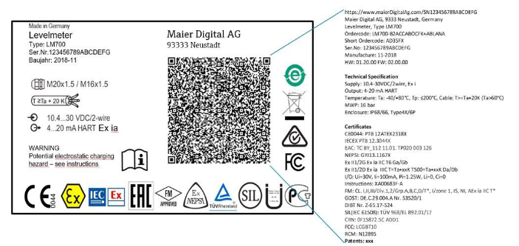

Figure 2.1: Nameplate

# Product Environment

The web application shall be developed utilizing the framework React, which is an open source front-end JavaScript library. It is used for creating user interfaces (UI) based on UI components [1] . The source code shall be converted to pure with the assistance of the JS platform *Node.js* as well as other modules. This ensures the display of the application in the browser without the use of Node.js.

Thus, the user’s web browser acts as the execution environment loading the application through Hypertext Transfer Protocol (Secure), also known as HTTP(S), as well as acquiring the data through REST-API from the AAS-Server.

Since the compiled project shall be hosted on a HTTP(S) server, it does not require an extraordinary infrastructure except providing HTML, CSS and JS to the user.

The AAS is comprised of a number of submodules containing information and functionalities of an asset. It is not only a digital representation of an asset but also acts as a link between physical objects and the intertwined, digital world [2].

# Product Usage

## Business Processes

## BP01 View Asset

Figure 4.1: BPMN diagram of view asset

|  |  |
| --- | --- |
| Business Process ID | BP01 |
| Involved Roles | User, AAS-Server |
| Result | The user is able to access a chosen server by entering the server address into a search bar. To ensure easier handling the most popular servers shall be suggested. After choosing a server a table containing the components of it are displayed. The user can select an asset and view all the sorted information provided by the AAS-Server regarding the given asset. Additionally, a user can return to the previous page by using the back button. |
| Triggering event | The user wants to view a chosen asset on a specific server. |
| Exceptions | The server is unavailable therefore the user’s web browser cannot acquire the information for the component list and the information regarding a specific asset. |
| Control points and measurement | There shall be search functions for servers and assets.  All the components of a chosen server shall be displayed.  The user can select an asset and more information about it shall be presented in a structured order.  A navigation button shall enable to user to return to the previous page. |

## BP02 Nameplate generation

Figure 4.2: BPMN diagram of nameplate generation

|  |  |
| --- | --- |
| Business Process ID | BP02 |
| Involved Roles | User, AAS-Server |
| Result | The application generates a graphical illustration of a nameplate for a given asset with the information provided by the AAS-Server. It contains General Information, Technical Specification, Certificates and Patents. Additionally, the information is stored in a QR-code displayed on the nameplate. Furthermore, the nameplate must conform to the DIN standard. The nameplate shall be displayed on the UI. |
| Triggering event | The user wants to look at the nameplate of a chosen asset. |
| Exceptions | The nameplate shall be generated regardless of missing information, however, the application shall alert the user that the nameplate is not complete. |
| Control points and measurement | * A nameplate corresponding to the DIN standard must be generated for every asset. * The information used for the generation should belong to the chosen asset. * It shall always be displayed in the same position on the web application. * If there is an error such as missing information, the user shall be notified. |

## BP03 Nameplate download

Figure 4.3: BPMN diagram of nameplate download

|  |  |
| --- | --- |
| Business Process ID | BP03 |
| Involved Roles | User, AAS-Server, User’s device |
| Result | A version of the nameplate in either SVG or PNG format is downloaded to the user’s device. |
| Triggering event | The user wants a version of the nameplate on their device. |
| Exceptions | The user’s device has no storage for the file or downloads a broken file that cannot be opened by the hardware. |
| Control points and measurement | A correct version of the nameplate is on the user’s device.  The user can open the downloaded file and examine the nameplate. |

Figure .: Use Case diagram

## Diagram Description automatically generatedUse cases

## UC01 Select a Server

Figure 4.5: Select a server flow chart

|  |  |
| --- | --- |
| Use Case ID | UC01 |
| Description | The user can select a server by entering the server address into the search bar. When clicking on the search bar a suggestion list opens and shows a suggestion list. |
| Involved roles | User, AAS-Server |
| System boundary | AAS-Server, web browser |
| Precondition | The user knows the server address and the server must exist as well as being available. |
| Postcondition on success | The interface visualizes a table filled with all the components that the server contains. |
| Triggering event | The user opens the website and wants to view the components of a specific server. |

## UC02 Browse the Server

Figure 4.6: Browse the server flow chart

|  |  |
| --- | --- |
| Use Case ID | UC02 |
| Description | The user can acquire the information of an asset by searching for the product name in the table directly or with the search bar. |
| Involved roles | User, AAS-Server |
| System boundary | AAS-Server, web browser |
| Precondition | The user knows the name of the product and is on the right server containing that specific product. |
| Postcondition on success | The table displays the product names of the assets that match the search key. |
| Triggering event | The user wants to find a certain product. |

## UC03 Select and view an asset

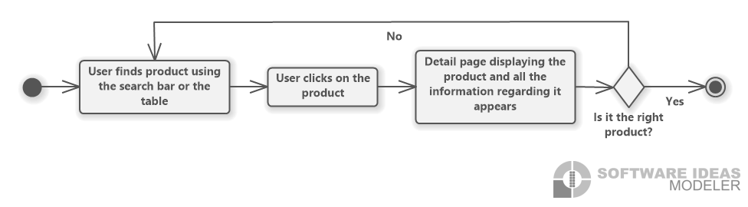

Figure 4.7: Select and view an asset flow chart

|  |  |
| --- | --- |
| Use Case ID | UC03 |
| Description | It describes the selection of an asset and the displayed data. |
| Involved roles | User, AAS-Server |
| System boundary | AAS-Server, web browser |
| Precondition | The user is on the right server containing that specific product. Additionally, if there are multiple assets with the same name, the user knows which one they are searching for. |
| Postcondition on success | The user is lead to a page displaying the data regarding the chosen asset and the generated nameplate. |
| Triggering event | The user wants to view the data of a selected product. |

## UC04 Download in SVG format

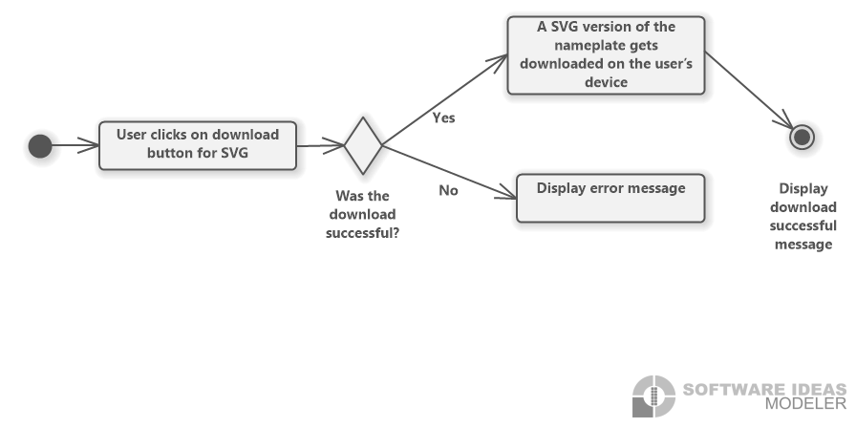

Figure 4.8: Download in SVG format flow chart

|  |  |
| --- | --- |
| Use Case ID | UC04 |
| Description | The nameplate shall be downloaded in SVG format. |
| Involved roles | User, User’s device |
| System boundary | Web browser |
| Precondition | The user’s device has enough space to store the file. |
| Postcondition on success | A SVG version of the nameplate is on the user’s device. |
| Triggering event | The user wants to download the nameplate in a SVG format. |

## UC05 Download in PNG format

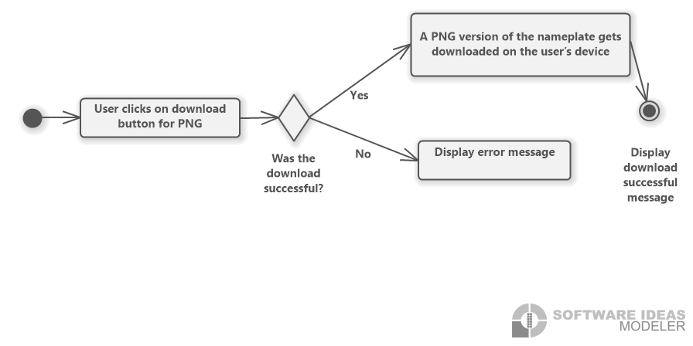

Figure 4.9: Download in PNG format flow chart

|  |  |
| --- | --- |
| Use Case ID | UC05 |
| Description | The nameplate shall be downloaded in PNG format. |
| Involved roles | User, User’s device |
| System boundary | Web browser |
| Precondition | The user’s device has enough space to store the file. |
| Postcondition on success | A PNG version of the nameplate is on the user’s device. |
| Triggering event | The user wants to download the nameplate in a PNG format. |

## Functional Requirements

**The requirements shall be described using a requirement number, an overview describing the requirement, originator, fit criterion and a priority number. The requirements shall be ranked from zero to five. Zero being the least important and five being the highest priority. This enables the developers to determine which requirements, have a higher priority and therefore need to be dealt with first or which ones are rather optional.**

## DNG.GUI.001 Responsive and compatible GUI

|  |  |
| --- | --- |
| Requirement ID | DNG.GUI.001 |
| Overview | The interface is built on a responsive web design thus it can be accessed on phone and laptop and the view shall adjust according to the user’s device.  It shall also be compatible with multiple browsers. |
| Priority | 2 |
| Originator | Customer |
| Fit Criterion | Testing whether there is a similar design on laptop and phone as well as on different Browsers, for instance, Chrome, Firefox and Edge. |

## DNG.GUI.002 Download buttons for SVG and PNG format

|  |  |
| --- | --- |
| Requirement ID | DNG.GUI.002 |
| Overview | The nameplates are downloaded onto the user’s device. |
| Priority | 4 |
| Originator | Customer |
| Fit Criterion | A SVG or PNG version of the exact nameplate displayed on the page shall be on the user’s device. The format depends on which button is pressed. |

## DNG.GUI.003 Search functionality

|  |  |
| --- | --- |
| Requirement ID | DNG.GUI.003 |
| Overview | The search functions allow the user to search for a certain product or a server. |
| Priority | 3 |
| Originator | Customer |
| Fit Criterion | It requires a search bar where the user can type in the server or product name with the assistance of autocomplete. When clicking the search button, the right asset on server shall be displayed for the user. |

## DNG.GUI.004 Navigation buttons

|  |  |
| --- | --- |
| Requirement ID | DNG.GUI.004 |
| Overview | When clicking the back button the user shall be led to the page, he previously viewed, while being directed to the following page when clicking the forward button. |
| Priority | 1 |
| Originator | Customer |
| Fit Criterion | With the back button the user shall be able to move to the previous page. Navigating to the root shall be possible, e.g., from detail page to table page to home page. The forward button shall forward the user to the next page. |

## DNG.GUI.005 QR-code generator

|  |  |
| --- | --- |
| Requirement ID | DNG.GUI.005 |
| Overview | The application is able to generate QR-codes for the nameplates. |
| Priority | 5 |
| Originator | Customer |
| Fit Criterion | QR-codes shall be generated for every asset and visible on the detail page. They shall correspond to the DIN Standard and contain information in the following order: General Information, Technical Specification, Certificates and Patents. |

## DNG.GUI.006 Nameplate generator

|  |  |
| --- | --- |
| Requirement ID | DNG.GUI.006 |
| Overview | It can create nameplates for the chosen asset. |
| Priority | 5 |
| Originator | Customer |
| Fit Criterion | Nameplates according to the DIN standard shall be generated out of the asset the user chose. It shall contain all the necessary information such as general Information, warning signs, certificates and a QR-code. A small version shall be displayed on the detail page. |

## DNG.GUI.007 Error handling

|  |  |
| --- | --- |
| Requirement ID | DNG.GUI.007 |
| Overview | The system has an error handling. |
| Priority | 4 |
| Originator | Team |
| Fit Criterion | When the server is down or does not exist, the user shall be notified. |

## Non-functional Requirements

## DNG.USER.001 User-friendly

|  |  |
| --- | --- |
| Requirement ID | DNG.USER.001 |
| Overview | The application should be user-friendly, thus, a user with no experience with the website shall be able to use it effortlessly. |
| Priority | 5 |
| Originator | Customer |
| Fit Criterion | An inexperienced user shall be able to navigate through the page in two minutes and use search functions in 30 seconds. If the user knows the right server and product name, it shall take them one minute to get to the detail page of the asset they were trying to look at and 20 seconds to download a SVG or PNG version of the nameplate. |

## DNG.PERF.001 Performance

|  |  |
| --- | --- |
| Requirement ID | DNG.PERF.001 |
| Overview | The software should maintain a high performance in terms of how fast a website loads including the time fetching data from the server and displaying it. |
| Priority | 3 |
| Originator | Customer |
| Fit Criterion | The standard loading time of websites is one to two seconds. However, taken into consideration that it depends on the internet connection as well, the pages will load in a duration of well below seven seconds. |

## DNG.REL.001 Reliability

|  |  |
| --- | --- |
| Requirement ID | DNG.REL.001 |
| Overview | The application needs to be reliable in terms of containing the right information. |
| Priority | 4 |
| Originator | Customer |
| Fit Criterion | The nameplates and QR-codes have to be generated according to the DIN standard. The information must belong to the chosen asset meaning there shall not be a false exchange of data regarding different assets. |

## DNG.MAIN.001 Maintainability

|  |  |
| --- | --- |
| Requirement ID | DNG.MAIN.001 |
| Overview | The website requires a high maintainability. |
| Priority | 3 |
| Originator | Team |
| Fit Criterion | Each team member shall be able to read and understand the code as well as knowing how to make changes. Additionally, developers not belonging to the team shall be able to do so as well after reading the code for five hours. |

## DNG.LIC.001 License

|  |  |
| --- | --- |
| Requirement ID | DNG.LIC.001 |
| Overview | The product is an open source software thus a license for publishing it is required. |
| Priority | 5 |
| Originator | Team |
| Fit Criterion | The product is published under the MIT license and it is added to the GitHub. |

# References

|  |  |
| --- | --- |
| [1] | W3Schools, "What is React?," [Online]. Available: https://www.w3schools.com/whatis/whatis_react.asp. [Accessed on 29.09.2022]. |
| [2] | A. O. S. P. Jörg Neidig, "Asset Administration Shell Reading Guide," 01 2022. [Online]. Available: chrome-extension://efaidnbmnnnibpcajpcglclefindmkaj/https://www.plattform-i40.de/IP/Redaktion/DE/Downloads/Publikation/AAS-ReadingGuide_202201.pdf?__blob=publicationFile&v=4#:~:text=The%20Asset%20Administration%20Shell%20(AAS,and%20capabilities%20%E2%80%9. [Accessed on 28.09.2022]. |