Software Requirements Specification

AAS Digital Nameplate Generator

Customer: Rentschler & Holder

Company address: Rotebühlplatz 41, 70178 Stuttgart

Supplier: Team 2

|  |  |  |
| --- | --- | --- |
| Role | Name | Email Address |
| Team Lead | Adrian Khairi | Inf21196@lehre.dhbw-stuttgart.de |
| Product Manager | Sophie Kirschner | Inf21083 @lehre.dhbw-stuttgart.de |
| Test Manager | Janin Ahlemeyer | Inf21006@lehre.dhbw-stuttgart.de |
| System Architect | Mika Kuge | Inf21059@lehre.dhbw-stuttgart.de |
| Technical Documentation | Maris Koch | Inf21050 @lehre.dhbw-stuttgart.de |
| Software Developer | Erika Zhang | Inf21174@lehre.dhbw-stuttgart.de |

Version Control

|  |  |  |  |
| --- | --- | --- | --- |
| Version | Date | Author | Comment |
| 1.0 | 04.10.2022 | Janin Ahlemeyer | Initialized the SRS and created a first version |
| 1.1 | 06.10.2022 | Janin Ahlemeyer | Fixed inaccuracies, e.g., diagrams and refined the formulation with Adrian Khairi’s - and Erika Zhang’s review |
| 1.2 | 09.10.2022 | Janin Ahlemeyer | Corrected the document with Adrian Khairi’s, Mika Kuge’s, Erika Zhang’s and the customer’s comments |
| 1.3 | 14.10.2022 | Janin Ahlemeyer | Refined the document with Adrian Khairi’s and Erika Zhang’s comments |
| 1.4 | 22.10.2022 | Janin Ahlemeyer | Added chapter prototype with the assistance of Mika Kuge and Maris Koch’s User Manual |

Table of Contents

1 Introduction 4

2 Scope 4

3 Overall Description 5

3.1 Product Perspective 5

3.1.1 User Interfaces 5

3.1.2 Hardware Interface 6

3.1.3 Software Interfaces 6

3.1.4 Communication Interface 6

4 Use Cases 6

4.1 UC01 Select a Server 7

4.2 UC02 Browse the Server 7

4.3 UC03 Select and view an asset 8

4.4 UC04 View nameplate preview 9

4.5 UC05 Download in SVG format 9

4.6 UC06 Download in PNG format 10

5 System Requirements 11

5.1 Functional Requirements 11

5.1.1 REQ1 Responsive and compatible GUI 11

5.1.2 REQ2 Dark and light mode menu 11

5.1.3 REQ3 Download menu for SVG and PNG format 12

5.1.4 REQ4 Search functionality 12

5.1.5 REQ5 Navigation buttons 12

5.1.6 REQ6 QR-code generator 13

5.1.7 REQ7 Nameplate generator 13

5.1.8 REQ8 Nameplate preview 13

5.1.9 REQ9 Error handling 14

5.2 Non-functional Requirements 14

5.2.1 NREQ1 User-friendly 14

5.2.2 NREQ2 Performance 14

5.2.3 NREQ3 Reliability 15

5.2.4 NREQ4 Maintainability 15

5.2.5 NREQ5 License 15

6 UI sketches 16

7 Prototype 16

8 Bug Fixes 17

# Introduction

The objective of this document is to provide a detailed overview of the product by outlining guidelines and specifications. Thus, setting the foundation of the project and creating an agreement for all the stakeholders involved. Furthermore, it should operate as a bridge between product management development. Therefore, helping the technical team to design and develop the software.

# Scope

The main objective of this project is to create a nameplate generator for an Asset Administration Shell, also known as “AAS”. Furthermore, a user-friendly front-end application shall be designed and implemented utilizing React. This includes a home page where the user can enter a server address. After selecting the server, the user shall be directed to a user interface (UI) listing all the assets available on the server. Additionally, the interface shall display the data regarding the asset chosen by the user in an organized and clear structure. Both search functions contain autocomplete. The interface allows the communication between any AAS server through REST-API as well as the ability to generate QR codes according to the DIN standard. Additionally, there shall be an option to download the data in SVG or PNG format. The application shall be tested to ensure compatibility with a diverse AAS server infrastructure.

The purpose of creating digital nameplates is to make nameplates environment-friendly due to a paper free solution. Moreover, it provides access to customers everywhere since it is not physically bound to a specific place. Not to mention the virtually unlimited space that can be used to display the information in more detail in reference to multiple assets. Furthermore, the information is dynamic. Thus, it can easily be changed and modified if necessary.

The nameplate generator is for customers that not only want to generate and print the type plates but also use it as a modern solution to provide a better service for their company as well as their own customers. It guarantees a simpler information collection process as well as unlimited access from any place.

# Overall Description

## Product Perspective

As visible in figure 2.1, the front-end application is a React based project built using HyperText Markup Language (HTML), JavaScript (JS) and Cascading Style Sheets (CSS). It shall be deployed on a server and accessed through the internet with a web browser.

The product relies on the AAS, which provides the information about the assets the product is going to display and utilize. This is accomplished with requests using the REST-API.

The user’s web browser acts as the execution environment loading the application through Hypertext Transfer Protocol (Secure), also known as HTTP(S), as well as acquiring the data through REST-API from the AAS-Server.

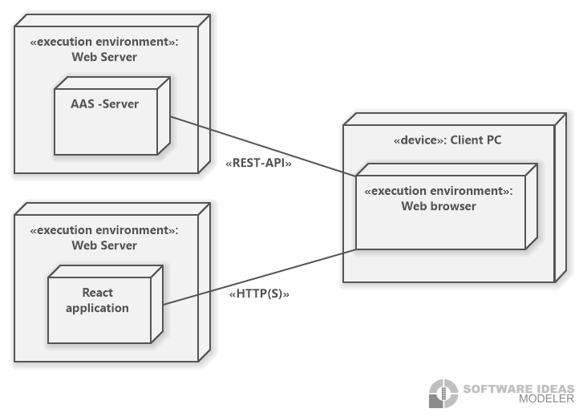

Figure 2.1: Client Model Deployment Diagram

# User Interfaces

A graphical user interface (GUI) consisting of a home, table and detail page need to be designed and created. It shall be coherent, e.g., using terminology effortlessly understood by the intended users or rather the target group as well as consisting of a dynamic design meaning it shall adapt to different screen sizes, e.g. smart phone and laptop. Users shall be able to search for a server or a certain product in 30 sec-onds. The user shall easily recognize sections of the GUI with the assistance of vis-ual cues such as arrows, bold fonts and highlighting.

The interface has to be consistent, e.g., the buttons and formulations have to be the same throughout the pages. Additionally, the interface shall be compatible to multiple browsers, e.g., Chrome, Firefox and Edge.

# Hardware Interface

Since the application runs using the internet, it requires the aptitude to connect to it. Additionally, it shall support most devices by running on smart phone as well as computers.

# Software Interfaces

The system shall use React v18.2.0 and request the data using HTML5 fetch API. The single page front-end application shall be built using HTML, JS and CSS. Source and destination format of data include JSON.

# Communication Interface

The communication architecture abides the client-server model thus employing a REST-compliant web service. The system shall use the HTTP(S) for communication over the internet.

# Use Cases

Figure 4.1: Use Case diagram

# UC01 Select a Server

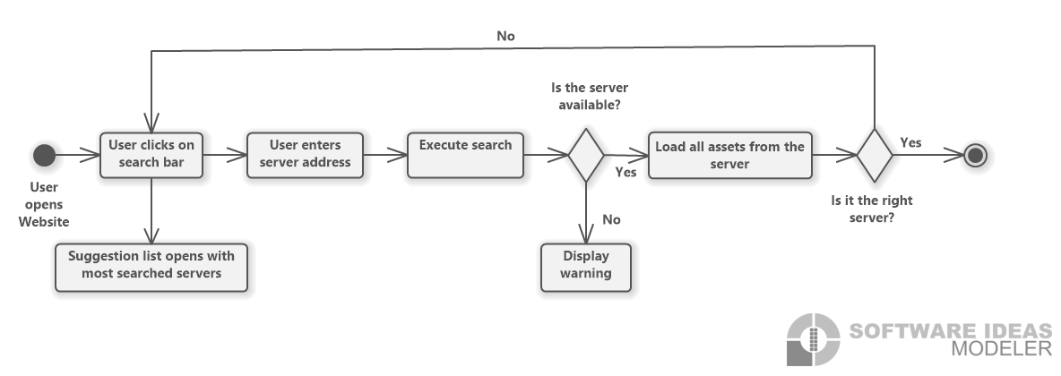

Figure 4.2: Select a server flow chart

|  |  |
| --- | --- |
| Use Case ID | UC01 |
| Description | The user gains access to a server by entering the server address into the search bar. When clicking on the search bar a suggestion lists opens and shows the most visited servers.  The search function contains autocomplete to ensure easier handling. |
| Involved roles | User, AAS-Server |
| System boundary | AAS-Server, web browser |
| Precondition | The user knows the server address and the server must exist as well as being available. |
| Postcondition on success | The interface visualizes a table filled with all the assets that the server contains. |
| Triggering event | The user opens the website and wants to view the assets of a specific server. |

# UC02 Browse the Server

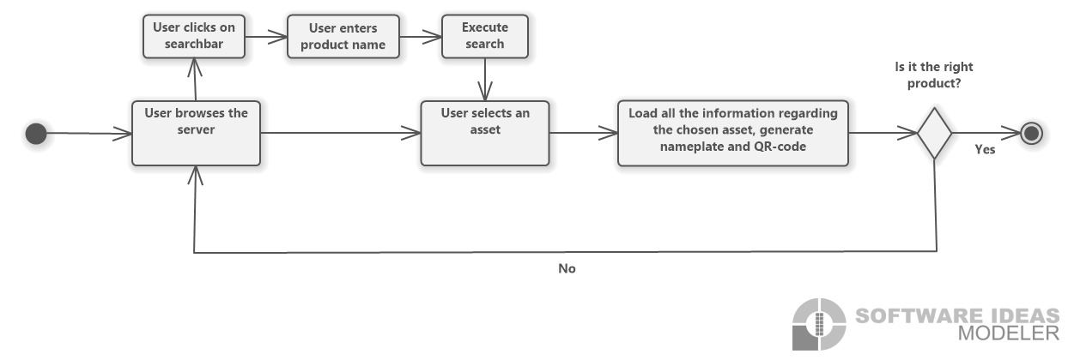

Figure 4.3: Browse the server flow chart

|  |  |
| --- | --- |
| Use Case ID | UC02 |
| Description | Acquire the information of an asset by searching for the product name in the asset list directly or with the search bar.  The search function contains autocomplete to ensure easier handling. |
| Involved roles | User, AAS-Server |
| System boundary | AAS-Server, web browser |
| Precondition | The user knows the name of the product and is on the right server containing that specific product. |
| Postcondition on success | The table displays the product names of the assets that match the search key. |
| Triggering event | The user wants to find a certain product. |

# UC03 Select and view an asset

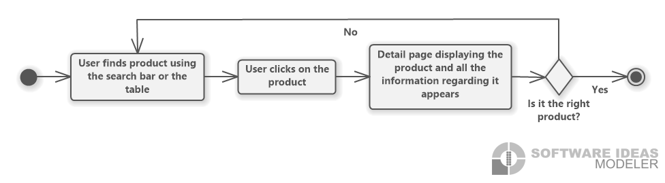

Figure 4.4: Select and view an asset flow chart

|  |  |
| --- | --- |
| Use Case ID | UC03 |
| Description | It describes the selection of an asset and displaying the data regarding it. |
| Involved roles | User, AAS-Server |
| System boundary | AAS-Server, web browser |
| Precondition | The user is on the right server containing that specific product. Additionally, if there are multiple assets with the same name, the user knows which one they are searching for. |
| Postcondition on success | The user is lead to a page displaying the data regarding the chosen asset. |
| Triggering event | The user wants to view the data of a selected product. |

# UC04 View nameplate preview

Ein Bild, das Text enthält.

Figure 4.5: Nameplate preview flow chart

|  |  |
| --- | --- |
| Use Case ID | UC04 |
| Description | A preview of the nameplate shall be shown. |
| Involved roles | User, AAS-Server |
| System boundary | AAS-Server, web browser |
| Precondition | A nameplate has been generated. |
| Postcondition on success | The preview of the nameplate filling the whole screen is displayed. |
| Triggering event | The user wants to inspect a preview of the nameplate in a bigger version. |

# UC05 Download in SVG format

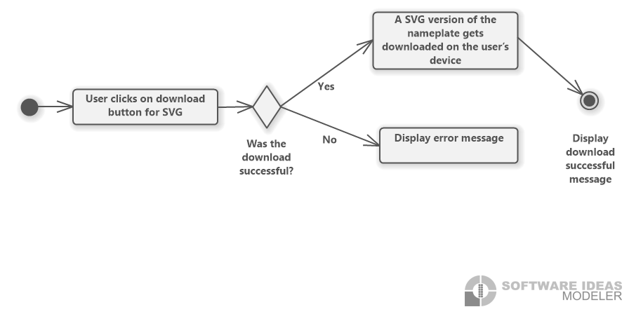

Figure 4.6: Download in SVG format flow chart

|  |  |
| --- | --- |
| Use Case ID | UC05 |
| Description | The nameplate shall be downloaded in SVG format. |
| Involved roles | User, User’s device |
| System boundary | Web browser |
| Precondition | The user’s device has enough space to store the file. |
| Postcondition on success | A SVG version of the nameplate is on the user’s device. |
| Triggering event | The user wants to download the nameplate in a SVG format. |

# UC06 Download in PNG format

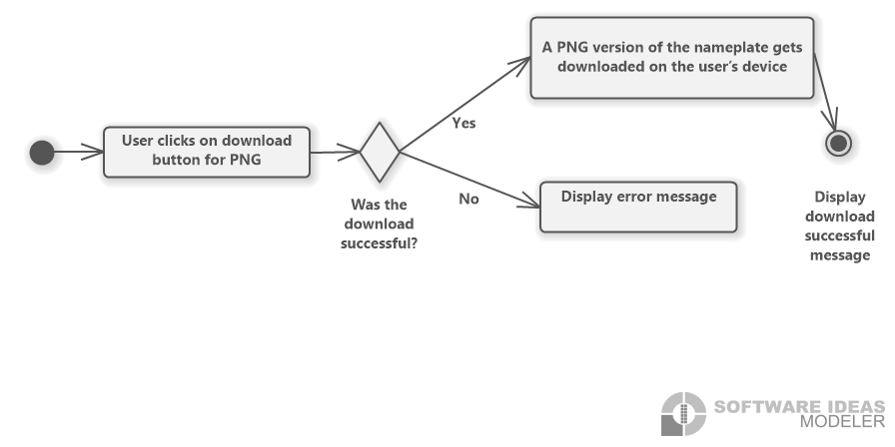

Figure 4.7: Download in PNG format flow chart

|  |  |
| --- | --- |
| Use Case ID | UC06 |
| Description | The nameplate shall be downloaded in PNG format. |
| Involved roles | User, User’s device |
| System boundary | Web browser |
| Precondition | The user’s device has enough space to store the file. |
| Postcondition on success | A PNG version of the nameplate is on the user’s device. |
| Triggering event | The user wants to download the nameplate in a PNG format. |

# System Requirements

**The requirements shall be described using a requirement number, an overview describing the requirement, originator, fit criterion and a priority number. The requirements shall be ranked from 0 to 5. 0 being the least important and 5 being the highest priority. This enables the developers to determine which requirements, have a higher priority and therefore need to be dealt with first or which ones are rather optional.**

# Functional Requirements

# REQ1 Responsive and compatible GUI

|  |  |
| --- | --- |
| Requirement ID | REQ1 |
| Overview | The interface is built on a responsive web design thus it can be accessed on phone and laptop and the view shall adjust according to the user’s device.  It shall also be compatible with multiple browsers. |
| Priority | 2 |
| Originator | Customer |
| Fit Criterion | Testing whether there is a similar design on laptop and phone as well as on different Browsers, for instance Chrome, Firefox and Edge. |

# REQ2 Dark and light mode menu

|  |  |
| --- | --- |
| Requirement ID | REQ2 |
| Overview | The buttons shall enable switching between light and dark mode. |
| Priority | 0 |
| Originator | Team |
| Fit Criterion | If the user is using light mode and clicks on the dark mode button the colors of the page shall change to a darker theme. If the user is using dark mode and clicks on the light mode button, the color theme shall change to a lighter one. |

# REQ3 Download menu for SVG and PNG format

|  |  |
| --- | --- |
| Requirement ID | REQ3 |
| Overview | The nameplates are downloaded onto the user’s device. |
| Priority | 4 |
| Originator | Customer |
| Fit Criterion | A SVG or PNG version of the exact nameplate displayed on the page shall be on the user’s device and the user is notified about the successful download. The format depends on which button is pressed. |

# REQ4 Search functionality

|  |  |
| --- | --- |
| Requirement ID | REQ4 |
| Overview | The search functions allow the user to search for a certain product or a server. |
| Priority | 3 |
| Originator | Customer |
| Fit Criterion | It requires a search bar where the user can type in the server or product name with the assistance of autocomplete. When clicking the search button, the right asset on server shall be displayed for the user. |

# REQ5 Navigation buttons

|  |  |
| --- | --- |
| Requirement ID | REQ5 |
| Overview | When clicking the back button the user shall be led to the page, he previously viewed, while being directed to the following page when clicking the forward button. |
| Priority | 1 |
| Originator | Customer |
| Fit Criterion | With the back button the user shall be able to move to the previous page. Navigating to the root shall be possible, e.g., from detail page to table page to home page. The forward button shall forward the user to the next page. |

# REQ6 QR-code generator

|  |  |
| --- | --- |
| Requirement ID | REQ6 |
| Overview | The application is able to generate QR-codes for the nameplates. |
| Priority | 5 |
| Originator | Customer |
| Fit Criterion | QR-codes shall be generated for every asset and visible on the detail page. They shall correspond to the DIN Standard and contain information in the following order: General Information, Technical Specification, Certificates and Patents. |

# REQ7 Nameplate generator

|  |  |
| --- | --- |
| Requirement ID | REQ7 |
| Overview | It can create nameplates for the chosen asset. |
| Priority | 5 |
| Originator | Customer |
| Fit Criterion | Nameplates according to the DIN standard shall be generated out of the asset the user chose. It shall contain all the necessary information such as general Information, warning signs, certificates and a QR-code. A small version shall be displayed on the detail page. |

# REQ8 Nameplate preview

|  |  |
| --- | --- |
| Requirement ID | REQ8 |
| Overview | The application provides a preview of the nameplate. |
| Priority | 1 |
| Originator | Team |
| Fit Criterion | The user can click on the nameplate enabling a bigger version to open and fill the screen so it can be looked at in more detail, e.g., zooming in. |

# REQ9 Error handling

|  |  |
| --- | --- |
| Requirement ID | REQ9 |
| Overview | The system has an error handling. |
| Priority | 4 |
| Originator | Team |
| Fit Criterion | When the server is down or does not exist, the user shall be notified. |

# Non-functional Requirements

# NREQ1 User-friendly

|  |  |
| --- | --- |
| Requirement ID | NREQ1 |
| Overview | A user with no experience with the website shall be able to use it effortlessly. |
| Priority | 5 |
| Originator | Customer |
| Fit Criterion | An inexperienced user shall be able to navigate through the page in two minutes and use search functions in 30 seconds. If the user knows the right server and product name, it shall take them one minute to get to the detail page of the asset they were trying to look at and 20 seconds to download a SVG or PNG version of the nameplate. |

# NREQ2 Performance

|  |  |
| --- | --- |
| Requirement ID | NREQ2 |
| Overview | The software should maintain a high performance in terms of how fast a website loads including the time fetching data from the server and displaying it. |
| Priority | 3 |
| Originator | Customer |
| Fit Criterion | The standard loading time of websites is one to two seconds. However, taken into consideration that it depends on the internet connection as well, the pages will load in a duration of well below seven seconds. |

# NREQ3 Reliability

|  |  |
| --- | --- |
| Requirement ID | NREQ3 |
| Overview | The application needs to be reliable in terms of containing the right information. |
| Priority | 4 |
| Originator | Customer |
| Fit Criterion | The nameplates and QR-codes have to be generated according to the DIN standard. The information must belong to the chosen asset meaning there shall not be a false exchange of data regarding different assets. |

# NREQ4 Maintainability

|  |  |
| --- | --- |
| Requirement ID | NREQ4 |
| Overview | The website requires a high maintainability. |
| Priority | 3 |
| Originator | Team |
| Fit Criterion | Each team member shall be able to read and understand the code as well as knowing how to make changes. Additionally, developers not belonging to the team shall be able to do so as well after reading the code for five hours. |

# NREQ5 License

|  |  |
| --- | --- |
| Requirement ID | NREQ5 |
| Overview | The product is an open source software thus a license for publishing it is required. |
| Priority | 5 |
| Originator | Team |
| Fit Criterion | The product is published under the MIT license and it is added to the GitHub. |

# UI sketches

A high fidelity prototype of the front-end application has been designed using the tool Figma and can be found under the following link: [Figma prototype](https://www.figma.com/proto/txYBDE6dJya51ZhB1Um5bT/UI_sketch?node-id=38%3A509&starting-point-node-id=38%3A509&scaling=scale-down).

The current illustration on the homepage is only a placeholder and will therefore be replaced with a nameplate later on.

At the top of the page there is a navigation bar containing a back button, either a sun or moon icon, a home, about and GitHub link. By clicking on the moon and sun icons the user can switch between dark and light mode. Through the back button the user can navigate to the previous page. Furthermore, the home link leads to the home page.

After searching for a server by clicking on the magnifying glass the user is led to an asset list where they can search for an asset. When clicking on the last row the table expands and a scrolling function is activated. This is simply for sketch purposes since the table will be generated dynamically. The first row leads the user to an example page of an asset, however, for show purposes it does not contain all the information nor the right nameplate. Lastly, clicking on the nameplate results in a nameplate preview with a bigger version filling the page.

# Prototype

This chapter is written based on the [User Manual](https://github.com/mk28/TINF21C_Team2_AAS_digital_nameplate/wiki/User-Manual) in the GitHub Wiki and serves as a foundation for the implementation of the project as well as the prototype.

As described in the previous chapter a [Figma prototype](https://www.figma.com/proto/txYBDE6dJya51ZhB1Um5bT/UI_sketch?node-id=38%3A509&starting-point-node-id=38%3A509&scaling=scale-down) has been created for the UI concept, however, the design is an objective of the fourth semester. Therefore, the proof of concept shall mostly contain the functional aspects.

The application shall be a single page application, thus, the current web page is dynamically rewritten with new data so the user never switches to another page unless they click on a link to an external website.

The home page contains a navigation bar consisting of a back button that enables the user to return to the previous page. This is accomplished by using the "React Router" library. The library writes into the browser history, which allows for navigation using the navigation buttons of the browser as well as buttons in the application itself. Alongside with a dark or light mode button that switches icons depending on the current mode the user is in. By clicking on the button, it toggles between a dark and light color theme. On the right side of the bar there shall be a home button, which directs the user to the start page and an about button, that displays further information about the project including but not limited to license information. Lastly, there is a link to the GitHub project. Furthermore, the start page contains a search bar, where the user can enter a server address. By clicking on the button illustrated as a magnifying glass the application connects to the server with the given address. If the server with the address responds, the user shall be forwarded to a list of assets that the server contains.

The asset list is generated dynamically and shall therefore contain as many rows as assets exist on the server as well as one header row. If the list is too long to fit on the screen completely, a scrolling function is activated to enable the user to browse the list. Additionally, the user can search for the asset name in the search bar above the table. Next to the search bar the server address is be displayed to ensure easier navigation.

If the user clicks on a row, the page shall asynchronously load the information of the chosen asset as well as generate a nameplate with a QR-code. The user can click on the nameplate to view it in full screen. Furthermore, the user can click on the download buttons to download the nameplate in either SVG or PNG format to their device.

# Bug Fixes

Since only a proof of concept has been created so far there have not been any bugs to fix. Therefore, this chapter will be filled in the fourth semester.