Machine Learning Usage in Spectroscopy-based binary classification

Materials used and Methodology
The entire program was coded in Google Colab, a Python version 3.6 environment, importing machine learning and dataset-focused libraries such as numpy, pandas, sklearn and umap.
The dataset provides 146 samples at an approximately 1:1 with and without ser ratio, where each sample has had the overall baseline subtracted and data centered around the mean, which was later scaled around the standard deviation.
The nature of the problem statement requires that a binary classificatory model must be used; cross-validation accuracy was compared among Logistic Regression, PLS-DA, Random Forest, Neural Network, and Support Vector Classifier (SVC) models.
Using GridSearchCV from sklearn, the best parameters for the model, as well as for the preprocessing of data(SelectKBest features, UMAP, PCA), are determined such that cross validation accuracy is maximized.

Results
The highest cross validation results were reported by the Random Forest and RBF SVC model at 0.6418 and, respectively, 0.6481. The other models did not perform as well, which is to be expected due to the small sample size and high features to samples ratio(1010:146). While the end cross validation accuracy is not high enough for one of the models to be implemented on their own, it’s enough to motivate a proof-of-concept to the classification problem. It is reasonable to predict that with more samples a model could reach an implementation-ready cross validation accuracy in the future.
RBF giving better results than linear signifies that the samples cannot be split through a single linear line.
Training data set vs generalized data set confusion matrices
SVC RBF

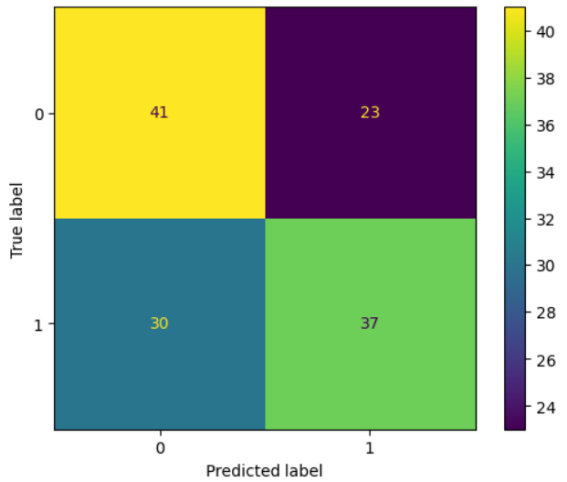
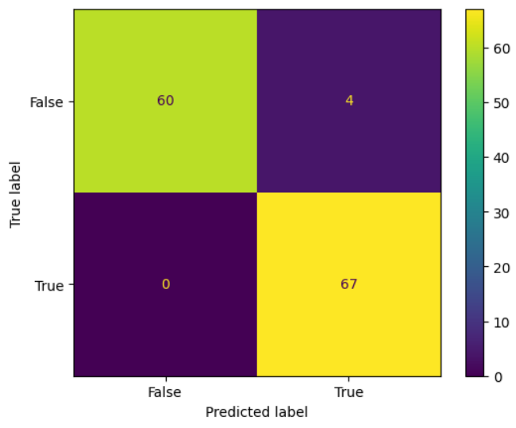

Random Forest

