# **Analysis of Second Vassiliev Measure Scans for SARS-CoV-2 S Proteins**

6/23/21

## Introduction

The sections following are an analysis comparing different versions of the spike proteins (S proteins) of SARS-CoV-2, its variants, and SARS-CoV from 2003. These proteins are analyzed with regards to a topological calculation called the second Vassiliev measure (V2).

## Alpha and Beta

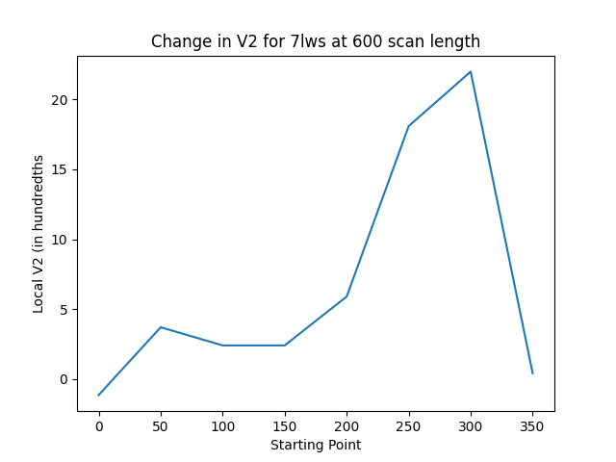Both of the figures shown below display the change in V2 as the scans’ starting points increase, both figures using 600 scan lengths. These are for S proteins of the Alpha (7lws) and Beta (7lyl) variants of SARS-CoV-2, both in the RBD-down conformations. As you can see, there is an increase in V2 at the 300 starting point of each plot, which indicates the chain of the protein containing CA atoms at indices 300 to 900.

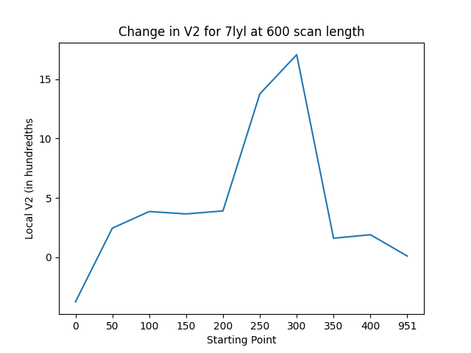

The graphs for scan lengths of 400 look similar, but with peak V2 measures at the 500 to 900 sections instead – still ending at 900, suggesting that there is a knot in the protein that becomes less of a knot after the 900-atom mark.

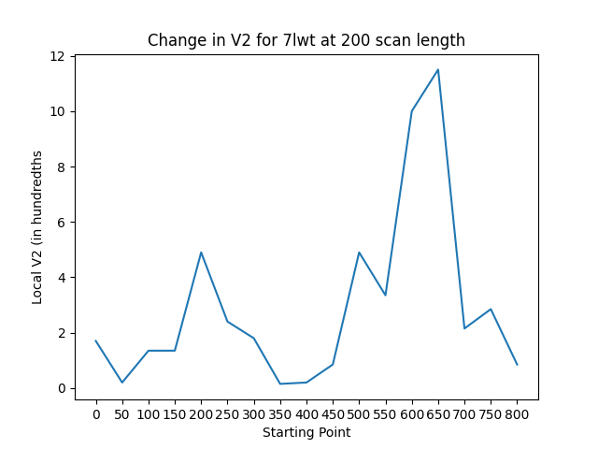

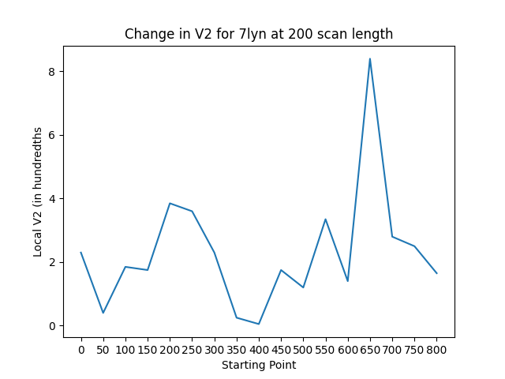

The graphs above are similar, except they are for the same S proteins for Alpha (7lwt) and Beta (7lyn) variants of SARS-CoV-2 but in the RBD-up conformation. Additionally, these graphs show the change in V2 across the entire proteins’ chains using scanning lengths of 200, rather than the 600 shown and 400 mentioned above. Still, in the RBD-up conformation, in 200, 400, and 600 scanning lengths, there is a peak in V2 at the section ending at around 900. In this case, however, the peak is actually from 650 to 850 – the V2 is a much smaller 0.0215 (0.028) at starting point 700 than the 0.115 (0.084) found at the peak for 7lwt (7lyn respectively). Interestingly enough, the same pattern can be found in the 200 scan-length scans of the RBD-down conformation versions of the S protein shown previously, where the peak is at atoms 650 to 850 rather than the expected 700 to 900.

## SARS-CoV-2 and 2003 SARS-CoV

While the 6zge (SARS-CoV-2 S protein) scans are still being processed, the scans for 6zgi, which is the furin-cleaved version of the S protein in closed conformation, have been processed. In this section I will compare 6zgi to 6acd, which is the RBD-up S protein for SARS-CoV from 2003.

The figures below show a familiar pattern, with 6acd’s V2 peak at 550 to 950 and 6zgi’s V2 peak at 600 to 1000. However, there is a stark difference between these proteins’ plots and those of the variants in the previous section. These plots show a reversal in sign for V2 in both proteins as the starting point progresses from 0 to 50. This is repeated in some other proteins’ scans, as with that of 7krq (a version of the S protein with a common mutation) shown as well.

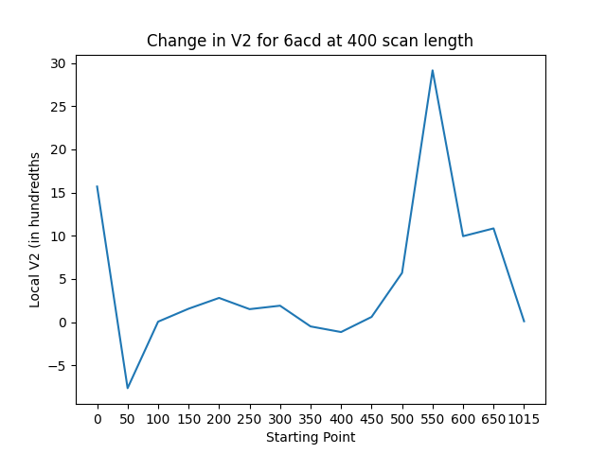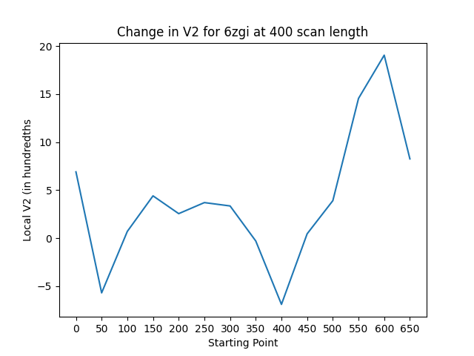 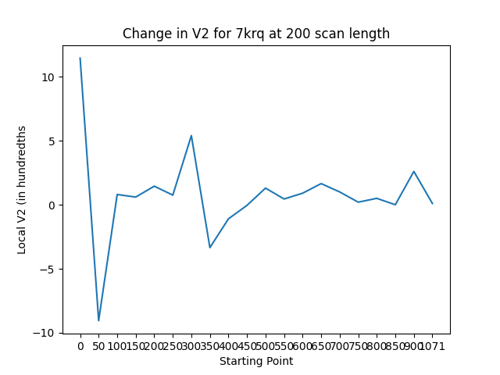

Created 7/7/2021

We have analyzed the second Vassiliev measure (V2) of the SARS-CoV-2 spike (S) protein at different sections using various window-sliding lengths (scan-lengths) of 200, 400 and 600 CA atoms. These scans were at intervals of 50 CA atoms, for example we would scan section 0 to 200 first, then 50 to 250. After we finish through the length of the protein, we scan 0 to 400, then 50 to 450, et cetera. This is to capture the tertiary structure of these individual sections as V2 data to see if we can measure how knotted they are and determine if that relates to the importance and functionality of a given scanned section. 200, 400, and 600 scan-lengths and intervals of 50 were chosen to efficiently compute V2 at as many segments of the proteins as was feasible.

\begin{figure}

\includegraphics[width=0.45\linewidth]{./figData/6zg200.png}\\

\includegraphics[width=0.45\linewidth]{./figData/6zg400.png}\includegraphics[width=0.45\linewidth]{./figData/6zg600.png}

\caption{The second Vassiliev measure of parts of the SARS-CoV-2 spike protein in uncleaved closed (6zge), cleaved closed (6zgi), cleaved open (6zgg), and cleaved intermediate (6zgh) using scanning lengths of 200, 400 and 600. }

\label{fig:rbdupdown}

\end{figure}

First, we analyze the tertiary structure of the SARS-CoV-2 S protein in 4 pre-fusion stages (closed uncleaved, closed cleaved, open cleaved, and intermediate cleaved). These different stages have structural changes that mostly affect the receptor-binding domain (RBD) and N-terminal domain (NTD). Notably, this means that for the closed conformation, the RBD is down, closed off and unable to bind to the ACE2 receptor. In the open conformation, 1 out of the 3 RBDs exposes itself so that it can assist in the binding process, with nearby NTDs moving as well. \cite{Wrobel2020}.

These scans can be seen in figure \ref{fig:rbdupdown}. The slopes of the graphs at amino acids from indices 328 to 530 are misleading due to a skip in the data where there are no amino acids recorded for the cleaved intermediate conformation of the protein (6zgh). This is mainly visible in the 400 scan-length graph for the wild SARS-CoV-2 spike proteins in various conformations, where the V2 appears to increase around that skip when it is actually because the line averages from the ordinary V2 around 300 to the V2 peak at around 560.

In the same plot, we see that there are two peaks for 6zgh and 6zgg, with the second, smaller peak at around amino acid 700 (around 470 for 6zgg on the 600 scan-length graph). The other two conformations, 6zge and 6zgi, do not share this secondary peak, and in the 400 scan-length graph their peaks sit around the 650th amino acid.

An earlier peak is also quite interesting in each of the wild spike proteins’ V2 because it acts the same for every scan-length – particularly regarding 6zge, 6zgi, and 6zgg, which excludes the intermediate cleaved stage. It is around amino acid 220 for the 200 scan-length graph, 170 for 400, and 110 for 600 scan-length. The interesting part of this peak is that for 200 and 400 scan-lengths, there is a specific order for the magnitude of the peak. 6zgi has the biggest V2, then 6zgg, then 6zge – although 6zgg and 6zge are flipped for the 600 scan-length plot. This suggests a particular change in the domain including amino acids in that area from one conformation to the other, in a way that specifically increases V2 for 6zgi and appears to act differently for 6zgh, presumably due to its intermediate state. There is also an extreme dip in V2 right before this small peak, visible in the 400 and 600 scan-length plots.

\begin{figure}

\includegraphics[width=0.45\linewidth]{./figData/RBD-Down200.png}\includegraphics[width=0.45\linewidth]{./figData/RBD-Down400.png}\\

\includegraphics[width=0.45\linewidth]{./figData/RBD-Down600.png}

\caption{The second Vassiliev measure of parts of spike proteins for SARS-CoV-2 variants in the closed, RBD down conformation (6zge, wild SARS-CoV-2; 7lws, UK variant; 7lyl, South African variant; 7kdk, D614G mutated) using scanning lengths of 200, 400 and 600. }

\label{fig:closedvariants}

\end{figure}

Next, we compare the tertiary structure of SARS-CoV-2 variants in closed and in open conformation, including the closed cleaved and open cleaved wild SARS-CoV-2 S. Figure \ref{fig:closedvariants} (600 scan-length) shows that perhaps the section containing the RBD and slightly beyond it has a different starting point for the different RBD-Down proteins. This is because the peak is at different amino acid residues, and because they start around the RBD starting point of 330 \cite{Xia2021}. However, when we look at the 400 scan-length graph, the peak’s location around 590 suggests that it is the section of the proteins that ends at amino acids around 950-1000 which is knotted in a way that increases V2 rather than the section starting around 350. This suggests that this ending point creates a knot-like structure but does not line up with any one domain. Sections in between the domains could be just as important as the labelled domains and subdomains with respect to functionality, however, and there may yet be a functionality connected to the V2 peak created along this segment \cite{Xia2021}.

Another point of interest is the fact that there is an order of magnitude with respect to the value of V2 for each protein at the peak. For both the 400 and 600 scan-length graphs, 7lyl has a smaller value than 7lws, which has a much smaller value than 7kdk. 6zge hovers around where 7lws and 7lyl are for both graphs.

\begin{figure}

\includegraphics[width=0.45\linewidth]{./figData/RBD-Up200.png}\includegraphics[width=0.45\linewidth]{./figData/RBD-Up400.png}\\

\includegraphics[width=0.45\linewidth]{./figData/RBD-Up600.png}

\caption{The second Vassiliev measure of parts of spike proteins for SARS-CoV-2 variants (7lww, Brazilian variant; 7lyn, South African variant; 6acd, SARS-CoV; 7lwt, UK variant; 6xkl, Hexapro; 6zgg, wild SARS-CoV-2) in the open, RBD up conformation using scanning lengths of 200, 400 and 600. }

\label{fig:openvariants}

\end{figure}

The same patterns can be seen in Figure \ref{fig:openvariants}. 6xkl, 6zgg, and 6acd all have V2 peaks at around 560, whereas 7lyn, 7lwt, and 7lww have more extreme V2 peaks closer to 600 (using the 400 scan-length). For the 600 scan-length, 7lyn, 7lwt, and 7lww have extreme V2 peaks around 380. 6zgg and 6acd have smaller peaks around 360, whereas 6xkl has a V2 peak at 600 scan-length with the starting amino acid of around 320. Like the RBD-Down proteins, this suggests that the interesting mutations are changing the V2 of the sections ending at around 950-1000, rather than around the starting residues of the RBD.

Additionally, there is a clear order of magnitude for the V2 values as follows, from least to greatest: 6zgg, 6acd, 6xkl, 7lyn, 7lww, 7lwt. This is visible for both the 400 and 600 scan-length graphs, and suggests that, especially given the fact that the wild proteins 6zge and 6zgg were the shortest peaks for both groups, there is some importance to the magnitude of the V2 values at these peaks – given the fact that the graph with the wild SARS-CoV-2 proteins only has V2 from -0.1 to 0.2, it would appear that the variants have more extreme knotting in the peak segments.

A third point of interest is the fact that for these larger scan-length graphs, there is a visible difference in magnitude between the two groups mentioned thus far. The Figure \ref{fig:closedvariants} peaks hover around 0.15, which 7kdk closer to 0.4. For the RBD-up proteins in Figure \ref{fig:openvariants}, however, the peaks were more diverse and averaged around 0.4. The shortest was around 0.2 (6zgg), while the tallest was close to 0.8 (7lwt). This strongly suggests that there is a topological difference between the two conformations of the RBD which increases V2 as the domains change into the ‘up’ position.