# Generate model in Avizo

* Threshold doesn’t matter that much
* Don’t care much about stray geometry

# Export model to stl

* Choose stl with binary little endian bit encoding

# Setup Maya to import stl files (do this only once)

* Open Plug-In Manager

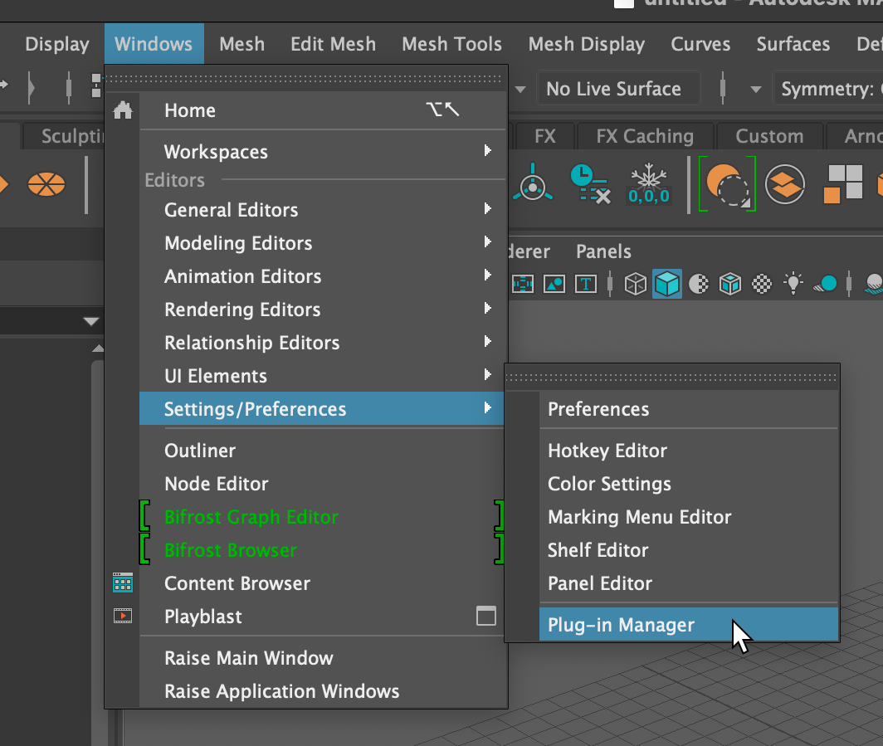

* Search for “stl”
* Check “Loaded” and “Auto load”

# Import stl model into Maya

* File → Import
* It will be in some arbitrary orientation and position

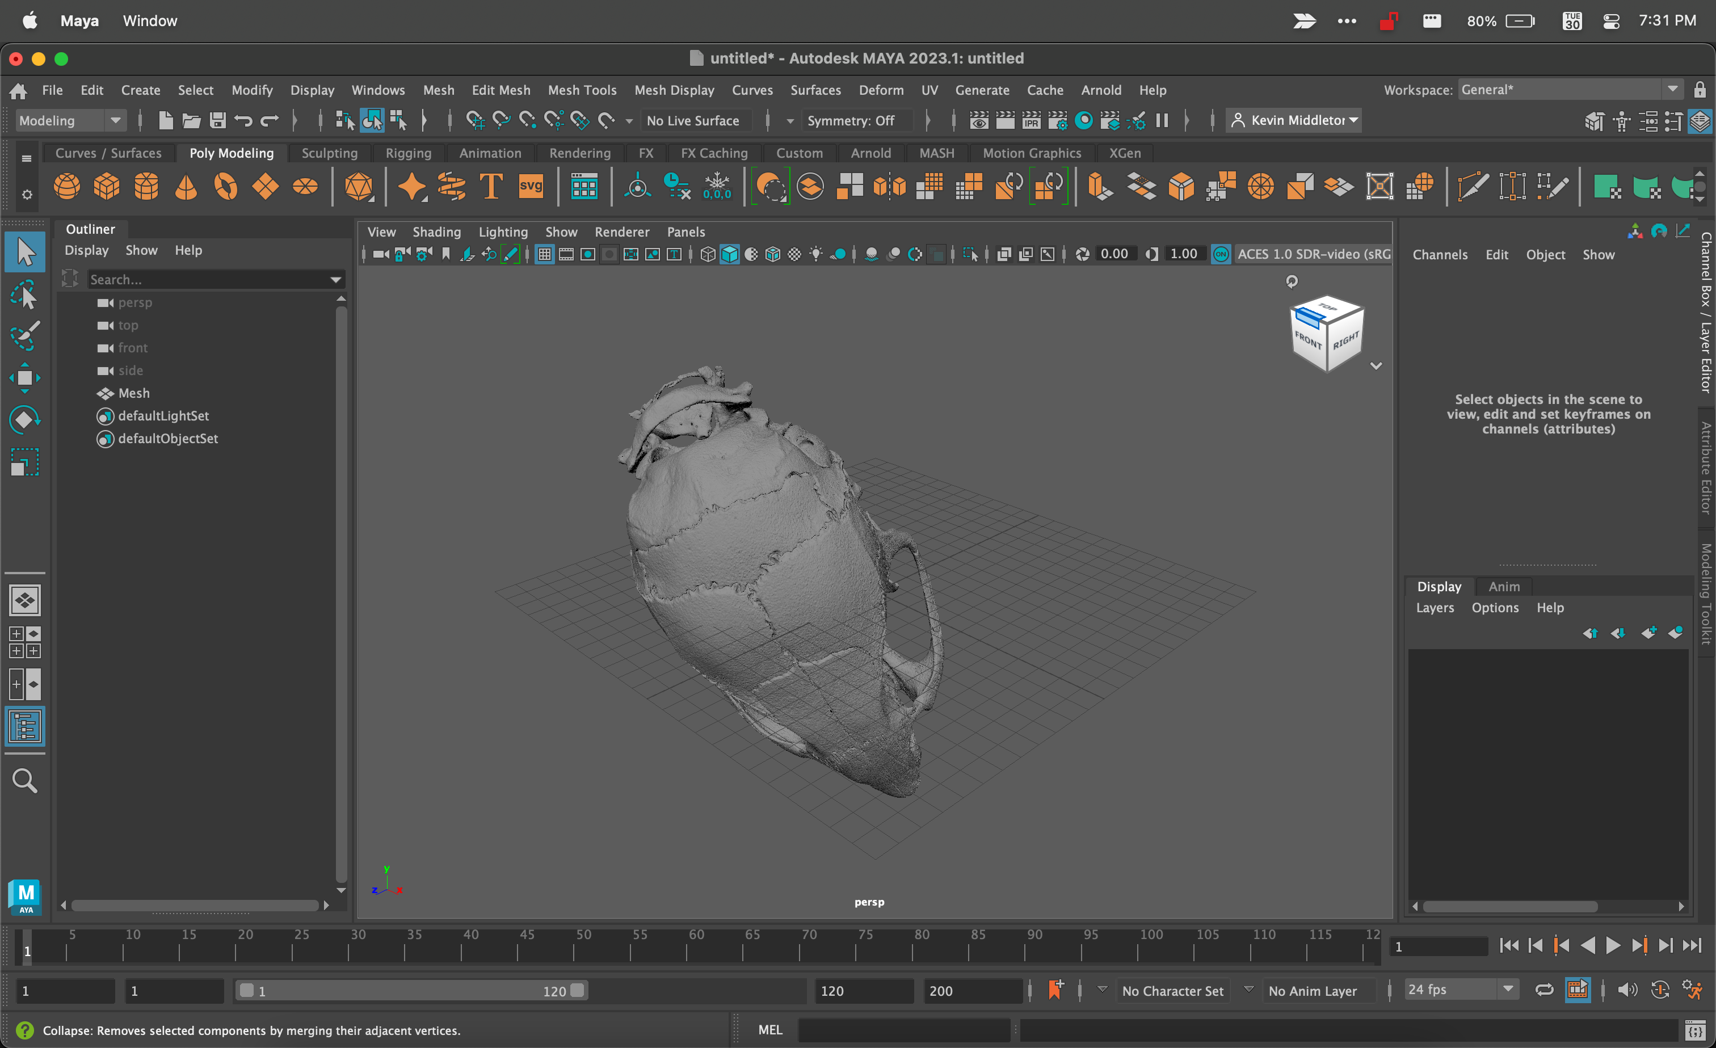

* Hover in viewport and press Spacebar to switch to 4-panel view

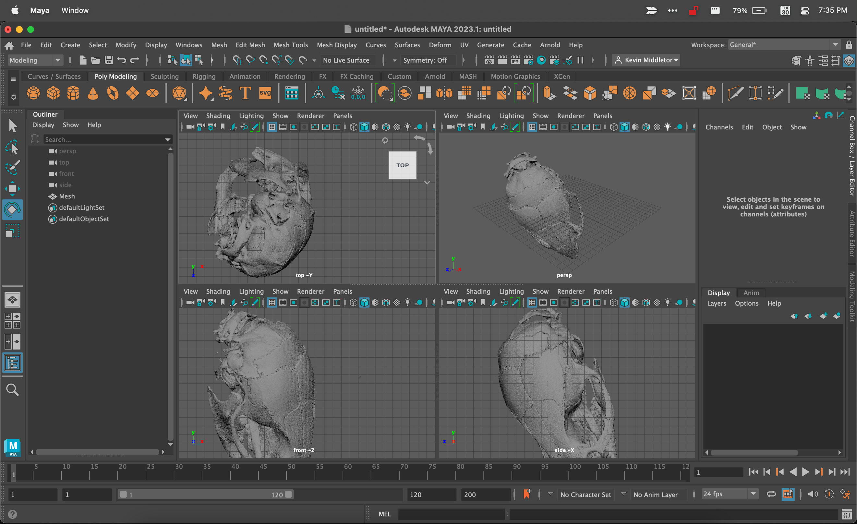

# Select mesh

* Translate/rotate/scale panel will open

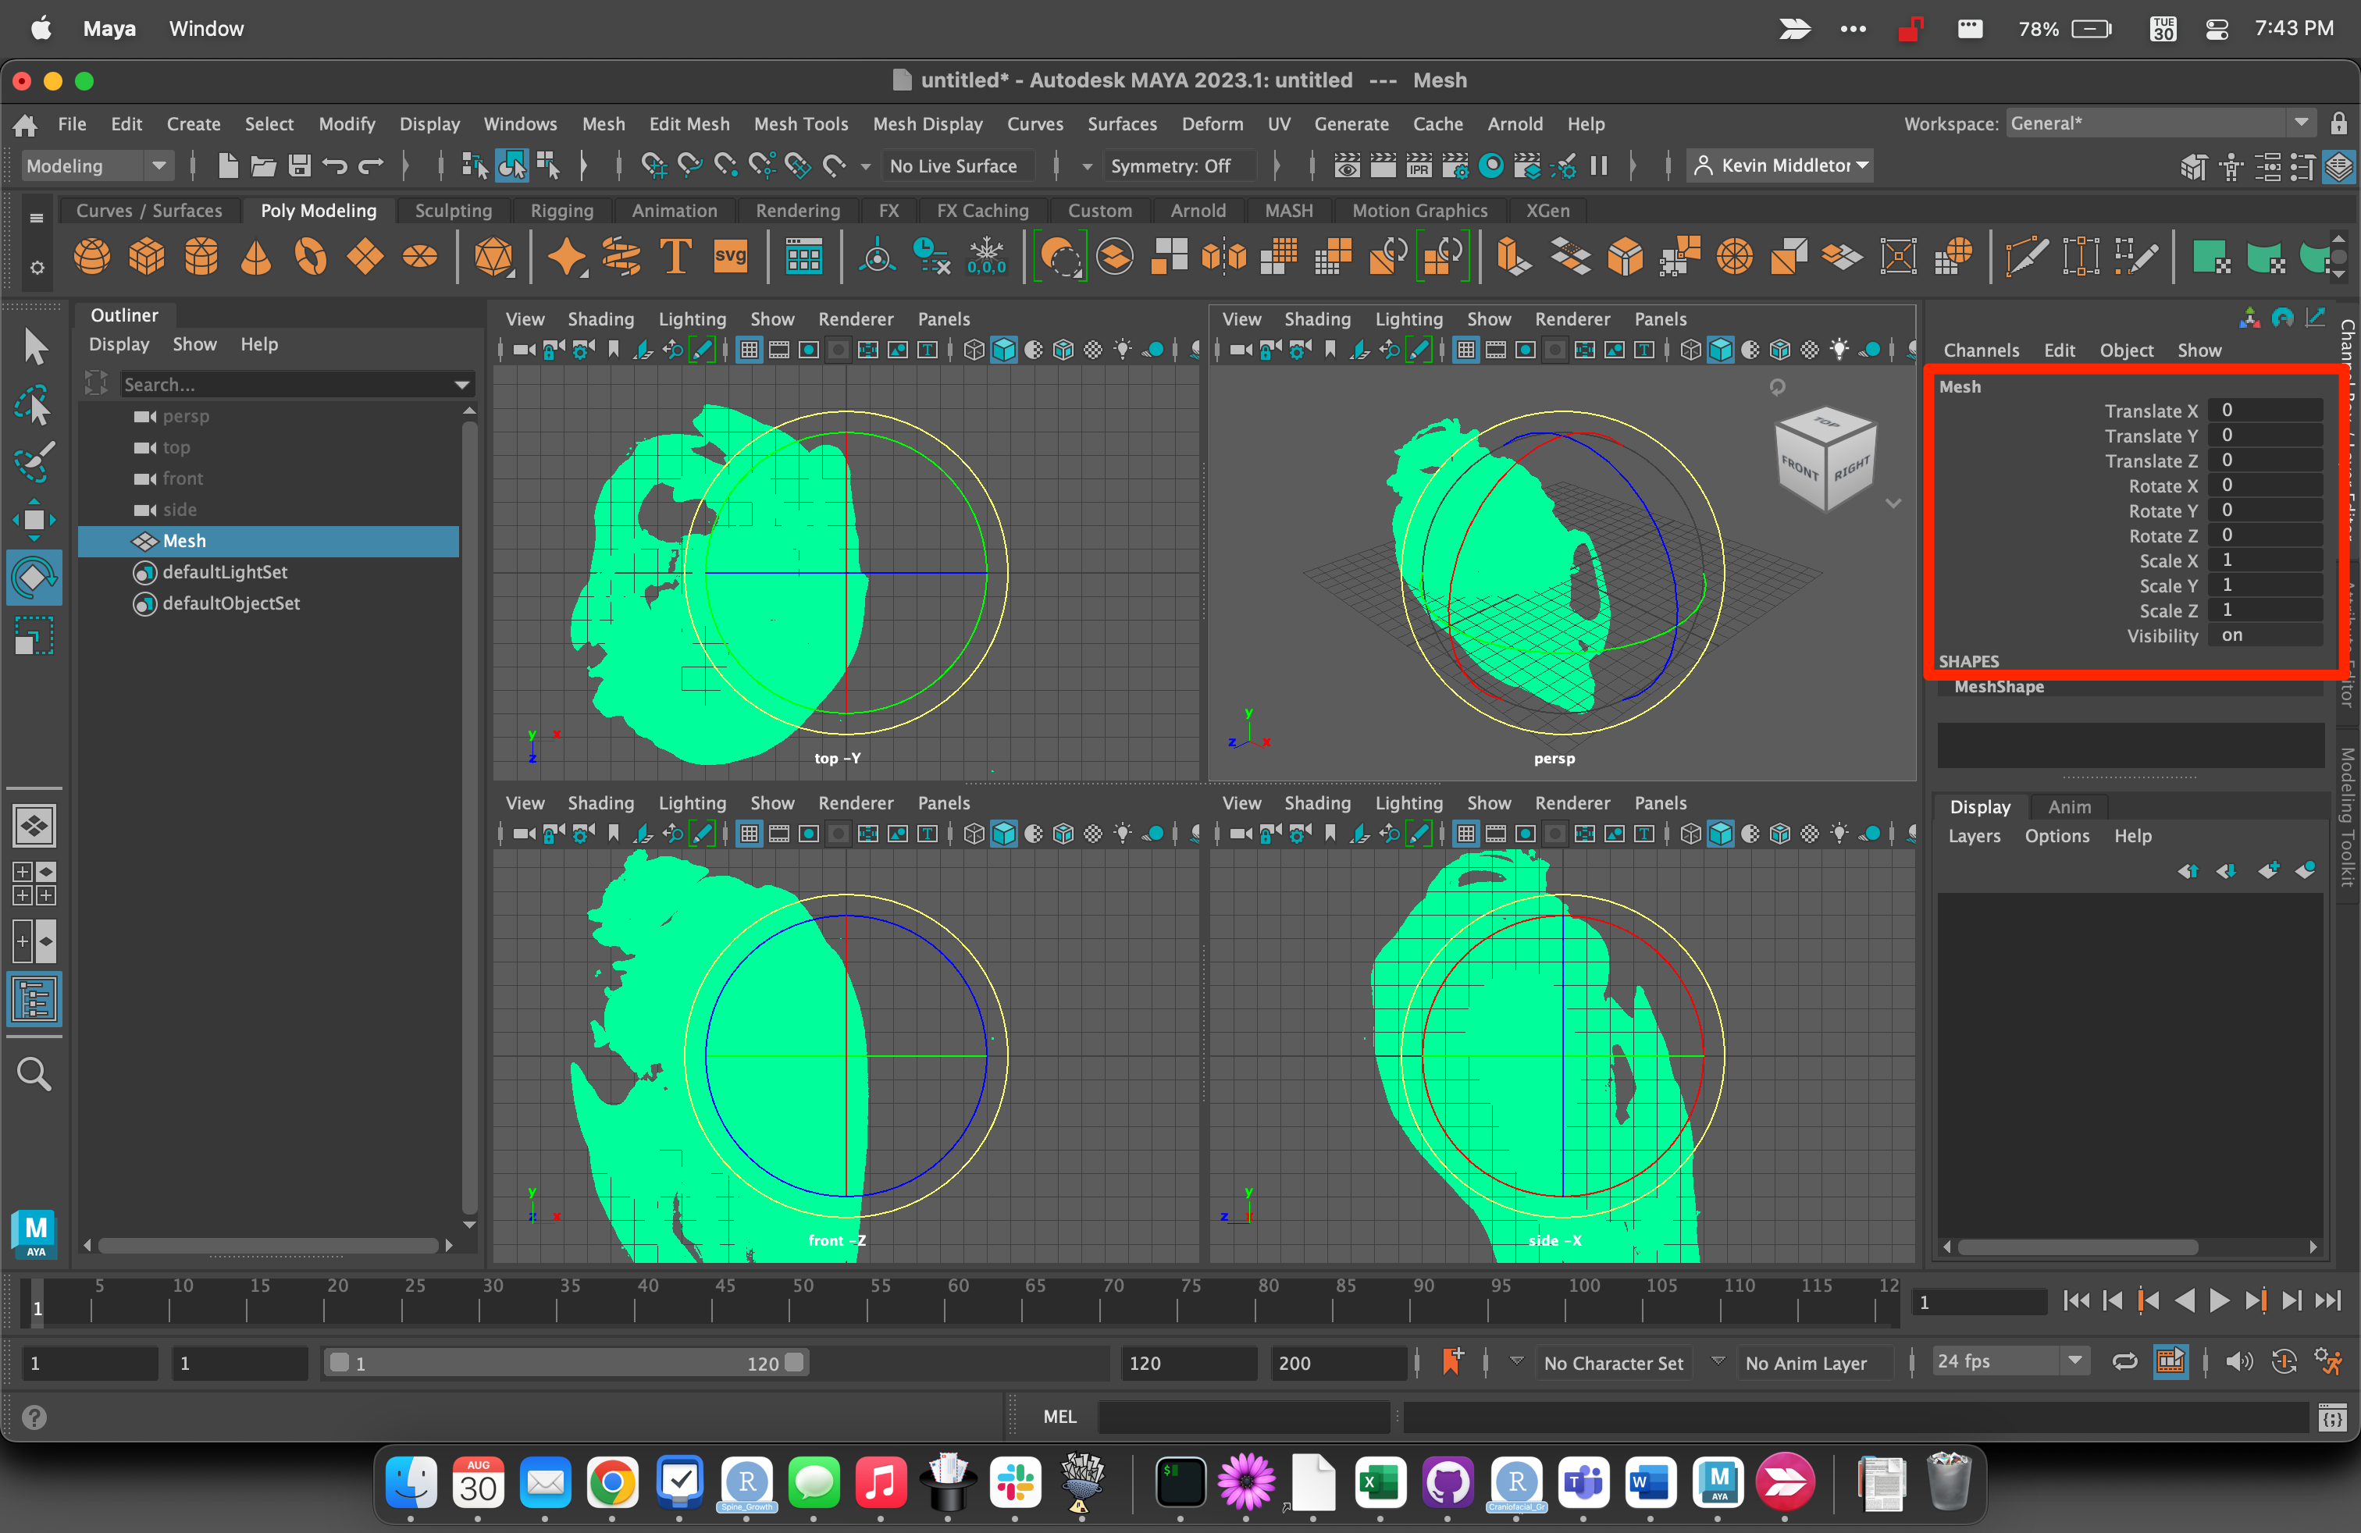

# Rotate into standard position

* X: Mediolateral
* Y: Dorsoventral
* Z: Rostrocaudal
* Use the yellow circle in the orthogonal viewports to constrain rotation.
* Deselect mesh to view shaded / Select to rotate

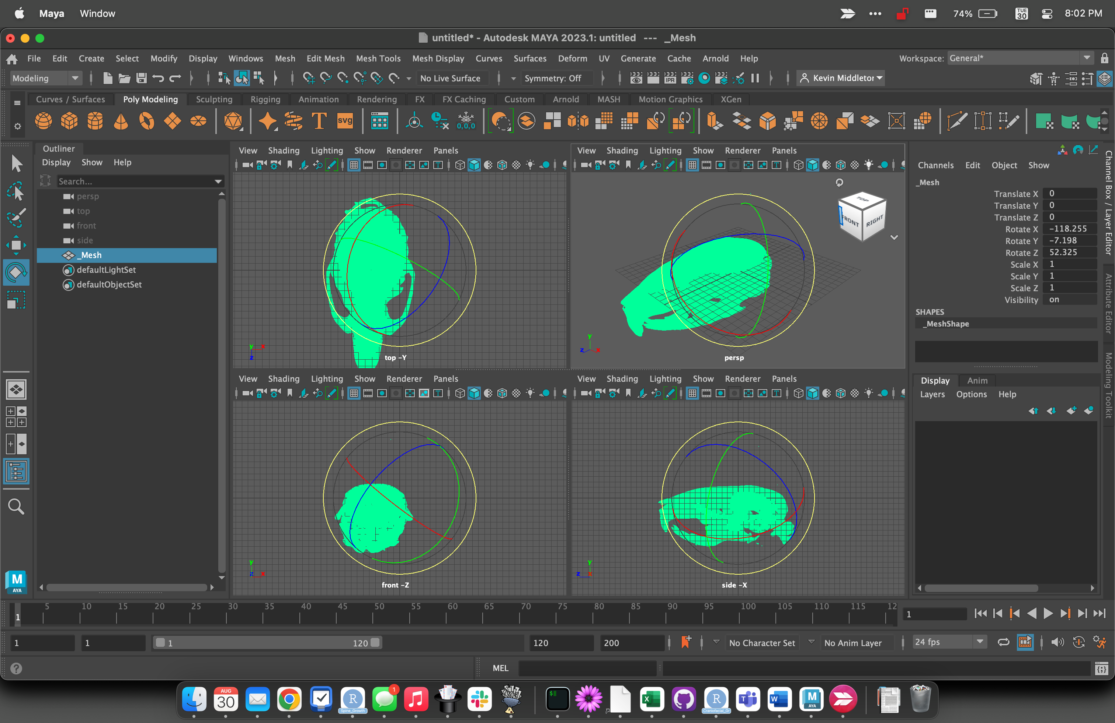

# Record rotation values

* Write to file or screen capture

# Rotate dataset in Avizo

# Crop dataset in Avizo

# Resave rotated dataset