Supplemental Information
Section 1 – Data Collection

Table S1 Lithium conversion table.
 | to Li | to Li₂O | to Li₂CO₃ | to LiOH
from Li | 1 | 2.153 | 5.325 | 6.048
from Li₂O | 0.464 | 1 | 2.473 | 2.809
from Li₂CO₃ | 0.188 | 0.404 | 1 | 1.136
from LiOH | 0.165 | 0.356 | 0.88 | 1

Table S2 USA inflation rate % and relevant adjustment factor to 2023 (2005-2024) ¹.
Year | Inflation Rate % | Adjustment factor to 2023
2005 | 3.39 | 0.64
2006 | 3.23 | 0.66
2007 | 2.85 | 0.68
2008 | 3.84 | 0.71
2009 | -0.36 | 0.70
2010 | 1.64 | 0.72
2011 | 3.16 | 0.74
2012 | 2.07 | 0.75
2013 | 1.46 | 0.76
2014 | 1.62 | 0.78
2015 | 0.12 | 0.78
2016 | 1.26 | 0.79
2017 | 2.13 | 0.80
2018 | 2.44 | 0.82
2019 | 1.81 | 0.84
2020 | 1.23 | 0.85
2021 | 4.70 | 0.89
2022 | 8.00 | 0.96
2023 | 4.12 | 1.00
2024 | 3.00 | 1.03

Table S3 Lithium brine resources by country. Country codes: ISO 3166-1 alpha-3.
Country Code | Deposit/project name | Resources (Min) (Mt Li content) | Resources (Mean) (Mt Li content) | Resources (Max) (Mt Li content)
AFG | Salt lakes-Afghanistan ² | 0.40 | 0.40 | 0.40
ARG | 3Q (Tre Quebradas) ^{2,3} | 0.75 | 1.03 | 1.30
 | Candelas ⁴ | 0.24 | 0.24 | 0.24
 | Cauchari-JV project-AL ^{2,5} | 0.90 | 1.04 | 1.18
 | Cauchari-Olaroz-LA ^{2,6-8} | 0.90 | 2.54 | 4.62
 | Centenario ratones ^{2,9,10} | 0.92 | 1.55 | 1.88
 | Diablillos ^{2,6,11} | 0.38 | 0.73 | 0.90
 | Hombre Muerto North ^{2,12} | 0.11 | 0.11 | 0.11
 | Hombre Muerto West ¹³⁻¹⁵ | 1.08 | 1.08 | 1.08
 | Hombre Muerto-Mina Fenix ^{2,16} | 0.84 | 1.08 | 1.33
 | Kachi ^{2,17} | 0.83 | 1.10 | 1.37
 | Mariana ^{2,18} | 0.23 | 0.61 | 0.98
 | Pastos Grandes ^{2,19} | 0.78 | 0.85 | 0.92
 | Pozuelos ^{2,20} | 0.24 | 0.45 | 0.67
 | Rincon-Argusy ^{2,21} | 0.05 | 0.05 | 0.05
 | Rincon-Power Minerals ^{2,22} | 0.01 | 0.02 | 0.03
 | Rincon-Rio Tinto ^{2,23} | 1.49 | 1.70 | 1.91
 | Sal de Oro ² | 0.39 | 0.39 | 0.39
 | Sal de Vida ^{2,6,11,24} | 0.30 | 0.75 | 1.22
 | Salar de Antofallo ^{2,25} | 2.22 | 2.22 | 2.22
 | Salar de Olaroz-Allkem ^{2,6,8,9,11,26-30} | 0.20 | 0.83 | 3.50
 | Salar de Pular ^{2,31} | 0.03 | 0.06 | 0.09
 | Salar de Rio Grande ^{2,32} | 0.21 | 0.31 | 0.41
 | Tolillar ³³ | 0.68 | 0.68 | 0.68
BOL | Remaining Unknow (USGS) ^{2,34} | 12.80 | 16.95 | 21.10
 | Uyuni ^{6,8,11,27-30} | 5.50 | 8.00 | 10.20
CAN | Beaverhill ⁶ | 0.59 | 0.59 | 0.59
 | Fox Creek ^{6,8,28} | 0.50 | 0.50 | 0.50
 | Kindersley ³⁵ | 0.86 | 0.86 | 0.86
 | Prairie ³⁶ | 0.85 | 0.85 | 0.85
 | Valley View ² | 0.07 | 0.07 | 0.07
CHL | Arizaro ³⁷ | 0.47 | 0.47 | 0.47
 | Atacama-ALB ³⁸ | 1.85 | 1.85 | 1.85
 | Atacama-SQM ³⁹ | 8.56 | 8.56 | 8.56
 | La Isla ^{2,40} | 0.27 | 0.27 | 0.27
 | Las Parinas ^{2,40} | 0.05 | 0.05 | 0.05
 | Maricunga ^{2,8,28,30} | 0.20 | 0.30 | 0.40
 | Pedernales ^{2,40} | 0.38 | 0.38 | 0.38
 | Punta Negra ^{2,40} | 0.22 | 0.22 | 0.22
 | Salar Blanco ⁴¹ | 0.36 | 0.36 | 0.36
 | Salar de Aguilar ^{2,40} | 0.07 | 0.07 | 0.07
 | Surire ⁴⁰ | 0.18 | 0.18 | 0.18
CHN | Chaerhan Lake ² | 1.35 | 1.35 | 1.35
 | DXC ² | 0.90 | 0.90 | 0.90
 | East Taijinair ² | 2.47 | 2.47 | 2.47
 | Lakkor Tso Salt Lake ⁴² | 0.41 | 0.41 | 0.41
 | Qarhan Lake ² | 7.17 | 7.17 | 7.17
 | Qinghai Yiliping ^{2,8,11,28-30} | 0.90 | 1.71 | 2.30
 | West Taijinair ² | 2.68 | 2.68 | 2.68
 | Zabuye (Zhabuye) ^{2,6,8,11,28,29} | 1.30 | 1.52 | 1.83
MNG | Chuluut area ² | 0.10 | 0.10 | 0.10
 | Delgerekh area ² | 0.20 | 0.20 | 0.20
 | Enkh area ² | 0.05 | 0.05 | 0.05
USA | Bonneville Salt Flats ⁶ | 1.97 | 1.97 | 1.97
 | Brawley ⁶ | 1.00 | 1.00 | 1.00
 | G. Salt Lake ^{2,6,8,29,30} | 0.50 | 0.51 | 0.53
 | Searles ^{2,6,30} | 0.03 | 0.13 | 0.32
 | Silver Peak ^{6,11,28,29,43} | 0.05 | 0.21 | 0.30

Table S4 Lithium ore resources by country. Country codes: ISO 3166-1 alpha-3. “0.00” < 0.004.
Country Code | Deposit/project name | Resources (Min) (Mt Li content) | Resources (Mean) (Mt Li content) | Resources (Max) (Mt Li content)
AFG | Drumgal ² | 0.10 | 0.10 | 0.10
 | Helmand Basin ⁶ | 0.20 | 0.20 | 0.20
 | Jamanak ² | 0.10 | 0.10 | 0.10
 | Katawaz Basin ⁶ | 0.01 | 0.01 | 0.01
 | Parun ² | 0.03 | 0.03 | 0.03
 | Pasghusta ² | 0.50 | 0.50 | 0.50
 | Pasghusta lower ² | 0.06 | 0.06 | 0.06
 | Paskhi ² | 0.06 | 0.06 | 0.06
 | Taghawkor ⁶ | 0.00 | 0.00 | 0.00
 | Tsamgal ² | 0.06 | 0.06 | 0.06
 | Yaryhgul ² | 0.10 | 0.10 | 0.10
AUS | Bald Hill ^{2,44} | 0.03 | 0.08 | 0.12
 | Buldania ^{2,45} | 0.04 | 0.05 | 0.07
 | Greenbushes ^{2,30,46} | 0.26 | 1.67 | 3.06
 | Kathleen Valley ^{2,47} | 0.84 | 0.91 | 0.98
 | Mt Cattlin ^{2,6,11,30,48} | 0.06 | 0.07 | 0.09
 | Mt Holland ^{2,49} | 1.32 | 1.61 | 1.90
 | Mt Marion ^{2,6,30} | 0.02 | 0.16 | 0.45
 | Pilgangoora ^{2,50} | 1.53 | 1.68 | 1.83
 | Wodgina ^{2,51} | 0.92 | 1.17 | 1.41
AUT | Wolfsberg ^{2,6,8,27,28,30,52} | 0.05 | 0.09 | 0.10
BRA | Aracuai (Cachoeira) ^{2,11} | 0.01 | 0.02 | 0.02
 | Bandeira ⁵³ | 0.25 | 0.25 | 0.25
 | Grota do Cirilo ^{9,30,54} | 0.09 | 0.55 | 0.92
 | Mibra ^{2,28,55} | 0.09 | 0.10 | 0.12
CAN | Authier ^{2,56} | 0.10 | 0.13 | 0.15
 | Barraute ^{6,11,30} | 0.11 | 0.20 | 0.37
 | Bernic ^{6,8,30} | 0.10 | 0.14 | 0.19
 | Big Bird (Curlew) ⁶ | 0.20 | 0.20 | 0.20
 | English River Greenstone ⁶ | 0.13 | 0.13 | 0.13
 | FI ^{6,11} | 0.03 | 0.03 | 0.03
 | Georgia Lake ^{2,57} | 0.07 | 0.07 | 0.08
 | Gods Lake ⁶ | 0.03 | 0.03 | 0.03
 | Irgon ² | 0.01 | 0.01 | 0.01
 | James Bay ^{2,6,11,58} | 0.13 | 0.29 | 0.62
 | La Corne ^{6,8,27} | 0.10 | 0.30 | 0.40
 | La Motte ^{6,30} | 0.02 | 0.52 | 1.02
 | Lithium Two ² | 0.00 | 0.00 | 0.00
 | Moblan ^{2,6,59} | 0.04 | 0.14 | 0.28
 | Moose 2 ⁶ | 0.02 | 0.02 | 0.02
 | Nama Creek ⁶ | 0.01 | 0.01 | 0.01
 | Niemi Lake ⁶ | 0.00 | 0.00 | 0.00
 | North American Lithium ⁶⁰ | 0.12 | 0.12 | 0.12
 | PAK ² | 0.21 | 0.21 | 0.21
 | Rose ^{2,61} | 0.14 | 0.21 | 0.28
 | Sep. Rapids ^{2,6,30} | 0.07 | 0.07 | 0.07
 | Seymour Lake ² | 0.03 | 0.03 | 0.03
 | Sirmac Lake ⁶ | 0.00 | 0.00 | 0.00
 | Snow Lake ^{2,6,62} | 0.03 | 0.04 | 0.05
 | Tanco ¹¹ | 0.14 | 0.14 | 0.14
 | Thor ^{6,11} | 0.02 | 0.02 | 0.02
 | Violet ^{6,11} | 0.01 | 0.01 | 0.01
 | Wekusko ⁶ | 0.03 | 0.03 | 0.03
 | Whabouchi ^{2,63} | 0.26 | 0.30 | 0.33
 | Yellowknife ^{2,6,30} | 0.11 | 0.12 | 0.13
CHN | Daoxian ^{6,8,28} | 0.20 | 0.20 | 0.20
 | Heyuan ² | 0.03 | 0.03 | 0.03
 | Jiajika (Giajika) ^{2,6,8,11,27,28,30,64} | 0.20 | 0.47 | 0.78
 | Jinchuan ⁶ | 0.50 | 0.50 | 0.50
 | Lijiagou ^{2,65} | 0.07 | 0.12 | 0.18
 | Maerkang ^{6,8,27,28,30} | 0.20 | 0.31 | 0.50
 | Ningdu ⁶ | 0.50 | 0.50 | 0.50
 | Xiangyuan ⁶⁶ | 0.12 | 0.12 | 0.12
 | Yelonggou ⁶⁷ | 0.06 | 0.06 | 0.06
 | Yichun ^{6,8,28,68} | 0.14 | 0.31 | 0.50
COD | Kitotolo ⁶ | 0.80 | 0.80 | 0.80
 | Manono ^{6,8,11,27,28} | 0.33 | 1.97 | 3.10
ESP | Mina Feli ⁶ | 0.01 | 0.01 | 0.01
FIN | Keliber ^{2,6,11,30,69} | 0.01 | 0.17 | 0.68
GHA | Ewoyaa ^{2,70} | 0.09 | 0.13 | 0.16
IRL | Blackstairs ² | 0.00 | 0.00 | 0.00
MLI | Goulamina ⁷¹ | 0.45 | 0.45 | 0.45
NAM | Karibib ^{2,6,11} | 0.02 | 0.11 | 0.15
PRT | Alvarroes ^{2,72} | 0.02 | 0.06 | 0.09
 | Barroso ^{2,6,30,73} | 0.01 | 0.06 | 0.13
 | Montalegre ² | 0.15 | 0.15 | 0.15
RUS | Achivansky (Uchastok) ⁶ | 0.05 | 0.05 | 0.05
 | Belerechenskoe ^{2,6} | 0.05 | 0.07 | 0.10
 | Etykinskoe ⁶ | 0.05 | 0.05 | 0.05
 | Goltsovoe ^{2,6,28} | 0.14 | 0.21 | 0.29
 | Kolmorzerskoe ^{2,6} | 0.40 | 0.62 | 0.84
 | Orlovskoe ⁶ | 0.05 | 0.05 | 0.05
 | Pogranichnoe ⁶ | 0.05 | 0.05 | 0.05
 | Polmostundrovskoe ^{2,6,28} | 0.14 | 0.25 | 0.40
 | Tastyg ^{2,6} | 0.05 | 0.18 | 0.30
 | Ulug-Tanzek ^{2,6,28} | 0.14 | 0.21 | 0.30
 | Urikskoe ^{2,6,28} | 0.14 | 0.21 | 0.30
 | Vishnyakovskoe ^{2,6} | 0.21 | 0.21 | 0.21
 | Voznesenskoe ^{2,6} | 0.14 | 0.31 | 0.48
 | Zavitinskoe ^{2,6} | 0.10 | 0.12 | 0.14
SWE | Jarkvissle ⁶ | 0.01 | 0.01 | 0.01
 | Varutrask ⁶ | 0.01 | 0.01 | 0.01
USA | Bessemer City ^{6,11} | 0.42 | 0.42 | 0.42
 | Carolina ⁷⁴ | 0.15 | 0.15 | 0.15
 | Cherryville ³⁰ | 0.34 | 0.34 | 0.34
 | Kings Mountain Bely ^{6,11,30} | 0.15 | 1.64 | 5.90
 | N. Carolina ^{6,8,27,28,30} | 2.60 | 3.80 | 5.50
UZB | Naukinskoe ² | 0.00 | 0.00 | 0.00
 | Shavazsai ² | 0.10 | 0.10 | 0.10
ZWE | Arcadia ^{2,75} | 0.28 | 0.30 | 0.31
 | Barkam ^{6,11} | 0.22 | 0.22 | 0.22
 | Bikita ^{2,6} | 0.06 | 0.11 | 0.17
 | Kamativi ^{6,11} | 0.28 | 0.28 | 0.28
 | Masvingo ⁶ | 0.06 | 0.06 | 0.06
 | Sabi Star ⁷⁶ | 0.61 | 0.61 | 0.61
 | Zulu ² | 0.10 | 0.10 | 0.10

Table S5 Lithium unconventional resources by countries. Country codes: ISO 3166-1 alpha-3. “0.00” < 0.004.
Country Code | Deposit/project name | Resources (Min) (Mt Li content) | Resources (Mean) (Mt Li content) | Resources (Max) (Mt Li content)
CAN | Clearwater ^{2,77} | 0.41 | 0.49 | 0.56
 | Exshaw ² | 0.73 | 0.73 | 0.73
 | Rocky ² | 0.17 | 0.17 | 0.17
CZE | Cinovec ^{2,78} | 0.85 | 1.06 | 1.28
DEU | Sadisdorf ² | 0.05 | 0.05 | 0.05
 | Vulcan ² | 2.98 | 2.98 | 2.98
 | Zinnwald ^{2,79} | 0.14 | 0.29 | 0.43
ESP | San Jose ^{2,80} | 0.17 | 0.24 | 0.32
FRA | Echassieres ² | 0.10 | 0.10 | 0.10
 | Treguennec ² | 0.03 | 0.03 | 0.03
KAZ | Smirnovskoe, Drozhilovskoye ² | 0.04 | 0.04 | 0.04
MEX | Sonora ^{2,81} | 0.95 | 1.30 | 1.66
 | Zacatecas ² | 0.05 | 0.05 | 0.05
PER | Falchani ^{2,82} | 0.89 | 0.96 | 1.04
SRB | Jabar ^{2,6,8,9,27,28,83} | 0.44 | 0.84 | 1.15
USA | Clayton Valley-Cypress ^{2,84} | 0.64 | 1.00 | 1.36
 | Clayton Valley-Zues ^{2,85} | 0.00 | 0.49 | 0.97
 | Fort Cady ^{2,86} | 0.04 | 0.13 | 0.22
 | Kings Valley-Thacker Pass ^{2,6,9,87} | 0.58 | 1.79 | 3.03
 | Paradox ^{2,88} | 0.04 | 0.09 | 0.15
 | Rhyolite Ridge ^{2,9,89} | 0.20 | 0.22 | 0.23
 | Salton Sea ^{2,6,8,27-30} | 0.51 | 1.12 | 2.00
 | Smackover-Arkansas ^{2,6,8,27-30,90} | 0.27 | 0.83 | 1.00
ZWE | Kamativi ^{2,6,11,91} | 0.03 | 0.17 | 0.28

Table S6 Lithium brine deposits cost relevant data by countries. Country codes: ISO 3166-1 alpha-3. “0.00” < 0.004. AISC = All-in Sustainability Cost; ICAPEX = Initial Capital Cost; LOM = Life of Mine; AP = annual production. “Sal de Vida” including Phase 1 and Phase 2 plants, LOM and AP data give separately.
Country code | Deposit/project name | AISC  (2023USD  /t LCE) | ICPEX  (2023USD  /t LCE) | LOM  (Year) | AP  (t LCE)
AFG | Salt lakes-Afghanistan ² | 10,874
ARG | 3Q (Tre Quebradas) ^{3,92} | 5,251 | 512 | 35 | 20,000
 | Candelas ⁴ | 6,483 | 1,311 | 25 | 14,000
 | Cauchari-JV project-AL ⁵ | 5,878 | 791 | 30 | 22,400
 | Cauchari-Olaroz-LA ^{6,7,92} | 5,013 | 415 | 40 | 40,000
 | Centenario ratones ¹⁰ | 5,012 | 417 | 25 | 14,000
 | Diablillos
 | Hombre Muerto North ¹² | 5,191 | 742 | 30 | 5,000
 | Hombre Muerto West ¹⁵ | 8,355 | 522 | 40 | 26,218
 | Hombre Muerto-Mina Fenix ^{16,92} | 7,645 | 2,203 | 40 | 9,800
 | Kachi ¹⁷ | 8,707 | 800 | 25 | 25,000
 | Mariana ¹⁸ | 4,585 | 3,038 | 25 | 10,000
 | Pastos Grandes ¹⁹ | 5,540 | 567 | 41 | 22976
 | Pozuelos
 | Rincon-Argusy ^{21,30} | 6,868 | 1,583 | 17 | 10,000
 | Rincon-Power Minerals ^{22,30} | 7,565 | 2,191 | 14 | 7,061
 | Rincon-Rio Tinto ^{23,30} | 5,569
 | Sal de Oro ^{92,93} | 5,776 |  | 20 | 25,000
 | Sal de Vida ²⁴ | 6,238 | 603 | 40/  37 | 15,000/  30,000
 | Salar de Antofallo
 | Salar de Olaroz-Allkem ^{6,26,30,92} | 6,616 | 531 | 32 | 25,000
 | Salar de Pular
 | Salar de Rio Grande
 | Tolillar ³³ | 6,928 | 778 | 35 | 28,538
BOL | Remaining Unknow (USGS)
 | Uyuni ³⁰ | 6,191
CAN | Beaverhill
 | Fox Creek
 | Kindersley ³⁵ | 4,747 | 1,342 | 20 | 12,500
 | Prairie ³⁶ | 3,185 | 2,784 | 20 | 6,000
 | Valley View
CHL | Arizaro ³⁷ | 7,131 | 2,048 | 20 | 25,000
 | Atacama-ALB ^{38,92} | 20,025
 | Atacama-SQM ^{39,92} | 16,625 | 329 | 9 | 253,000
 | La Isla
 | Las Parinas
 | Maricunga ³⁰ | 5,567
 | Pedernales
 | Punta Negra
 | Salar Blanco ⁴¹ | 5,238 | 1,361 | 20 | 23,950
 | Salar de Aguilar
 | Surire
CHN | Chaerhan Lake ⁹² | 6,703
 | DXC ³⁰ | 5,258
 | East Taijinair ⁹² | 7,232
 | Lakkor Tso Salt Lake ⁹² | 7,385
 | Qarhan Lake ⁹² | 7,594
 | Qinghai Yiliping ⁹² | 7,299
 | West Taijinair ⁹² | 7,535
 | Zabuye (Zhabuye) ^{6,30} | 5,894
MNG | Chuluut area ² | 8,857
 | Delgerekh area ² | 8,857
 | Enkh area ² | 8,857
USA | Bonneville Salt Flats
 | Brawley
 | G. Salt Lake
 | Searles
 | Silver Peak ^{6,92} | 10,329

Table S7 Lithium ore deposits cost relevant data by countries. Country codes: ISO 3166-1 alpha-3. AISC = All-in Sustainability Cost; ICAPEX = Initial Capital Cost; LOM = Life of Mine; AP = annual production.
Country code | Deposit/project name | AISC  (2023USD  /t LCE) | ICPEX  (2023USD  /t LCE) | LOM  (Year) | AP  (t LCE)
AFG | Drumgal ³⁰ | 9,312
 | Helmand Basin ³⁰ | 9,312
 | Jamanak ³⁰ | 9,312
 | Katawaz Basin ³⁰ | 9,312
 | Parun ³⁰ | 9,312
 | Pasghusta ³⁰ | 9,312
 | Pasghusta lower ³⁰ | 9,312
 | Paskhi ³⁰ | 9,312
 | Taghawkor ³⁰ | 9,312
 | Tsamgal ³⁰ | 9,312
 | Yaryhgul ³⁰ | 9,312
AUS | Bald Hill ^{44,92} | 5,506 | 631 | 3.6 | 22,999
 | Buldania
 | Greenbushes ^{6,30,92} | 4605
 | Kathleen Valley ^{47,92} | 4,064 | 228 | 23 | 115,597
 | Mt Cattlin ⁹² | 5,493
 | Mt Holland ⁹² | 7,878
 | Mt Marion ⁹² | 4,834
 | Pilgangoora ⁹² | 3,987
 | Wodgina ⁹² | 2,914
AUT | Wolfsberg ⁵² | 20,973 | 7,661 | 14.6 | 7,744
BRA | Aracuai (Cachoeira) ⁹² | 1,194
 | Bandeira ⁵³ | 4,117 |  | 14 | 24,164
 | Grota do Cirilo ^{30,92} | 4,268
 | Mibra
CAN | Authier ⁵⁶ | 3,888 | 806 | 13.8 | 16,933
 | Barraute
 | Bernic
 | Big Bird (Curlew)
 | English River Greenstone
 | FI
 | Georgia Lake ⁵⁷ | 1,487 | 1,497 | 9 | 14,838
 | Gods Lake
 | Irgon
 | James Bay ^{6,58} | 3,026 | 437 | 19 | 45,998
 | La Corne ⁶ | 5,302
 | La Motte
 | Lithium Two
 | Moblan ⁵⁹ | 3,977 | 750 | 21 | 44,514
 | Moose 2
 | Nama Creek
 | Niemi Lake
 | North American Lithium ^{60,92} | 4,525 |  | 20 | 28,198
 | PAK
 | Rose ⁶¹ | 4,621 | 916 | 17 | 30,235
 | Sep. Rapids
 | Seymour Lake
 | Sirmac Lake
 | Snow Lake
 | Tanco ³⁰ | 5,038
 | Thor
 | Violet
 | Wekusko
 | Whabouchi ⁶³ | 6,120 | 458 | 24 | 32,851
 | Yellowknife ³⁰ | 8,782
CHN | Daoxian
 | Heyuan
 | Jiajika (Giajika) ^{30,92} | 4,136
 | Jinchuan
 | Lijiagou ⁹² | 2,677
 | Maerkang ³⁰ | 5,919
 | Ningdu
 | Xiangyuan ⁹² | 4,798
 | Yelonggou ⁹² | 2,457
 | Yichun ⁹² | 1,211
COD | Kitotolo
 | Manono ³⁰ | 9,208
ESP | Mina Feli
FIN | Keliber ⁶⁹ | 11,661 | 3,158 | 6 | 32,309
GHA | Ewoyaa ⁷⁰ | 3,654 | 365 | 12 | 42,475
IRL | Blackstairs ² | 7,390
MLI | Goulamina ^{71,92} | 3,032 | 1,615 | 21 | 10,772
NAM | Karibib ³⁰ | 8,583
PRT | Alvarroes ⁹² | 4,505
 | Barroso ^{30,73} | 5,437 | 770 | 14 | 25,979
 | Montalegre ² | 7,345
RUS | Achivansky (Uchastok) ³⁰ | 13,466
 | Belerechenskoe ³⁰ | 13,466
 | Etykinskoe ³⁰ | 8,162
 | Goltsovoe ³⁰ | 13,466
 | Kolmorzerskoe ³⁰ | 13,466
 | Orlovskoe ³⁰ | 13,466
 | Pogranichnoe ³⁰ | 13,466
 | Polmostundrovskoe ³⁰ | 13,466
 | Tastyg ³⁰ | 13,466
 | Ulug-Tanzek ³⁰ | 13,466
 | Urikskoe ³⁰ | 13,466
 | Vishnyakovskoe ³⁰ | 13,466
 | Voznesenskoe ³⁰ | 13,466
 | Zavitinskoe ³⁰ | 13,466
SWE | Jarkvissle
 | Varutrask
USA | Bessemer City
 | Carolina ⁷⁴ | 8,271 | 3,826 | 11 | 26,400
 | Cherryville ³⁰ | 5,038
 | Kings Mountain Bely ³⁰ | 7,020
 | N. Carolina ³⁰ | 12,792
UZB | Naukinskoe ³⁰ | 9312
 | Shavazsai ³⁰ | 9312
ZWE | Arcadia ^{75,92} | 2,959 | 300 | 18.3 | 39,321
 | Barkam
 | Bikita ^{30,92} | 3,865
 | Kamativi
 | Masvingo
 | Sabi Star ⁹² | 2,811
 | Zulu

Table S8 Lithium unconventional deposits cost relevant data by countries. Country codes: ISO 3166-1 alpha-3. AISC = All-in Sustainability Cost; ICAPEX = Initial Capital Cost; LOM = Life of Mine; AP = annual production.
Country code | Deposit/project name | AISC  (2023USD  /t LCE) | ICPEX  (2023USD  /t LCE) | LOM  (Year) | AP  (t LCE)
CAN | Clearwater ⁷⁷ | 8,654 | 1,887 | 50 | 29,375
 | Exshaw
 | Rocky
CZE | Cinovec ⁷⁸ | 5,367 | 1,037 | 25 | 25,860
DEU | Sadisdorf
 | Vulcan ^{2,94} | 7,119 | 1,920 | 30 | 27,273
 | Zinnwald ^{2,79} | 10,682 | 1,253 | 45 | 31,163
ESP | San Jose ⁸⁰ | 9,965 | 1,343 | 26 | 17,142
FRA | Echassieres
 | Treguennec
KAZ | Smirnovskoe, Drozhilovskoye
MEX | Sonora ⁸¹ | 5,454 | 1,615 | 20 | 30,045
 | Zacatecas
PER | Falchani ⁸² | 5,770 | 823 | 43 | 70,419
SRB | Jabar
USA | Clayton Valley-Cypress ⁸⁴ | 12,592
 | Clayton Valley-Zues ⁸⁵ | 11,904
 | Fort Cady
 | Kings Valley-Thacker Pass ⁸⁷ | 8,579 | 1,557 | 40 | 66,800
 | Paradox
 | Rhyolite Ridge ⁸⁹ | 4,101 | 1,640 | 26 | 21,951
 | Salton Sea
 | Smackover-Arkansas
 | Kamativi

Table S9 Regional classification and countries included in this study. Country codes: ISO 3166-1 alpha-3.
Regional abbreviation | Regional full name | Countries included in this study (Code)
AFR | Africa | COD, GHA, MLI, NAM, ZWE
AUS | Australia | AUS
CHN | China | CHN
EU | Europe | AUT, CZE, DEU, ESP, FIN, IRL, PRT, SRB, SWE
LATAM | Latin America | ARG, BOL, BRA, CHL
NAM | North America | CAN, USA
OTH | Other countries | AFG, KAZ, MNG, RUS, UZB

Table S10 Twelve distinct analytical groups for “Step 1”. Regional abbreviations follow Table S9. “Uncon” denotes unconventional lithium sources treated collectively across regions.
Resource types | Existing Regions
Ore | AFR, AUS, CHN, EU, LATAM, NAM, OTH
Brine | CHN, EU, LATAM, NAM
Uncon | All

Table S11 Factors to calculate Estimated Recoverable Minerals (ERM) by regions. Regional abbreviations follow Table S9
Region | Lower  Coefficient A | Median  Coefficient A | Higher  Coefficient A | Factor α for Ore | Factor α for Brine & Uncon | STD for  Factor α | Factor β for Ore | Factor β for Brine & Uncon | STD for  Factor β
LATAM | 78% | 100% | 125% | 45% | 40% | 20% | 80% | 59% | 10%
NAM | 68% | 100% | 146% | 50% | 45% | 20% | 90% | 63% | 10%
AUS | 68% | 100% | 134% | 60% | 45% | 20% | 90% | 63% | 10%
CHN | 33% | 100% | 108% | 50% | 45% | 20% | 85% | 59% | 10%
EU | 82% | 100% | 122% | 50% | 45% | 20% | 90% | 63% | 10%
AFR | 63% | 100% | 126% | 45% | 40% | 20% | 80% | 55% | 10%
OTH | 22% | 100% | 121% | 45% | 40% | 20% | 80% | 55% | 10%

Section 2 – Flow chart for methodology
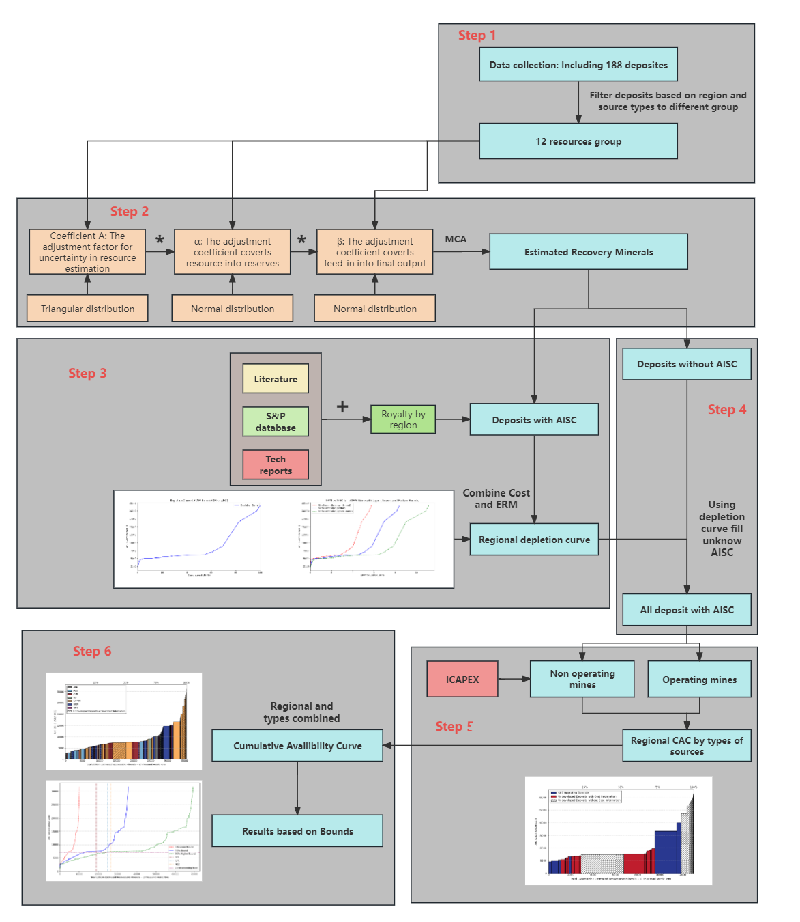
Figure S1 Flow chart for the “Six-step method for building a Cumulative Availability Curve (CAC)”.

Section 3 – Detailed figures and tables of the results
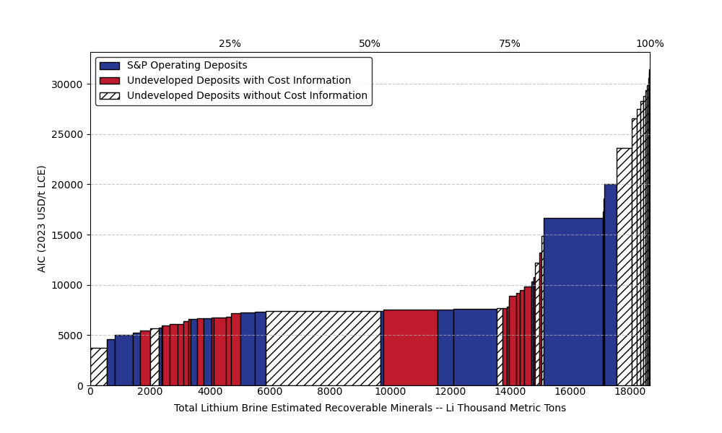 | 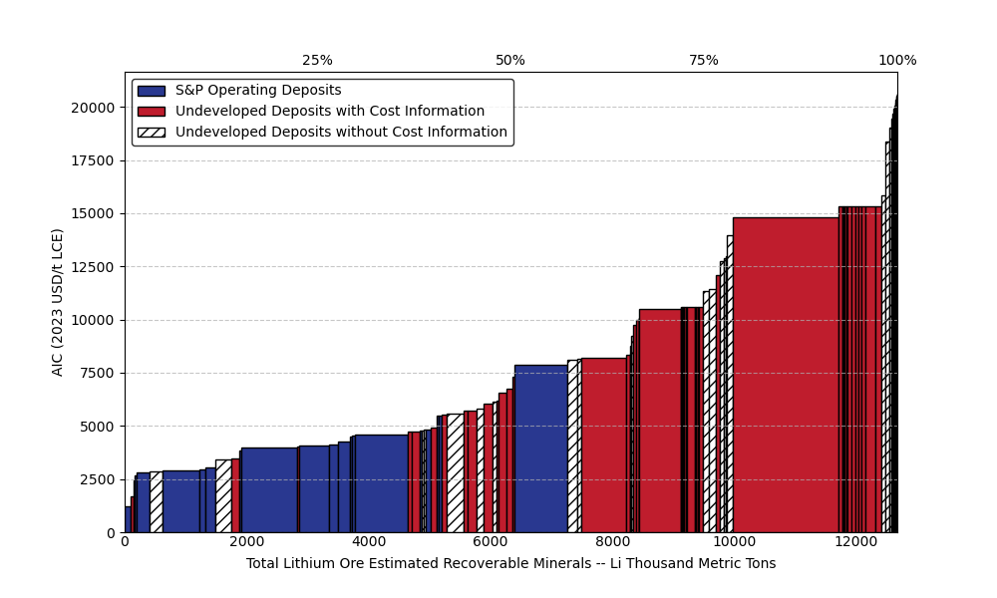
(a) | (b)
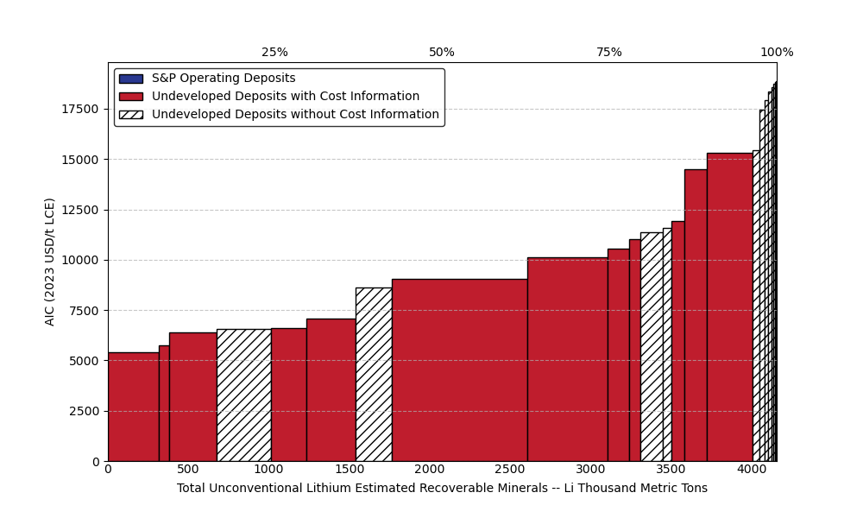 | 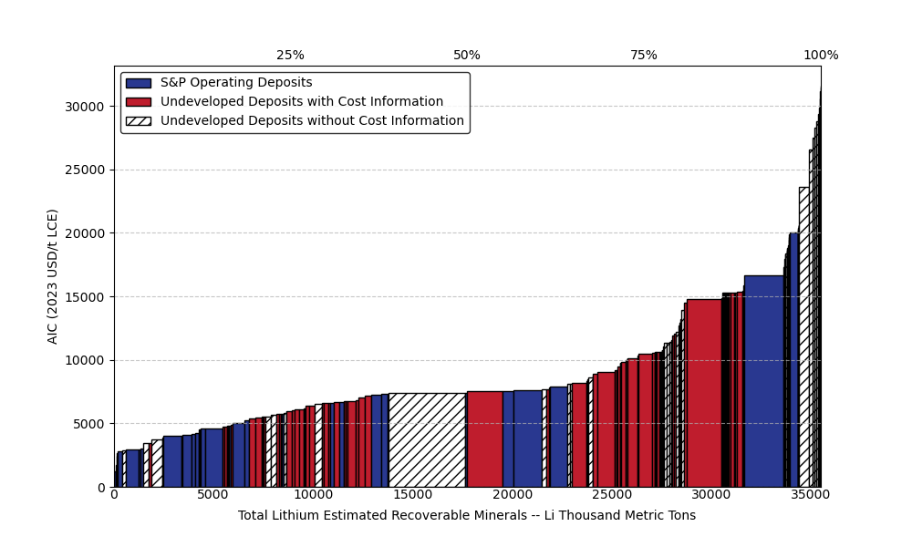
(c) | (d)
Figure S2 Global lithium CAC separated by operating status. (a) for brine (b) for ore (c) for unconventional source (d) for total lithium sources. Related to Figure 3-6.
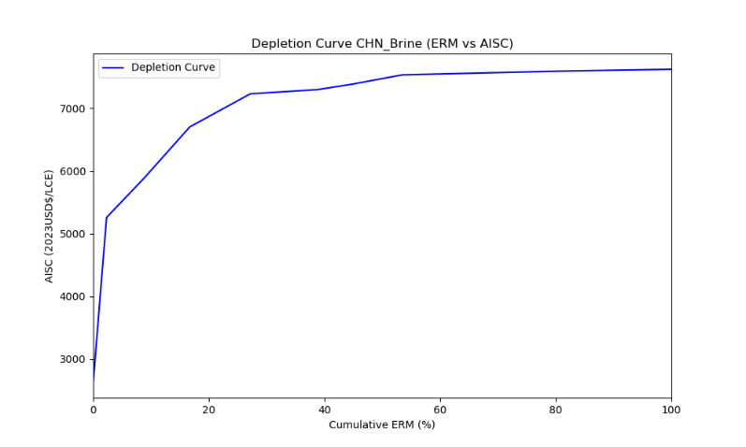 | 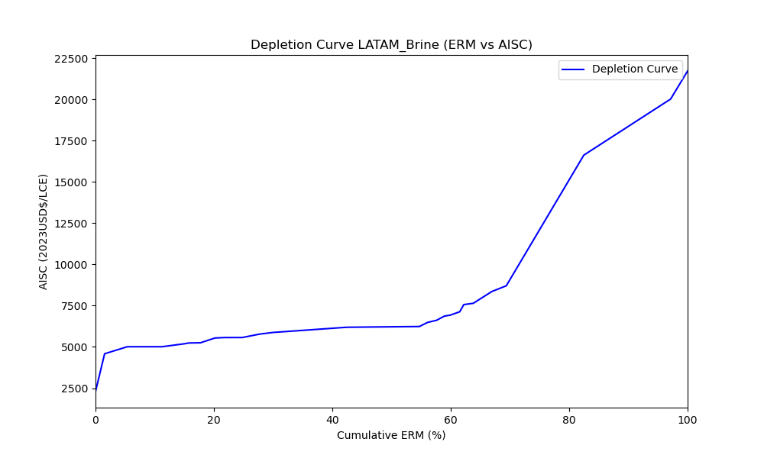
(a) | (b)
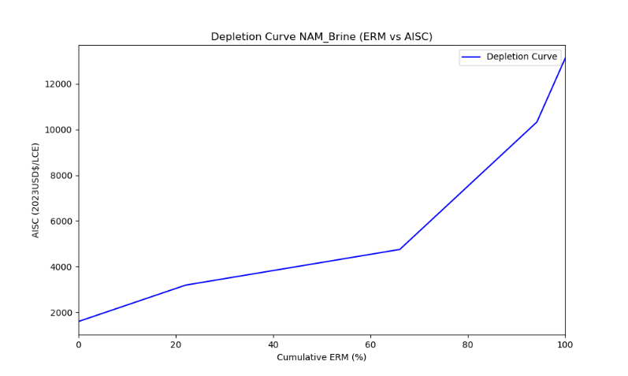 | 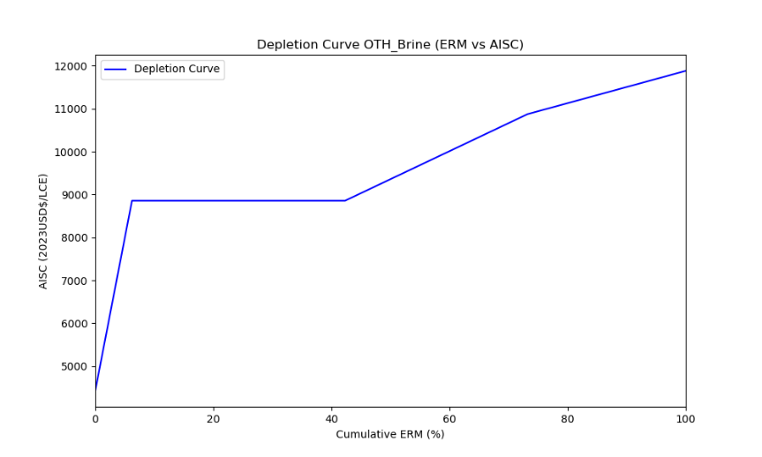
(c) | (d)
Figure S3 Lithium depletion curve for brine with cost information. (a) for China (b) for Latin America (c) for North America (d) for other regions. Related to Figure 3.
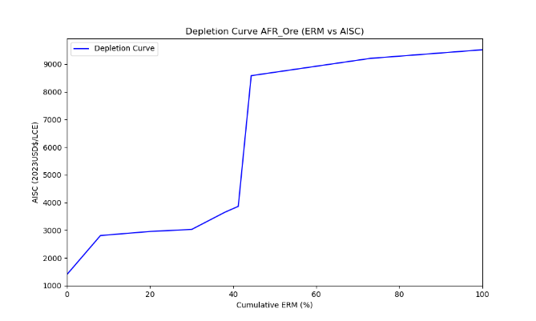 | 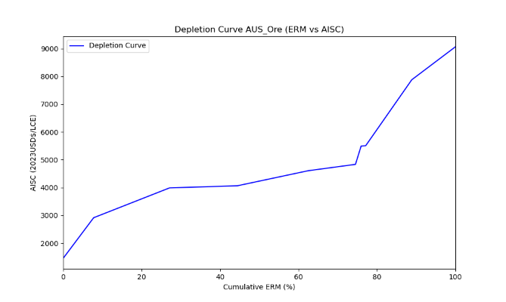
(a) | (b)
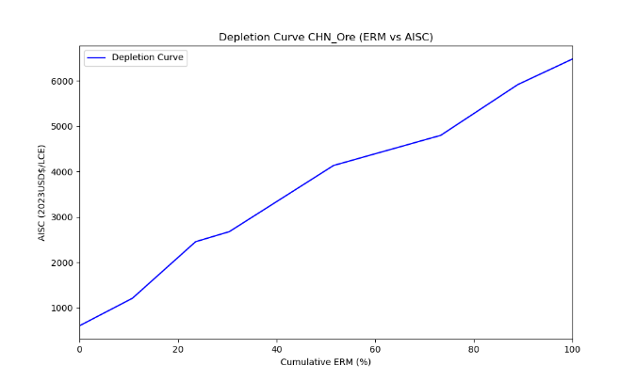 | 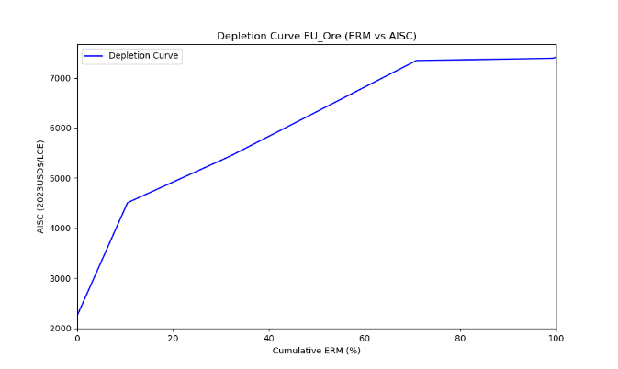
(c) | (d)
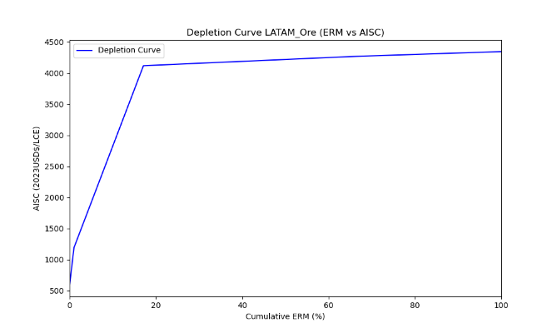 | 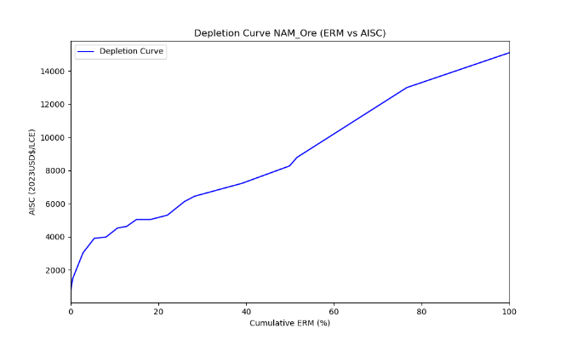
(e) | (f)
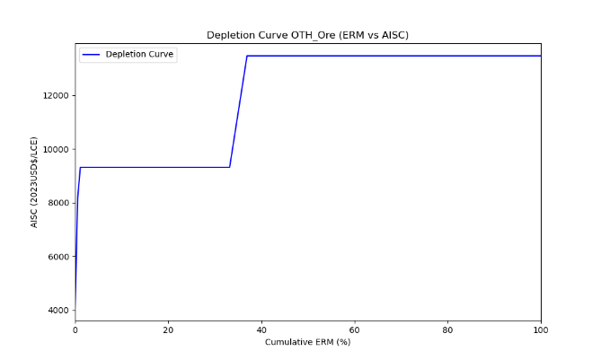
(g)
Figure S4 Lithium depletion curve for ore with cost information. (a) for Africa (b) for Australia (c) for China (d) for Europe (e) for Latin America (f) for North America (g) for other regions. Related to Figure 4.

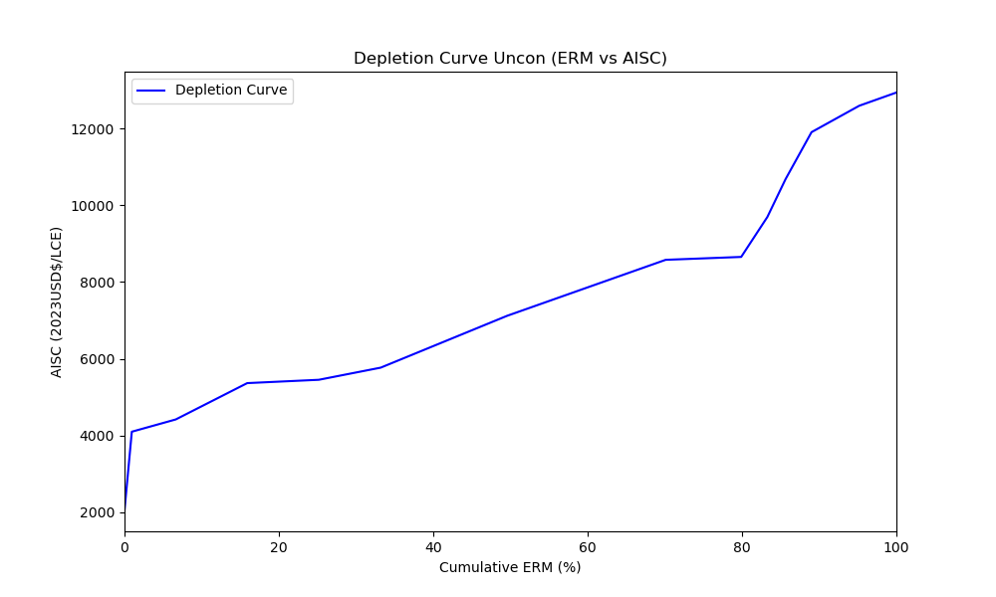
Figure S5 Lithium depletion curve for unconventional source. Related to Figure 5.
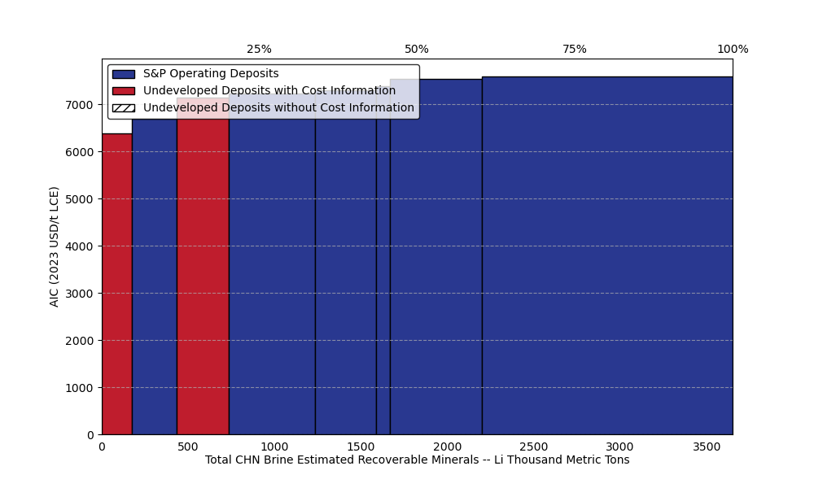 | 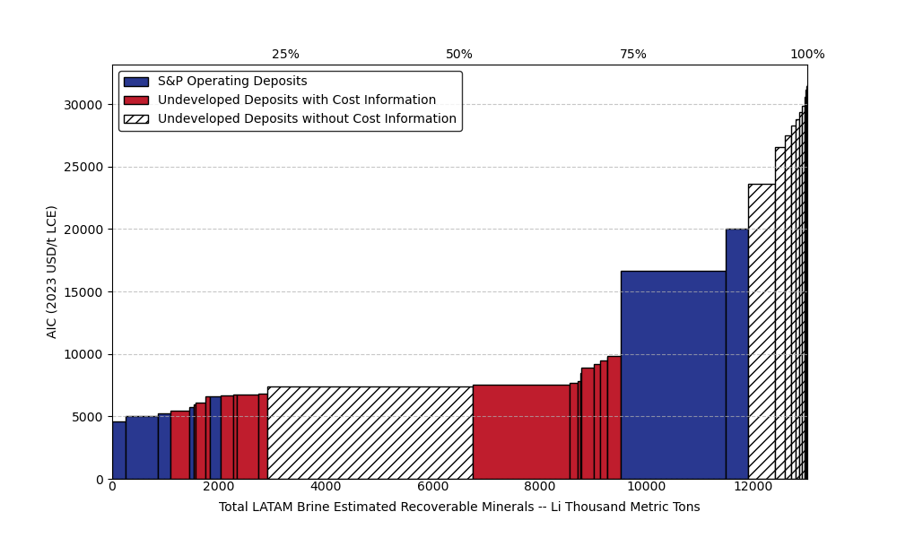
(a) | (b)
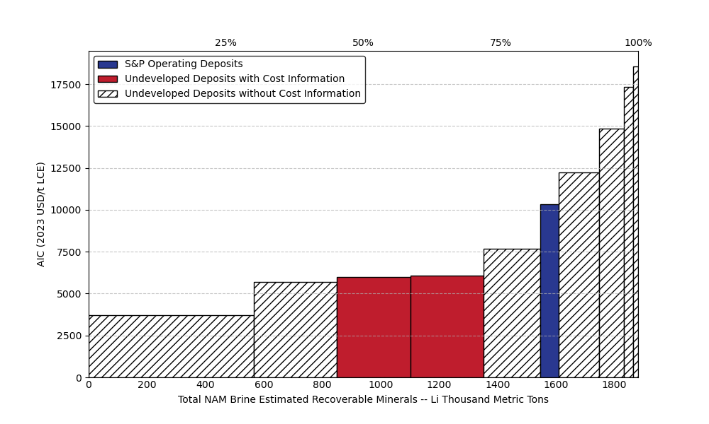 | 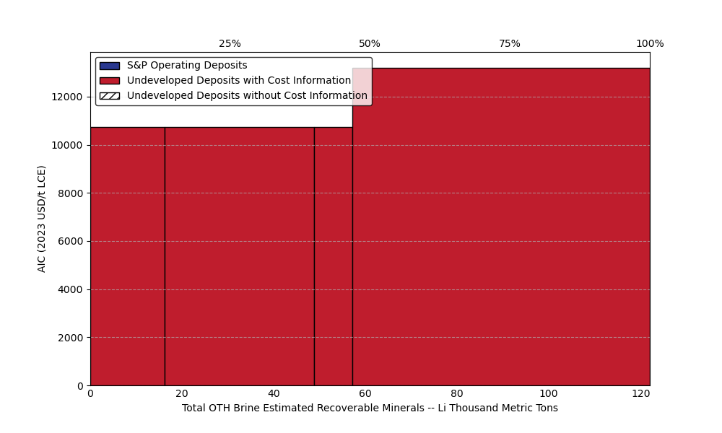
(c) | (d)
Figure S6 Regional lithium CAC from brine. (a) for China (b) for Latin America (c) for North America (d) for other regions. Related to Figure 3.
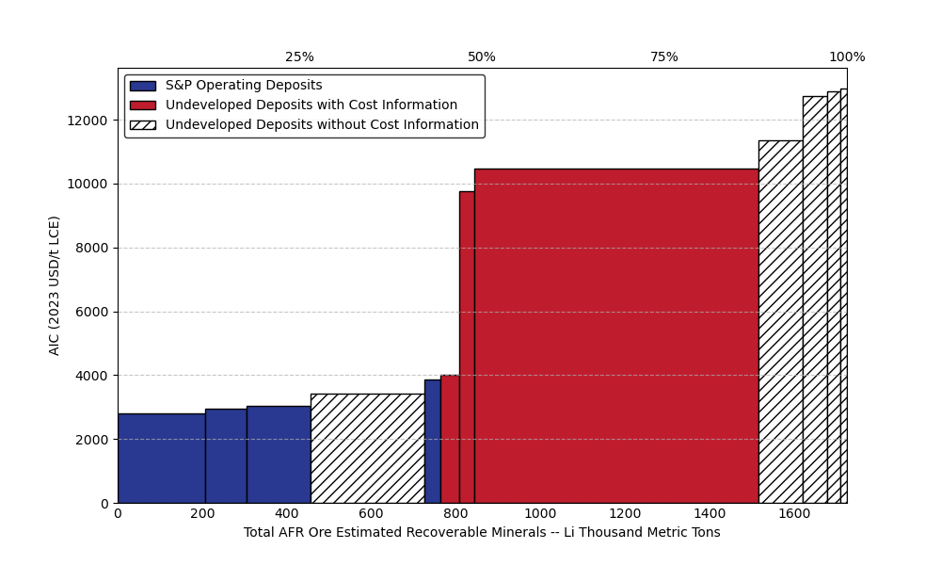 | 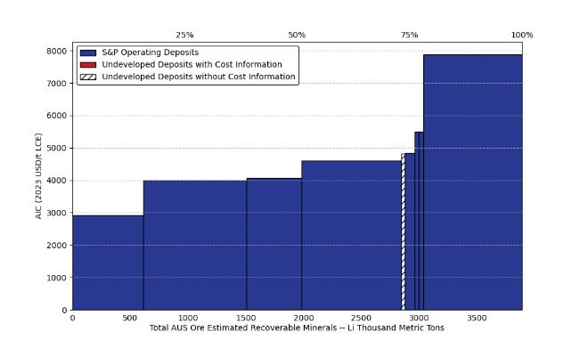
(a) | (b)
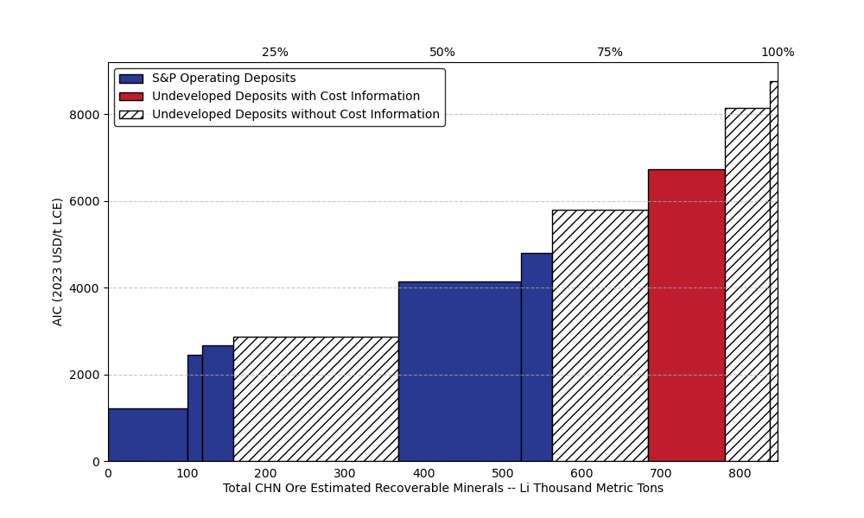 | 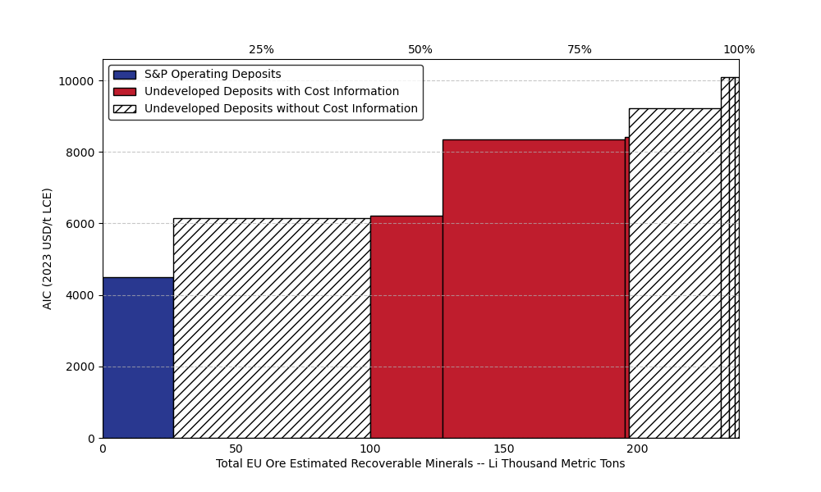
(c) | (d)
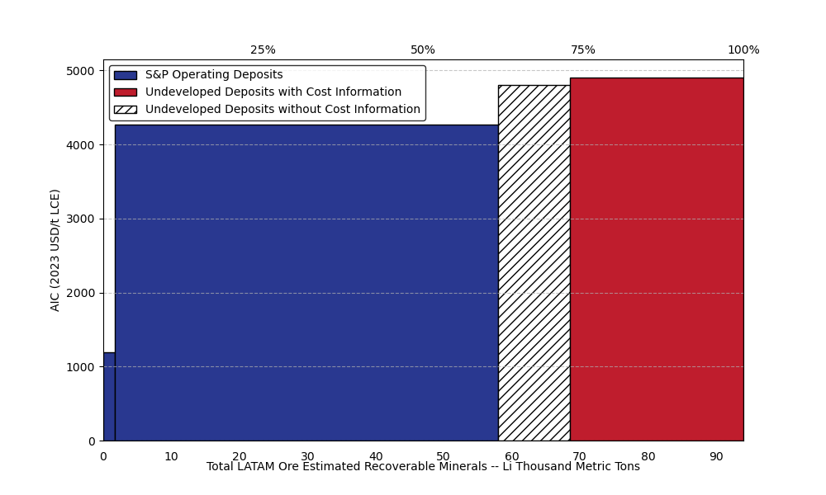 | 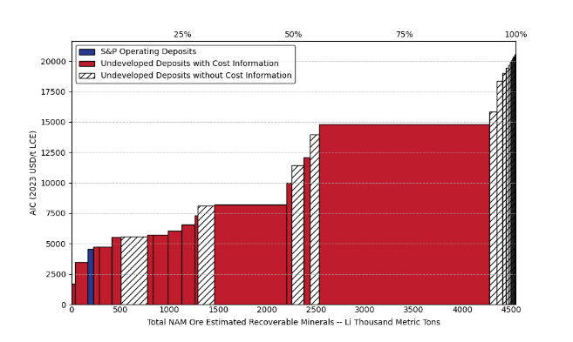
(e) | (f)
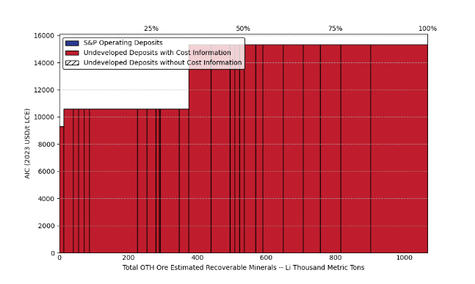
(g)
Figure S7 Regional lithium CAC from ore. (a) for Africa (b) for Australia (c) for China (d) for Europe (e) for Latin America (f) for North America (g) for other regions. Related to Figure 4.

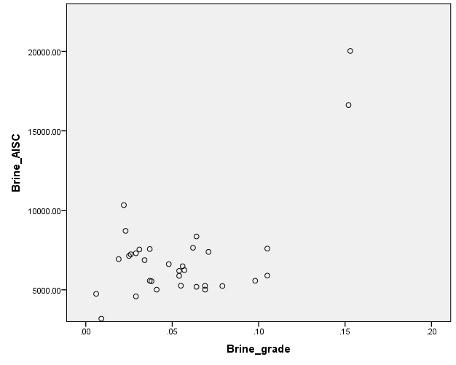
(a)
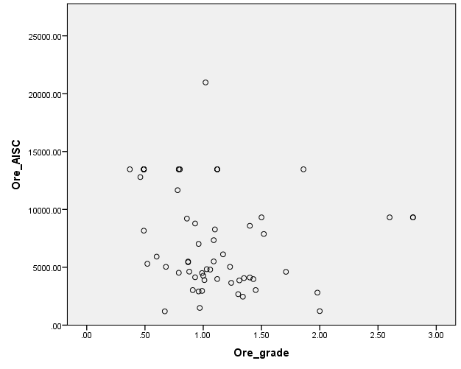
(b)
Figure S8 Relationship between lithium deposit grade and AISC. (a) for ore (b) for brine. No clear relationship between variables.

Section 4 – A brief introduction to Morphological Analysis and scenarios samples

Morphological analysis is a structured exploratory technique that systematically maps the key dimensions and plausible states of a complex system, enabling the identification of internally consistent combinations of future conditions⁹⁵⁻⁹⁷. In the context of the lithium value chain, it provides a transparent way to organise and assess uncertainties that stem from external drivers beyond addressed in the Cumulative Availability Curve (CAC) construction. By decomposing the value chain into critical parameters, morphological analysis helps to illustrate how diverse sources of uncertainty may interact and propagate. By applying morphological analysis to develop two simple scenarios, Green Leap (GL) and Fragmented Transition (FT), this approach demonstrates how CAC derived data can support scenario building and interact with uncertainties arising from external factors shaping the lithium value chain.
With in the morphological analysis framework⁹⁶, the first step following the definition of the definition of the scenario field is the identification of key factors. Through a review of the literature, six parameters relevant to the lithium value chain uncertainty were identified: non-energy lithium consumption^{98,99}, New Energy Vehicles (NEVs) demand^{100,101}, battery technology development^{102,103}, lithium supply chain robustness^{104,105}, secondary supply and storage use^{98,106}, climate policy ambition^{107,108}. These factors collectively influence the balance of between lithium supply and demand across extraction, utilisation and recycling stages.
The subsequent step involves the analysis of key factors, which entails the systematic definition of “hypotheses” within the morphological box. Each factor is described through two or three plausible developmental settings, capturing distinct trajectories that may shape the evaluation of the lithium value chain. The full settings is presented in S3-Table 1. Finally, the combination of compatible “hypothesis” bundles enables the construction of internally consistent scenarios. On this basis, two illustrative scenarios are developed to support the interpretation and application of the morphological analysis: Green Leap (GL) and Fragmented transition (FT). The storyline of these two scenarios can be summarised as:
Green Leap:
The Green Leap scenario reflects a world in which countries work closely together to advance economic development and climate ambitions. Strong cooperation fuels global growth, which in turn drives a pronounced rise in the demand of lithium. Open trade and improving industrial capacity allow lithium to be integrated more widely across value chain. Rapid progress in lithium-ion battery technologies, accelerates the electrification of transport and expands the use of stationary storage systems. Recycling techniques also mature steadily and become economically viable in several applications, providing an increasingly valuable secondary source. Although lithium supply expands, the strengthening of ESG requirements slows the rate at which new projects can proceed. Overall, Green Leap portrays a coordinated, technology-driven pathway in which climate cooperation and innovation reinforce a rapid transition.
Fragmented Transition
The Fragmented Transition scenario describes a world where geopolitical tensions intensify, and trade restrictions become more common. Countries increasingly view lithium as a strategic mineral, and the resource nationalism uprising. Despite this conflict context, governments continue to pursue emissions reduction based on the published National Determined Contribution (NDC). Global economic continues to exhibit a trend of steady growth, impacting both non-energy lithium and road transport demand. The spread of lithium battery technologies is uneven: only a few countries with both resources and domestic markets establish integrated supply chains, while others turn to alternative low-carbon technologies. Recycling expands rapidly, and second-life use of EV batteries becomes more widespread as a response to constrained primary supply.
Overall, the two scenarios point to markedly different development pathways. Under the green Leap scenario, global cooperation steers the system towards a more efficient trajectory. Lithium resources are developed widely with ESG constraints, guided primarily by cost considerations, and can circulate freely across regions. Mining and refining activities may remain relatively concentrated, supported by open trade and coordinated industrial development, in contrast, the Fragmented Transition scenario reflects a world in which countries prioritise the development of their own lithium deposits and invest in domestic refining capacity. Regions with limited lithium availability are likely to channel greater effort into alternative low-carbon options, such as hydrogen technologies, which rely less on lithium. Recycling also becomes a strategic focus, with governments treating secondary supply as an essential component of supply-chain security. The contrast between these two scenarios highlights how restriction on lithium trade may reshape the global landscape of lithium supply and alter the pathways through which the value chain develops.
Building on the qualitative scenarios developed through the morphological framework, these storylines can be translated into numerical assumptions that are readable by Integrated Assessment Models (IAMs). Parameter values are derived from the literature and adjusted to reflect the characteristics of scenarios. For example, Knehr et al. (2003) ¹⁰⁹ report lithium intensities for lithium-ion batteries are range from 91-121 g/kWh. On this basis, different learning trajectories can be assigned across scenarios for lithium material intensity per vehicle, thereby capturing uncertainty in future technology development. Among all factors, the most pronounced data gaps related to the availability of lithium on the supply side, which is the focus of this study. The Cumulative Availability Curve (CAC) is used to derive regional production costs and extractable quantities. By specifying a base-year production level and an upper bound on production growth rate in subsequent years, a consistent set of supply-side inputs is produced for use in modelling simulations. Scenario descriptions subsequently inform further constraints on these pathways, while other uncertainties influence effective availability through the optimisation process. A schematic illustration of the CAC and scenario linkage, using ESG restriction and geopolitical risk as examples, is presented in Table S15.
Table S15 Morphological table of scenario development.
Non-energy lithium consumption | Moderate Growth: Under Geopolitical Constraints  With moderate economic expansion and persistent geopolitical risks, demand for non-energy lithium applications grows slowly and remains somewhat constrained. Limited cross-border cooperation reduces investment certainty and slows the uptake of lithium in industrial, chemical and consumer-product uses, leading to a relatively subdued trajectory for non-energy consumption.  FT | Rapid Expansion: Under Global Economic Cooperation  Strong international cooperation supports robust economic growth, stimulating rapid increases in non-energy lithium consumption. Broad improvements in industrial activity, material innovation and global trade facilitate accelerated uptake of lithium across chemical, industrial and consumer sectors. As a result, non-energy demand becomes an increasingly important driver of total lithium use.  GL
New energy vehicles (NEVs) demand | Low Growth: Weak Transport Demand and Limited NEV uptake  Global economic performance weakens in the face of sustained shocks, leading to a subdued level of road transport demand. Environmental concerns become less salient as households and governments prioritise economic stability, resulting in slow uptake of NEVs. Penetration rates remain particularly low in developing economies where affordability and infrastructure constraints persist. | Moderate Growth: Steady Expansion and Rising NEV Penetration  The global economy continues to grow, but the pace of expansion slows under persistent trade frictions. Road transport demand follows a moderate trajectory, and environmental awareness gains broad societal acceptance. NEV uptake makes tangible progress; however, this advancement is largely confined to a small number of countries with strong domestic industrial capabilities. Heightened resource nationalism and restricted trade flows limit the diffusion of NEV technologies and prevent the formation of broader comparative advantages, resulting in uneven adoption across regions.  FT | High Growth: Rapid Transport Demand Coupled with Accelerated NEV Uptake  International cooperation strengthens supporting robust economic growth and rising living standards. Transport demand accelerates rapidly. Rapid advances in clean technologies and heightened environmental awareness drive a sharp increase in NEV penetration, alongside widespread adoption of electrified public transport.  GL
Battery technology development | Limited Progress: Slow Innovation under Constrained R&D  Economic stagnation constrains investment in research and development, leading to slow innovation and limited technological advancement. Reductions in battery costs progress only marginally, while improvements in pack-level energy density and material intensity (measured per kWh) advance at a similarly sluggish pace. | Moderate Advancements: Diversified Technological Pathways  Governments uphold their domestic emission reduction targets, providing steady momentum for transport sector transitions. However, restrictions on lithium trade and broader geopolitical risks heighten concerns over supply chain security, promoting countries t pursue more diversified technological pathways. Therefore, multiple automotive powertrain options develop in parallel. progress in lithium-ion battery technologies remains stable, but not transformative.  FT | Breakthrough Innovation: Rapid Advances Driven by Global Cooperation  Under conditions of strong international cooperation and a shared commitment to ambitious decarbonisation goals, lithium -ion batteries emerge as the central technological solution and experience rapid, transformative progress. Significant improvements are achieved in production costs, pollutant emissions, pack size and metal intensity, accelerating their competitiveness across transport segments. Complementary battery technologies for buses, trucks and other heavy-duty applications also advance swiftly, reinforcing lithium-ion batteries as a primary driver of the transport sector's energy transition.  GL
Lithium supply chain robustness | Constrained Supply: Geopolitical Restrictions and Domestic-First Expansion  Heightened geopolitical tensions and resource nationalism lead countries to prioritise domestic development of mining and processing capacity. Resource-rich nations gain a strategic advantage, while cross-border flows of lithium raw materials and intermediates diminish due to export controls, investment restrictions and fragmented trade relations. This inward-looking expansion results in a more regionally segmented supply landscape, amplifying vulnerabilities to localised disruptions and reducing the overall resilience of the global lithium supply chain.  FT | Stable Supply with High Demand Pressure: ESG Constraints on Expansion  Lithium supply grows at a steady pace, supported by stable demand and ongoing expansion of existing mining and refining capacity. However, the development of new projects progresses only slowly under increasingly stringent ESG requirements, contributing to higher overall extraction costs and modestly constraining project approval, particularly in regions with weaker ESG performance.  GL | Disordered Expansion: Rapid Demand Growth and Lagging Regulatory Frameworks  Lithium demand rises sharply, driven by both energy and non-energy sectors requirements. However, regulatory frameworks and ESG oversight evolve slowly, and international coordination remains limited. As a results, lithium extraction enters a phase of disordered expansion, characterised by uneven project development and inconsistent operational standards. The absence of a stable and well-regulated market contributes to pronounced price volatility, preventing supply and demand from reaching a sustainable equilibrium.
Secondary supply and storage use | Moderate Recycling and High Storage Uptake  Under the combined pressure of climate targets and rising environmental awareness, lithium recycling technologies achieve steady progress and begin to operate at cost-competitive levels in selected applications. Demand for stationary storage continues to grow in line with broader electrification trends, while the share of end-of-life EV batteries repurposed for storage increases at a stable pace.  GL | Recycling Expansion Under Trade Constraints  In response to lithium trade restrictions and the need to strengthen supply-chain security, countries accelerate the development of domestic recycling capacity, reducing costs to commercially viable levels and enabling secondary supply to act as an important buffer during import disruptions. However, despite rapid growth in recycling, secondary supply remains insufficient to offset limitations in primary production. As a result, the deployment of stationary storage expands only slowly, even though a substantial share of retired EV batteries is channelled into second-life applications.  FT
Climate policy ambition | National Target Compliance  Countries pursue their own Nationally Determined Contributions (NDCs) and implement domestic mitigation policies within their respective institutional frameworks. While emissions reduction efforts continue, the absence of robust international coordination limits policy alignment.  FT | Cooperative Action Towards the 2 °C Target  Under strong international collaboration, countries align their policy frameworks and collectively advance the mitigation efforts required to meet the Paris Agreement’s 2 °C goal.  GL
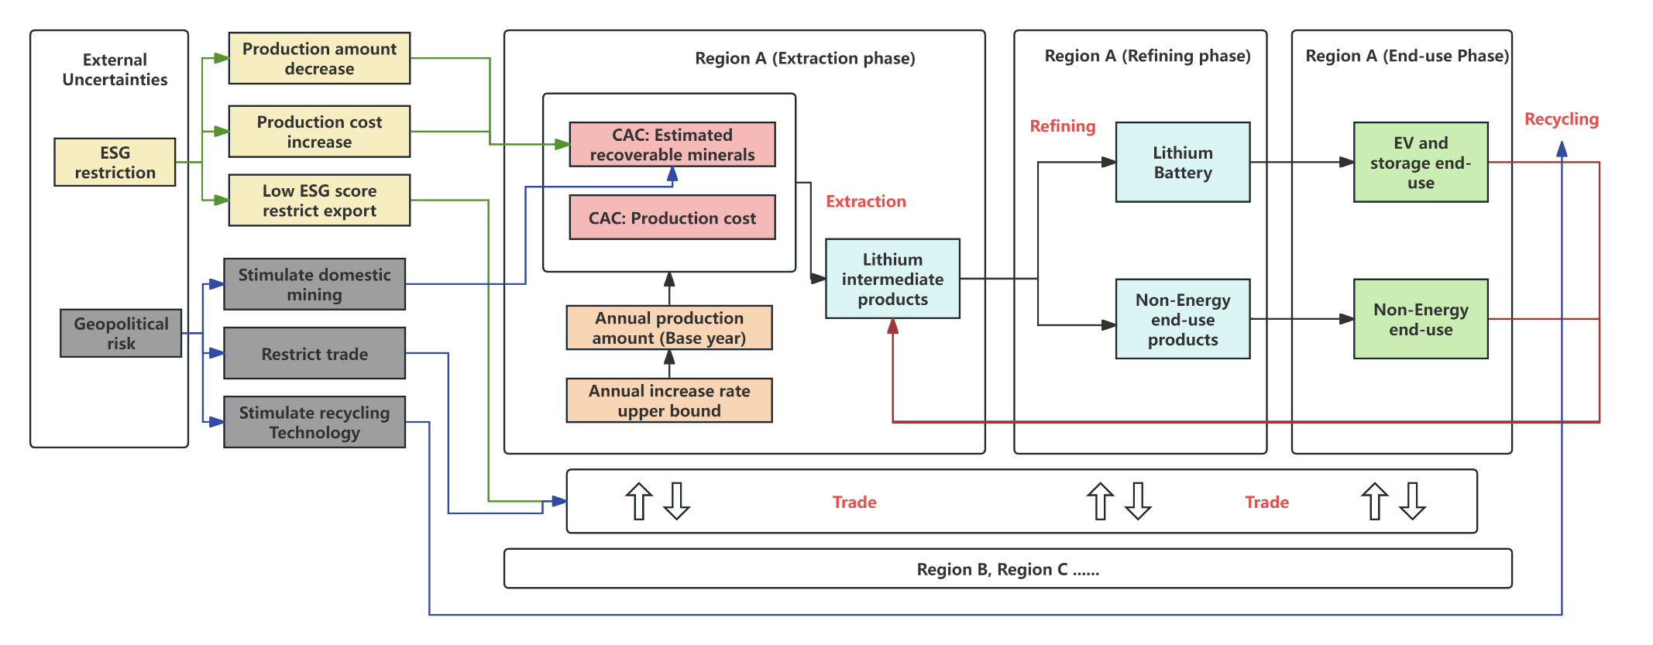
Figure S9 Linkage Between External Uncertainties and Scenario Formation. Using ESG restriction (Green lines) and Geopolitical risk (Blue lines) as examples.
Supplemental references
S1. The World Bank. (n.d.). Inflation, consumer prices (annual %) - United States.
S2. Fleming, M., Kannan, S.G., and Eggert, R. (2024). Long-run availability of mineral resources: The dynamic case of lithium. Resources Policy 97, 105226.
S3. NeoLithium (2021). Tres Quebradas (3Q) Lithium Project. https://minedocs.com/21/3Q_(Tres_Quebradas)-CP-012021.pdf.
S4. Galan (2021). Excellent Preliminary Economic Assessment Results for Candelas Project in Catamarca, Argentina. https://wcsecure.weblink.com.au/pdf/GLN/02459769.pdf.
S5. AdvantageLithium (2019). Advantage Lithium Corp. Announces Positive Pre-Feasibility Study Results For The Cauchari JV. https://www.newswire.ca/news-releases/advantage-lithium-corp-announces-positive-pre-feasibility-study-results-for-the-cauchari-jv-826992858.html.
S6. Ambrose, H., and Kendall, A. (2020). Understanding the future of lithium: Part 1, resource model. Journal of Industrial Ecology 24, 80-89. https://doi.org/10.1111/jiec.12949.
S7. LithiumAmericas (2020). NI 43 – 101 TECHNICAL REPORT Updated Feasibility Study and Mineral Reserve Estimation to Support 40,000 tpa Lithium Carbonate Production at the Cauchari-Olaroz Salars, Jujuy Province, Argentina https://s203.q4cdn.com/736266488/files/doc_downloads/our_projects/cauchari_olaroz/2020-10-19-Technical-Report.pdf.
S8. Mohr, S.H., Mudd, G.M., and Giurco, D. (2012). Lithium Resources and Production: Critical Assessment and Global Projections. Minerals 2, 65-84.
S9. Bowell, R.J., Lagos, L., de los Hoyos, C.R., and Declercq, J. (2020). Classification and characteristics of natural lithium resources. Elements 16, 259-264.
S10. Eramet (2023). Eramet in Argentina Centenario-Ratones Lithium Project. https://www.eramet.com/wp-content/uploads/2023/04/2023-03-08-Eramet_Centenario_Investors-Presentation.pdf.
S11. Kesler, S.E., Gruber, P.W., Medina, P.A., Keoleian, G.A., Everson, M.P., and Wallington, T.J. (2012). Global lithium resources: Relative importance of pegmatite, brine and other deposits. Ore Geology Reviews 48, 55-69. https://doi.org/10.1016/j.oregeorev.2012.05.006.
S12. KnightPiesold (2019). NI 43-101 PRELIMINARY ECONOMIC ASSESSMENT REPORT for the HOMBRE MUERTO NORTE PROJECT SALTA PROVINCE, ARGENTINA https://www.lithiumsouth.com/wp-content/uploads/HMN-Final-Report-190808.pdf.
S13. Galan (2023). Phase 2 DFS Confirms Tier One Status of Hombre Muerto West (HMW) Lithium Brine Project in Argentina. https://wcsecure.weblink.com.au/pdf/GLN/02720109.pdf.
S14. Galan (2023). Phase 1 of Hombre Muerto West (HMW) DFS Delivers Compelling Economic Results for Accelerated Production. https://wcsecure.weblink.com.au/pdf/GLN/02682245.pdf.
S15. Galan (2024). Hombre Muerto Project. https://galanlithium.com.au/projects/hombre-muerto-west/.
S16. Integral (2023). Resource and Reserve Report Pre-Feasibility Study Salar del Hombre Muerto. https://arcadiumlithium.com/wp-content/uploads/2024/07/2023-Livent-Resource-and-Reserve-Report-Salar-del-Hombre-Muerto.pdf.
S17. LakeResources (2023). Lake Resources Kachi Project Phase One Definitive Feasibility Study. https://lakeresources.com.au/wp-content/uploads/2023/12/lke_kachi-dfs_19-dec-23.pdf.
S18. Advisian (2018). Preliminary Economic Assessment of the Marana Lithium Brine Project. https://minedocs.com/21/Mariana-PEA-11152018.pdf.
S19. LithiumAmericas (2023). Lithium Resources Update Pastos Grandes Project Slata Provice, Argentina. https://s203.q4cdn.com/736266488/files/doc_downloads/2023-04-30-Technical-Report.pdf.
S20. HainsEngineering (2018). Technical Report on the Salar De Pozuelos Project, Salta Province, Argentina Prepared for Lsc Lithium Corporation. https://docslib.org/doc/12889719/technical-report-on-the-salar-de-pozuelos-project-salta-province-argentina-prepared-for-lsc-lithium-corporation.
S21. Argosy Minerals Limited (2018). Argosy Delivers Exceptional PEA Results For Rincon Lithium Project. https://announcements.asx.com.au/asxpdf/20181128/pdf/440q663bmjz5wk.pdf.
S22. PowerMinerals (2023). PEA delivers outstanding project economics for battery-grade lithium carbonate operation at Rincon salar. https://www.powerminerals.com.au/site/pdf/192380b1-cbf3-43a7-b42b-95f89b6fd414/Update-Rincon-PEA-delivers-outstanding-project-economics-for-batterygrade-lithium-carbonate-operation-at-Rincon-salar.pdf.
S23. Rio Tinto (2024). Rincon Project Mineral Resources and Ore Reserves https://editorial.northernminergroup.com/wp-content/uploads/2024/12/rio-tinto-rincon.pdf.
S24. Montgomery & Associates Consultores Limitada (2023). SEC Technical Report Summary Sal de Vida Lithium Brine Project. https://minedocs.com/27/Sal-de-Vida-TRS-11152023_compressed.pdf.
S25. Select Lithium (2016). Salar de Antofalla Project. https://selectlithium.com/salar-de-antofalla/.
S26. Allkem (2023). Olaroz Lithium Facility NI 43-101 Technical Report - Feasibility Study. https://www.scribd.com/document/792725155/1698636645-olaroz-lithium-facility-ni-43-101-technical-report-feasibility-study-final.
S27. Evans, R.K. (2008). An abundance of lithium. Santiago: World Lithium 1, 1-17.
S28. Gruber, P.W., Medina, P.A., Keoleian, G.A., Kesler, S.E., Everson, M.P., and Wallington, T.J. (2011). Global Lithium Availability. Journal of Industrial Ecology 15, 760-775. https://doi.org/10.1111/j.1530-9290.2011.00359.x.
S29. Tahil, W. (2008). The trouble with lithium 2: Under the microscope. Meridian international research, 1-54.
S30. Yaksic, A., and Tilton, J.E. (2009). Using the cumulative availability curve to assess the threat of mineral depletion: The case of lithium. Resources Policy 34, 185-194. https://doi.org/10.1016/j.resourpol.2009.05.002.
S31. Minerals，, P. (n.d.). Pular Lithium Project. https://www.powerminerals.com.au/site/projects/lithium-brine-project/pular-lithium-project.
S32. Pursuit Minerals (2024). Rio Grande Sur Lithium Project. https://pursuitminerals.com.au/rio_grande_sur/.
S33. Ausenco (2023). Tolillar Project NI 43-101 Technical Report Update on Preliminary Economic Assessment https://minedocs.com/25/Tolillar-PEA-8102023.pdf.
S34. USGS (2024). Mineral Commodity Summaries 2024. https://pubs.usgs.gov/periodicals/mcs2024/mcs2024.pdf.
S35. Sproule (2022). NI 43-101 Technical Report: Resource Assessment of the Kindersley Lithium Project in Saskatchewan, Canada for Grounded Lithium Corp. https://groundedlithium.com/wp-content/uploads/2022/12/115092.GroundedLithium.FinalReportRev1.pdf.
S36. Arizona Lithium (2023). Prairie Lithium PFS Confirms Extremely Low Operating Costs of $2,819 USD Per Tonne. https://www.arizonalithium.com/wp-content/uploads/2024/01/02758730.pdf.
S37. Lithium Chile (2024). Lithium Chile Announces Pre-Tax NPV of US$3,853,000,000 and Pre-Tax IRR of 42.1% from Pre-Feasibility Study on Arizaro Project. https://lithiumchile.ca/wp-content/uploads/2024/07/July-23-2024-LITHIUM-CHILE-ANNOUNCES-PRE-TAX-NPV-OF-US3853000000-AND-PRE-TAX-IRR-OF-42.1-FROM-PRE-FEASIBILITY-STUDY.pdf.
S38. Albemarle (n.d.). Lithium Extraction at Salar de Atacama. https://www.albemarle.com/cl/en/what-we-offer/reliable-supply/salar-de-atacama.
S39. WSP (2022). Technical Report Summary: Operation Report Salar De Atacama. https://minedocs.com/22/Salar-de-Atacama-TR-042022.pdf.
S40. Cabello, J. (2021). Lithium brine production, reserves, resources and exploration in Chile: An updated review. Ore Geology Reviews 128, 103883. https://doi.org/10.1016/j.oregeorev.2020.103883.
S41. Water, A., and Worley (2022). Definitive feasibility study update, Mineral Salar Blance - Lithium Project Stage one III region, Chile. https://lithiumpowerinternational.com/wp-content/uploads/2022/01/NI43-101_DFS2022_LR.pdf.
S42. Zijin Mining (n.d.). Lakkor Tso Lithium project. https://www.zjky.cn/global/program-detail-71783.htm.
S43. SRK (2023). SEC Technical Report Summary Pre-Feasibility Study Silver Peak Lithium Operation Nevada, USA. https://www.sec.gov/Archives/edgar/data/915913/000091591323000037/exhibit9631231202210-k.htm#i2ab4d569b3ee4e029d9d2ae1c46da4f8_7.
S44. Tawana (2017). Bald Hill Lithium - Tantalum Project to Deliver Outstanding Cash Flows and Returns. https://announcements.asx.com.au/asxpdf/20170711/pdf/43kkjk14z4kr79.pdf.
S45. Liontown (2021). Mineral Resurces, Reserves and CP statements. https://www.ltresources.com.au/wp-content/uploads/2023/05/624aa87d3dd52088027b8837_Resources-Reserves-and-CP-Statements.pdf.
S46. IGO (2023). Greenbushes CY23 Resources and Reserves. https://www.igo.com.au/site/pdf/483721a4-afe7-4723-a907-6efce0c66748/Greenbushes-CY23-Resources-and-Reserves.pdf.
S47. Liontown (2021). Kathleen Valley DFS confirms Tier-1 global lithium project with outstanding economics and sector-leading sustainability credentials. https://wcsecure.weblink.com.au/pdf/LTR/02450567.pdf.
S48. Allkem (2023). SEC Technical Report Summary Mt Cattlin Lithium Project. https://s203.q4cdn.com/709125885/files/doc_downloads/TechnicalRep/New/Mt-Cattlin-Lithium-Project-Australia.pdf.
S49. SQM (2022). Technical Report Summary Mt. Holland Lithium project. https://www.sec.gov/Archives/edgar/data/909037/000110465922049694/tm2210998d1_ex96-2.htm.
S50. Pilbara Minerals (2023). Substantial 109Mt Mineral Resource increase to 414Mt - further extends Pilgangoora's position as a world class lithium project. https://minedocs.com/24/Pilgangoora-MR-08072023.pdf.
S51. Mineral Resources (2022). Lithium Mineral Resources and Reserve Update. https://minedocs.com/23/Mineral_Resources_MR_10072022.pdf.
S52. European Lithium (2023). Wolfsberg Lithium Project Definitive Feasibility Study Results. https://minedocs.com/23/Wolfsberg-FS-03082023.pdf.
S53. Lithium Ionic (2023). Lithium Ionic Announces PEA and Expanded Mineral Resource Estimate for Bandeira; Post-tax NPV8% US$1.6 Billion & IRR of 121%. https://www.lithiumionic.com/_resources/news/231019-2.pdf.
S54. Sigma (2022). Grota Do Cirilo Lithium Project. https://minedocs.com/19/Grota-do-Cirilo-Xuxa-FS-Barreiro-PFS-5302022.pdf?utm_source=chatgpt.com.
S55. AMG (2017). AMG Lithium & Tantalum. https://amg-nv.com/wp-content/uploads/AMG-Lithium-Tantalum.pdf.
S56. Sayona (2019). Authier Lithium Project Update Definitive Feasibility Study https://www.ree.environnement.gouv.qc.ca/dossiers/3211-16-020/3211-16-020-16.pdf.
S57. RockTech (2022). Rock Tech Lithium completes Pre-Feasibility Study for its Georgia Lake Project https://res.cloudinary.com/rocktech/image/upload/v1668567754/M_Info_PFS_Summary_Release_ENG_FINAL_1ad1f00e98.pdf.
S58. SLR, WAVE, and WSP (2023). SEC Technical Report Summary Allkem Limited James Bay Lithium Project. https://s203.q4cdn.com/709125885/files/doc_downloads/TechnicalRep/New/James-Bay-Lithium-Project-Canada.pdf.
S59. Sayona (2024). Moblan Lithium Project Definitive Feasibility Study: Positive Results Deliver C$2.2B NPV. https://clients3.weblink.com.au/pdf/SYA/02774427.pdf.
S60. Sayona (2023). Definitive Feasibility Study Confirms NAL Value with A$2.2B NPV. https://wcsecure.weblink.com.au/pdf/SYA/02654503.pdf.
S61. CriticalElements (2023). Critical Elements Lithium Announces New Positive Feasibility Study for the Rose Lithium Project Generating an After-Tax NPV8% of US$2.2B and an After-Tax IRR of 65.7%. https://www.cecorp.ca/wp-content/uploads/2022-08-29-news-release-CRE.pdf.
S62. SnowLake (2024). Building a Clean Energy Company. https://snowlakeenergy.com/wp-content/uploads/2024/03/Snow-Lake-Corporate-Deck-March-2024.v1.pdf.
S63. BBA, DRA, SGS, and WSP (2023). SEC Technical Report Summary Pre-Feasibility Study on the Whabouchi mine Nemaska, Quebec. https://s203.q4cdn.com/709125885/files/doc_downloads/TechnicalRep/Nemaska-Whabouchi-Mine-Canada.pdf.
S64. Sen, N. (2024). 四川探明近百万吨锂资源量，盛新锂能参股，探转采工作正推进 (in Chinese). https://www.thepaper.cn/newsDetail_forward_26057778.
S65. Xu, S., and Wen, D. (2024). 直击股东大会｜李家沟项目采矿系统试生产 川能动力董事长：有充分信心为股东带来持续回报 (in Chinese). https://news.qq.com/rain/a/20240518A04ZK000.
S66. Zijin Mining (n.d.). Xiangyuan Hard-Rock Lithium-containing Polymetallic Mine. https://www.zijinmining.com/global/program-detail-71786.htm.
S67. Chengxin Lithium Energy (2023). 盛新锂能集团股份有限公司 2022年年度报告 (in Chinese). https://file.finance.sina.com.cn/211.154.219.97:9494/MRGG/CNSESZ_STOCK/2023/2023-3/2023-03-07/8868659.PDF.
S68. Yichun Gov (2021). 宜春市矿产资源总体规划（2021-2025年）（in Chinese）. https://www.doc88.com/p-74487196273821.html.
S69. SKR (2023). Keliber Lithium Project, Finland Technical Report Summary https://minedocs.com/26/Keliber_Lithium_Project_TRS_12312022.pdf.
S70. Atlantic (2023). Definitive Feasibility Study. https://minedocs.com/25/Ewoyaa_FS_06292023.pdf.
S71. Firefinch (2021). Goulamina Lithium Project Update to DFS Delivers NPV of A$4.1 Billion and 83% IRR. https://minedocs.com/22/Goulamina-FS-12062021.pdf.
S72. Lepidico (2019). Alvarrões assays indicate larger lithium Resource https://cdn.lepidico.com/production/LPD_190308_Alvarroes_assays_indicate_larger_lithium_Resource_be5f31182d.pdf.
S73. Savannah (2025). The Barroso Lithium Project: Developing Europe’s largest spodumene project. https://www.savannahresources.com/media/4ljdtggi/savannah-presentation.pdf.
S74. Piedmont (2021). Piedmont Completes Bankable Feasibility Study of the Carolina Lithium Project With Positive Results. https://www.listcorp.com/asx/pll/piedmont-lithium-limited/news/piedmont-completes-bfs-of-the-carolina-lithium-project-2647099.html.
S75. Prospect Resources (2021). Lycopodium completes Direct OFS for Arcadia Project https://prospectresources.com.au/wp-content/uploads/2022/07/61068491.pdf.
S76. ChengXin Lithium (n.d.). Mine in Africa (Sabi Star Mine). https://en.cxlithium.com/product/45.html.
S77. E3 Lithium (2024). Clearwater Project NI 43-101 Technical Report on Pre-Feasibility Study https://minedocs.com/27/Clearwater-PFS-06202024.pdf.
S78. European Metals (2022). PFS Update Delivers Outstanding Results 75% Increase in Cinovec NPV to US$1.94B 16% Increase in Production to 29,386 TPA. https://api.investi.com.au/api/announcements/emh/7381a65f-d0b.pdf.
S79. Snowden Optiro (2025). Report for Zinnwald Lithium plc & Zinnwald Lithium GmbH https://zinnwaldlithium.com/wp-content/uploads/2025/03/167-RPT-GEN-019_Rev0.pdf.
S80. Infinity (2021). San Jose Lithium Project. https://wcsecure.weblink.com.au/pdf/INF/02435564.pdf.
S81. Ausenco (2018). Technical Report on the Feasibility Study for the Sonora Lithium Project, Mexico. https://bacanoralithium.com/_userfiles/pages/files/documents/bacanorafstechnicalreport25012018_compressed.pdf.
S82. Pacific, D. (2024). Falchani Lithium Project NI 43-101 Technical Report Preliminart Economic Assessment - Update. https://americanlithiumcorp.com/wp-content/uploads/2024/02/GPERPPR7027-Falchani-Update-of-PEA-Final-Report-22022024.pdf.
S83. Ergo (2023). An economic impact assessment of the Jadar lithium-borates project. https://ergostrategygroup.com/wp-content/uploads/2023/08/Ergo-Strategy-Group-Jadar-Economic-Impact-Assessment-Sep23-EN-spread.pdf.
S84. Fayram, T.S., Lane, T.A., and Kalmbach, D.W. (2020). NI 43-101 Technical Report Prefeasibility Study Clayton Valley Lithium Project. https://minedocs.com/20/Clayton_Valley_(Cypress)_PFS_05192020.pdf.
S85. Noram Lithium (2021). Updated Lithium Mineral Resource Estimate Zeus Project. https://noramlithiumcorp.com/site/assets/files/3886/2021-09-21-ni-43-101-report.pdf.
S86. AmericanPacific (2018). Updated Lithium Mineral Resource Estimate Zeus Project, Clayton Valley Esmeralda County, Nevada, USA. https://announcements.asx.com.au/asxpdf/20181217/pdf/441926y31gw1v9.pdf.
S87. LithiumAmericas (2022). Feasibility Study National Instrument 43-101 Technical Report for the Thacker Pass Project Humboldt County, Nevada, USA. https://minedocs.com/19/Thacker-Pass-FS-11022022.pdf.
S88. Anson Resources (2022). Paradox Lithium Project, USA Definitive Feasibility Study Presentation. https://company-announcements.afr.com/asx/asn/8b826134-2fe3-11ed-918b-c2e20985e019.pdf.
S89. Fluor (2022). IONEER USA Corp. Rhyolite Ridge Lithium-Boron Project Definitive Feasibility Study (DFS) Report https://www.ioneer.com/wp-content/uploads/2022/07/300420-dfs-executive-summary-metric_final.pdf.
S90. Standard Lithium (2023). Standard Lithium Announces Positive Preliminary Feasibility Study Results for Its South West Arkansas Project. https://minedocs.com/25/Standard-Lithium-South-West-Arkansas-PFS-PR-08082023.pdf.
S91. CAT (2022). Kamativi Lithium Project Update. https://webfiles.thecse.com/2022.10.20_NR_-_CAT_Update_on_Kamativi_Project.pdf?hF5rpznVts74PwRVnCECB11FSizA82vI.
S92. S&P. (n.d.). Mine Economics
S93. Milei, J.G., Caputo, L.A., Lucero, L.E., Thiem, M.R., González, J.M., and Hereñú, C. (2025). Portfolio of Lithium. Secretaría de Minería. https://www.argentina.gob.ar/sites/default/files/portfolio_lithium_2025.pptx.pdf.
S94. Vulcan Energy (2023). Vulcan Zero Carbon Lithium™ Project Phase One DFS results and Resources-Reserves update. https://announcements.asx.com.au/asxpdf/20230213/pdf/45ljfy3ycb8t4t.pdf.
S95. Johansen, I. (2018). Scenario modelling with morphological analysis. Technological Forecasting and Social Change 126, 116-125.
S96. Kosow, H., and Gaßner, R. (2008). Methods of future and scenario analysis: overview, assessment, and selection criteria (DEU).
S97. Watson, J., Ketsopoulou, I., Dodds, P., Chaudry, M., Tindemans, S., Woolf, M., and Strbac, G. (2018). The security of UK energy futures.
S98. Miatto, A., Wolfram, P., Reck, B.K., and Graedel, T.E. (2021). Uncertain future of American lithium: a perspective until 2050. Environmental Science & Technology 55, 16184-16194.
S99. Sun, X., Hao, H., Geng, Y., Liu, Z., and Zhao, F. (2024). Exploring the potential for improving material utilization efficiency to secure lithium supply for China's battery supply chain. Fundamental Research 4, 167-177. https://doi.org/10.1016/j.fmre.2022.12.008.
S100. Martin, G., Rentsch, L., Höck, M., and Bertau, M. (2017). Lithium market research–global supply, future demand and price development. Energy Storage Materials 6, 171-179.
S101. Speirs, J., Contestabile, M., Houari, Y., and Gross, R. (2014). The future of lithium availability for electric vehicle batteries. Renewable and Sustainable Energy Reviews 35, 183-193.
S102. Calderon, J., Smith, N., Bazilian, M., and Holley, E. (2024). Critical mineral demand estimates for low-carbon technologies: What do they tell us and how can they evolve? Renewable and Sustainable Energy Reviews 189, 113938.
S103. Vega-Muratalla, V.O., Ramírez-Márquez, C., Lira-Barragán, L.F., and Ponce-Ortega, J.M. (2024). Review of lithium as a strategic resource for electric vehicle battery production: Availability, extraction, and future prospects. Resources 13, 148.
S104. Busch, P., Chen, Y., Ogbonna, P., and Kendall, A. (2025). Effects of demand and recycling on the when and where of lithium extraction. Nature Sustainability, 1-11.
S105. Jones Jr, E.C. (2024). Lithium supply chain optimization: A global analysis of critical minerals for batteries. Energies 17, 2685.
S106. Bajolle, H., Lagadic, M., and Louvet, N. (2022). The future of lithium-ion batteries: Exploring expert conceptions, market trends, and price scenarios. Energy Research & Social Science 93, 102850.
S107. Davis, S.J., Lewis, N.S., Shaner, M., Aggarwal, S., Arent, D., Azevedo, I.L., Benson, S.M., Bradley, T., Brouwer, J., Chiang, Y.-M., et al. (2018). Net-zero emissions energy systems. Science 360, eaas9793. doi:10.1126/science.aas9793.
S108. Gong, H., and Andersen, A.D. (2024). The role of material resources for rapid technology diffusion in net-zero transitions: Insights from EV lithium-ion battery Technological Innovation System in China. Technological Forecasting and Social Change 200, 123141. https://doi.org/10.1016/j.techfore.2023.123141.
S109. Knehr, K.W., Kubal, J.J., Nelson, P.A., and Ahmed, S. (2022). Battery Performance and Cost Modeling for Electric-Drive Vehicles (A Manual for BatPaC v5.0). Argonne National Laboratory (ANL), Argonne, IL (United States). https://www.osti.gov/biblio/1877590

