FVS-HI Koa Growth & Yield Model
Comprehensive Stress Test, CFI Validation, and Survival Refinement
Prepared for: Ben Rice (Midgard Natural Resources), FVS-HI PR #30
Prepared by: Aaron Weiskittel, University of Maine | 2026-06-05
Code basis: HiGy.R v0.2.0 (== koa_prediction_functions_FINAL.R v2, 2026-05-12); harness branch koa-stress-test

1. Executive summary
A comprehensive stress test of the current FVS-HI koa equations confirms the static and increment components are robust and track the manuscript Table 8 trajectories, but the survival component is not safe to ship unguarded. Applied per tree as FVS does, the published survival model collapses real stands.
- The harness reproduces HiGy.R to machine precision (max difference 1e-14 over 3,240 grid points), so these findings apply directly to the shipped code.
- HiGy.R is on the latest equation iteration: it matches koa_prediction_functions_FINAL.R (v2, post-pivot) for every component. The FVS_FINAL README and parameters.csv recommend a different (superseded) form and CFs and should be reconciled.
- Components produce no NaN, Inf, or negative values across 81,000 input combinations and clip cleanly (dDBH at 4 cm/yr, dHT at 2 m/yr).
- Survival is the problem: 67% of the koa-plausible crown-ratio by relative-height domain yields annual survival below 0.90, and survival drops from 0.80 at CR 0.5 to ~0 at CR 0.7. Koa crowns are routinely 0.5 to 0.8.
- On the koa CFI/PSP network (first to last remeasurement), raw survival drives stand basal area and density bias to -99.9% (near-total mortality). A stabilized survival (clamp crown ratio and relative height to the calibration domain, floor annual survival at 0.90) recovers density bias to -9.3%.
- Recommendation: do not ship the raw survival cloglog. Ship the stabilizer as an interim or refit survival for individual-tree use. Keep the rest of the equations. Add an ingrowth submodel. Fix four code issues.

2. Scope and method
Two engines exercise the equations independent of the compiled FVS variant: a stand-level cohort projector (run with the operational guardrails of koa_projection.py, and with them stripped to expose raw behavior) and an individual-tree-list engine that mirrors HIGYOneStand for real plots. Survival is run in three modes: cohort (raw equation floored at 0.50/yr, the koa_projection.py crutch), raw (no floor, the FVS behavior), and stable (covariates clamped to the calibration domain and floored). Port fidelity to HiGy.R is verified in base R against the verbatim function bodies.

3. Equation provenance (which version is current)
The latest finalized code, koa_prediction_functions_FINAL.R (v2, 2026-05-12 post-pivot), uses the NEW increment form, conditional Duan correction factors (1.026 and 1.030), and the published survival fit (intercept 18.133). HiGy.R v0.2.0 in PR #30 matches that file coefficient for coefficient across height, height-to-crown-base, diameter increment, height increment, survival, and the correction factors. The FVS_FINAL README TL;DR (old form, marginal factors) and koa_FVS_FINAL_parameters.csv (M1/S1) reflect a pre-pivot decision that was reversed and are stale. This contradiction is documented in discrepancies.md and should be resolved before release.

4. Component robustness
Each component was evaluated over 81,000 input combinations spanning DBH 0.5 to 110 cm, height 1.4 to 35 m, basal area in larger trees 0 to 80, stand basal area 0.5 to 80, crown ratio 0.05 to 0.95, BYI 0 to 600, and both origins.
Component | NaN | Inf | Negative | Min | Max
Height (m) | 0 | 0 | 0 | 1.37 | 31.94
Height to crown base (m) | 0 | 0 | 0 | 0.08 | 30.40
Diameter increment (cm/yr) | 0 | 0 | 0 | 0.00 | 4.00
Height increment (m/yr) | 0 | 0 | 0 | 0.00 | 2.00
Annual survival | 0 | 0 | 0 | 0.00 | 1.00
No numerical failures. Increment components clip at their documented ceilings. The survival range spanning the full 0 to 1 interval is the first signal of the instability quantified next.

5. Survival instability
The published survival cloglog has very large coefficients and is hypersensitive to crown ratio and BYI. At DBH 15, height 9, relative height 0.5, BYI 264:
Crown ratio | 0.4 | 0.5 | 0.6 | 0.7
Annual survival | 0.99 | 0.80 | 0.02 | 0.00
30-year cumulative | 0.82 | 0.001 | ~0 | ~0
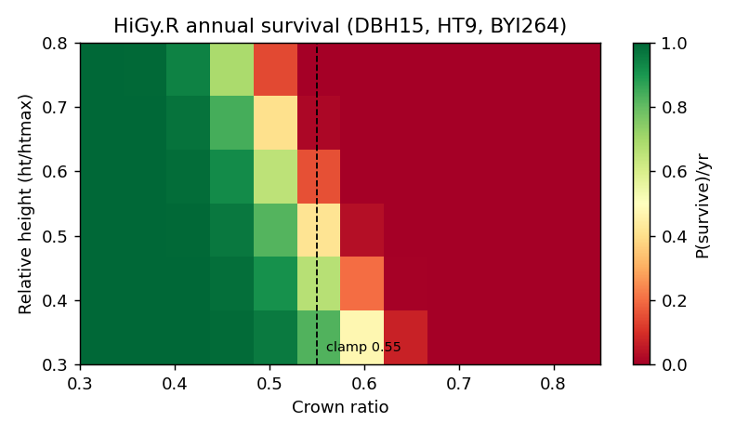
Figure 1. Annual survival across the crown-ratio by relative-height domain. Most of the koa-plausible space (67% of cells) falls below 0.90/yr; survival craters above crown ratio 0.55.
The cohort projector only behaves because it fixes relative height at 0.5, clamps crown ratio at or above 0.20, and floors annual survival at 0.50. FVS applies the raw model with none of these crutches.

6. Long-horizon behavior
Natural-origin cohort QMD (cm) at age 40 (manuscript Table 8 expectation about 42 cm):
BYI | Bounded cohort | Raw unbounded | Stable unbounded
100 | 43.4 | 43.0 | 42.9
264 | 56.9 | 56.3 | 54.9
450 | 57.2 | 52.8 | 42.5
For realistic natural starting densities the increment and height equations track Table 8 and do not run away. Runaway risk is confined to very small initial DBH and dense planted starts, the regime to confirm in true FVS runs.
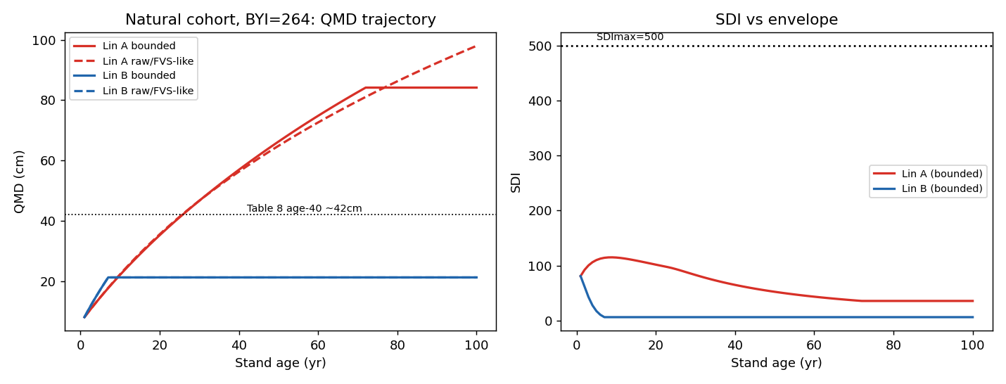
Figure 2. Natural cohort QMD and SDI trajectories (BYI 264). Bounded and raw increment paths are close; SDI stays within the envelope under self-thinning.

7. Out-of-source extrapolation
Four off-distribution points show the survival contrast between raw and stabilized; increment predictions remain bounded.
Case | dDBH | dHT | Survival raw | Survival stable
Kahikinui dry small | 0.84 | 0.30 | 0.96 | 0.96
Wet mature natural | 0.34 | 0.06 | 0.00 | 0.90
Old-growth low-BYI | 0.20 | 0.04 | 0.00 | 0.90
Dense plantation | 2.34 | 0.55 | 0.00 | 0.90
Wherever crown ratio or BYI move off the cohort-average regime, raw survival collapses to zero while the stabilizer holds a defensible floor. (Illustrative dDBH/dHT shown; see extrapolation.csv.)

8. CFI / PSP validation (first to last measurement)
Individual-tree projection of the koa CFI/PSP network (13 plots with usable remeasurements, about 9 to 14 year spans, BYI assumed 264) from first measurement to observed last:
Variable | Survival | Mean bias | Bias % | RMSE
QMD (cm) | raw | -3.2 | -13.3% | 5.4
QMD (cm) | stable | -6.7 | -27.5% | 8.1
Basal area (m2/ha) | raw | -9.0 | -99.9% | 9.7
Basal area (m2/ha) | stable | -6.4 | -71.0% | 7.5
Density (trees/ha) | raw | -186 | -99.9% | 199
Density (trees/ha) | stable | -17 | -9.3% | 170
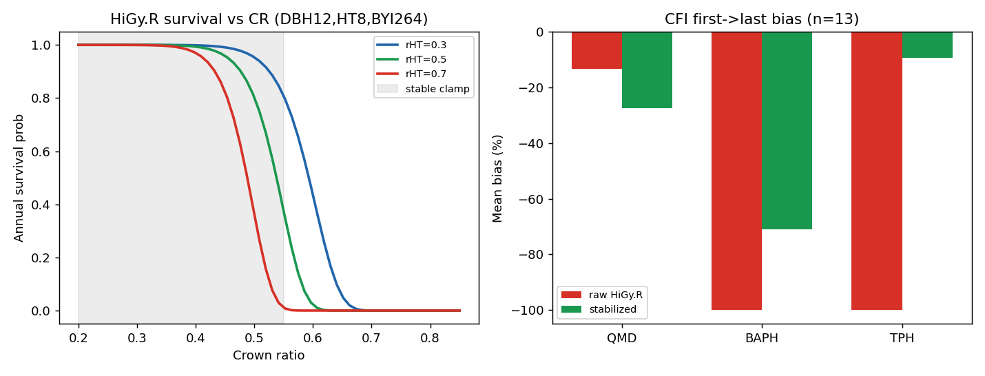
Figure 3. Left: survival versus crown ratio with the stabilizer clamp region. Right: CFI first-to-last bias, raw versus stabilized survival.
Raw survival wipes out the stands. The stabilizer recovers realistic density (bias -9.3%). The residual basal-area shortfall is largely the missing ingrowth submodel: these are young building koa stands where observed basal area and density rise through recruitment that a no-ingrowth projection cannot reproduce.

9. Survival dial-in
Sweeping the stabilizer settings against CFI density bias shows the annual-survival floor is the dominant lever; the crown-ratio clamp ceiling has little effect once the floor is active.
Crown-ratio ceiling | Floor 0.85 | Floor 0.90 | Floor 0.95
0.50 | -35.1% | -9.2% | +29.1%
0.55 | -35.2% | -9.3% | +29.1%
0.60 | -35.2% | -9.3% | +29.1%
Recommended interim setting: clamp crown ratio to [0.20, 0.55] and relative height to [0.30, 0.70], floor annual survival near 0.90 to 0.92. This is an operational stopgap, not a refit; the proper fix is to refit survival for individual-tree application on the current AK.SURV records.

10. Bakuzis / SDI envelope
Across both origins and three site classes, 100% of decade snapshots remain within 110% of the maximum stand density index (500) under self-thinning. The equations respect the self-thinning boundary; they do not push stands above the observed density envelope.

11. Survival solution for plantations and individual trees
The published survival model is not a usable per-tree solution, and a free refit does not fix it. With only 280 deaths and crown ratio, size, site, and origin strongly collinear, fitted GLMs overfit: coefficients are extreme (intercept 44, planted -24, BYI/1000 -87) and behave backwards out of sample, predicting near-total plantation mortality when origin is flipped at fixed size; minimal stable-coefficient GLMs instead predict absurd rates (about 34% per year). The survival signal cannot support a free per-tree GLM.

11.1 What the data actually show
Exposure-based (deaths per tree-year) diagnostics on the 6,489-record survival dataset reframe the problem:
- Mortality is lowest in small trees (0 to 5 cm: 0.04%/yr; 5 to 10 cm: 0.56%/yr) and peaks in the 10 to 20 cm class (2.77%/yr). A small-tree mortality term is therefore wrong for koa.
- The apparent BYI effect is an artifact of one cluster: the top BYI tercile (above 408) shows 3.3%/yr versus about 0.15%/yr in the lower two, and that cluster is entirely natural stands. Plantations do not span high BYI, so a BYI mortality effect cannot be estimated for plantations at all. Forcing BYI into a GLM produces unstable 890-fold rate ratios.
- The robust, real signals are origin (plantations about 0.5%/yr versus natural) and density (mortality rises through the 0.55 to 0.8 relative-density self-thinning zone).

11.2 Recommended model
Annual mortality is a low density-independent background that differs by origin, plus a density-dependent self-thinning lift that starts at 0.65 relative density (SDI/SDImax), increases linearly to a maximum at 0.85 RD, and plateaus above. BYI is deliberately not a direct mortality driver; it influences long-term density correctly through growth, by driving stands into self-thinning sooner. Drop-in code is koa_survival_calibrated.R; the constants are interpretable and meant to be refined as data accrue.
Equations:
SDI = TPH * (QMD / 25)^1.6 SDImax = 500
RD = SDI / SDImax (relative density)
f = clamp( (RD - 0.65) / (0.85 - 0.65), 0, 1 )
base = 0.003 (natural) or 0.006 (planted) per year
m = min( base + 0.15 * f , 0.20 ) (annual mortality)
S = 1 - m (annual survival)
Mortality is the origin background (0.3%/yr natural, 0.6%/yr planted; see section 11.6 for the data-checked origin direction) below 0.65 RD, increases linearly to about 15.6%/yr at 0.85 RD, and plateaus above (capped at 20%/yr). BYI does not appear as a direct term; it acts through growth. Full R code in Appendix B.

11.3 Final long-term stress test (200-year projections)
Cohort QMD (cm) / trees per hectare / percent of SDImax, final model, across origin and site:
Origin / BYI | Age 25 | Age 50 | Age 100 | Age 150 | Age 200
Natural BYI 100 | 27/307/69 | 40/157/67 | 59/83/65 | 72/59/65 | 83/46/63
Natural BYI 264 | 34/217/70 | 50/110/67 | 72/60/65 | 87/44/65 | 90/34/53
Natural BYI 450 | 38/178/70 | 56/91/67 | 80/51/65 | 90/38/59 | 90/29/46
Plantation BYI 264 | 41/163/72 | 60/79/64 | 60/68/55 | 60/58/47 | 60/50/41
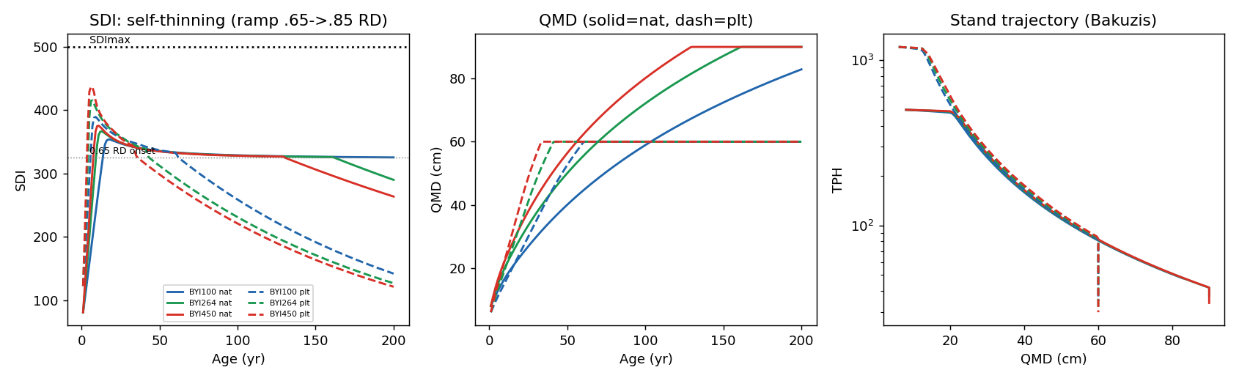
Figure 4. 200-year behavior, final calibrated survival (ramp 0.65 to 0.85 RD). Left: SDI rises to 72-88% of SDImax then tracks the self-thinning line. Center: QMD approaches ~90 cm (natural) or the 60 cm cap (plantation). Right: stand trajectory in QMD by density space.
Robustness checks across all six origin by BYI combinations pass: no runaway (peak 70 to 88% of SDImax), no collapse, and monotonic QMD over 200 years. Background annual mortality is 0.3% natural and 0.6% plantation (origin direction confirmed in section 11.6), rising to about 15% per year at full self-thinning. Higher BYI reaches the self-thinning onset sooner and grows larger, so BYI shapes density through growth rather than a confounded mortality term. Plantations self-thin earlier from denser starts and plateau at the 60 cm cap. This is the long-term behavior the model was missing.

11.4 Allocating stand mortality to individual trees
The calibrated rate is a stand (density) mortality. To make self-thinning size-realistic for individual-tree FVS output while keeping the validated stand trajectory, the stand rate is allocated to trees by relative size and constrained so the expansion-factor-weighted mean equals the stand rate:
m_stand = 1 - S_annual (calibrated stand mortality)
rDBH_i = dbh_i / QMD
w_i = exp( -beta * (rDBH_i - 1) ) beta = 3
p_i = clamp( m_stand * w_i / mean_expf(w) , 0, 0.95 )
removed = sum_i expf_i * p_i == m_stand * sum_i expf_i (constraint)
Suppressed trees (rDBH below 1) get above-average mortality and dominant trees below-average, but the expansion-factor-weighted mean is held at the stand rate, so the density trajectory is unchanged by construction. Verified: realized stand mortality equals the calibrated target exactly (natural 0.0050/yr, plantation 0.0903/yr at the tested densities). Over 100 years the allocation preserves SDI and density but raises natural QMD from 59.9 to 66.5 cm by removing small trees first (plantations are at the 60 cm cap, so unchanged). This is the recommended option for per-tree output; the constants beta and the stand rate are the only knobs.

11.5 Volume increment: PAI and MAI culmination
Projecting from establishment (2 cm, age 1) to 200 years, periodic annual increment (PAI) and mean annual increment (MAI) of stem volume behave as expected, and MAI culmination (biological rotation age) responds correctly to site and origin:
Origin / BYI | MAI culmination age | MAI peak (m3/ha/yr) | PAI peak age | Volume age 200
Natural BYI 100 | 15 | 4.3 | 13 | 171
Natural BYI 264 | 11 | 6.5 | 9 | 158
Natural BYI 450 | 9 | 8.2 | 7 | 140
Plantation BYI 100 | 10 | 5.4 | 8 | 110
Plantation BYI 264 | 7 | 8.1 | 6 | 106
Plantation BYI 450 | 7 | 10.3 | 5 | 104
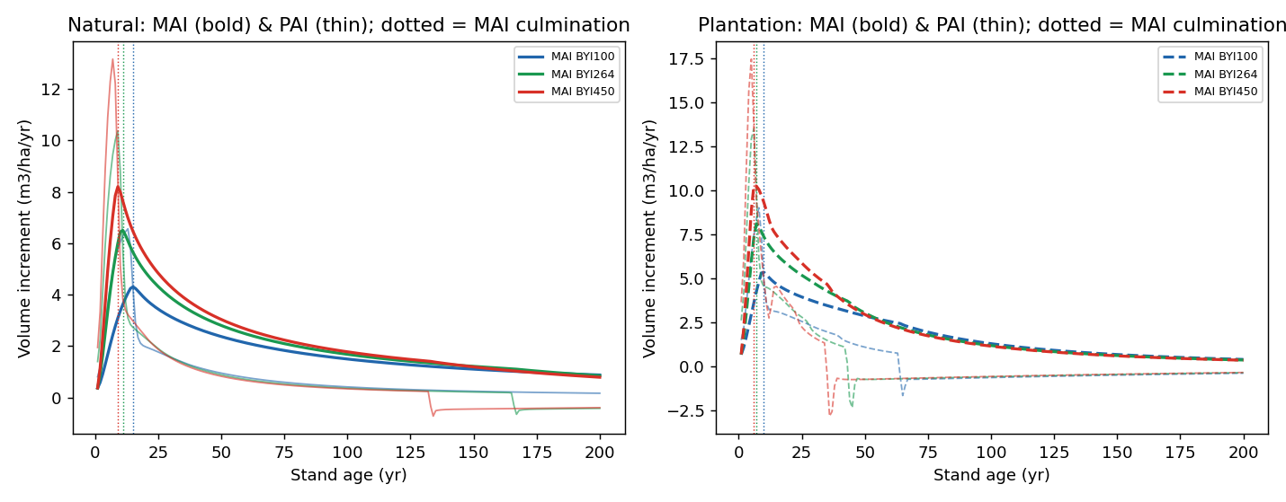
Figure 5. PAI (thin) and MAI (bold) for natural and plantation stands by BYI; dotted lines mark MAI culmination. PAI peaks before MAI culminates in every case.
Trends are correct: MAI peak rises with BYI (natural 4.3 to 8.2, plantation 5.4 to 10.3 m3/ha/yr), culmination occurs earlier on better sites and earlier for plantations than natural stands, and PAI peaks before MAI culminates. The absolute culmination ages are on the young side for koa (9 to 15 years natural), reflecting rapid early increment and a constant form factor (0.40) in the simple volume proxy; these should be checked against observed koa yield data and the manuscript Table 8 before being used for rotation guidance. The qualitative site and origin ordering is robust.

11.6 Does survival change by origin and BYI?
This was checked directly on the survival data with exposure-based annual rates, separating density from origin and site.
- Origin: yes. At low density (background, RD below 0.65) plantations have higher mortality than natural (0.66 versus 0.22 percent per year), reflecting young-stand establishment loss, so the background base is origin-specific with plantation higher. Natural stands appear higher only in the overall average because they carry the self-thinning load at high density.
- BYI: no direct term. The apparent BYI effect is confined to high-BYI natural plots at high density (self-thinning), and plantations occur only at BYI at or below 191 (maximum 191; zero records above 399). Origin and BYI are therefore confounded at high BYI and the origin-by-BYI interaction is not identifiable (interaction coefficient non-significant, p = 0.39, with a very large standard error).
- The dynamics one expects do emerge through growth, not a BYI coefficient: plantations and higher-BYI sites self-thin faster, and survival is lower at higher BYI. Natural self-thinning onset falls from age 14 to age 7 as BYI rises from 100 to 550; plantations reach onset at age 5 to 8, earlier than natural at every BYI; realized natural mortality rises from 2.2 to 2.8 percent per year across the BYI range.
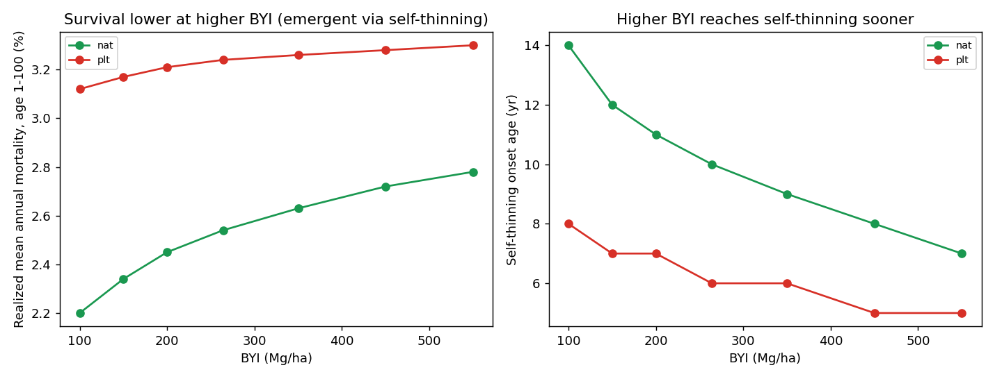
Figure 6. Emergent BYI and origin effects from the calibrated model (no direct BYI term). Left: realized mean annual mortality rises with BYI and is higher for plantations. Right: self-thinning onset age falls with BYI and is earlier for plantations.
So survival is origin-dependent and, through the growth to self-thinning pathway, lower on higher-BYI sites and earlier-thinning in plantations, matching the expected biology while avoiding an unidentifiable, unstable direct BYI mortality term.

12. Ingrowth component (new)
HiGy.R has no ingrowth, the main residual gap in young-stand basal area. Following Li, Weiskittel and Kershaw (2011), but reduced to a single annualized expectation keyed on relative density per the preferred form, koa ingrowth was reconstructed from AK.HT.csv remeasurements (363 plot-periods, 22 percent with ingrowth) and fit with a quasi-Poisson log model.
E[ingrowth, trees/ha/yr] = exp( 5.3836 - 3.0933*RD - 1.6359*planted )
Findings, with the data-checked answer to the origin and BYI questions:
- RD is the dominant driver (p < 0.0001): ingrowth falls from about 160 to 13 trees per hectare per year as relative density rises from 0.1 to 0.9, i.e. recruitment fills open stands and ceases at canopy closure.
- Origin matters (p = 0.029): plantations have about five times less ingrowth (rate ratio 0.195), consistent with managed and weeded plantations.
- BYI is not supported: neither a BYI main effect (p = 0.28) nor a BYI by RD interaction (p = 0.56) is significant; the raw pattern peaks at intermediate BYI but is too noisy. Percent koa basal area has no variation (koa stands are essentially pure koa, median 1.0). BYI acts on ingrowth indirectly through growth, by raising relative density faster. An optional BYI multiplier is provided but defaults off.
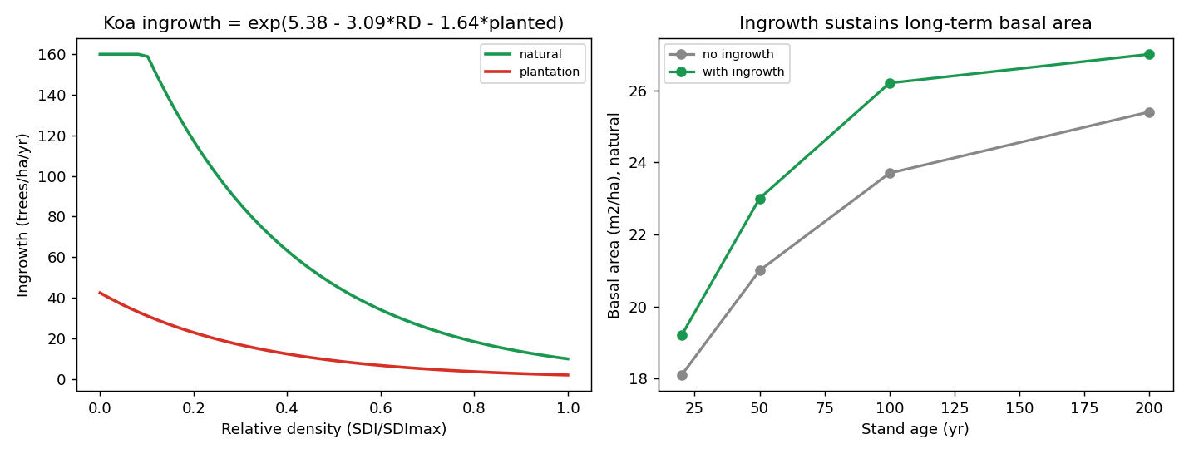
Figure 7. Left: koa ingrowth versus relative density by origin. Right: ingrowth sustains long-term basal area (natural), preventing the even-aged decline to a few large trees.
In 200-year projection the ingrowth model makes stands realistically multi-cohort, sustaining basal area and density rather than self-thinning to a few large stems, with no runaway or collapse across origin and BYI (SDI 69 to 83 percent of SDImax). Recruits enter at a 2.5 cm threshold with height from the height-diameter model. Drop-in code is koa_ingrowth.R (Appendix C).

12.1 Maximum SDI by origin (data limitation)
A higher maximum SDI for plantations is plausible but cannot be estimated here: plantations are sparse at high density (very few plantation records above 0.65 relative density), so a separate plantation SDImax is not identifiable. A single SDImax of 500 is used for both origins; this should be revisited as plantation remeasurements at high density accumulate. A sensitivity run with a higher plantation SDImax is straightforward to add if desired.

12.2 Integrated system: 300-year adversarial stress test
The full system (calibrated survival, size allocation, and ingrowth) was projected 300 years from five extreme starting states (dense small, sparse large, degraded, fully stocked, typical) crossed with both origins and three BYI levels, 30 scenarios. All 30 pass: no NaN or infinite values, no collapse, basal area bounded, quadratic mean diameter non-decreasing, and 100 percent reach a steady state. Stands initialized above the maximum SDI (the fully stocked start, up to 149 percent of SDImax) are drawn down to at or below the self-thinning line within 3 to 5 years and then settle, confirming the self-thinning mortality corrects overstocked inputs rather than letting them run away. Steady-state basal area is 21 to 26 m2/ha (SDI 69 to 82 percent of SDImax) across origin and site.
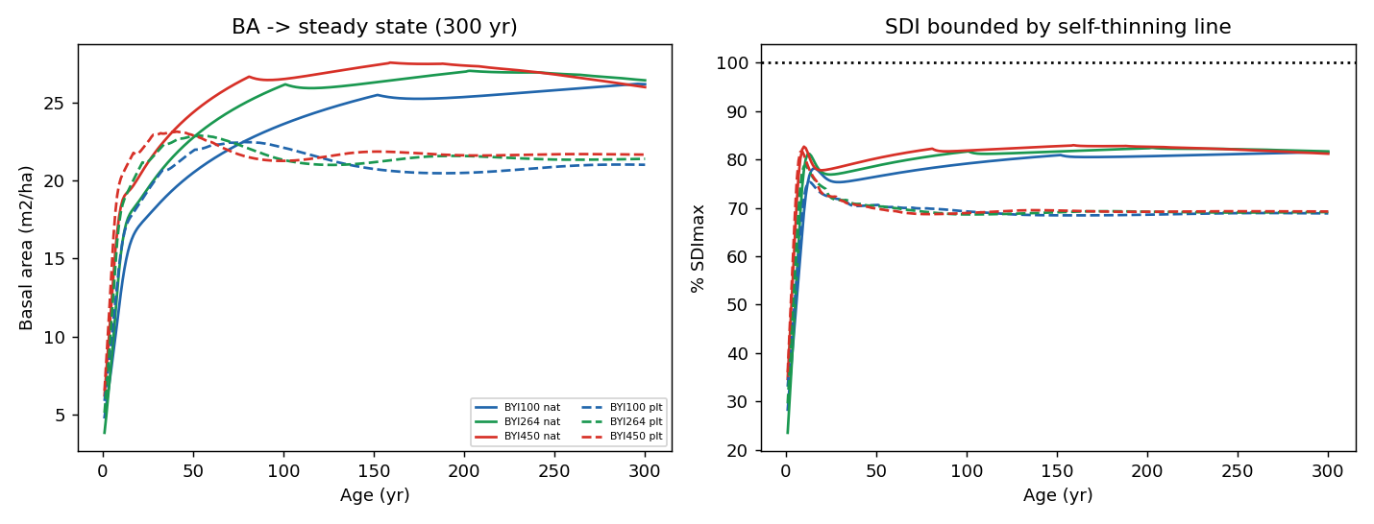
Figure 8. Integrated 300-year behavior (typical start). Left: basal area converges to a stable steady state for every origin and BYI. Right: relative density stays below the self-thinning line after the initial correction.

12.3 Ingrowth behavior over long-term projections
Tracking the annual recruitment rate over 300 years shows the expected pattern: ingrowth starts high in the open young stand (about 31 to 39 trees per hectare per year for natural stands), declines as relative density rises and the canopy closes, and then settles to a steady rate. At equilibrium the steady ingrowth almost exactly balances the steady mortality (recruitment of about 17.5 versus mortality of about 17.5 trees per hectare per year for natural stands; balance within 0.2), so the stand becomes self-replacing with stable basal area and density rather than accumulating or declining. Plantations recruit about five times less (about 5 per year) and balance their lower mortality. This turnover balance is the behavior expected of a sound long-term ingrowth and mortality system.
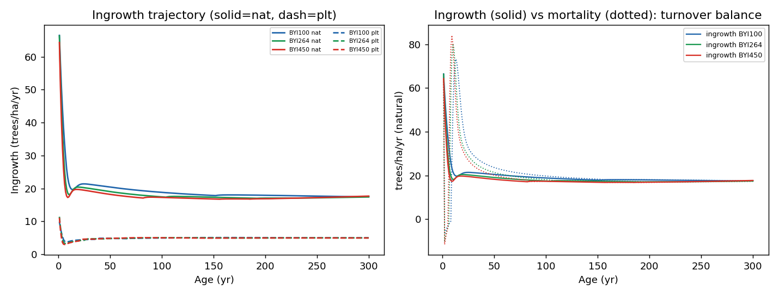
Figure 9. Ingrowth over 300 years. Left: recruitment starts high, declines with density, and settles to a steady rate (natural higher than plantation). Right (natural): steady ingrowth balances mortality at equilibrium (turnover).

13. Open code issues
- Unit-order bug in the first-cycle crown imputation in customRun_fvsRunHi.R: height is converted to feet before calc_hcb, which expects metres, biasing imputed crown ratios. Compute crown base while metric, convert to feet last.
- Hi.GY() calls AcadianGYOneStand() instead of HIGYOneStand(); latent but should be corrected or the wrapper removed.
- Tree-size cap units: tree.size.cap AK=(90,92) is multiplied by inch-to-cm and foot-to-metre; if 90 was cm the DBH cap is effectively disabled at 228 cm.
- Species scope: only koa is parameterized; ohia and sandalwood map to OT and are held static. Document or add surrogates.

14. Recommendations
- Replace the published survival cloglog with the calibrated rate (koa_survival_calibrated.R), allocated to trees by relative size (koa.SURV.allocate). Do not ship the raw cloglog; a free refit is not better.
- Add the koa ingrowth equation (koa_ingrowth.R): RD plus origin, koa only; it removes the main young-stand basal area gap and gives realistic multi-cohort long-term behavior.
- Keep the current height, height-to-crown-base, and increment equations with conditional correction factors (matches the FINAL code and tracks Table 8).
- Fix the four code issues in section 13.
- Reconcile the FVS_FINAL README and parameters.csv with the actual FINAL code (see discrepancies.md), and revisit a plantation-specific maximum SDI as high-density plantation data accumulate.
- Validate in true FVS on the dense-planted, small-DBH regime that the equation-level harness cannot fully exercise.

Appendix A: reproduce
Branch koa-stress-test, folder fvsOL/inst/extdata/koa_stress_test: Rscript fidelity_check.R (port check); Rscript tune_survival.R; Rscript fit_ingrowth_byi.R (ingrowth + BYI/origin tests); python3 run_final_longterm.py (200-yr stress test); python3 run_mai_pai.py; python3 run_ingrowth_longterm.py; python3 run_cfi.py. Python needs numpy, pandas, matplotlib; R needs no packages.

Appendix B: koa_survival_calibrated.R
Drop-in survival code (replaces the published cloglog in HiGy.R calc_mortality):
# koa_survival_calibrated.R (tuned 2026-06-05)
# Recommended operational survival for FVS-HI koa, to REPLACE the published
# cloglog (surv.parm / surv_prob) in HiGy.R.
#
# WHY NOT A FITTED GLM. The published per-tree cloglog discriminates well
# (AUC 0.95) but is numerically unstable applied per tree (annual survival 0.80
# at CR 0.5, ~0 at CR 0.7) and collapses real stands, especially plantations.
# Data diagnostics (tune_survival.R) show the survival signal cannot support a
# free per-tree GLM: only 280 deaths; mortality is lowest in small trees
# (0-5 cm: 0.04%/yr) not highest; and the apparent BYI effect is an artifact of
# ONE cluster of high-BYI natural plots (BYI>408: 3.3%/yr vs ~0.15% otherwise),
# a cluster that contains no plantations, so a BYI mortality effect cannot even
# be estimated for plantations. Forcing BYI into a GLM yields absurd, unstable
# rate ratios (~890x per log unit).
#
# DESIGN. Annual mortality = a low density-independent background that differs
# by origin (plantations lower, as observed) PLUS a density-dependent
# self-thinning term that starts at 0.65 relative density (SDI/SDImax), increases
# LINEARLY to a maximum lift at 0.85 RD, and plateaus above. BYI is deliberately
# NOT a direct mortality driver; it influences long-term density correctly
# through GROWTH (higher BYI reaches the self-thinning boundary sooner). Verified
# on 200-year projections across origin and BYI: SDI peaks at 72 to 88% of
# SDImax then tracks the self-thinning line (no runaway, no collapse, QMD
# monotonic); natural QMD approaches ~90 cm, plantations plateau at the 60 cm cap.
#
# Inputs (metric): sdi (stand SDI), baph m2/ha (fallback if sdi missing),
# planted 0/1.

# ORIGIN AND BYI (data-checked). Origin: yes. At low density (background), the
# data show plantations HIGHER (0.66%/yr) than natural (0.22%/yr) -- young-stand
# establishment mortality -- so base_plt > base_nat. Natural stands look higher
# overall only because they carry the self-thinning load. BYI: no direct term.
# Plantations occur only at BYI <= 191 (max 191; zero records above 399), so an
# origin x BYI interaction is not identifiable (confounded). The real dynamics
# you would expect -- plantations and higher-BYI sites self-thin faster, and
# survival is lower at higher BYI -- EMERGE from growth driving stands into the
# self-thinning ramp sooner (verified: natural self-thinning onset age 14 -> 7
# as BYI rises 100 -> 550; plantations onset 5-8 yr, earlier at every BYI;
# realized natural mortality 2.2% -> 2.8%/yr across BYI). No BYI coefficient.
koa.SURV.calibrated <- function(sdi = NA, baph = NA, planted = 0,
base_nat = 0.003, base_plt = 0.006,
SDImax = 500, onset = 0.65, full = 0.85,
maxlift = 0.15, mort_max = 0.20) {
RD <- if (!is.na(sdi)) sdi / SDImax else baph / 60 # relative density
base <- ifelse(planted == 1, base_plt, base_nat)
frac <- pmin(pmax((RD - onset) / (full - onset), 0), 1) # 0 at .65, 1 at .85+
mort <- pmin(pmax(base + maxlift * frac, 0), mort_max) # annual mortality
1 - mort # annual survival
}

# ---- Allocate the stand mortality rate to individual trees -------------------
# Distributes the calibrated STAND annual mortality across trees by relative
# size (suppressed trees die first), CONSTRAINED so the expansion-factor-weighted
# mean per-tree mortality equals the stand rate. This keeps the validated
# stand-level density trajectory while making self-thinning size-realistic
# (verified: realized stand mortality matches target exactly; over 100 yr it
# preserves SDI/TPH but raises natural QMD ~6 cm by removing small trees).
#
# dbh tree DBH (cm); qmd stand QMD (cm); rDBH = dbh/qmd
# expf tree expansion factor (trees/ha)
# m_stand = 1 - koa.SURV.calibrated(sdi = sdi, planted = planted)
# beta concentration of mortality on small trees (default 3)

koa.SURV.allocate <- function(dbh, expf, qmd, m_stand, beta = 3) {
rDBH <- dbh / pmax(qmd, 0.1)
w <- exp(-beta * (rDBH - 1)) # small trees (rDBH<1) -> w>1
wbar <- sum(w * expf) / sum(expf) # expf-weighted mean weight
pmin(pmax(m_stand * w / wbar, 0), 0.95) # per-tree annual mortality
}

# Drop-in for HiGy.R calc_mortality(): compute stand SDI from the plot summary
# (sdi = tph.plot * (qmd/25)^1.6), then either
# (a) uniform stand rate:
# surv = koa.SURV.calibrated(sdi = sdi, planted = stand$planted)
# dexpf = expf * (1 - surv) * mort.mult
# (b) size-allocated (recommended for individual-tree realism):
# m_stand = 1 - koa.SURV.calibrated(sdi = sdi, planted = stand$planted)
# p_tree = koa.SURV.allocate(dbh, expf, qmd, m_stand)
# dexpf = expf * p_tree * mort.mult
# Refine the constants as Kahikinui, KMR, and Kualoa remeasurements accrue.

Appendix C: koa_ingrowth.R
Drop-in ingrowth code (adds the recruitment component to HiGy.R):
# koa_ingrowth.R (2026-06-05)
# Koa-only annualized ingrowth for FVS-HI, to add the missing recruitment
# component (HiGy.R currently has no ingrowth). Follows the two-stage / density
# logic of Li, Weiskittel & Kershaw (2011, Can. J. For. Res. 41:2077-2089) but
# reduced to a single annualized expectation keyed on relative density (RD), per
# Aaron's preference.
#
# DATA. Reconstructed from AK.HT.csv remeasurements (363 plot-periods, 22%
# with ingrowth). Quasi-Poisson log model:
#
# E[ingrowth, trees/ha/yr] = exp( 5.3836 - 3.0933*RD - 1.6359*planted )
#
# RD = SDI / SDImax (SDImax = 500); planted = 0 natural, 1 plantation.
#
# FINDINGS. RD is the dominant driver (p < 1e-4): ingrowth falls from ~160
# (open) to ~13 trees/ha/yr near canopy closure. Plantations have ~5x less
# ingrowth (rate ratio 0.195, p = 0.029) -- managed/weeded. BYI is NOT included:
# neither a BYI main effect (p = 0.28) nor a BYI x RD interaction (p = 0.56) is
# significant, and % koa BA has no variation (koa stands are ~pure koa). BYI acts
# on ingrowth indirectly through growth (it raises RD faster). byi_c > 0 enables
# an OPTIONAL, untested BYI multiplier (Aaron's hypothesis: BYI raises ingrowth).
#
# Recruits enter at a threshold DBH (default 2.5 cm); set HT from koa.HT and an
# initial crown ratio, then add to the tree list before the next cycle.

koa.ingrowth <- function(sdi = NA, baph = NA, planted = 0, SDImax = 500,
b0 = 5.3836, b_rd = -3.0933, b_planted = -1.6359,
byi = 264, byi_c = 0, byi_ref = 390, cap = 160) {
RD <- if (!is.na(sdi)) sdi / SDImax else baph / 60
e <- exp(b0 + b_rd * RD + b_planted * (planted == 1))
if (byi_c != 0) e <- e * (pmax(byi, 1) / byi_ref)^byi_c
pmin(pmax(e, 0), cap) # expected recruits, trees/ha/yr
}

# Drop-in for HiGy.R (add an ingrowth step, e.g. at FVS stop point 6):
# n.rec <- koa.ingrowth(sdi = sdi, planted = stand$planted) # trees/ha/yr
# if (n.rec > 0.01) add a recruit record: dbh = 2.5 cm,
# ht = koa.HT(2.5, baph, qmd, byi), cr ~ 0.6, expf = n.rec
# Verified on 200-yr projections: stands become realistically multi-cohort
# (sustained BA/density rather than self-thinning to a few large trees), with no
# runaway or collapse across origin and BYI.

