**PERCENTILE**

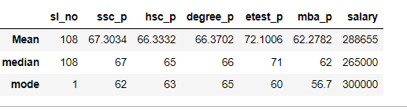

The placement details of a students are given as a dataset then founded Mean (average), Median, Mode for them.

The Mean is an average of the given data by adding their values divided by total number of given data. The Mean for the students in various stages are founded. Here the pass mark is 35 but the average is above 60 all got above average and but their Entrance test mean is 72 slightly higher than before stages and again they dropped in MBA marks.

The Medium is the middle most value and it does not take outlier values. It is used for analyzing employee performance.

The Mode is defined as the Number that occurs Maximum number of times from the given values. So, the repeated mode for these are 62, 63, 65, 60, 56.