Percentile

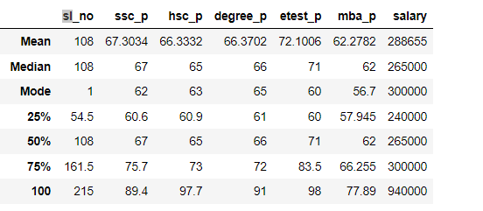

percentile of ssc _Pass mark for q1 25 % is 60.6 then q2 of 50 % is 67 the difference between these two quadrants is 25%

But the mark is increased by 7% i.e. 67 is the increment growth.

In q3 75% of students scored 75.7 the difference between q2 and q3 is 25 % but the increment growth is 8% (i.e. from 67 to 75.7)

in every quadrant there is an average difference of about 7% to 8 %.

The q4 100 % of students scored 89.4 the difference between q3 and q4 is 25 % but the increment growth is 14%.

The percentile of hsc_Pass mark for q1 25 % is 60.9 then q2 of 50 % is 65 the difference between these two quadrants is 25% bu

increment growth is increased by 5%.

In q3 75% of students scored 73 the difference between q2 and q3 is 25 % but the increment growth is 8%

in every quadrant there is an average difference of about 5% to 8 %.

The q4 100 % of students scored 91 the difference between q3 and q4 is 25 % but the increment growth is 8%.

The percentile of degree Pass mark for q1 25 % is 61 then q2 of 50 % is 66 the difference between these two quadrants is 25% but

increment growth is increased by 5%.

In q3 75% of students scored 72 the difference between q2 and q3 is 25 % but the increment growth is 6%

in every quadrant there is an average difference of about 5% to 6 %.

The q4 100 % of students scored 91 the difference between q3 and q4 is 25 % but the increment growth is 19%.

The percentile of entrance pass mark for q1 25 % is 60 then q2 of 50 % is 71 the difference between these two quadrants is 25% but

increment growth is increased by 11%

In q3 75% of students scored 83.5 the difference between q2 and q3 is 25 % but the increment growth is 13%

in every quadrant there is an average difference of about 11% to 13%.

The q4 100 % of students scored 98 the difference between q3 and q4 is 25 % but the increment growth is 15%.

The percentile of MBA passmark for q1 25 % is 57.94 then q2 of 50 % is 62 the difference between these two quadrants is 25% but

increment growth is increased by 5%

In q3 75% of students scored 66.25 the difference between q2 and q3 is 25 % but the increment growth is 4%

in every quadrant there is an average difference of about 5% to 4%.

The q4 100 % of students scored 77.89 the difference between q3 and q4 is 25 % but the increment growth is 11%.