BCSE203E

Web Programming Mini Project

Done by

Midhul Kiruthik M(23BCE0783)

Sachin(23BCE2121)

8. Design a web page for transparent agricultural products selling e-commerce platform. It should have product display pages, pin to bag (add cart), payment gateway options, billing, invoice generation, check out process and so on. The necessary details must be stored in the back end (MySQL).The website must have professional design, look and structure. You may visualize the web pages organization to ensure fair prices to farmers.

**Project Title:** Agri Link – Transparent Agricultural Products Selling E-Commerce Platform

**1. Introduction**

AgriLink is an online e-commerce platform designed to connect farmers directly with consumers. The platform ensures **fair pricing**, **transparency**, and a **seamless shopping experience** for users.

**2. Features Implemented**

--**Product Display Pages**

* Showcasing farm-fresh products with images, descriptions, and pricing.
* Implemented a **search functionality** for easy navigation.

-- **Shopping Cart (Pin to Bag)**

* Users can add products to the cart and manage quantities.
* **Cart persists** even after page refresh.

-- **User Authentication**

* **Signup & Login with JWT authentication**
* Profile management with order history

-- **Orders & Checkout**

* Users can place orders, and order details are stored in MySQL.
* Order status tracking: **Pending → Shipped → Delivered**

--**Database (MySQL)**

* **Users Table:** Stores customer and farmer details.
* **Products Table:** Contains product information, pricing, and farmer details.
* **Orders & Order Items Tables:** Manages user orders and transaction records.

-- **Professional Design (UI/UX)**

* Implemented a **modern and futuristic UI**
* **Responsive Design** for mobile & desktop
* **Enhanced navigation** (Header, Footer, Home Page)

**3. Features Under Development**

>**Payment Gateway Integration** (e.g., Razorpay, PayPal)  
> **Invoice Generation**  
> **Admin Dashboard for Farmer & Product Management**

**4. Challenges Faced & Solutions**

| **Challenge** | **Solution** |
| --- | --- |
| Product images not displaying correctly | Used actual Google image links & fixed database entries |
| Clicking products didn’t navigate to details page | Fixed Next.js routing & ensured dynamic pages work |
| Search API not returning results correctly | Debugged query and adjusted SQL LIKE statements |
| Styling inconsistencies | Implemented structured CSS |

**5. Next Steps**

📌 **Implement secure payments**  
📌 **Enhance order tracking system**  
📌 **Test & deploy the platform**

**6. Conclusion**

The **AgriLink platform** is in the final stages of development, with core features completed. The next steps involve **final testing, payment integration, and deployment** to ensure a **fully functional e-commerce experience**.

Home Page:

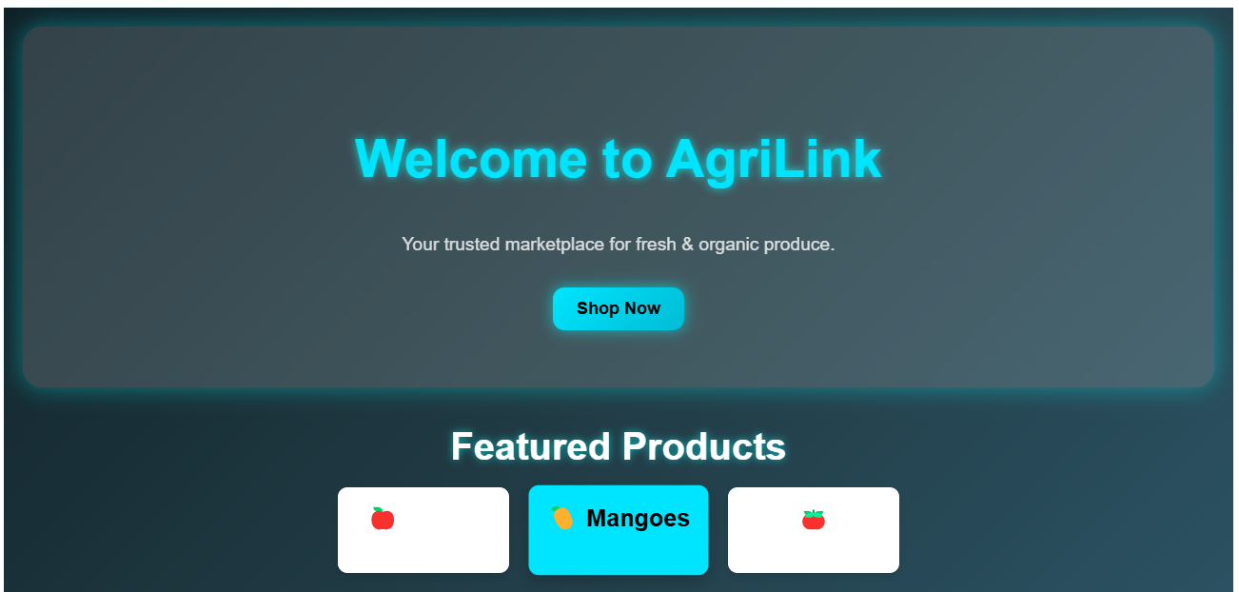

Register Page:

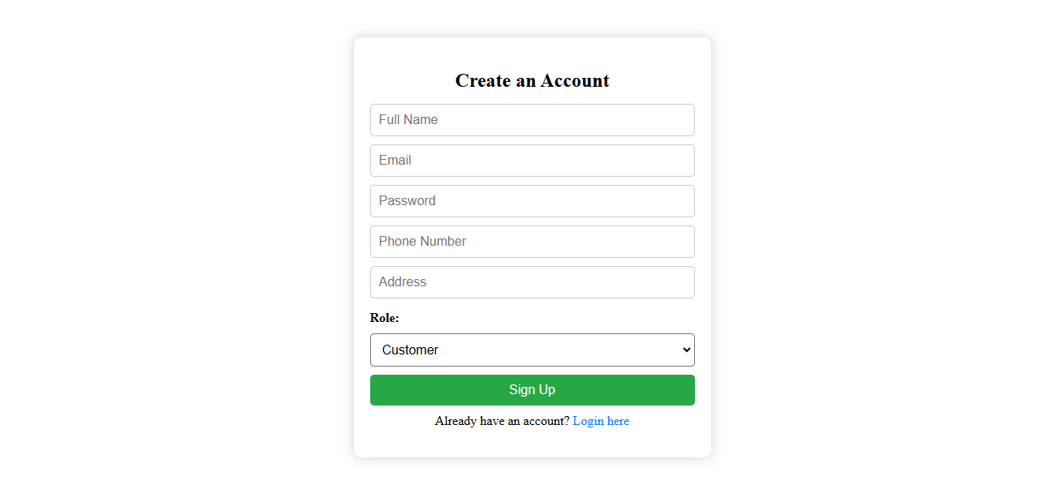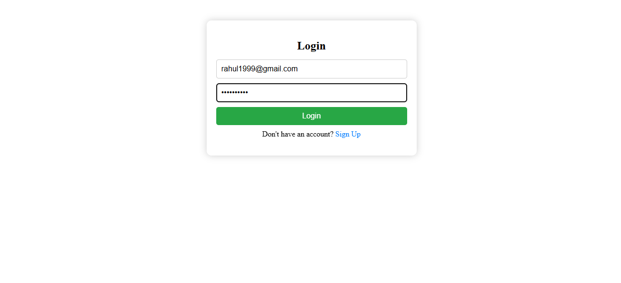

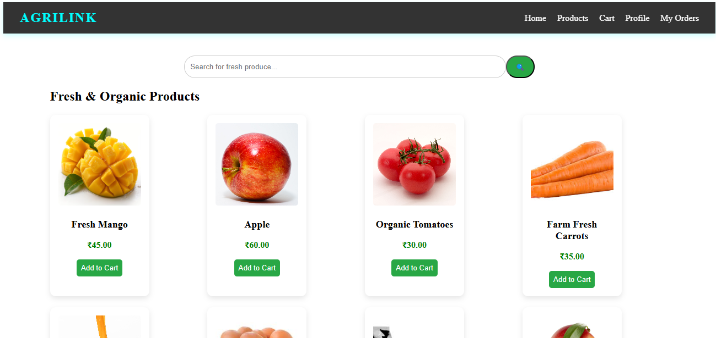Products Page:

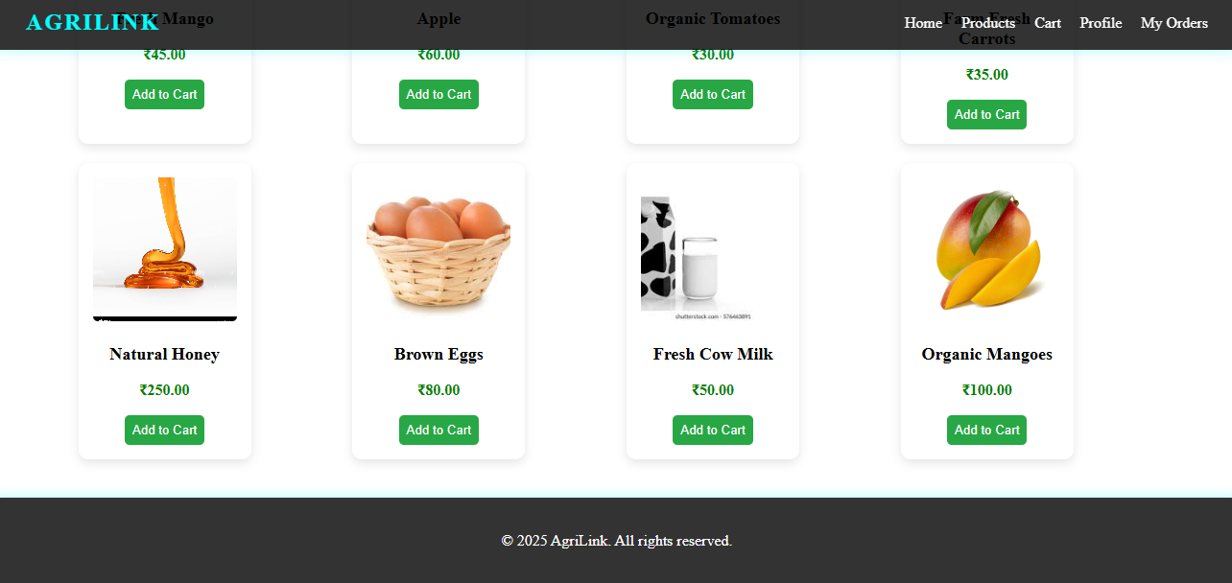

Products Details Page:

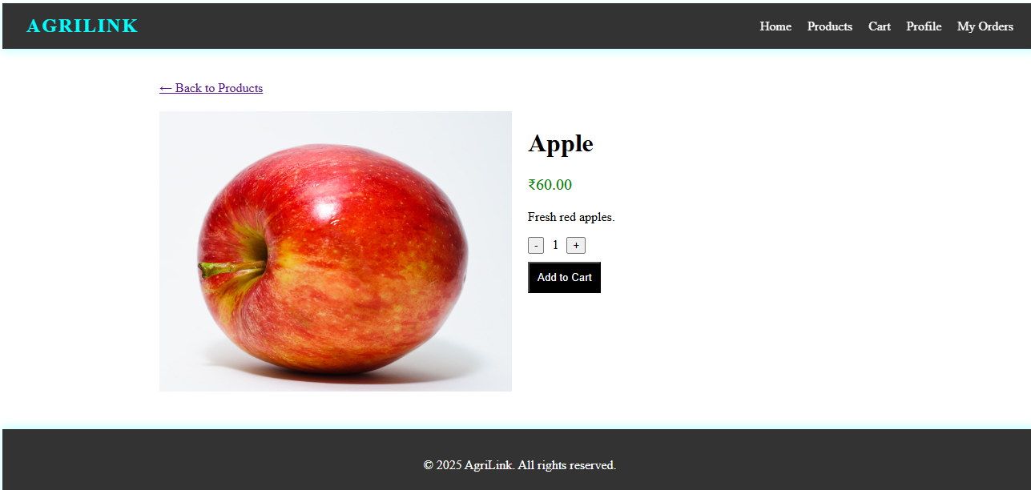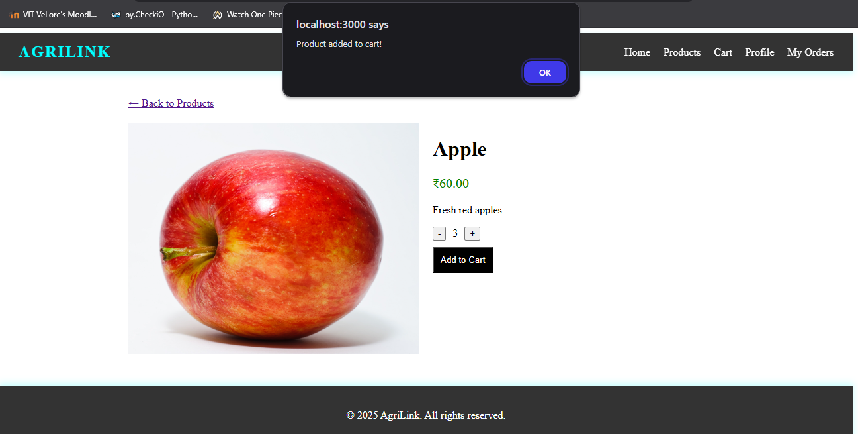

Cart Page: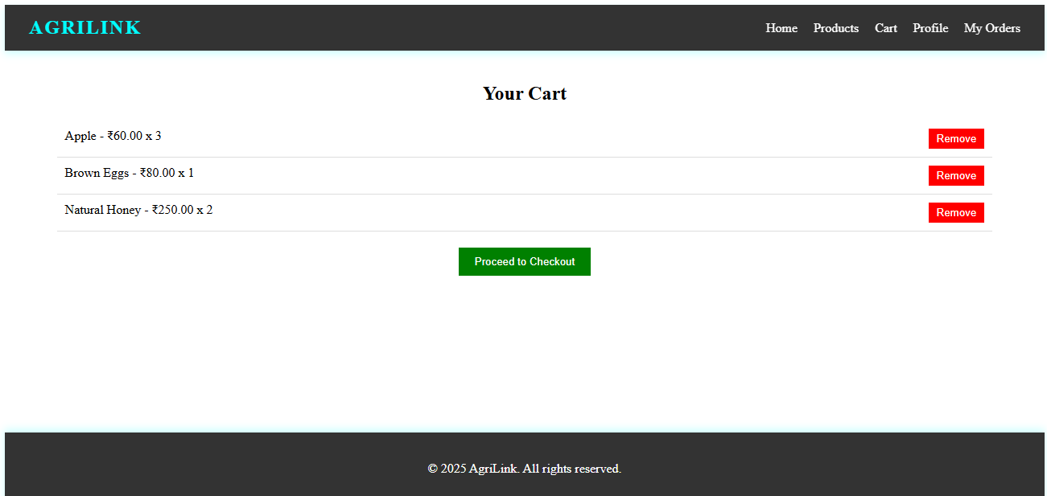

My Orders Page: 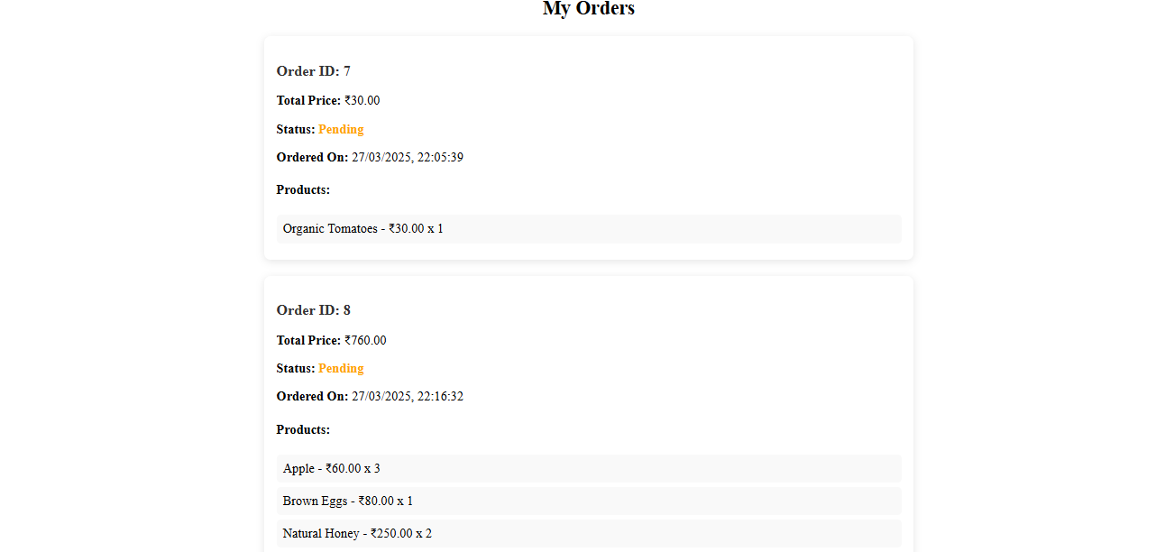

Profile page:

GIT LINK:  
<https://github.com/MidhulKiruthik/AgriLink>