Aim: Develop a web page to replicate your VTOP Timetable of Winter Semester 2024 – 2025 using basic html tags. The timetable should be exactly same as VTOP format.
HTML Tags need to be used:
Tags used | Attributes
<br>
<h1>
<table> | border, rowspan, colspan, align=center/left/right, cellpadding=, cellspacing=
<tr>
<td> | bg-color
<th>
<caption>
<font> | color, face, size

Procedure:
- In notepad or any editor or IDE type the necessary code & save with the file name mentioned with .html extension display your time table.
- To view your web page, simply double click your html file.
CODE:
<!DOCTYPE html>
<head>
<meta ln="en">
<title>Time Table</title>
</head>
<body>
<h1 align="center">
<font face="Times New Roman" color="blue" size="8">TIME TABLE </font><br>

</h1>

<table align="center" border="2" bordercolor="#3c8dbc" style="border-collapse: collapse;" cellpadding="5" cellspacing="4" >
<caption><strong> VTOP Timetable of Winter Semester 2024-2025</strong></caption>
<tbody align="center" >
<tr bgcolor="#e2e2e2" align="center" style="width: 50px;" >
<th style="font-weight: normal;" rowspan="2">
<font face="Open Sans">THEORY
</font>
</th>
<td > Start </td>
<td > 08:00</td>
<td> 09:00</td>
<td> 10:00</td>
<td>11:00</td>
<td>12:00</td>
<td>-</td>
<td>Lunch</td>
<td>14:00</td>
<td>15:00</td>
<td>16:00</td>
<td>17:00</td>
<td>18:00</td>
<td width="50px">18:51</td>
<td width="50px">19:01</td>
</tr>
<tr bgcolor="#e2e2e2">
<td>End</td>
<td> 08:50</td>
<td> 09:50</td>
<td> 10:50</td>
<td>11:50</td>
<td>12:50</td>
<td>-</td>
<td>Lunch</td>
<td>14:50</td>
<td>15:50</td>
<td>16:50</td>
<td>17:50</td>
<td>18:50</td>
<td>19:00</td>
<td>19:50</td>
</tr>
<tr bgcolor="#e2e2e2">
<th style="font-weight: normal;" rowspan="2">LAB</th>
<td> Start</td>
<td> 08:00</td>
<td> 08:51</td>
<td> 09:51</td>
<td>10:41</td>
<td>11:40</td>
<td>12:31</td>
<td>Lunch</td>
<td>14:00</td>
<td>14:51</td>
<td>15:51</td>
<td>16:41</td>
<td>17:40</td>
<td>18:31</td>
<td>-</td>
</tr>
<tr bgcolor="#e2e2e2">
<td>End</td>
<td> 08:50</td>
<td> 09:40</td>
<td> 10:40</td>
<td>11:30</td>
<td>12:30</td>
<td>13:20</td>
<td>Lunch</td>
<td>14:50</td>
<td>15:40</td>
<td>16:40</td>
<td>17:30</td>
<td>18:30</td>
<td>19:20</td>
<td>-</td>
</tr>
<tr>
<th bgcolor="#e2e2e2" rowspan="2" style="font-weight: normal;" >MON</th>
<td c bgcolor="#e2e2e2">THEORY</td>
<td> A1</td>
<td> F1</td>
<td> D1</td>
<td>TB1</td>
<td>TG1</td>
<td>-</td>
<td bgcolor="#e2e2e2">Lunch</td>
<td bgcolor="#FC6C85" align="center" style="vertical-align: middle; padding: 3px; width: 50px;">A2-BCSE204L-TH-SJT301-ALL</td>
<td bgcolor="FC6C85" align="center" style="vertical-align: middle; padding: 3px; width: 50px;" >F2-BCSE304L-TH-SJT409-ALL</td>
<td bgcolor="FC6C85" align="center" style="vertical-align: middle; padding: 3px; width: 50px;">D2-BMAT202L-TH-SJT404-ALL</td>
<td bgcolor="FC6C85" align="center" style="vertical-align: middle; padding: 3px; width: 50px;">TB2-BECE204L-TH-SJT304-ALL</td>
<td bgcolor="FC6C85" align="center" style="vertical-align: middle; padding: 3px; width: 50px;">TG2-BCSE203E-ETH-SJT401-ALL</td>
<td align="center">-</td>
<td align="center" >V3</td>
</tr>
<tr>
<td bgcolor="#e2e2e2">LAB</td>
<td> L1</td>
<td> L2</td>
<td> L3</td>
<td>L4</td>
<td>L5</td>
<td>L6</td>
<td bgcolor="#e2e2e2">Lunch</td>
<td>L31</td>
<td>L32</td>
<td>L33</td>
<td>L34</td>
<td>L35</td>
<td>L36</td>
<td>-</td>
</tr>
<tr>
<th style="font-weight: normal;" bgcolor="#e2e2e2" rowspan="2" ><font face="">TUE</th>
<td bgcolor="#e2e2e2">THEORY</td>
<td > B1</td >
<td> G1</td>
<td> E1</td>
<td>TC1</td>
<td>TAA1</td>
<td>-</td>
<td bgcolor="#e2e2e2" style="width: 50px; padding: auto;">Lunch</td

>
<td bgcolor="FC6C85" align="center" style="vertical-align: middle; padding: 3px; width: 50px;">B2-BECE204L-TH-SJT304-ALL</td>
<td>G2</td>
<td bgcolor="FC6C85" align="center" style="vertical-align: middle; padding: 3px; width: 50px;">E2-BSTS102P-SS-SJT311A-ALL</td>
<td bgcolor="FC6C85" align="center" style="vertical-align: middle; padding: 3px; width: 50px;">TC2-BCSE205L-TH-SJT323-ALL</td>
<td>TAA2</td>
<td>-</td>
<td align="center" style="vertical-align: middle; padding: 3px; width: 50px;">V4</td>
</tr>
<tr>
<td bgcolor="#e2e2e2">LAB</td>
<td bgcolor="FC6C85" align="center" style="vertical-align: middle; padding: 3px; width: 50px;"> L7-BCSE204P-LO-SJT621-ALL</td>
<td bgcolor="FC6C85" align="center" style="vertical-align: middle; padding: 3px; width: 50px;"> L8-BCSE204P-LO-SJT621-ALL</td>
<td> L9</td>
<td>L10</td>
<td bgcolor="FC6C85" align="center" style="vertical-align: middle; padding: 3px; width: 50px;">L11-BCSE203E-ELA-SJT517-ALL</td>
<td bgcolor="FC6C85" align="center" style="vertical-align: middle; padding: 3px; width: 50px;">L12-BCSE203E-ELA-SJT517-ALL</td>
<td bgcolor="#e2e2e2">Lunch</td>
<td>L37</td>
<td>L38</td>
<td>L39</td>
<td>L40</td>
<td>L41</td>
<td>L42</td>
<td>-</td>
</tr>
<tr>
<th style="font-weight: normal;" bgcolor="#e2e2e2" rowspan="2" >WED</th>
<td bgcolor="#e2e2e2">THEORY</td>
<td> C1</td>
<td> A1</td>
<td> F1</td>
<td>V1</td>
<td>V2</td>
<td>-</td>
<td bgcolor="#e2e2e2">Lunch</td>
<td bgcolor="FC6C85" style="border: 1px solid #3c8dbc; text-align: center;
vertical-align: middle; padding: 3px; width: 50px;">C2-BCSE205L-TH-SJT323-ALL</td>
<td bgcolor="FC6C85" style="border: 1px solid #3c8dbc; text-align: center;
vertical-align: middle; padding: 3px; width: 50px;">A2-BCSE204L-TH-SJT301-ALL</td>
<td bgcolor="FC6C85" style="border: 1px solid #3c8dbc; text-align: center;
vertical-align: middle; padding: 3px; width: 50px;">F2-BCSE304L-TH-SJT409-ALL</td>
<td bgcolor="FC6C85" style="border: 1px solid #3c8dbc; text-align: center;
vertical-align: middle; padding: 3px; width: 50px;">TD2-BMAT202L-TH-SJT404-ALL</td>
<td>TBB2</td>
<td>-</td>
<td>V5</td>
</tr>
<tr>
<td bgcolor="#e2e2e2">LAB</td>
<td> L13</td>
<td> L14</td>
<td> L15</td>
<td>L16</td>
<td>L17</td>
<td>L18</td>
<td bgcolor="#e2e2e2">Lunch</td>
<td>L43</td>
<td>L44</td>
<td>L45</td>
<td>L46</td>
<td>L47</td>
<td>L48</td>
<td>-</td>
</tr>
<tr>
<th style="font-weight: normal;" bgcolor="#e2e2e2" rowspan="2" >THU</th>
<td bgcolor="#e2e2e2">THEORY</td>
<td> D1</td>
<td> B1</td>
<td> G1</td>
<td>TE1</td>
<td>TCC1</td>
<td>-</td>
<td bgcolor="#e2e2e2">Lunch</td>
<td bgcolor="FC6C85" style="border: 1px solid #3c8dbc; text-align: center;
vertical-align: middle; padding: 3px; width: 50px;">D2-BMAT202L-TH-SJT404-ALL</td>
<td bgcolor="FC6C85" style="border: 1px solid #3c8dbc; text-align: center;
vertical-align: middle; padding: 3px; width: 50px;">B2-BECE204L-TH-SJT304-ALL</td>
<td>G2</td>
<td bgcolor="FC6C85" style="border: 1px solid #3c8dbc; text-align: center;
vertical-align: middle; padding: 3px; width: 50px;">TE2-BSTS102P-SS-SJT311A-ALL</td>
<td>TCC2</td>
<td>-</td>
<td>V6</td>
</tr>
<tr>
<td bgcolor="#e2e2e2">LAB</td>
<td bgcolor="FC6C85" style="border: 1px solid #3c8dbc; text-align: center;
vertical-align: middle; padding: 3px; width: 50px;"> L19-BCSE203E-ELA-SJT517-ALL</td>
<td bgcolor="FC6C85" style="border: 1px solid #3c8dbc; text-align: center;
vertical-align: middle; padding: 3px; width: 50px;"> L20-BCSE203E-ELA-SJT517-ALL</td>
<td bgcolor="FC6C85" style="border: 1px solid #3c8dbc; text-align: center;
vertical-align: middle; padding: 3px; width: 50px;"> L21-BMAT202P-LO-PRP119-ALL</td>
<td bgcolor="FC6C85" style="border: 1px solid #3c8dbc; text-align: center;
vertical-align: middle; padding: 3px; width: 50px;">L22-BMAT202P-LO-PRP119-ALL</td>
<td bgcolor="FC6C85" style="border: 1px solid #3c8dbc; text-align: center;
vertical-align: middle; padding: 3px; width: 50px;">L23-BECE204P-LO-PRP135-ALL</td>
<td bgcolor="FC6C85" style="border: 1px solid #3c8dbc; text-align: center;
vertical-align: middle; padding: 3px; width: 50px;">L24-BECE204P-LO-PRP135-ALL</td>
<td bgcolor="#e2e2e2">Lunch</td>
<td>L49</td>
<td>L50</td>
<td>L51</td>
<td>L52</td>
<td>L53</td>
<td>L54</td>
<td>-</td>
</tr>
<tr>
<th style="font-weight: normal;" bgcolor="#e2e2e2" rowspan="2" >FRI</th>
<td bgcolor="#e2e2e2">THEORY</td>
<td> E1</td>
<td> C1</td>
<td> TA1</td>
<td>TF1</td>
<td>TD1</td>
<td>-</td>
<td bgcolor="#e2e2e2">Lunch</td>
<td bgcolor="FC6C85" style="border: 1px solid #3c8dbc; text-align: center;
vertical-align: middle; padding: 3px; width: 50px;">E2-BSTS102P-SS-SJT311A-ALL</td>
<td bgcolor="FC6C85" style="border: 1px solid #3c8dbc; text-align: center;
vertical-align: middle; padding: 3px; width: 50px;">C2-BCSE205L-TH-SJT323-ALL</td>
<td bgcolor="FC6C85" style="border: 1px solid #3c8dbc; text-align: center;
vertical-align: middle; padding: 3px; width: 50px;">TA2-BCSE204L-TH-SJT301-ALL</td>
<td bgcolor="FC6C85" style="border: 1px solid #3c8dbc; text-align: center;
vertical-align: middle; padding: 3px; width: 50px;">TF2-BCSE304L-TH-SJT409-ALL</td>
<td >TDD2</td>
<td>-</td>
<td>V7</td>
</tr>
<tr>
<td bgcolor="#e2e2e2">LAB</td>
<td> L25</td>
<td> L26</td>
<td> L27</td>
<td>L28</td>
<td>L29</td>
<td>L30</td>
<td bgcolor="#e2e2e2">Lunch</td>
<td>L55</td>
<td>L56</td>
<td>L57</td>
<td>L58</td>
<td>L59</td>
<td>L60</td>
<td>-</td>
</tr>
<tr>
<th style="font-weight: normal;" bgcolor="#e2e2e2" rowspan="2" >SAT</th>
<td bgcolor="#e2e2e2">THEORY</td>
<td> V8</td>
<td> X11</td>
<td> X12</td>
<td>Y11</td>
<td>Y12</td>
<td>-</td>
<td bgcolor="#e2e2e2">Lunch</td>
<td>X21</td>
<td>Z21</td>
<td>Y21</td>
<td>W21</td>
<td>W22</td>
<td>-</td>
<td>V9</td>
</tr>
<tr>
<td bgcolor="#e2e2e2">LAB</td>
<td> L71</td>
<td> L72</td>
<td> L73</td>
<td>L74</td>
<td>L75</td>
<td>L76</td>
<td bgcolor="#e2e2e2">Lunch</td>
<td>L77</td>
<td>L78</td>
<td>L79</td>
<td>L80</td>
<td>L81</td>
<td>L82</td>
<td>-</td>
</tr>
<tr>
<th style="font-weight: normal;" bgcolor="#e2e2e2" rowspan="2" >SUN</th>
<td bgcolor="#e2e2e2">THEORY</td>
<td> V10</td>
<td> Y11</td>
<td> Y12</td>
<td>X11</td>
<td>X12</td>
<td>-</td>
<td bgcolor="#e2e2e2">Lunch</td>
<td>Y21</td>
<td>Z21</td>
<td>X12</td>
<td>W21</td>
<td>W22</td>
<td>-</td>
<td>V11</td>
</tr>
<tr>
<td bgcolor="#e2e2e2">LAB</td>
<td> L83</td>
<td> L84</td>
<td> L85</td>
<td>L86</td>
<td>L87</td>
<td>L88</td>
<td bgcolor="#e2e2e2">Lunch</td>
<td>L89</td>
<td>L90</td>
<td>L91</td>
<td>L92</td>
<td>L93</td>
<td>L94</td>
<td>-</td>
</tr>
</tbody>
</table>
</body>
</html>
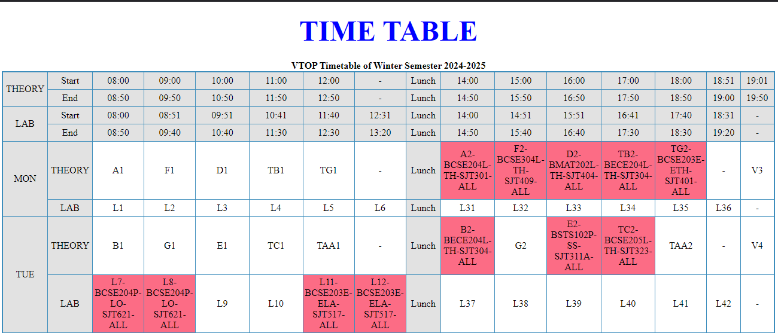
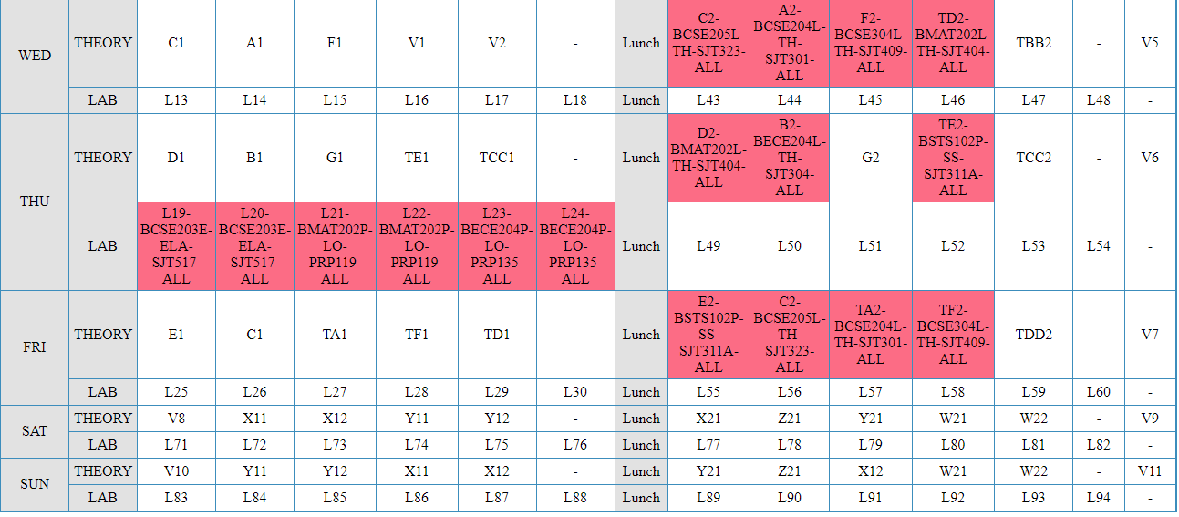
<Paste output screenshot with timestamp>
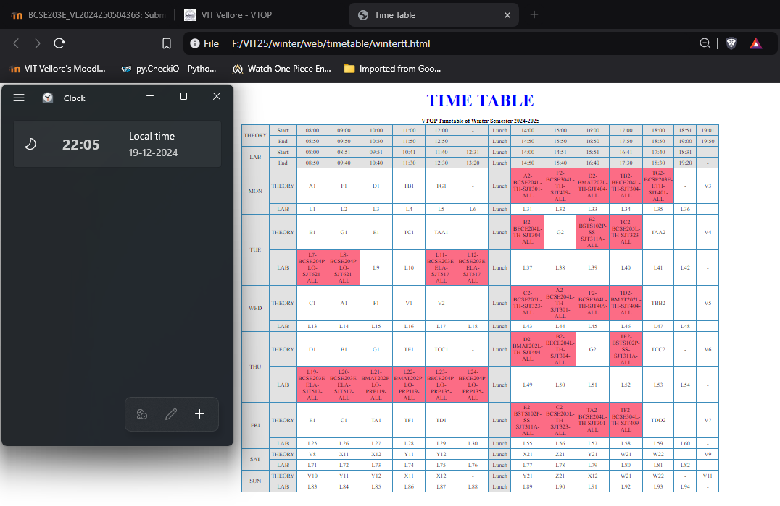
Result:
Thus the a web page to replicate your VTOP Timetable of Winter Semester 2024 – 2025 was created using basic html tags. The output was verified.
Done by MIDHULKIRUTHIK M(23BCE0783)

