Exno 1 d) Develop a web page to create registration page using html form tags.
Aim: Develop a web page to create registration page using html form tags. The tentative registration page template is given below. Your page should include,
- Use table to create forms with proper alignment.
- Apply different html input types (text, number, checkbox, radio and so on)
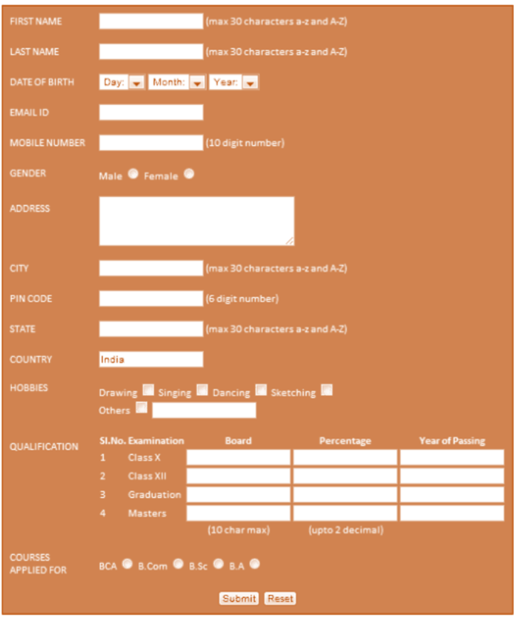
(Reference: progmgpalace)
HTML Tags need to be used:
Tags/elements/methods used | Attributes
<br>
<h1>
<p>
<table> | Use rowspan and colspan
<form>
<input> | Use different types
HTTP methods | get, post
<label>

Procedure:
- Create an html file named as registration.html to design a page as per the above-mentioned template.
- Multiple pages can also be created and connected together using form actions.
- Use HTTP methods (get and post) to understand the differences between them.
- In notepad or any editor or IDE type the necessary code & save with the file name mentioned with .html extension display your time table.
- To view your web page, simply double click your html file.

<Paste your code>
<Paste cropped output>
<Paste output screenshot with timestamp>
Result:
Thus a registration web page was created using basic html form and table tags. The output was verified.

