Exno 1 c) Develop a web page to display your profile using basic html tags.
Aim: Develop a web page to display your profile using basic html tags. The tentative profile page template is given below. Your page should include,
- Use image, text as hyperlink reference.
- Apply internal navigation (Hyperlinking to your E-Mail Address)

(Reference: dribbble)
HTML Tags need to be used:
Tags used | Attributes
<br>
<h1>
<p>
<img> | src, height, width, alt, caption
<a> | href, target (_blank,_parent,_self,_top) [Note: Use Hyperlinking to your E-Mail Address]
<li>
<ul>
<font>

Procedure:
- Create an html file named as home.html to design a page as per the above-mentioned template. It may have the following
  - Name, Address, Telephone number, Email-id, Photo
  - Educational Details (X, XII, I Year, Second Year – Institute name, Max mark, scored mark, percentage or CGPA, class) (Use table)
  - Co-curricular activity details (Use List)
  - Extracurricular activity details (Use List)
  - Technical skill set details (Use List)
  - Hobbies, Personal details
- Multiple pages can also be created and connected together using links.
- In notepad or any editor or IDE type the necessary code & save with the file name mentioned with .html extension display your time table.
- To view your web page, simply double click your html file.

<Paste your code>
<!DOCTYPE html>
<html lang="en">
<head>
<meta charset="UTF-8">
<title>My Profile</title>
</head>
<body>
<div style=" background-image: url(bg.jpeg); width: 1260px;"> <h1 style="color: white; text-align: center; height: 50px;" >My Profile</h1></div>

<table border="2" style="border-collapse: collapse; width:300px; height: 541px;">
<tr style="background-color: orange;">
<th><h2 style=" color: white;">Personal Information</h2></th></tr>
<tr style="height: 50px;"><td><p><b>Name:</b><br><p style="text-indent: 10%;"> MidhulKiruthik.M</p></p></td></tr>
<tr><td style="height: min-content;"><p><b>Gender:</b><br><p style="text-indent: 10%;">Male</p></p></td></tr>
<tr><td><p><b>Address:</b><br><p style="text-indent: 10%;"> 1/410B Selva Nagar,Trichy</p></p></td></tr>
<tr><td><p><b>Telephone:</b><br><p style="text-indent: 10%;"> 8270006969</p></p></td></tr>
<tr><td><p><b>Email:</b> <br><a href="mailto:midhulkiruthik2005@gmail.com"><p style="text-indent: 8%;"> midhulkiruthik2005@gmail.com</p></a></p></td></tr>
</table>
<hr style="border:ridge black; ">
<table border="2" style="width: 600px; height: 300px; position: absolute; top: 93px; right: 180px; left: 340px; border-collapse: collapse;">
<tr style="background-color: orange;"> <th><h2 style="color: white; ">Co-curricular Activities</h2></th></tr>
<tr><td><ul>
<li >Attended Science Fair</li>
<li>Participated in Hackathon</li>
<li>Published Research Paper</li>
</ul></td></tr>
<tr style="background-color: orange;"> <th><h2 style=" color: white;">Extracurricular Activities</h2></th></tr>
<tr><td><ul>
<li>Basketball Team Captain</li>
<li>Volunteer at NGO</li>
<li>Event Organizer for College Fest</li>
</ul></td></tr>
</table>
<table border="2" style="width: 600px; height: 200px; position: absolute; top: 435px; right: 180px; left: 340px; border-collapse: collapse;">
<tr style="background-color: orange; height: 1%;" ><th colspan="6"> <h2 style=" color: white;">Educational Details</h2></th></tr>
<tr>
<th style="padding: 10px;">Level</th>
<th>Institute Name</th>
<th>Max Marks</th>
<th>Scored Marks</th>
<th>Percentage/CGPA</th>
<th>Class</th>
</tr>
<tr align="center" >
<td>X</td>
<td>RSK CBSE School</td>
<td>500</td>
<td>450</td>
<td>90%</td>
<td>First</td>
</tr>
<tr align="center">
<td>XII</td>
<td>ZEE School</td>
<td>600</td>
<td>540</td>
<td>90%</td>
<td>First</td>
</tr>
<tr align="center">
<td>1st Year</td>
<td>VIT</td>
<td>10</td>
<td>9</td>
<td>9.0 CGPA</td>
<td>First</td>
</tr>
<tr align="center">
<td>2nd Year</td>
<td >VIT</td>
<td>10</td>
<td>8.8</td>
<td>8.8 CGPA</td>
<td>First</td>
</tr>
</table>
<table border="2" style="width: 300px; height: 180px; position: absolute; top: 93px; right: 280px; left: 970px; border-collapse: collapse;">
<tr style="background-color: orange;"><th>
<h2 style=" color: white; ">Technical Skills</h2></th></tr>
<tr><td><ul>
<li>Programming: C, C++, Python</li>
<li>Web Development: HTML, CSS, JavaScript</li>
<li>Database: SQL</li>
</ul></td></tr>
<tr style="background-color: orange; text-align: center; height: 10px"><td ><h2 style=" color: white; ">Hobbies</h2></td></tr>
<tr><td><ul>
<li>Reading Books</li>
<li>Photography</li>
<li>Traveling</li></ul>
</td></tr>
<div style="width: 300px; height: 200px; position: absolute; top: 460px; right: 280px; left: 1050px;"><img src="profile.jpg" alt="Your Photo" height="150" width="150" style="background-color: orange; padding: 10px; border-radius: 50%; "> </div>
</body>
</html>

<Paste output screenshot with timestamp>
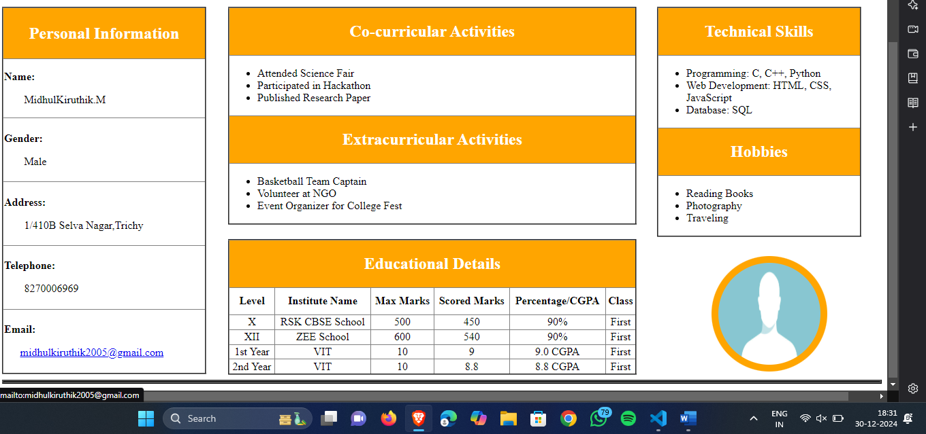
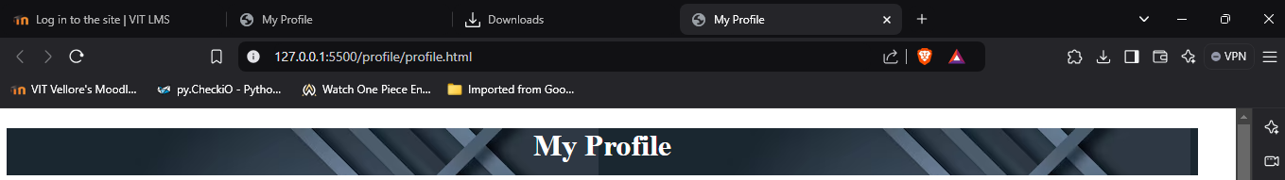

Result:
Thus a web page was created to display my profile using basic html tags. The output was verified.

