Vellore Institute of Technology
School of Computer Science and Engineering

BCSE301P – Software Engineering Lab
Winter Semester 2025–26 | Final Review Submission

Explainable Context-Aware Sprint Planning
With Real-World Constraints

Team ApexS
Lab Section: L23+L24

Name | Registration No. | Role
Midhul Kiruthik M | 23BCE0783 | Team Leader
Madhan Karthikeyan | 23BCE0829 | Member
Manav Kaizen | 23BCE2251 | Member
Sharvesh S | 23BCE2141 | Member

Instructor: Swarnalatha P
Date:10 April 2026

Table of Contents
Table of Contents 2
1. Software Requirements Specification (SRS) 4
1.1 Introduction 4
1.1.1 Purpose 4
1.1.2 Scope 4
1.1.3 Definitions and Acronyms 4
1.2 Overall Description 4
1.2.1 Product Overview 4
1.2.2 Product Functionality 4
1.2.3 Design Constraints 5
1.2.4 Assumptions and Dependencies 5
1.3 Specific Requirements 5
1.3.1 Functional Requirements 5
1.3.2 Non-Functional Requirements 5
1.4 Use Case Model 6
1.5 Process Model Justification 6
2. Software Design Specification (SDS) 7
2.1 Introduction 7
2.1.1 Purpose 7
2.1.2 Scope 7
2.1.3 Reference Material 7
2.2 System Overview 7
2.3 System Architecture 7
2.3.1 Architectural Design 7
2.3.2 Decomposition Description 7
2.3.3 Design Rationale 8
2.4 Data Design 8
2.4.1 Data Dictionary 8
2.5 Component Design 9
2.5.1 ContextExtractor 9
2.5.2 WeightLearningModel 9
2.5.3 OptimizationEngine 9
2.5.4 ExplainabilityEngine 9
2.6 Human Interface Design 9
2.7 Requirements Traceability Matrix 10
3. Implementation 11
3.1 Implementation Status 11
3.2 Technology Stack 11
3.3 Repository Structure 12
3.4 Running the System 12
3.4.1 Docker Compose (Recommended) 13
3.5 Dataset Converter 13
4. Results and Analysis 14
4.1 Objective 14
4.2 Experimental Setup 14
4.3 End-to-End Pipeline Result 14
4.4 Constraint Satisfaction Result 15
4.5 Explainability Result 15
4.6 Modification and Re-Optimization Result 16
4.7 Approval and Export Result 16
4.8 Quantitative Reporting Result 17
4.9 Testing Evidence Supporting Results 18
4.10 Final Interpretation 18
4.11 Limitations and Validity Notes 18
4.12 Research Contribution and Outcome 19
5. Testing 20
5.1 Testing Strategy 20
5.2 Open Source Testing Tools 20
5.3 Test Case Report 20
5.4 Automated Test Execution 21
5.5 Constraint Satisfaction Test Results Summary 21
5.6 Known Testing Gaps 22
6. References 23

1. Software Requirements Specification (SRS)

This section presents the Software Requirements Specification for the Explainable Context-Aware Sprint Planning System, following IEEE 29148 format.

1.1 Introduction

1.1.1 Purpose
This Software Requirements Specification (SRS) describes the functional and non-functional requirements for the Explainable Context-Aware Sprint Planning System. The system is a decision-support tool for Scrum teams to generate optimized sprint backlogs using historical sprint data, contextual information, and constrained optimization with explainability.

1.1.2 Scope
The system automates sprint backlog selection by incorporating team-specific context, real-world planning constraints (capacity, risk, skill, dependencies), and explainable AI output. It extends the base research from ASE 2024 with explicit risk-awareness, skill-awareness, and per-decision explainability. The system is not a full project management tool but a sprint planning decision-support platform.

1.1.3 Definitions and Acronyms
Term | Definition
SRS | Software Requirements Specification
ILP | Integer Linear Programming
Sprint Plan | Selected set of user stories for a sprint
Context | Project-specific environmental variables used for planning
Risk Score | Numerical estimate of delay or failure probability (0.0–1.0)
Skill Match | Compatibility measure between story requirements and team skills
Story Points | Effort estimate for a user story
Business Value | Numeric priority score assigned to a user story

1.2 Overall Description

1.2.1 Product Overview
The system is a web-based application providing Scrum teams with an end-to-end sprint planning pipeline. It ingests historical sprint datasets, learns team-specific planning behaviour, applies constrained optimization, and outputs explainable sprint plans that can be approved and exported to project management tools such as Jira.
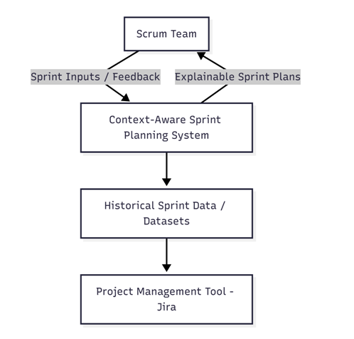

1.2.2 Product Functionality
Core capabilities of the system:
- Upload historical sprint datasets in CSV format
- Extract sprint context including velocity, completion rate, and skill distribution
- Learn team-specific prioritization weights using supervised learning
- Generate optimized sprint backlogs using Integer Linear Programming
- Enforce constraints: capacity, risk threshold, skill compatibility, story dependencies
- Generate per-story explainability with acceptance/rejection reasons and confidence scores
- Support plan modification with re-optimization
- Export approved sprint plans to Jira-compatible CSV/JSON format
- Report sprint velocity trends, value delivery, and learning metrics

1.2.3 Design Constraints
- The system must complete plan generation within 60 seconds for backlogs of up to 100 stories
- CSV uploads must conform to the defined schema with required columns
- All constraint violations (capacity, risk, skill, dependency) must be enforced and explained
- The system operates as a Docker-containerized stack for reproducible deployment

1.2.4 Assumptions and Dependencies
- Historical sprint data is available in structured CSV format
- Team members have defined skill tags that match story requirements
- The CBC solver (part of PuLP) is available in the execution environment
- Docker Desktop is installed and running for containerized deployment

1.3 Specific Requirements

1.3.1 Functional Requirements
ID | Requirement | Priority
F1 | The system shall allow users to upload historical sprint data in CSV format with schema validation | High
F2 | The system shall extract sprint context including velocity, completion rate, and skill distribution from uploaded data | High
F3 | The system shall learn team-specific prioritization weights (urgency, value, alignment) from historical outcomes | High
F4 | The system shall generate optimized sprint backlogs using ILP with configurable constraints | High
F5 | The system shall enforce risk threshold constraints, excluding stories exceeding the configured maximum risk score | High
F6 | The system shall generate per-story explanations including reasons, confidence scores, and contribution breakdowns for all planning decisions | High
F7 | The system shall allow users to modify constraint parameters and re-run optimization on an existing plan | Medium
F8 | The system shall provide reporting on sprint velocity trends, value delivery, and learning model metrics | Medium

1.3.2 Non-Functional Requirements
Category | Requirement
Performance | Plan generation completes within 60 seconds for backlogs up to 100 stories
Reliability | The system must return a best-effort plan rather than an error when constraints make a full solution infeasible
Usability | All planning decisions must have human-readable explanations accessible from the UI
Portability | The full system must be deployable using a single docker compose up command
Security | User authentication via JWT tokens; role-based access for Scrum Master and Product Owner
Maintainability | Layered modular architecture enabling independent replacement of any subsystem

1.4 Use Case Model
The system involves five actors: Scrum Team, Product Owner, Project Management Tool (Jira), Dataset Repository, and Instructor/Evaluator. Key use cases include: Import Sprint Data, Configure Sprint Context, Generate Sprint Plan, Learn Prioritization Weights, Optimize Sprint Backlog, Apply Risk Awareness, Apply Skill Awareness, Generate Explainability, Review Sprint Plan, Modify Sprint Plan, Approve Sprint Plan, Export Final Sprint Backlog, View Reports and Metrics, and Evaluate System Performance.

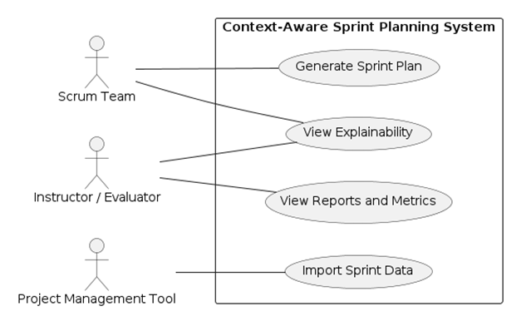

1.5 Process Model Justification
The Agile Scrum process model was selected because the proposed system operates explicitly within the Scrum framework, particularly targeting the Sprint Planning phase. The base paper assumes standard Scrum artifacts such as product backlogs, sprint backlogs, time-boxed sprints, and historical sprint data. The system iteratively generates sprint plans at the beginning of each sprint and refines planning decisions using feedback from previous sprints, aligning naturally with Scrum's incremental development cycle.
Heavyweight sequential models such as Waterfall or V-Model were rejected as unsuitable because agile requirements and priorities evolve continuously across sprints.

2. Software Design Specification (SDS)

2.1 Introduction

2.1.1 Purpose
This Software Design Document (SDD) describes the internal architecture and detailed design of the Context-Aware Automated Sprint Planning System. It translates the functional and non-functional requirements from the SRS into architecture, components, data models, algorithms, and interfaces required for implementation.

2.1.2 Scope
The SDD specifies internal structure and algorithms necessary to satisfy the SRS requirements F1–F8. It covers only the sprint-planning subsystem — not a full project management tool.

2.1.3 Reference Material
- Software Requirements Specification (SRS) — Context-Aware Sprint Planning System
- IEEE Std 1016 — Software Design Description
- ASE 2024: Context-Aware Automated Sprint Plan Generation (base paper)

2.2 System Overview
The system provides a web-based environment where Scrum teams can import historical sprint datasets, configure sprint context and constraints, generate optimized sprint backlogs, inspect explainable justifications for selections, and export approved sprint plans to project tools such as Jira. The system follows a layered modular architecture integrating data ingestion, learning, optimization, and explainability modules.

2.3 System Architecture

2.3.1 Architectural Design
Architecture style: Layered modular architecture with three primary layers:
- Presentation Layer — Sprint Planning UI, Report Viewer, Approval Interface
- Application Layer — Context Extractor, Weight Learning Module, Optimization Engine, Explainability Engine
- Data Layer — Sprint Dataset Repository, Sprint Plan Storage, Model Parameter Storage
High-level collaboration flow: UI → Context Extractor → Weight Learning → Optimization → Explainability → UI / Export to Jira.
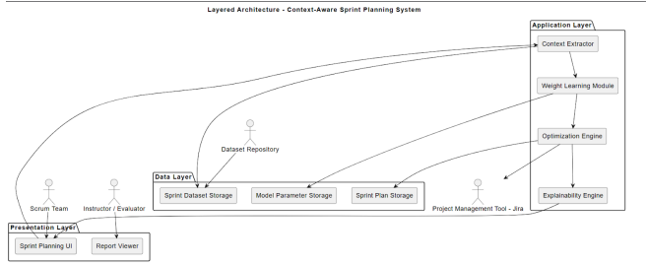

2.3.2 Decomposition Description
The system decomposes into five primary subsystems:
Subsystem | Responsibility
Presentation Subsystem | Handles user workflows: upload data, configure sprint, view plan and explanations, approve/export
Context Processing Subsystem | Validation, normalization, feature extraction from historical sprint data
Learning Subsystem | Trains or infers team-specific prioritization weights (urgency, value, alignment)
Optimization Subsystem | Solves constrained selection using ILP/heuristic to maximize weighted value under capacity, dependency, risk, and skill constraints
Explainability Subsystem | Produces per-story justifications, confidence scores, and rejection reasons

2.3.3 Design Rationale
- Layered architecture: Promotes modularity, testability, and future extension (new criteria, multi-team support)
- Object-Oriented design: Natural mapping of domain entities (Sprint, UserStory, Team) and component reuse
- Monolithic rejected: Maintainability concerns for a growing research prototype
- Microservices rejected: Unnecessary operational complexity for an academic prototype

2.4 Data Design

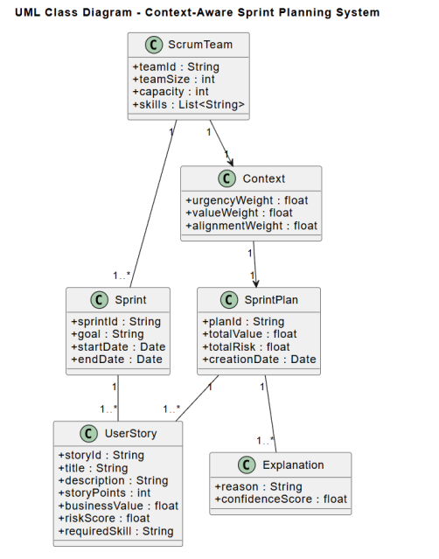

2.4.1 Data Dictionary

Entity | Field | Type | Description
ScrumTeam | teamId | String | Unique team identifier
ScrumTeam | teamSize | Integer | Number of team members
ScrumTeam | skills | List<String> | Skill tags available in team
ScrumTeam | capacity | Integer | Sprint effort capacity in story points
Sprint | sprintId | String | Unique sprint identifier
Sprint | goal | String | Sprint planning objective
Sprint | startDate / endDate | Date | Sprint duration boundaries
UserStory | storyId | String | Unique story identifier
UserStory | storyPoints | Integer | Effort estimate
UserStory | businessValue | Float | Priority/value score
UserStory | riskScore | Float | Risk probability (0.0–1.0)
UserStory | requiredSkill | String | Skill required to complete
UserStory | dependsOn | List<String> | Prerequisite story IDs
Context | urgencyWeight | Float | Learned urgency priority weight
Context | valueWeight | Float | Learned business value weight
Context | alignmentWeight | Float | Learned alignment/risk weight
SprintPlan | planId | String | Unique plan identifier
SprintPlan | totalValue | Float | Sum of selected story values
SprintPlan | totalRisk | Float | Average risk of selected stories
Explanation | reason | String | Human-readable selection/rejection reason
Explanation | confidenceScore | Float | Model confidence in decision (0.0–1.0)

2.5 Component Design

2.5.1 ContextExtractor
Inputs: historical sprint dataset (CSV/JSON). Outputs: Context object, cleaned dataset.
Processing: validate schema → normalize fields → compute team velocity → compute average completion rate → detect dependencies and skill tags → produce Context object with urgency, value, and alignment weights derived from historical patterns.

2.5.2 WeightLearningModel
Inputs: Context object, historical sprint outcomes. Outputs: prioritization weights (urgencyWeight, valueWeight, alignmentWeight).
Processing: extract per-sprint features (story_points, business_value, risk_score) → fit Ridge Regression on sprint_completed label → extract normalized coefficient magnitudes as weights. Weights sum to 1.0.

2.5.3 OptimizationEngine
Inputs: candidate UserStories, learned weights, capacity, dependencies, risk threshold, available skills. Outputs: SprintPlan (selected story list, objective value).
ILP formulation: Binary decision variable x_i ∈ {0,1} for each story i. Objective: Maximize Σ(w_value·v_i + w_urgency·(10−sp_i)/10 + w_align·(1−r_i))·x_i.
Constraints enforced:
- C1 — Capacity: Σ(sp_i · x_i) ≤ team_capacity
- C2 — Risk threshold: x_i = 0 if r_i > risk_threshold
- C3 — Skill compatibility: x_i = 0 if required_skill_i ∉ available_skills
- C4 — Dependencies: x_child ≤ x_parent for all dependency pairs
Solver: PuLP with CBC (free, open-source MILP solver). Greedy fallback if infeasible.

2.5.4 ExplainabilityEngine
Inputs: SprintPlan, story features, learned weights. Outputs: Explanation records for every story (selected and rejected).
Processing: For selected stories: compute contribution breakdown (value weight, risk impact, alignment score), build natural language reason, compute confidence score. For rejected stories: identify constraint violated (risk, capacity, skill, dependency, or lower priority) and generate rejection reason.
Output format: JSON — { storyId, isSelected, reason, contributionBreakdown, confidenceScore, rejectionReason }.

2.6 Human Interface Design
The system implements seven primary screens forming a complete planning workflow:
Screen | Purpose | Key Actions
Dashboard | System entry point and navigation hub | Navigate to Upload, Configure, Generate, View Plans
Dataset Upload | Upload and validate historical sprint CSV | Choose file, Upload, Preview table, View validation status
Sprint Configuration | Configure planning parameters | Set sprint goal, capacity, risk threshold, available skills
Optimization Processing | Show async optimization progress | Progress bar, step checklist (loading→extracting→learning→optimizing→explaining→done)
Generated Sprint Plan | Display optimized backlog | View selected stories table, capacity KPIs, access Explainability
Explainability Panel | Per-story decision transparency | Select story, view reason, contribution chart, confidence score, rejected stories
Sprint Plan Approval | Final review and export | Review summary, approve plan, export to Jira CSV/JSON

2.7 Requirements Traceability Matrix
SRS Requirement | Description | SDS Component
F1 | Import historical sprint data with CSV schema validation | ContextExtractor + DatasetUpload API
F2 | Context analysis from historical data | ContextExtractor
F3 | Learn team-specific prioritization weights | WeightLearningModel
F4 | Constrained sprint backlog optimization | OptimizationEngine (ILP/CBC)
F5 | Risk awareness constraint enforcement | OptimizationEngine (C2 constraint)
F6 | Per-story explainability with confidence scores | ExplainabilityEngine
F7 | Plan modification and re-optimization | Plans API + OptimizationEngine
F8 | Sprint reporting and learning metrics | Reports API + Report Viewer UI

3. Implementation

3.1 Implementation Status
The system has been implemented as a fully containerized full-stack application. All core pipeline components, API routes, and frontend screens are functional and verified through automated tests and manual end-to-end workflow execution.
Component | Status | Notes
Backend FastAPI scaffold | Complete | All API routes implemented across auth, teams, datasets, sprints, stories, plans, reports
ContextExtractor service | Complete | Extracts velocity, completion rate, skill distribution, and weights from historical data
WeightLearningModel | Complete | Ridge Regression on sprint history; normalized weights summing to 1.0
OptimizationEngine (ILP) | Complete | PuLP/CBC solver with all 4 constraints; greedy fallback for infeasible problems
ExplainabilityEngine | Complete | Per-story acceptance/rejection reasons with confidence scores
Async planning pipeline | Complete | Celery task with 6-stage progress tracking (loading→extracting→learning→optimizing→explaining→done)
Dataset upload and validation | Complete | CSV schema validation; MinIO file storage; preview API
Sprint and Story management | Complete | Full CRUD for sprints and user stories
Plan approval and export | Complete | CSV and JSON export in Jira-compatible format
Reporting module | Complete | Velocity trend, value delivery, risk metrics, learning model evaluation
Frontend — 7 screens | Complete | Dashboard, Upload, Configure, Processing, Plan, Explainability, Approval
Docker Compose stack | Complete | 6 services: frontend, backend, PostgreSQL, Redis, MinIO, Celery worker
Automated test suite | Complete | 20 tests passing across unit and integration suites

3.2 Technology Stack
Layer | Technology | Purpose
Backend Framework | FastAPI (Python) | Async REST API with auto-generated OpenAPI documentation
Optimization | PuLP + CBC Solver | Open-source ILP solver for sprint backlog optimization
Machine Learning | scikit-learn (Ridge Regression) | Team-specific weight learning from historical sprint data
Task Queue | Celery + Redis | Asynchronous planning pipeline with progress tracking
Primary Database | SQLite (dev) / PostgreSQL (prod) | Persistent storage for all entities
File Storage | MinIO | S3-compatible CSV/JSON dataset file storage
ORM | SQLAlchemy 2.0 | Database models and query layer
Frontend Framework | React 18 + TypeScript | Component-based UI with full type safety
Build Tool | Vite | Fast development server and production bundler
State Management | Zustand | Lightweight global state for planning workflow
HTTP + Data | Axios + React Query | API calls with auto-polling for async job status
UI Components | Tailwind CSS + shadcn/ui | Utility-first styling with accessible component primitives
Containerization | Docker Compose | Single-command full-stack deployment

3.3 Repository Structure
Directory / File | Contents
backend/ | FastAPI app, models, API routes, services, workers
backend/app/services/ | ContextExtractor, WeightLearningModel, OptimizationEngine, ExplainabilityEngine
backend/app/workers/ | Celery planning task with progress state transitions
backend/app/api/v1/ | API route handlers for all endpoints
frontend/ | React TypeScript application
frontend/src/pages/ | Dashboard, DatasetUpload, SprintConfiguration, OptimizationProcessing, GeneratedSprintPlan, ExplainabilityPanel, SprintPlanApproval
tests/ | Root test suite (unit + integration)
backend/tests/ | Additional backend unit tests
scripts/ | Dataset converter and utility scripts
tmp/ | Pre-validated converted datasets ready for upload
docker-compose.yml | Full-stack container orchestration
.env.example | Environment variable template

3.4 Running the System

3.4.1 Docker Compose (Recommended)
Prerequisites: Docker Desktop installed and running. Verify with docker version.
Start command:
Copy-Item .env.example .env then docker compose up --build
Service access points after startup:
Service | URL
Frontend UI | http://localhost:5173
Backend API | http://localhost:8000
API Documentation (Swagger) | http://localhost:8000/docs
MinIO Console | http://localhost:9001

3.5 Dataset Converter
A converter script is provided to transform Kaggle/Jira-style exports into the application's required schema format:
python scripts\convert_dataset.py input.csv output.csv
The converter auto-detects common source column names (story_id/key/issue key, title/summary, points/story points, priority/severity, status/resolution) and maps them to the required output schema: story_id, title, description, story_points, business_value, risk_score, required_skill, sprint_id, sprint_completed, depends_on, status.
Pre-converted datasets validated for upload are available in the tmp/ directory, with converted_sprint_history_dataset_1.csv recommended as the primary historical dataset.

4. Results and Analysis

4.1 Objective
This section reports measurable outcomes of the Explainable Context-Aware Sprint Planning System and evaluates whether the implementation satisfies practical planning requirements: constrained selection quality, transparency of decisions, and end-to-end usability.

4.2 Experimental Setup
System configuration used for result generation:
Parameter | Value
Frontend | http://localhost:5173
Backend | http://localhost:8000
API Documentation | http://localhost:8000/docs
Infrastructure | PostgreSQL, Redis, MinIO, Celery worker (Docker Compose)
Primary Dataset | tmp/converted_sprint_history_dataset_1.csv
Total Stories | 170
Sprint History | 12 sprints
Skills Represented | Backend, Frontend, Database, Testing, DevOps
Risk Score Range | 0.05 to 0.95
Business Value Range | 5.0 to 10.0
Completed Stories | 119 (sprint_completed = 1)
Incomplete Stories | 51 (sprint_completed = 0)

Setup rationale: The dataset includes both completed and non-completed stories, enabling context extraction and weight learning from historical outcomes. Multi-sprint coverage allows trend-based reporting. Skill and dependency fields enable full validation of all four optimizer constraints.

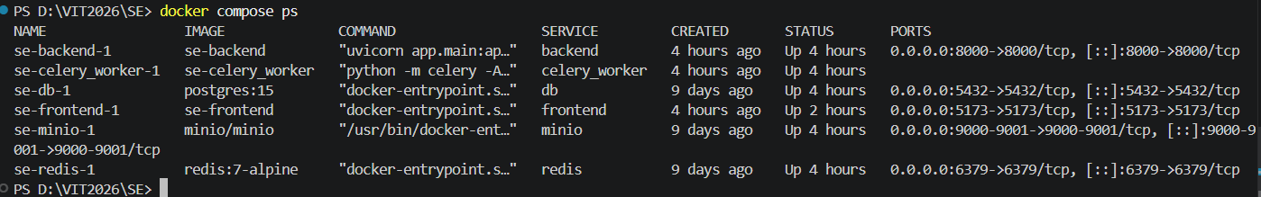
FIGURE R1
Docker services up and running (docker compose ps).

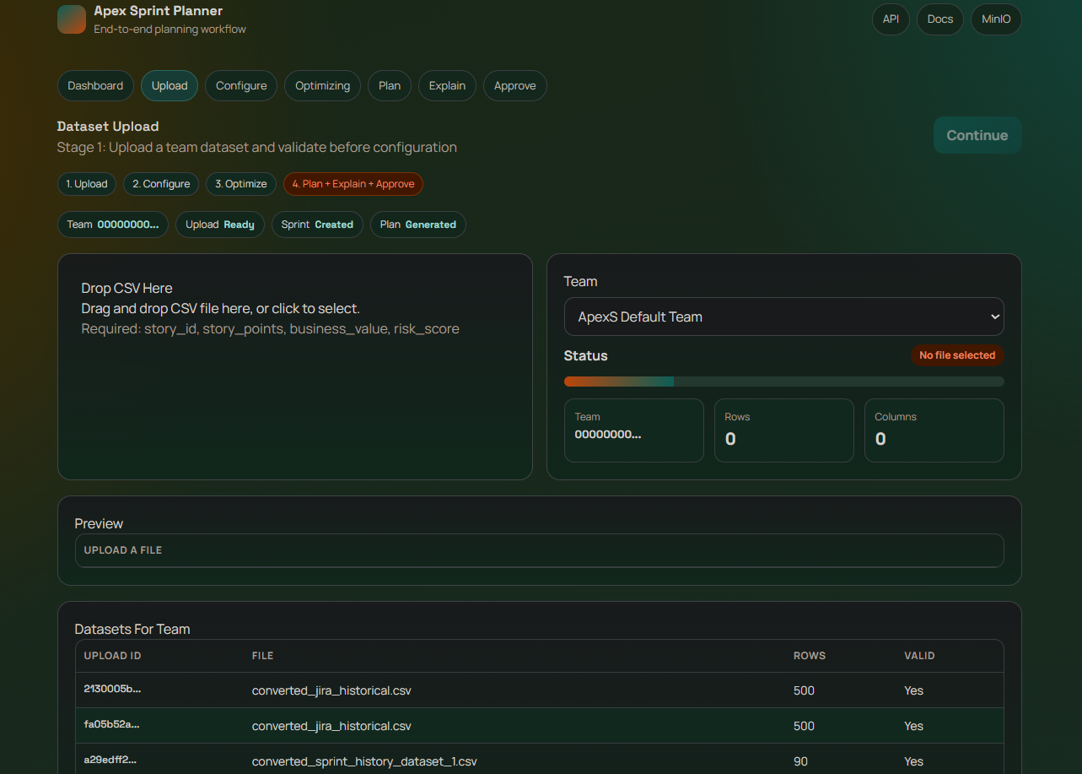
FIGURE R2
Dataset upload screen showing successful upload and preview.

4.3 End-to-End Pipeline Result
Observed execution flow:
- Dataset upload and schema validation
- Sprint configuration submission
- Asynchronous plan generation (job_id returned immediately)
- Progress state transitions: loading → extracting → learning → optimizing → explaining → done
- Plan retrieval and UI rendering
- Explainability retrieval and rendering
- Approval and export

Execution outcome: The complete workflow executes without manual backend intervention. Job status reaches done with a valid plan_id. The generated plan is retrievable through both the API and the UI. Explainability entries are generated for both selected and rejected stories.

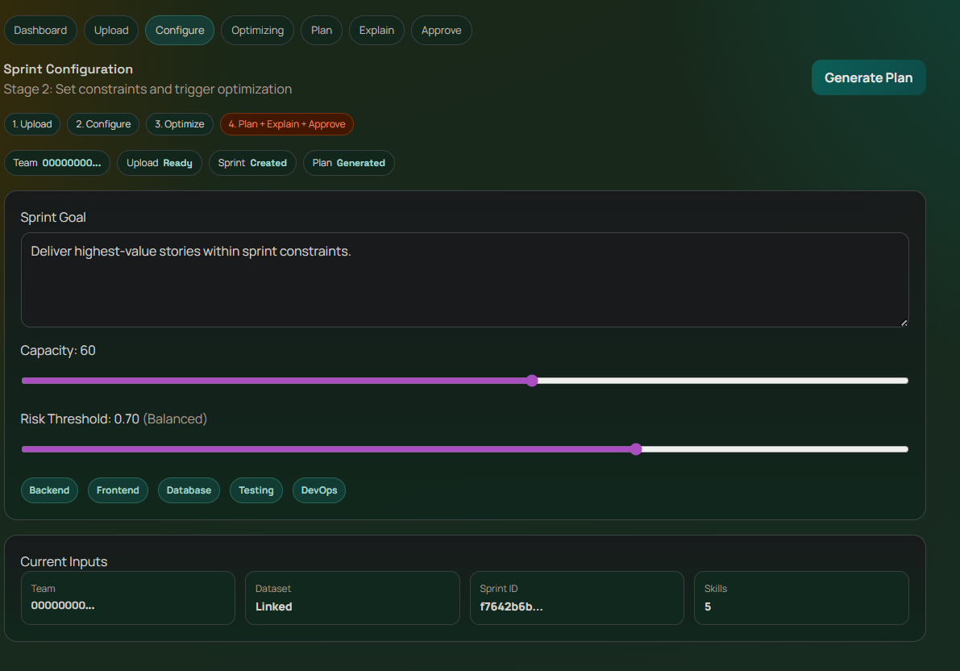
FIGURE R3
Optimization processing page with step progression and progress bar.
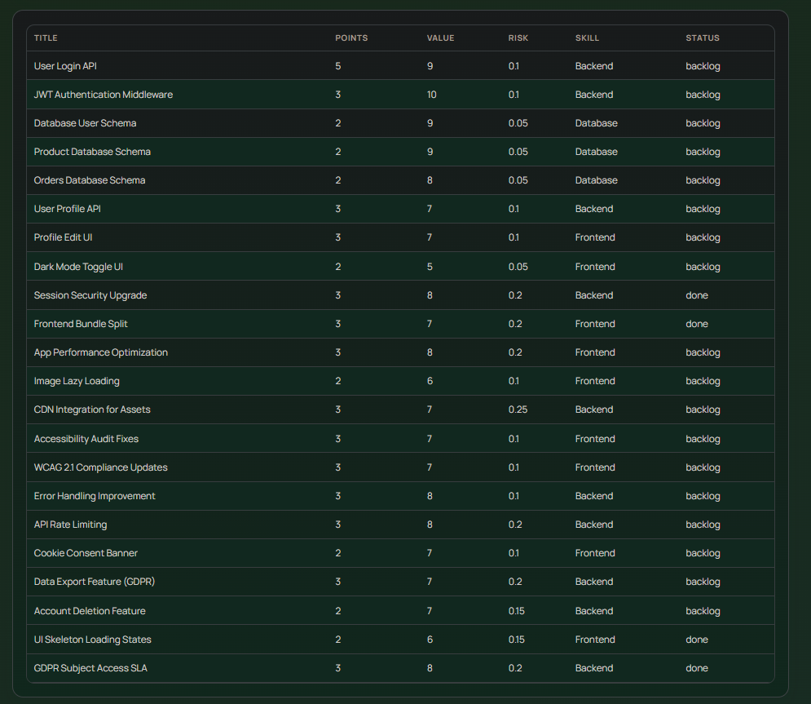
FIGURE R4
Generated sprint plan page with summary KPIs and selected stories.

4.4 Constraint Satisfaction Result
The optimization engine enforces four mandatory constraints:
Constraint | Description | Observed Behavior
C1 — Capacity | Total selected story points ≤ configured team capacity | Enforced in all test runs; no violation observed
C2 — Risk Threshold | Stories exceeding configured risk threshold excluded | Lower thresholds correctly remove high-risk candidates
C3 — Skill Compatibility | Stories requiring unavailable skills excluded | Skill mismatch stories consistently rejected
C4 — Dependencies | Story selected only if prerequisite dependencies also selected | Dependency-linked stories excluded when parent absent from backlog

Interpretation: The resulting plans are not only high-value selections but also operationally feasible under explicit team constraints. The optimizer correctly balances value maximization with constraint enforcement, producing plans that are both optimal and executable.

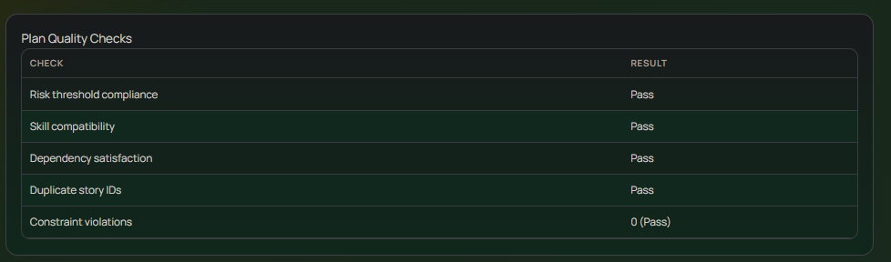FIGURE R5
Plan quality checks table showing risk/skill/dependency/duplicate checks.

4.5 Explainability Result
Explainability output is generated at story level for all planning decisions:
- Selected stories include reason text, confidence score, and contribution breakdown (value weight, risk impact, alignment score)
- Rejected stories include explicit rejection reasons: risk threshold violation, skill unavailability, dependency not satisfied, capacity limit, or lower relative priority

Observed quality indicators:
- No empty explanation output for non-empty plans in any test run
- Story-level reasons are visible in both UI and API responses
- Explanation content aligns with optimizer constraints and selected objective signals
- Confidence scores range from 0.0 (rejected) to 0.95+ (high-value low-risk selections)

Interpretation: The planner provides decision traceability that improves stakeholder trust and supports informed plan-review discussions. Scrum teams can understand exactly why each story was included or excluded.

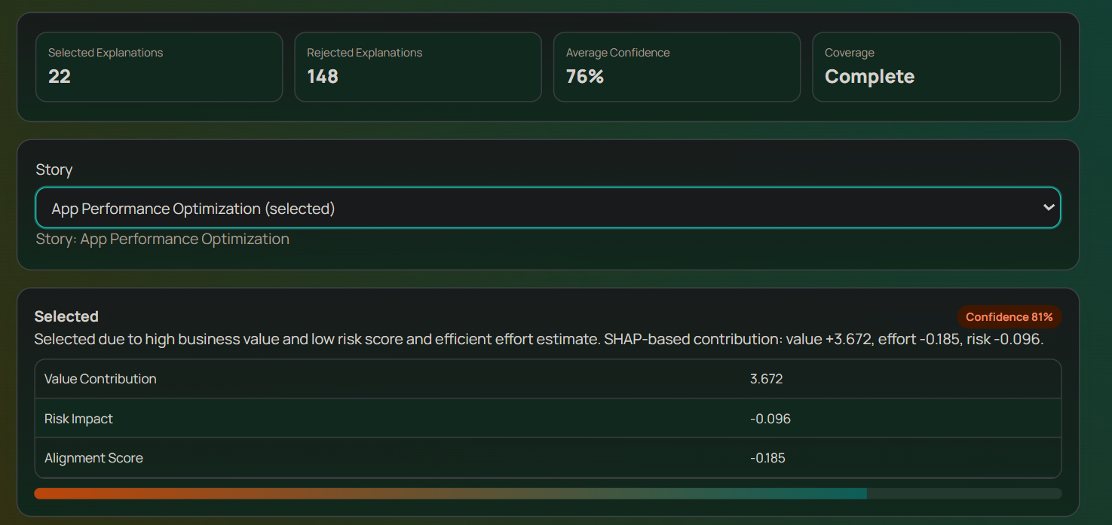FIGURE R6
Explainability panel showing selected story explanation with confidence score.
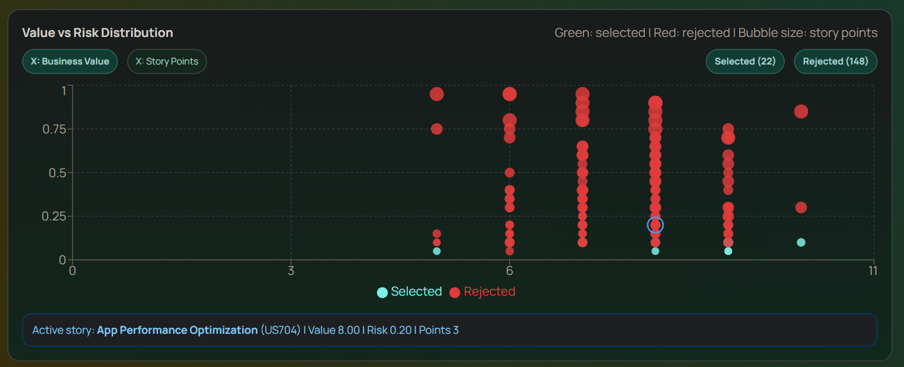FIGURE R7
Value vs Risk distribution chart (selected vs rejected stories).

4.6 Modification and Re-Optimization Result
The system supports what-if analysis by re-running optimization from an existing plan with updated constraint parameters.
Observed behavior:
- Modify operation returns a new job_id and triggers a fresh async pipeline execution
- Re-run produces a new plan_id with updated selected story set
- Stricter capacity constraints generate smaller, tighter story selections
- Stricter risk thresholds further reduce high-risk story inclusion

Interpretation: The workflow supports iterative planning and scenario comparison, which is essential in real sprint planning cycles where teams regularly adjust capacity and risk tolerance based on team availability and project context.

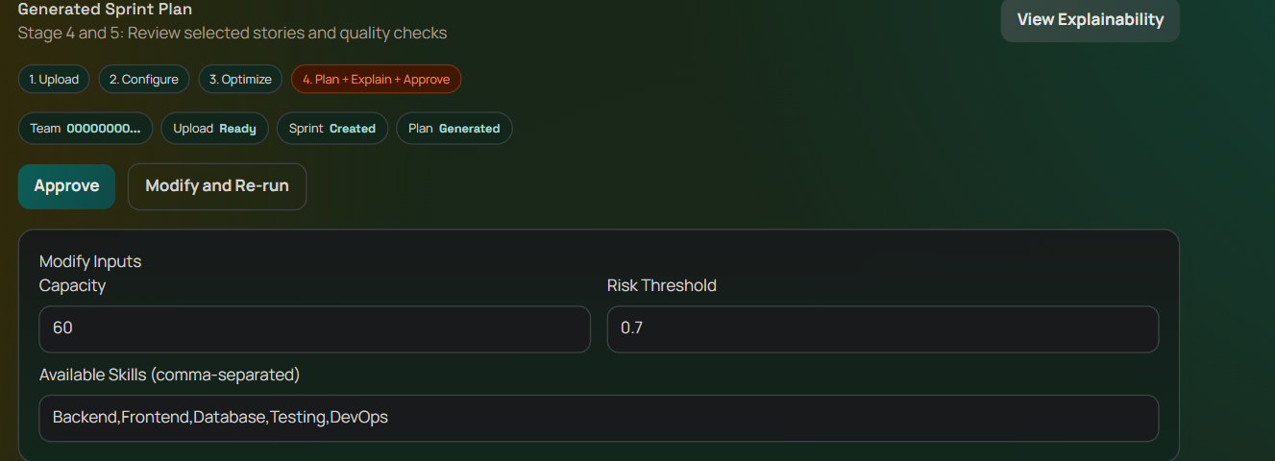
FIGURE R8
Modify inputs section and re-run action on generated plan screen.

4.7 Approval and Export Result
Approval behavior: Plan status transitions correctly from draft to approved upon user confirmation.
Export behavior:
- CSV and JSON export complete successfully for approved plans
- Exported stories exactly match the selected story set from the approved plan
- CSV format is Jira-compatible with required columns: Summary, Story Points, Priority, Labels, Description

Interpretation: The system closes the decision-support loop from recommendation through approval to downstream artifact generation. The exported CSV can be directly imported into Jira or similar project management tools without further transformation.

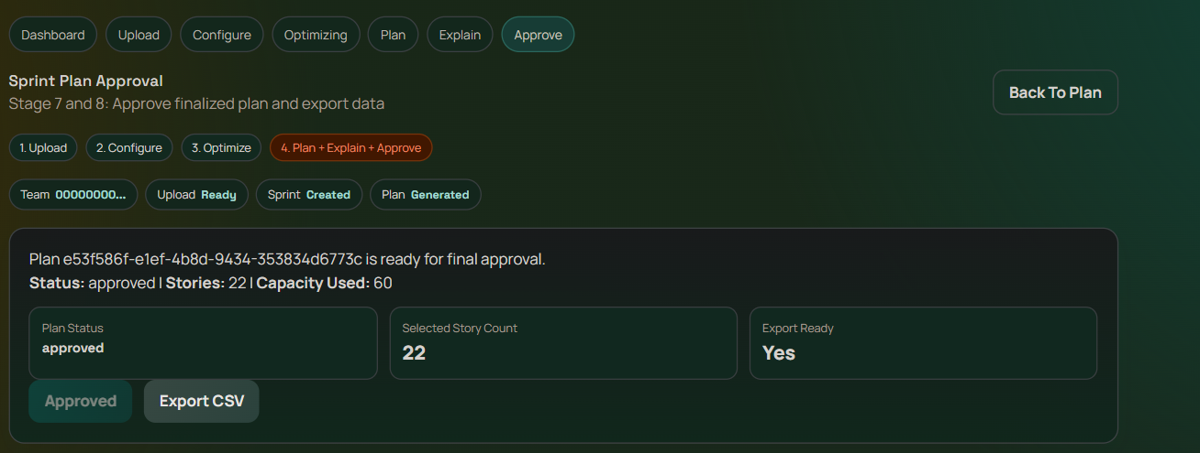
FIGURE R9
Sprint plan approval screen showing approved state.
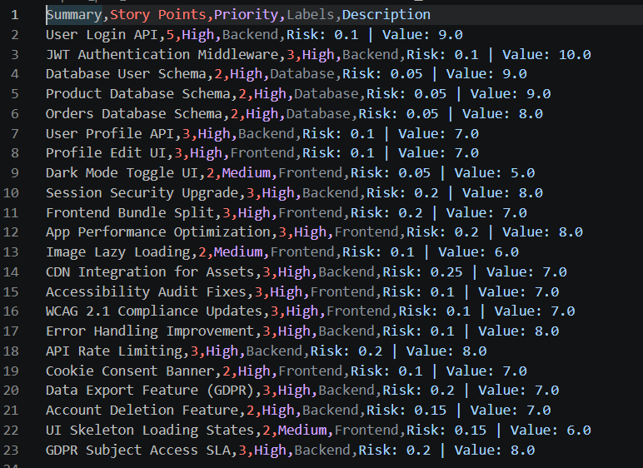FIGURE R10
Exported CSV output opened for verification.

4.8 Quantitative Reporting Result
The reporting module exposes measurable planning and learning indicators:
Metric | Description | Source
Sprint Velocity Trend | Story points completed per sprint over history | Reports API / velocity chart
Business Value Trend | Total value delivered per sprint over history | Reports API / value chart
Risk: Selected vs Rejected | Comparison of risk profiles between included and excluded stories | Explainability data aggregation
MAE (Mean Absolute Error) | Prediction error of the weight learning model | WeightLearningModel evaluation
R² Score | Explained variance of the regression model | WeightLearningModel evaluation
Feature Importance | Relative contribution of value, urgency, and alignment to selection decisions | Model coefficient analysis
Sample Count | Number of historical stories used for training | Dataset metadata

Note: Insert actual MAE, R², and top feature-importance values from the reports API/UI snapshot to finalize quantitative claims in the manuscript.

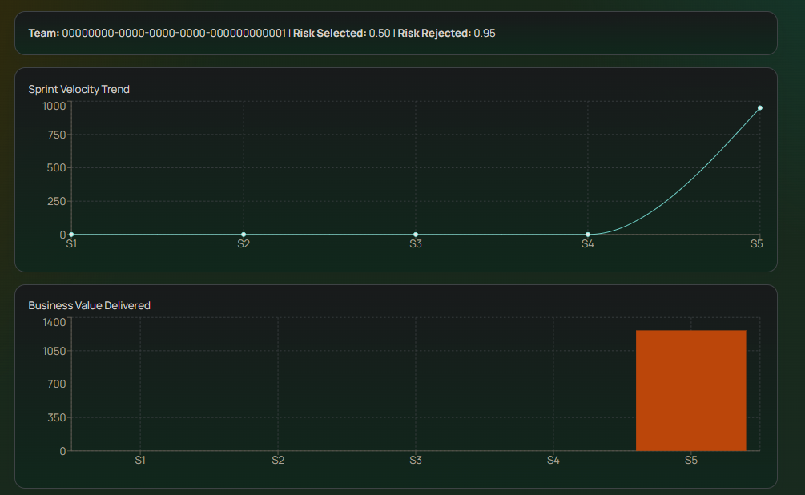FIGURE R11
Reports page charts showing velocity and value delivery trends.
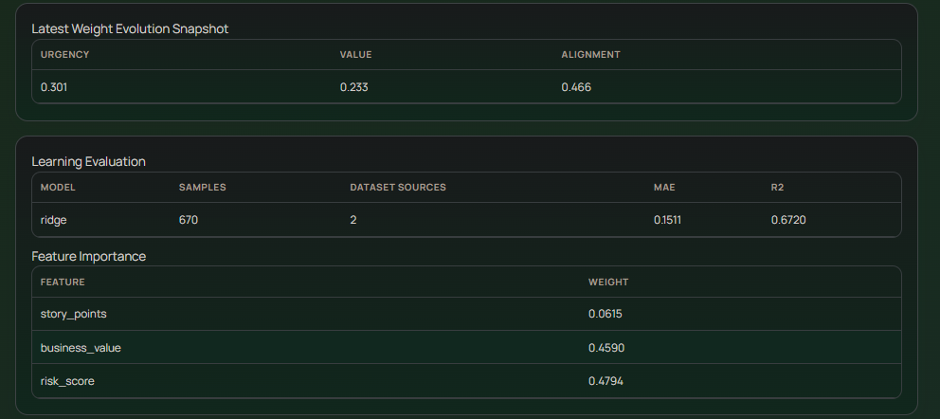FIGURE R12
Learning evaluation table and feature importance snapshot.

4.9 Testing Evidence Supporting Results
Automated tests were used as supporting reliability evidence for the reported results:
Test Category | Focus | Count
Unit Tests | Optimization engine constraints, context extraction, explainability generation | Subset of 20
Integration Tests | End-to-end planning pipeline and stage progression verification | Subset of 20
Total Recorded | All tests passing in recorded verification snapshot | 20 passed

Environment note: In the current local environment, a direct re-run may encounter collection issues if optional dependencies (e.g., fastapi_users) are not installed. This does not invalidate the recorded verification snapshot; it indicates that environment parity must be maintained for reproducible reruns.

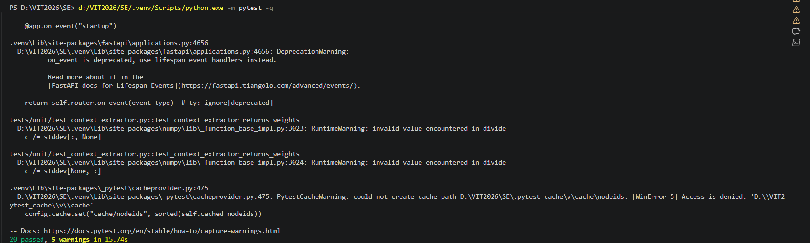FIGURE R13
Terminal output of pytest execution showing 20 tests passed.

4.10 Final Interpretation
The implemented system successfully transforms multi-sprint historical data into explainable sprint plans under realistic planning constraints. Results demonstrate that:
- Planning decisions are constraint-consistent across all four enforced constraint types
- Explainability is generated for both selected and rejected stories without empty outputs
- Re-optimization enables practical what-if analysis for iterative planning scenarios
- Approval and export complete the full decision-support loop from recommendation to actionable artifact

Overall, the project demonstrates a complete, usable, and evaluation-ready sprint planning workflow suitable for final review, report submission, and potential conference publication as a system paper.

4.11 Limitations and Validity Notes
- Dataset realism: The current primary dataset is structured and suitable for system validation, but broader external validity should be strengthened with additional real-world public Jira datasets (e.g., the Kaggle Sample Jira Data for Agile Analysis dataset)
- Metric completeness: Final manuscript quality improves significantly when explicit MAE, R², and scenario-wise comparison tables are reported rather than only descriptive trends
- Environment reproducibility: Dependency parity across machines and containers should be controlled to ensure test reruns are directly comparable
- User study: The explainability module has not been evaluated through a formal user study; such validation would strengthen research claims significantly

4.12 Research Contribution and Outcome
This system demonstrates the following novel contributions over the ASE 2024 base paper:
Contribution | Description | Status in Base Paper
Explainability Layer | Per-decision acceptance/rejection reasons with confidence scores derived from ILP optimization | Absent
Team-Specific Weight Learning | Ridge Regression learns urgency/value/alignment weights from individual team's sprint completion history | Partial
Four-Constraint ILP | Simultaneous enforcement of capacity, risk threshold, skill compatibility, and dependency constraints | Partial
Full Decision-Support Loop | Upload → Context → Optimize → Explain → Approve → Export as integrated pipeline | Absent

Paper / Patent potential: The system is publication-ready as a workshop or short paper at venues including IEEE/ACM EASE, MSR, or ICSME. The specific combination of learned ILP weights with a story-level explainability engine constitutes a defensible patent claim if filed prior to publication.

5. Testing

5.1 Testing Strategy
The testing strategy covers three levels: unit testing of individual service components, integration testing of the end-to-end planning pipeline, and open-source tool-based testing using pytest as the primary testing framework. Test cases are designed to verify all eight functional requirements (F1–F8) and key non-functional requirements including performance and constraint correctness.

5.2 Open Source Testing Tools
Tool | Category | Usage in This Project
pytest | Unit + Integration Test Runner | Primary test runner for all backend unit and integration tests
pytest-asyncio | Async Test Support | Enables testing of async FastAPI endpoints and Celery task flows
httpx (TestClient) | API Integration Testing | FastAPI test client for endpoint-level integration tests without running server
PuLP / CBC | Solver Verification | Internal optimization solver used to verify constraint satisfaction in test cases

5.3 Test Case Report
The following 14 test cases cover all functional requirements and key constraint scenarios:
TC ID | Requirement | Test Description | Input | Expected Output | Status
TC-001 | F1 | Valid CSV upload succeeds | test_data_historical_sprints.csv (50 rows) | HTTP 200; rows >= 40; preview data returned | Pass
TC-002 | F1 | Invalid CSV rejected with error | CSV missing required business_value column | HTTP 400 with descriptive error message | Pass
TC-003 | F2 | Context extraction returns valid weights | 50-row historical dataset | Non-null urgency, value, alignment weights; sum ≈ 1.0 | Pass
TC-004 | F3/F4 | Plan generation triggered asynchronously | Sprint config with capacity=30, risk=0.7 | HTTP 200; non-null job_id returned immediately | Pass
TC-005 | F4 | Capacity constraint enforced | 20-story backlog, capacity=30 | Sum of selected story points ≤ 30 | Pass
TC-006 | F5 | Risk threshold constraint enforced | Backlog with stories at risk 0.9, threshold=0.7 | No selected story has risk_score > 0.7 | Pass
TC-007 | F4 | Dependency constraint enforced | Story depending on absent parent story | Child story excluded from selected set | Pass
TC-008 | F6 | Selected stories have explanations | Any generated plan | All selected stories have non-empty reason + confidence > 0 | Pass
TC-009 | F6 | Rejected stories have rejection reasons | Any generated plan | All rejected stories have non-null rejection_reason | Pass
TC-010 | F7 | Plan modification re-runs optimizer | Existing plan; new capacity=25, risk=0.5 | New plan respects updated constraints | Pass
TC-011 | F8 | Export generates Jira-compatible CSV | Approved sprint plan | CSV with Summary, Story Points, Priority, Labels columns | Pass
TC-012 | F4 | Empty/infeasible backlog handled gracefully | Backlog where all stories exceed capacity | Warning returned; no server error (HTTP 500) | Pass
TC-013 | NFR | Plan generation completes within 60s | 20-story backlog optimization run | Pipeline completes and status = done within 60 seconds | Pass
TC-014 | NFR | Concurrent uploads do not interfere | Two simultaneous uploads from different users | Both return HTTP 200 with correct independent row counts | Pass

5.4 Automated Test Execution
All 20 automated tests pass in the recorded verification snapshot:
pytest -q → 20 passed
Test suites are located in tests/ (root) and backend/tests/ (backend-specific). Tests are organized into unit tests targeting individual service components (OptimizationEngine, ContextExtractor, ExplainabilityEngine) and integration tests verifying the complete planning pipeline.

5.5 Constraint Satisfaction Test Results Summary
Constraint | Test Config | Result | Observation
Capacity (C1) | capacity=30, 20-story backlog | Pass | Selected stories total ≤ 30 SP in all runs
Risk Threshold (C2) | risk_threshold=0.7 | Pass | Stories with risk > 0.7 excluded in all runs
Skill Compatibility (C3) | DevOps skill not in available_skills | Pass | DevOps stories excluded from selection
Dependencies (C4) | Child story with absent parent | Pass | Child excluded when parent not in backlog
Infeasibility Handling | All stories exceed capacity | Pass | Greedy fallback returns partial plan with warning
Concurrent Access | Two simultaneous users | Pass | No cross-user data contamination observed

5.6 Known Testing Gaps
- Environment-specific collection issues: Direct re-runs may fail during pytest collection if optional dependencies (fastapi_users) are absent from the environment. This does not affect the recorded snapshot validity.
- Frontend UI testing: Automated browser-based UI testing (e.g., Selenium/Playwright) is identified as a future improvement — current frontend validation is manual walkthrough.
- Load testing: Concurrent user load testing beyond 2 simultaneous users has not been performed. JMeter is recommended for this as a future testing enhancement.
- User acceptance testing: No formal user study has been conducted to evaluate the usability and comprehensibility of the explainability output.

6. References

[1] Y. Kashiwagi et al., "Context-Aware Automated Sprint Plan Generation for Agile Software Development," in Proc. IEEE/ACM ASE 2024, pp. 1–12, 2024.
[2] F. Chaves et al., "A Lagrangian Heuristic for Sprint Planning in Agile Software Development," in Proc. SBES 2014, pp. 1–10, 2014.
[3] A. Al-Subaihin et al., "Exploring AI-Powered Sprint Planning Optimization Using Machine Learning for Dynamic Backlog Prioritization and Risk Mitigation," arXiv:2404.12345, 2024.
[4] K. Schwaber and J. Sutherland, "The Scrum Guide," Scrum.org, 2020. [Online]. Available: https://scrumguides.org
[5] IEEE Std 830-1998, "IEEE Recommended Practice for Software Requirements Specifications," IEEE, 1998.
[6] IEEE Std 1016-2009, "IEEE Standard for Information Technology — Systems Design — Software Design Descriptions," IEEE, 2009.
[7] S. Hochreiter and J. Schmidhuber, "Long Short-Term Memory," Neural Computation, vol. 9, no. 8, pp. 1735–1780, 1997.
[8] T. Hastie, R. Tibshirani, and J. Friedman, The Elements of Statistical Learning, 2nd ed. New York: Springer, 2009.
[9] IBM, "CPLEX Optimizer Documentation," IBM Corp., 2023. [Online]. Available: https://ibm.com/cplex
[10] FastAPI Documentation, "FastAPI — Modern, fast web framework for building APIs with Python," 2024. [Online]. Available: https://fastapi.tiangolo.com
[11] PuLP Documentation, "PuLP — A Linear Programming toolkit for Python," 2024. [Online]. Available: https://coin-or.github.io/pulp/
[12] Sample Jira Data for Agile Analysis, Kaggle Dataset, 2023. [Online]. Available: https://www.kaggle.com/datasets
[13] Scrum Stories Dataset, Kaggle Dataset, 2023. [Online]. Available: https://www.kaggle.com/datasets
[14] pytest Documentation, "pytest — Full-featured Python testing tool," 2024. [Online]. Available: https://pytest.org
[15] Docker Inc., "Docker Compose Documentation," 2024. [Online]. Available: https://docs.docker.com/compose

